H446 OCR Programming Project

*Eshan Fadi*

*Upton Court Grammar School*

*Centre Number: 51427*

*Candidate Number: 8052*

Abrupt Animus

Table of Contents

Project Ideas 12

Engine and Language Evaluations 12

Unity – C# 13

Unreal Engine – C++ 13

Godot Engine – GDScript 13

Python (using Pygame) 14

RPG in a Box – Bauxite 14

Chosen Idea and Justification 15

Analysis 16

Problem Identification 16

Computational Methods 16

Stakeholders 19

SillyAustralian ® - Henry Masters (Founder and CEO) 19

DrunkDriving ™ - Amarveer Flora (CEO) 20

Research 21

Titanfall 2 (AKA TF|2) 21

Half Life (and other Source Engine games) 23

Omori 25

Conclusion 26

Interview 27

Essential Features 31

Movement 31

Walking/Strafing 31

Sprinting 31

Jumping 31

Crouching (both toggle and hold) 31

Sliding 31

Wallrunning 32

Grappling 32

Double Jump 32

Boosting 32

Combat 32

Fire 32

Zoom 32

Swap weapon 33

Quick melee 33

Pick up weapon 33

Reload 33

Sound Effects 34

Saving 34

Scoring System 34

Dialogue System 35

Death Screens 35

Graphical User Interface (GUI) 35

Limitations 35

Solution Requirements 36

Hardware and Software Requirements 37

Success Criteria 38

Design 41

Decomposition 41

Combat 41

Weaponry 41

Swapping 41

Guns 41

Melee 41

Grenades 41

Player 41

Movement 41

Horizontal 41

Vertical 41

Wallrunning 42

Entities 42

Drones 42

Soldiers 42

Tanks 42

Civilians 42

Environment 43

Ground 43

Walls 43

Pickups 43

Interacts 43

UI 43

HUD 43

Menu 43

Title screen 43

Options 43

Pause 44

Save menu 44

Checkpoints 44

Load game 44

Dialogue 44

Interpreter 44

Actors 44

Managers 44

Structure Definition 45

Algorithms 45

Movement 45

Enemy Entities 51

Weapon and its Interaction 54

Dialogue 57

Save System 62

Usability 64

Game Design 64

First Designs: 65

Main Menu: 65

Save Slot Menu: 66

Game HUD: 66

Choice: 69

Subtitles: 69

Pause Menu: 70

2nd: 70

Main Menu: 70

Save Slot Menu: 71

Pause Menu: 72

3rd: 72

Main Menu: 72

Save Slot Menu: 73

Final Agreed Designs: 73

Main Menu: 74

Save Slot Menu: 74

Game HUD: 75

Choice: 75

Subtitles: 76

Pause Menu: 76

Variables and Data Structures 76

Enumerators 81

PlayerMovementState: 81

DerivativeType: 82

MemberState: 82

Databases 82

Dialogue: 82

SceneInfo: 82

Naming Conventions 83

Class Diagrams 84

Entities 84

Weapons 85

Iterative Tests 85

Strafing 86

Looking 87

Boosting 87

Jumping 88

Crouching 89

Different crouch keys 90

Looking and strafing combined tests 90

Fire 91

Reload 92

Swap weapon 93

Add weapon 93

Weapon pointing to target 94

Spike Testing 95

Entity Movement 96

Entity Searching 97

Entity Combat 98

Saving and Loading 99

Save Data Application 100

Displaying Saves Normally 100

Displaying Saves when making a new save slot 101

Selecting a new menu 101

Player Death 102

Quitting 102

Loading Screen 103

Moveability and Cursor state when loading a scene 103

UI Audio 104

Volume Slider 105

FOV Sliders 106

Wallrunning 107

Transpiling a line 108

Dialogue Interaction 109

Post Tests 110

Robustness 110

Glitches 111

Strafing 111

Jumping 112

Crouching 113

Using weapons 114

Taking damage 116

Saving 117

Dialogue 117

Entity behaviour 119

Usability Tests 120

Development 121

Prototype 1 121

Input Detection 121

Movement 122

Interview 130

Interview 135

Miscellaneous 151

End of prototype tests 152

Strafing 152

Looking 153

Boosting 154

Jumping 154

Crouching 155

Different crouch keys 155

Looking and strafing combined tests 156

Interview 157

Prototype 2 157

Interacting with weapons 157

Entities (Damage) 167

Interview 173

End of prototype tests 185

Entity Movement 185

Entity Searching 187

Entity Combat 187

Interview 188

Prototype 3 189

Automatically Reloading 189

Held Zoom 190

Weapon point to target 191

Saving and Loading System 194

Interview 209

Menus and level transitions 210

Miscellaneous 224

Referencing the Game Manager 224

Referencing the camera 226

End of prototype tests 226

Saving and Loading 226

Save Data Application 227

Displaying Saves Normally 227

Displaying Saves when making a new save slot 228

Moveability and Cursor state when loading a scene 228

Interview 229

Prototype 4 229

Button to loading screen 229

Interview 231

Audio 232

Options 236

Interview 238

Movement 240

Interview 240

End of prototype tests 251

UI Sounds 251

Volume Slider 252

FOV Slider 253

Sliding 254

Boosting 255

Double Jumping 255

Wallrunning 257

Interview 258

Prototype 5 259

Dialogue 259

Interview 274

End of prototype tests 277

Transpiling a line 277

Dialogue Interaction 277

Interview 279

Evaluation 279

Evaluative Testing 279

Robustness 279

Evidence – Normal 280

Evidence – Intense 280

Glitches 281

Jittery movement 281

Weapon duplication 283

HUD Disappearance 284

Dialogue if skip 284

Strafing 285

Jumping 290

Crouching 293

Boosting 295

Wallrunning 297

Using weapons 300

Taking damage 304

Saving 306

Dialogue 310

Entity behaviour 312

Usability Tests 314

Evidence – There is no game 316

Evidence – Opening the game, Main Menu 317

Evidence – Option Menu in the Main Menu 317

Evidence – Empty Slot Menu 318

Evidence – Filled Slot Menu 318

Evidence – Loading Screen 319

Evidence – HUD 319

Evidence – Pause Menu 320

Evidence – Options menu in the Pause Menu 320

Success Criteria 321

Interview 322

Limitations and Maintenance 322

Bibliography 326

Appendix (All the game’s code) 328

UISounds.cs 328

CASCapsuleVisualiser.cs 329

FPS.cs 329

IsGroundedTest.cs 330

PosAndVelocity.cs 331

DialogueInteraction.cs 331

TreeNode.cs 346

Entity.cs 346

PlayerEntity.cs 348

EnemyEntity.cs 349

Drone.cs 357

Tank.cs 359

Soldier.cs 360

EnemyManager.cs 360

AudioManager.cs 360

DialogueDatabaseManager.cs 361

DialogueManager.cs 362

MenuManager.cs 364

PlayerManager.cs 367

Options.cs 373

PauseGame.cs 374

BodyDetection.cs 375

PlayerGunInteraction.cs 375

PlayerLook.cs 381

PlayerMovement.cs 382

Checkpoint.cs 394

LevelBullets.cs 395

LevelHighscores.cs 395

PlayerData.cs 396

WorldFlags.cs 398

SaveData.cs 398

SaveSystem.cs 399

SerializableStructs.cs 403

GUISlots.cs 404

LevelLoading.cs 406

NewGame.cs 407

SelectSlot.cs 407

SlotSelection.cs 407

GlobalConstants.cs 408

Interactable.cs 408

# Project Ideas

|  |  |  |  |  |
| --- | --- | --- | --- | --- |
| Idea | Short Explanation | Complexity | Language | Computational Methods |
| Movement first-person-shooter game | A game where the player must simultaneously manage their momentum and there aim | Medium - ample use of math and GUI. Movement must be fine-tuned along with movement-based bug fixes. Player physics, and bullet physics, enemy AI, and modular interconnected components, OOP, libraries | C#, C++, GDScript, Python, easier with engines | OOP, database, modular design, abstraction for the GUI, reusability for functions |
| Game engine | An application designed to help and aid someone in the creation of game or another app | Difficult - lots of math, OOP, GUI, implementing a physics engine, along with functionality for any component, must include compilers and built in libraries to assist in building the game | C#, C++ | OOP, decomposition of functions |
| Programming Language | Writing a language and run it either being compiled, or to interpreted | Easy - filled with trees and if statements, and exception raising, must have built in functions, handle memory and add basic data structures | C#, C++, CPython | Selection, trees, decomposition, and modular design for various parts of the compiler |

## Engine and Language Evaluations

The purpose of an engine within software development is to speed up the development speed. Usually, these contain tools that manage and automate significant background processes, such as the script execution order, a built-in physics engine, and a lighting pipeline. Many modern engines feature a modular design for their workflow, with there being objects which you can attach components to, to add further functionality to the object. Some of these may be colliders, materials, or even scripts.

### Unity – C#

Released in 2005, Unity is an extremely useful engine that has great capabilities for both 3D and 2D, with powerful tools to assist in the creation of apps (mostly games) and experiences. It has a huge community surrounding it, making it incredibly easy to learn, with a wide variety of plugins to aid in the development of certain aspects of the process. The currently supported language used within it is C#, part of the C family. The language is quite easy to learn, having aspects like Python and JavaScript. It also simultaneously has the speed and access of C++, as it is a compiled language. I have some previous experience in using both Unity and C#, but the majority of their functionality is still to be explored. However, Unity recently made some economic decisions that have severely damaged the reputation of the company and software. As such, if I wish to continue the project afterwards, I may end up having to completely transfer the entire project to another piece of software, so this may not be the best long-term solution.

### Unreal Engine – C++

All the way from 1998, this engine is well known for boasting incredible visuals without much effort required from the developer. It is comparatively easier to optimise the application to run faster, as certain mesh optimizations exist natively to Unreal Engine 5 (namely Nanite). Proven its ability repeatedly, the Unity scandal has brought more eyes upon this amazing piece of software. However, due to its fabulous visual capabilities by default, making lightweight applications and games is far tougher, as many layers must be stripped away. Furthermore, it is well known that Unreal Engine is not built for the 2D experience, limiting the type of content that it can create. The language of choice for UE5 is C++, a language notorious for being extremely difficult to learn with low-level concepts such as pointers mixed in with high-level abstractions such as object-oriented programming. I have little-to-none prior experience programming with C++, so the learning curve to use UE5 is far greater than the other options.

### Godot Engine – GDScript

Godot is the game engine equivalent to Blender 3D in the 3D modelling world - a completely free and open-source alternative, which is only getting better and better every update, and will most likely become the industry standard within a decade. It uses a node-based system to construct the world and all objects which is similar to the systems that other game engines use. This intuitive system allows for more flexibility, greatly helping in the learning process. Godot mainly uses GDScript, a custom language which the engine supports completely for all platforms. It also supports C# and C++, but C# is not currently available to be compiled for the web in Godot 4.2 (the latest version of Godot at the time of writing). Godot can also support any other language using extensions to the engine. The worthwhile option would be GDScript, which is similar in syntax to JavaScript and Python, and has many built in functions such as is_on_floor() to handle common and simple checks automatically. The number of tutorials that the community and the Godot team themselves have made is vast and is only increasing, as many people flock from Unity to Godot, making it so that learning the engine and its language would be far easier than before.

### Python (using Pygame)

Python and Pygame together allow anyone to easily pick up and create anything and everything that they want. Unlike the other entries on this list, this is not an engine, which means that the creator must program in every feature, from collision handling and response, to manually testing individual locations for objects, instead of placing them in a visual scene and moving them easily. This significantly slows down the development of the application and can be extremely tedious as everything must be done by the developer, reducing the amount of creativity and passion that can be put into the project. While the language itself is extremely easy to learn, the underlying concepts behind game development such as matrix transformations and quaternions are extremely difficult to understand and waste one’s time when implementing them in such a small timescale. Such a project would be better suited to one with a far longer time frame to work within.

### RPG in a Box – Bauxite

Made using Godot, RPG in a Box is a game engine that has everything built within it for you: a voxel editor, fully working dialogue system, a sound effects generator, and even a visual scripting language. While many of the other engines on this list also have visual scripting as part of their arsenal, none use it or recommend it as much as RPG in a Box. It also has a secondary fully working scripting language called Bauxite, which is extremely similar to Lua, a famous programming language that has been used to make amazing games such as Hades. The engine is designed to be as friendly to a normal person as possible, such that no prior experience is required to even begin making something within this engine, but this also happens to be its downfall. Since so many features are required to use the built-in system to have full functionality, it becomes harder to implement higher level concepts without effectively writing your own engine.

## Chosen Idea and Justification

The game engine is far too complex and time consuming for the constraint of time, while also requiring more learning than either of the other options. The programming language on the other hand, is simpler and would not allow me to easily incorporate as many computational methods. The movement first-person-shooter game is a great medium between the complexity of the two other options, while also allowing me to incorporate a great deal of creativity and interesting implementations of the course content. Furthermore, I will be using Unity to implement this since I have prior experience using the engine and C# as well, so I can spend more time focusing on constructing the project than learning how to use the program itself. I also get the benefit of using an engine which allows me to focus on unique ideas, rather than implementing standard algorithms and techniques.

# Analysis

## Problem Identification

An up-and-coming group of the gaming community is a collection of speedrunners, craving for fast movement and fluidity to beat the games faster and faster. To satiate this need, I have decided to construct a fast-paced movement first-person-shooter game, demanding both an understanding of momentum and precise aim, to hit a selection of enemies and reach the end of the level as fast as possible. The game will also have a secondary genre of a role-playing game, allowing players to progress and unlock more movement abilities and upgrade already existing ones to navigate the game at faster rates. Applying restrictions to the upgrades players can apply at one time will force them to strategically use their available abilities wisely and changing their style of play based upon the current scenario. For example, puzzle-based sections may better be played using a set of upgrades (typically called a build) that benefits movement and its control. On the other hand, while in combat it could be better to use a build that increases one’s health and damage dealt.

## Computational Methods

|  |  |  |
| --- | --- | --- |
| Method | Why | How |
| Thinking abstractly | Referring to the process of separating ideas from reality, it can be understood in two separate ways: abstraction for the developer, and abstraction for the player. For the developer, abstraction refers to the difference between the code and the hardware and hence creating a model that will make the best use of the hardware. For the player, abstraction is the difference between the information given to them (such as the GUI, colours of effects) and the actual code and logic behind it all. | Only the bare minimum information is provided to the player, making sure that they only know what the developer wants them to know. Workings of certain mechanics could be summarised within a paragraph or shown through cutscene tutorials. Information on weapon states can be shown with images instead of text. As much as possible should follow the show-not-tell principle and detail does not need to reach that of realism. |
| Thinking procedurally | Otherwise known as decomposition, this is the process of breaking a large problem into sub-problems, making the overall task much simpler. Without the ability to decompose, designing and creating a game would be completely impossible. People already decompose problems to solve them. By splitting a huge problem into extremely simple ones, it makes the entire task far easier and reduces the time wasted in trying to solve a complicated problem. All the saved time will create a better product in the end. | The task of creating a game can be split into the many parts of game development, such as programming, art design, and other things. Within programming, it can be used to split the game into separate modules, classes, and functions. Grouping together related functions with importable modules will reduce the amount of code one needs to write and is better to maintain and debug. It is also far easier to create a function that does only one job and have a separate function call all the pieces when they are required, avoiding code duplication and errors that might occur when doing so. |
| Thinking ahead | When designing programs, rewriting the same code or similar code over and over again can be boring, inefficient, and a pain to debug, while also reducing the readability and increasing how error-prone it becomes. It also becomes far faster to program if all the steps have been planned out beforehand, such as inputs and outputs. Identifying spots where one can cache data to improve data access speeds and reducing memory usage will also allow the game to run faster, while leaving more resources for other parts of the program. Thinking ahead also references planning out the timing of when to implement features and how long it should take to do so. | One can simplify repeatable code by extracting them into functions and their respective calls. Taking this a level up means using classes (and hence Object-Oriented Programming) to reduce code duplication as much as possible. This fits in with using Unity and C# since it uses objects as the framework, and so programming using OOP will be far easier and better supported. When multiple objects may access the same data, this data will be cached in a static section of the class, increasing memory efficiency. Techniques like polymorphism and abstract classes will further reduce the need to rewrite code. |
| Performance modelling | In games where skilfully timing and predicting trajectories is the aim, having any source of freezing or lag (when there is a significant difference between the player’s inputs and the outputs displayed on the screen) will result in a sub-par, even rage-inducing experience, due to issues out of the player’s control. While this is the intention for some games, it is not the intention for mine, and as such, code should be written efficiently to improve the player’s experience. Performance modelling will help in analysing inefficiencies and hence places that could be rewritten, resulting in an overall all better game. | While doing the programming can be more enjoyable than other parts of the development process, wasting time testing inefficient and longwinded solutions can be a massive bane that may end up costing you the project. Being able to evaluate the performance of a function or script before it is rigorously tested by modelling it and quantitative analysis will help identify weak points in algorithms and potential places to improve the efficiency, reducing the lag a player might experience. One useful tool to quickly measure a function’s efficiency is Big O Notation, showing how effective the algorithm is as the input size increases. |
| Thinking concurrently | Not every process in a game can run sequentially. Sometimes things must run simultaneously to run properly, such as physics calculations alongside GUI rendering, and especially input sensing, which must be handled concurrently with other inputs, such as moving and firing. Also, waiting for other tasks to finish or acquire data can block the CPU, which is more wasted time, so allowing the CPU to switch to another task while it waits is efficient use of its cycles. | The Unity Engine already manages a multitude of processes concurrently by assigning them to separate threads, which can then be picked up by separate cores. Other tasks such as highly parallelisable numerical tasks and graphical tasks can be offloaded to the GPU, which performs the same code on many different data (SIMD architecture) in a huge array of parallel cores. |
| Thinking logically | Without the ability for the program to change what it performs based upon the inputs, many projects and pieces of software would be virtually impossible to create. The ability to loop code also significantly reduces repetition of code, reducing the error rates from poorly duplicated code, and making it easier to debug. | Making different functions run when different input keys are pressed is the entire backbone of games, and as such, having the ability to change control flow is incredibly important. Not only that, but having code run on certain conditions being fulfilled makes sure that only necessary code is run and avoids potential crashes. For example, if a raycast (shooting an imaginary ray and checking if it hit any object) hits an object, the pickup animation might be different for different weapons if the object hit was even a weapon in the first place. In certain situations, however, using a switch statement is more efficient that using many if statements, since in a compiled language, the compiler simplifies switch statements into a switch table, which is a table of all the relevant memory locations for the different parts of code, and a hashing function is used to map the match to the memory location. This ability is more efficient than evaluating many if statements. Just as integral is the ability to have all the game code, or at least the relevant sections, be rerun at the start of the next frame, allowing for an interactive experience and to make sure that the game can actually be played. Looping can be used elsewhere within movement calculations and predictions or for iterating through lists and arrays. |
| Backtracking | When programming, it is not always sure beforehand whether a solution will work, or if is worth implementing a certain way. As such, you may have to backtrack to previous working solutions and try a different approach to settle upon a far better solution. Over time, this maintains or improves the code, will also keeping the development enjoyable, and motivation high. | Sometimes, potential optimisations may be more hassle than the old solution and one’s time could be better spent elsewhere. If at the time such a solution does not present itself, you can leave it for the time being and come back to it at a later date, when your brain as refreshed and other parts of the code may be completed. This allows you to come up with fixes that you may not have thought of before, since you can leverage the other code, and a fresh mindset. |

## Stakeholders

A stakeholder is a person/organisation that is interested in a project, in this case, my game. These people have the power to change significant parts of the documents as they are the ones who the developers must consult when implementing certain features and how those features will work. For example, these people might be users of the program, such as the players of a game, or they could be producers and publishers wishing to make money from selling the program.

### SillyAustralian ® - Henry Masters (Founder and CEO)

My main stakeholder is the founder and CEO of the amazing game development company, SillyAustralian ®, Henry Masters. Masters is a huge fan of precision platformers with lots of challenge, as they prioritise a skilful experience that one can get better at, constantly keeping them within the flow state. Some examples are Celeste and Super Meat Boy, both being loved by players of the precision platformer genre. However, they also like role-playing games (RPGs), such as the hit 2015 indie game, Undertale from the brilliant mind of Toby Fox, and The Legend of Zelda: Breath of the Wild from well-known console and game production company, Nintendo Co., Ltd.

Recently, the company is wishing to start adding a secondary part to their business by publishing other small games under big names and help with the marketing of the experience to allow the developer to reach a larger audience than they may have gotten without going through the publisher. As such, they are willing to provide feedback on the actual code of the game, making sure it is optimised for various devices which may or may not have the greatest hardware, preferring efficient solutions as well. This leads to them requiring a game that runs fast and smoothly as their top priority, since the game should be accessible to as many people as possible, and they are willing to have compromises on the visual clarity of the game and the background story of the game as this does not contribute to the gameplay experience. They would also very much all the code to be easily maintainable, as they wish to continue developing the game after with their own software team. This means that I have to use many easy-to-read notations and naming styles.

### DrunkDriving ™ - Amarveer Flora (CEO)

My secondary stakeholder, handling the playtesting of the game and complexity of the playstyle is Amarveer Flora, the CEO of DrunkDriving ™, along with a small selection of his employees. Also a fan of difficult combat in games such as Elden Ring and Dark Souls, they have experience with massively multiplayer online role-playing games (MMORPG) such as Hypixel Skyblock and Black Desert Online. Similarly to these games, they also like the simple but logical gameplay that comes with automation games like Beltmatic and the Minecraft modpack, Techopolis 2. Importantly, they have great experience with shooter games like Overwatch 2, Fortnite, and Call of Duty, while having great reaction times. This makes them a great stakeholder to test the game for bugs while being able to play at the recommended difficulty of the game. They similarly prioritise the player’s gameplay experience, but they are more focused on the bugs and the instability of the game. Having many bugs in common gameplay will lead to an unfair and dissatisfactory play, so their priority is fixing as many of the bugs as possible, such that a player does not ever experience a frustrating playthrough. They are also willing to get rid of certain features such that the core gameplay elements are kept, and so they will be secondarily overseeing the features added to make sure priority is given to the features the player will interact the most.

## Research

### Titanfall 2 (AKA TF|2)

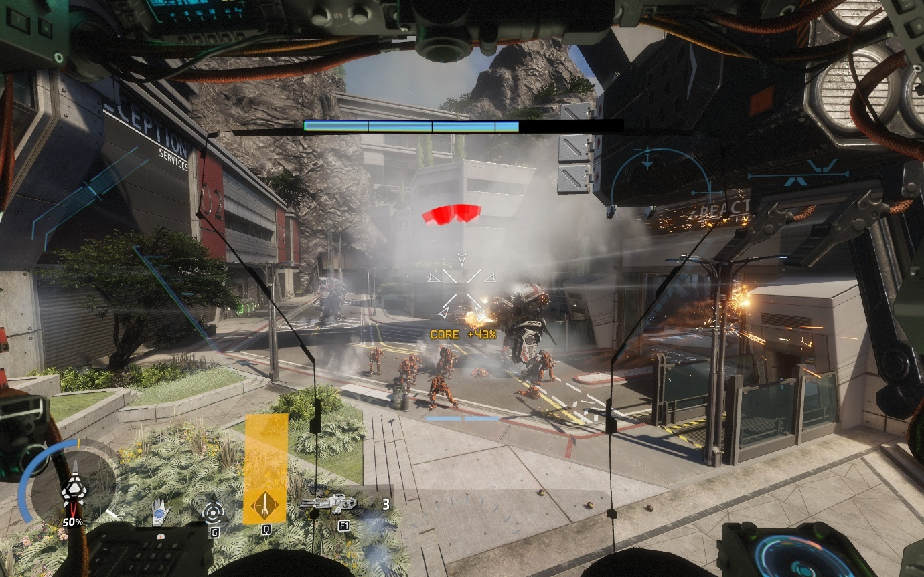

*(Fighting as a titan in Effect and Cause)*

Released on 28th October 2016 by Respawn Entertainment and published by Electronic Arts, Titanfall 2 is movement shooter, where the player swaps between moving around as a human character called a pilot and playing within a Titan, where the style of play completely changes. As a human, the player has access to wallrunnning, sliding, double jumping, and other abilities depending on the level. As a Titan, the player is able to gain great combat abilities, specific to the kit that they choose to apply to the Titan, all of which overpowers a human in every aspect. However, the movement capabilities of the Titan are reduced, leading to the only shared ability between all Titan kits to be the ability to move around. Some kits can fly, others can dash, but most of them have no extra movement capabilities. The 20-foot-tall war machines also struggle to get in some places, and as such the player will need to frequently exit them to reach other places or remove large volumes of health from enemy Titans via hijacking. This excellently illustrates the design philosophy for each of the levels in TF|2 – ‘211’: two parts pilot combat, one part pilot movement/puzzle solving, and one part Titan combat.

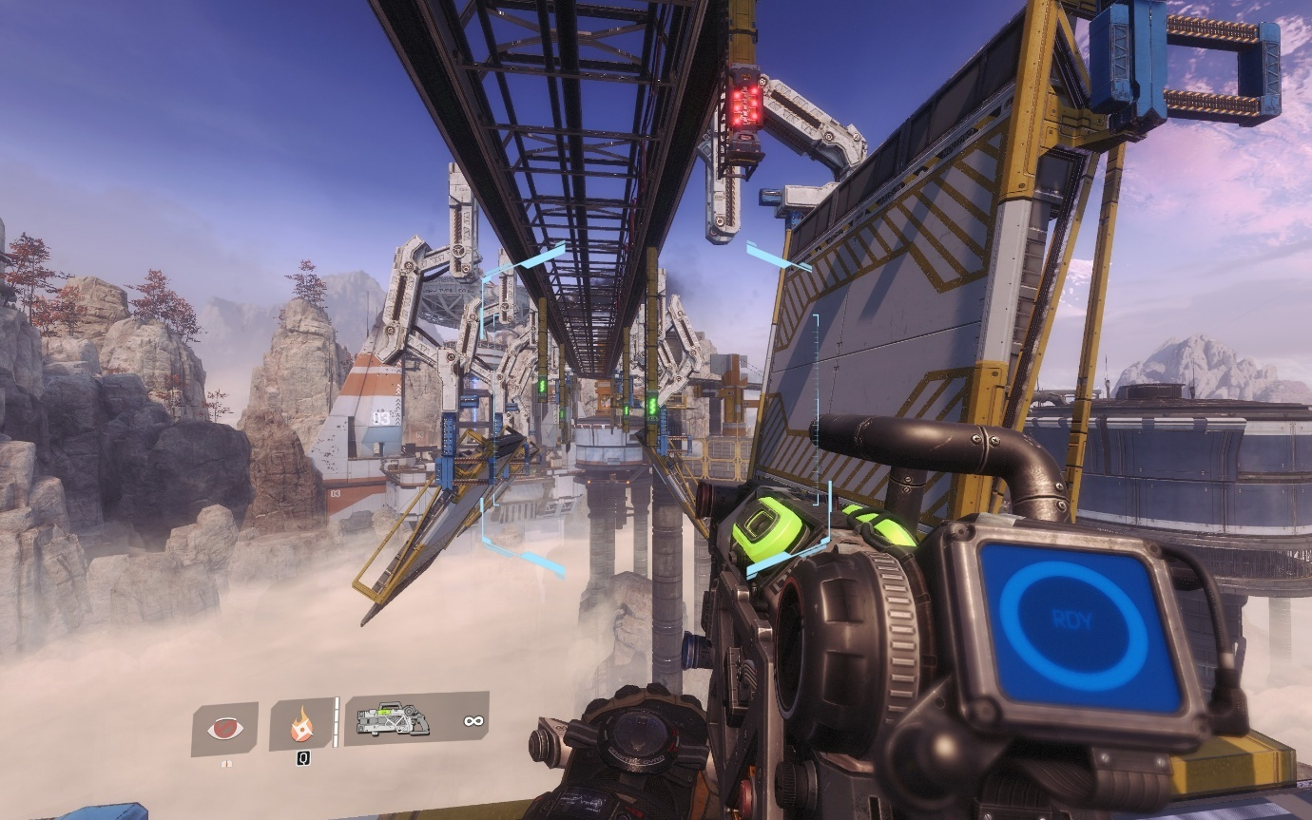

*(A time-based puzzle in The Beacon where the player must activate the platforms correctly using this level’s special feature, the Arc Tool)*

When designing levels, the team at Respawn Entertainment made each of them based upon on a different feature. For example, in the level Cause and Effect, the player swaps between the past and the present, managing enemies in both timelines, and using the changes between the two to help in accessing different areas. This planning technique is something that would be wise to follow, but since levels are designed to be completed in speed (and making long levels can be difficult) it might instead be smarter to split a theme across multiple levels, which are typically called zones. It should not be overdone however, as the feeling of ‘wanting more’ is always better than the feeling of boredom.

### Half Life (and other Source Engine games)

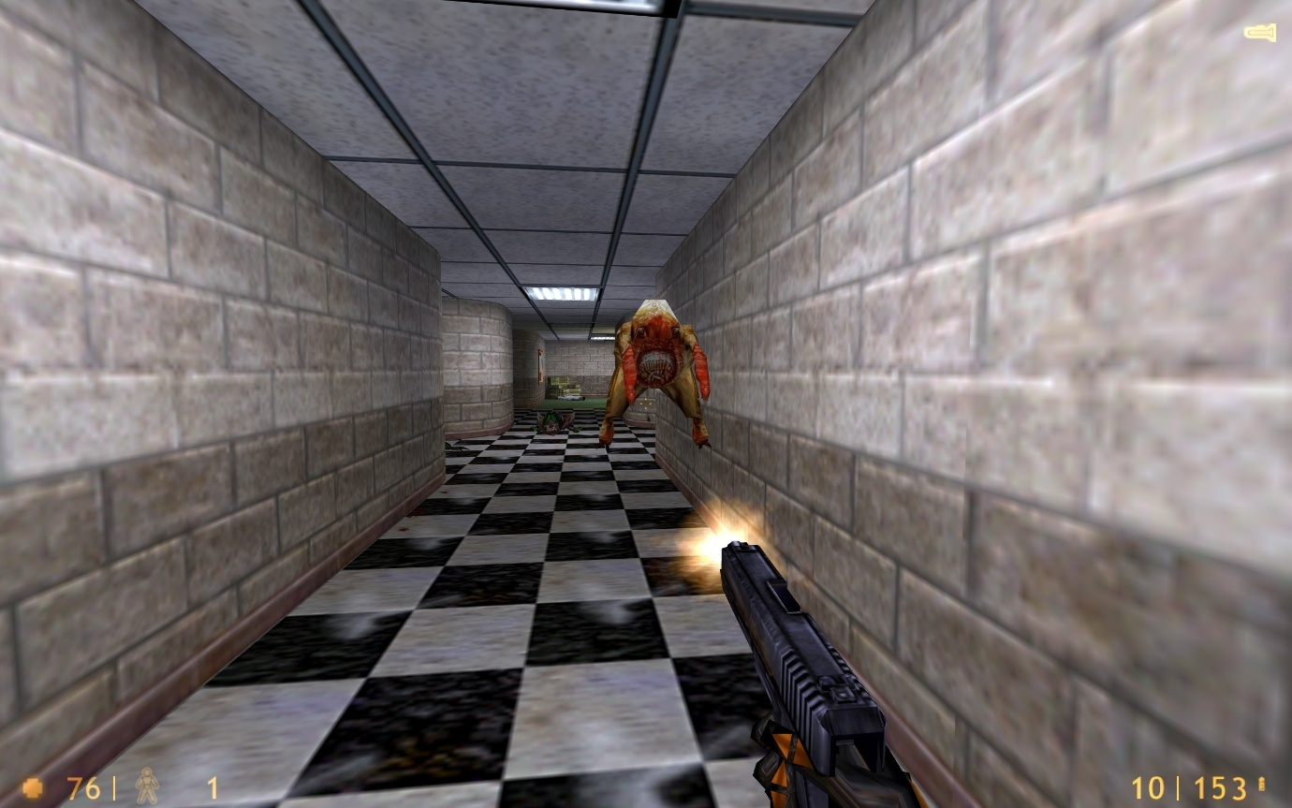

*(Freeman fighting against a headcrab in Office Complex)*

Half Life was the inspiration for many of Titanfall 2’s puzzle design, where there is a minimum amount of momentum required to traverse and solve the puzzles. Released in 1998 as Valve Corporation’s first game after 2 years of work, Half Life set the standard for what an amazing story-based first-person shooter game should be. It carefully and cleverly introduced the player to all its mechanics, and showing the depth that they could be used. Across the 19 chapters, and approximately 12 hours of immersive gameplay, Valve crafted an experience that tells the story of the creation of a dystopia, and Gordan Freeman (a young scientist) along with his attempts to stop it.

Valve built their debut game on GoldSrc – an extremely modified version of the Quake Engine and the Quake II Engine from id Software (the developers estimate that the resulting code is over 75% their own). The Quake Engine had a feature within its movement calculation code called ‘air acceleration’, which as its name suggests, allows the player to accelerate in midair. Normally, this wouldn’t matter, since the drag from moving forward and the deceleration that you experience when touching the floor is enough to cancel all speed increase. However, with a special movement technique called air strafing and bunnyhopping, it’s possible to gain speed, essentially to as fast as you want. Valve later modified and upgraded this to make the Source Engine which debuted alongside Half Life 2 and Counter-Strike: Source, and later on the Source 2 Engine with Half Life: Alyx. Since all the later engines were based of the previous engines, they all contain the same similar movement code and hence speedrunning techniques, which is incredibly useful for speedrunners since they can reuse their own skills.

The Half Life franchise is also well known for its incredibly realistic AI, which is especially well demonstrated with the Overwatch Soldiers from Half Life 2 and the following games in the series. The soldiers are capable of replicating and enforcing blitzkrieg-style military tactics against the player and making smart decisions in the usage of their weapons. There is also a clear hierarchy present within each team, and the behaviours of the different soldiers are cleverly explained behind the story of the game.

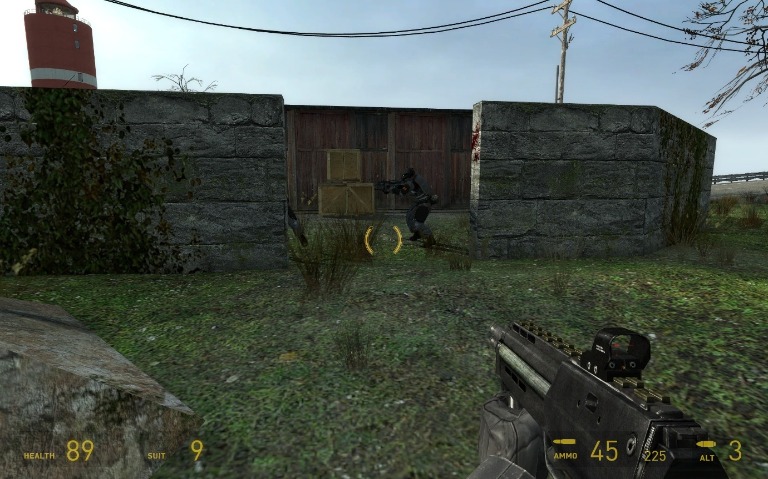

*(The Combine AI has decided to seek cover with its teammate, and reload under cover)*

The Combine AI functions as a multi-part system, with each enemy following a set of logical steps, then reporting back to a manager system, which assigns the respective enemies the appropriate roles based on the number of targets. Each soldier will then maintain that slot until their schedule finishes, which is a set of tasks assigned to it, such as finding cover, or firing at the player. This complex system allows for the tactics that the enemies should enact, while also keeping the situation manageable for the player, since the system will not allow more than 2 enemies to attack the same target simultaneously, which makes it a brilliant basis to design the enemy AI for my game as well.

### Omori

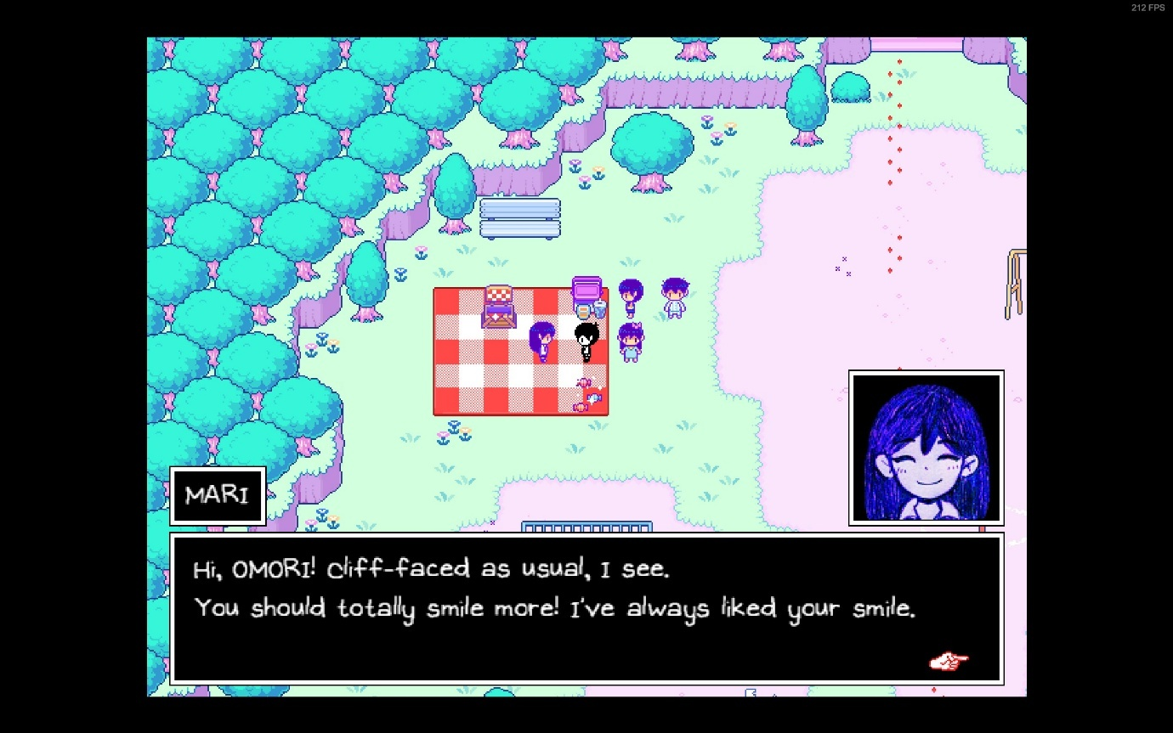

*(Mari talking to her brother, Omori, who is also the player)*

An absolutely phenomenal role-playing game (RPG) by OMOCAT using RPG Maker MV, Omori tells two interconnected stories of two connected teenage boys, dealing with both friendship and guilt. The bulk of the game is spent interacting with characters in both the storylines and completing quests for all of them. Dialogue systems in games can be incredibly complex and important, giving one an insight into how the characters of the game is feeling, and the possible options can change based on what the player has done. If the player has completed a quest, the system must be able to detect the change to the relative variables and change accordingly.

The importance of dialogue in a game comes not from the words, but the feelings they invoke and pass on to the player. After all, if the only things a character says is just describing the current situation, better world design or even a signpost is what you need to have ‘dialogue’, instead of implementing such a complicated system. However, the inverse is not true – a signpost cannot represent emotion as well as a set of characters, no matter whether they display the emotion or not.

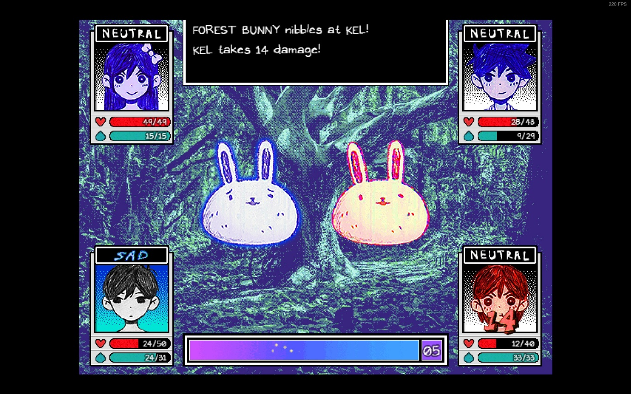

*(Kel takes damage from a forest bunny, one of the enemies the player is currently fighting)*

Omori’s system links together facial emotions and text effects to further accentuate the feelings of the characters. I, on the other hand, do not need to invoke emotions through facial expressions, nor do I need such extravagant text effects such as shaking and waving. However, applying colour, italicising and bolding text is useful in pointing out the most important things to the player while they are skimming through the text, while also helping them retain those specific pieces of information. In the game that I am making, the player will be under a lot of stress, so being able to skim dialogue quickly is important.

### Conclusion

From my research into these different games, I have decided on different elements of these games that would fit well into this game. From Titanfall 2, the main inspiration for this game, the way it splits the game into long chapters will be utilised. The ability to run along walls will also be used. However, the majority of the movement will be taken from Half Life and the various other source games since this is the basis for even TF|2’s own movement. I will also be utilizing part of the design philosophy (211), splitting part of the levels into both combat and the parkour section where the player has to get around to different locations.

From Half Life 2, I will be utilising part of the enemy’s AI system, although it will not be implemented to that extent. Rather, the manager AI will only exist to alert other enemies’ part of the same group of the player’s existence. This is necessary to keep the project within a reasonable timeframe.

Omori will be the inspiration for the dialogue system, although only text will be on it: no images or animated faces since the dialogue is only a secondary aspect of the game, not meant to detract from the main shooter aspect of the game, since the RPG aspect is just a sub-genre.

### Interview

For this interview, I needed to gain an insight into the exact features that the stakeholders wanted, and as such I convened with both. First, I prepared some questions, spread across different categories:

* Movement
  + What should be the basic movement options?
  + Any special movement options?
  + Should movement be location specific?
* Combat
  + What should the basic combat abilities be?
  + Should the player have multiple weapons, and if so, how many?
* Audio
  + Should there be sound effects?
  + Should there be a soundtrack?
* Systems
  + Dialogue
    - What should the system be capable of?
    - Should there be quests?
  + Saving
    - Is this system needed?
    - Should it be slot-based?
  + Currency
    - Will the game have any currency?
    - What should the currency be used for?
    - Is this a necessary system?
  + Any extra systems?
* World
  + Should the game be split into levels?
  + Should enemies be placed in predetermined locations in the world?
  + Should the world be modelled, or just prototype models?
* UI
  + Should there be a main menu?
  + Should there be a pause menu?
  + Should there be a HUD?

Upon asking these questions, I was able to obtain the following responses from both my stakeholders:

What should be the basic movement options?

The player should be able to move both slowly and quickly in all directions on the floor. They should also be able to jump off the floor. They should also be able to crouch, both as a hold key and a toggle, where the held version should take priority.

Any special movement options?

Special movement options should be the ability to run along walls, an ability to grapple to any surface in the world, an ability to slide when the player is running fast enough. A slide should provide a speed boost for the first second of entering it. Being able to jump in mid-air and multiplicatively increase their speed is also useful.

Should movement be location specific?

No, the movement should be useable anywhere, with only the ability to run along walls being specific to walls only and not the ceiling.

What should the basic combat abilities be?

The player should be able to fire bullets from a gun, and be able to reload the gun, if infinite ammunition is not an option. Zooming in would also be useful so the player can have higher precision when firing. The player needs to also be able to swap their current weapons with the ones on the ground or dropped from enemies if possible. Finally, an optional add-on is the ability to quickly perform a melee upon any enemy using the current weapon in hand.

Should the player have multiple weapons, and if so, how many?

The player should have access to hold onto multiple weapons but should only be able to use 1 at any given moment. A nice middle ground between too many and too few is 4 weapons. This should work well with the fact that weapons should be of 3 types: blades, explosives, and bullets.

Should there be sound effects?

Yes, the game needs to have sound effects to indicate if an action has taken place. However, you don’t need to design the effects, just put in the systems to add them in place.

Should there be a soundtrack?

No, the game does not need to have a soundtrack, it should just use the same system as the sound effects, but you need not implement it.

What should the dialogue system be capable of?

It should be able to display text on the screen at a minimum and have easy syntax so that we can have people writing the dialogue with no other knowledge of how the rest of the game works. Optionally, it can include things like choices for the player and animation keys for characters to face other characters.

Should there be quests?

No, a quest system is not needed and is also optional in combination with the dialogue system’s choices.

Is the saving system needed?

Saving is integral for any player in any game and should be one of the higher priority systems that would be implemented.

Should it be slot-based?

Many games do use a slot-based system where you can only have a limited number of saves at a time. We are not a fan of this system however and would like the player to be able to make an infinite number of slots, with its own data.

Will the game have any currency?

The game should have the capability for currency, granted to the player upon killing enemies, and performing other important actions.

What should the currency be used for?

The currency should be used to buy upgrades to the player, such as more health, and more health regeneration.

Is this a necessary system?

No, it need not be implemented at all and is completely optional. This system should be implemented last

Any extra systems?

It would be interesting to have a system to challenge the player into getting through a level as fast as possible or perhaps deciding to survive as a pacifist. This could be a scoring system. It would be interesting to make the game dynamically make itself harder as the player plays as a pacifist more and more: this could tie into some story behind the game, such as calling it a glitch meter and making the player a robot.

Should the game be split into levels?

The game should be split into multiple different levels and have the capability to set up more levels as much as possible.

Should enemies be placed in predetermined locations in the world?

This is both yes and no. For replayabilty, the enemies should have partly random spawn locations, but these should all be within predetermined locations, so that speedrunners can enjoy speedrunning the game more, while still having a level of difficulty to the run.

Should the world be modelled, or just prototype models?

Leave everything as simple objects, and we shall replace them with our own models once you pass the project to us (SillyAustralian). This covers all graphical elements; they need only be placeholders.

Should there be a main menu?

Yes, the player needs somewhere to start the game and decide which save to play, along with managing settings or quitting the game. The buttons in this menu, and any other following interactable menu, should produce sound effects when hovered over and pressed on with the left click.

Should there be a pause menu?

The player should be able to pause the game, stopping all actions including the game’s physics and enemy attacks. This menu should allow the player to manually save and load, if implemented, and allow them to change their settings and finally quit to the main menu or quit the game.

Should there be a Heads-Up-Display?

Absolutely! The HUD is very important for the player to see some information about data about themselves that they need to keep track of. This can include the player’s health and their currently equipped weapons, along with information related ot that weapon.

## Essential Features

### Movement

#### Walking/Strafing

Walking is the basic movement action that the player can enact and will need this to start of many other actions. Comparatively to other ground-based movement, the speed of this will be situated in the middle of the rest.

#### Sprinting

While walking can be all one might need, getting to places faster is important to avoid getting hit in combat, or complete certain puzzles within the required timeframe. Sprinting will increase the ground acceleration that is enacted, and the player will also have a higher top speed compared to walking.

#### Jumping

Another staple of the movement actions, jumping allows the player to easily gain vertical momentum, and it can be developed by allowing the player to jump while in the air, or jumping off walls.

#### Crouching (both toggle and hold)

Crouching will shrink the player’s hitbox vertically, granting access to smaller passageways, and providing a potential advantage in combat, since the area that enemies can attack the player in is far smaller. To balance this out, crouching will force the player to move much more slowly and will be the slowest ground-based movement option.

#### Sliding

When above a certain speed, using the crouch button will instead lock the player into a sliding state. Sliding should first increase, then decrease the player’s speed, encouraging you to leave your slide earlier to gain speed. The target direction will be the current direction of movement, but input will only allow slight nudges in direction, rather than a controlling factor, allowing the bare minimum control. Friction while in a sliding state will also be a lot lower than other states.

#### Wallrunning

A much more advanced movement option, this makes the player stick to walls and allow them to move along it. This opens the possibilities of combat terrains and puzzles and is usually included in movement-shooter games. The player can also jump off these walls, which may lead to a variety of solutions to different situations the player may encounter.

#### Grappling

While not as common in other games, grappling is still fun to use, but is also far harder to control, since this requires one to plan trajectories. It is also much harder to implement but is still well enjoyed by many players in the game’s it shows up in, such as the multiplayer mode of Titanfall 2, or as a basic movement option of Ghostrunner.

#### Double Jump

This is a far more common ability, where while in air, the player can press the jump button again to gain an extra boost vertically, akin to a jump on the ground. Without this, the player is only permitted to jump while touching the ground.

#### Boosting

Like a dash that might appear in other games, a boost is a multiplicative increase to the player’s speed and will allow them to gain speed much faster than attainable through other methods. Due to the potential of exponential speed, both a maximum limit for boosting must be set, while also implementing a heavy cooldown for using it.

### Combat

#### Fire

On the combat side, firing is an essential action. Without this, it would not be called a movement-shooter. Firing will be a catch-all term for using weaponry, such as slicing with a blade, shooting a weapon, or throwing a grenade.

#### Zoom

While a player may not use this as much when they are moving around a lot, it is still a staple of the shooter genre to include some sort of zoom capability on weaponry or on your visuals to be able to see long distance clearer. This may have a side effect of encouraging a stealthy and cautious playstyle instead, but this could be negated by having more difficult sections later in the game.

#### Swap weapon

From the beginning of first-person shooters, the usefulness of having multiple weapons and the strategy that appears from doing so was always an incredible lure into the games of the past. This inherent feature stuck through the generations and remains as an expected feature in a shooter. However, starting from Halo, the number of weapons one could carry could be limited, due to the limitations of the controller at the time. As such, another trend of having a limited number of weapons that the player could equip at one time rose in popularity. It’s an incredibly easy way of bringing depth into any shooter, by making the player have to choose which weapons, they want to use, and by having a limited ammunition capacity, also making the player choose if they can wait to get ammunition, or if they need to change weapons now.

#### Quick melee

While unlikely that the player might repeatedly get within close range of any of the enemies, there must be a close, high damage option for the player to enact. The melee is a powerful move, that depending on game-to-game, can be one of the highest damage options available. This ability allows the player to use any weapon to inflict a strike onto an enemy, no matter the usual use of the weapon.

#### Pick up weapon

Since the player can run out of ammunition, it is likely that they will end up without any weapons with ammunition in them, other than blades. As such, it is possible for the player to pick up weapons dropped by enemies or placed in boxes throughout the level to counteract this difficulty.

#### Reload

Guns do not have a limitless capacity of ammunition, and to help players to immerse better with the game, the player can reload the magazine in the currently active weapon if applicable to do so. This can add a further layer of strategy to the game, as a player can decide to reload in the middle of a magazine before entering a gunfight or not do so if they fear they will get hit in a moment.

### Sound Effects

The brain is very good at linking different senses together for the same piece of information. Having different sound effects (sfx) link to different actions will act as either a confirmation that the action has been processed, or it may warn the player of danger.

### Saving

Saving is needed for longer games, since players can get incredibly frustrated with losing progress every single time they close the game. As such, saving has been implemented in many major games as a basic feature. Different games do the system slightly differently, usually splitting into 3 different types. The first is where the player has many slots and can save the game into any of these save slots and have multiple different places they can pick up from. This can also be used to have entirely different playthroughs existing at the same time. The second method has only one save slot but saves progressively by making a new save every single time. This only allows for one playthrough, but many checkpoints that the player can load back into. The third method is the one that I shall implement, where a mix of the other two types is used. Specifically, the player will have multiple slots, where each slot denotes a playthrough. Each slot will have multiple versions based on manual saves or automatic ones based on checkpoint.

### Scoring System

Each level is scored based on:

* Time to complete.
* Enemies killed.
* Secrets collected.
* Inverse of death count.

Further point bonuses will be granted for:

* Using less weapons (melee only)
* No deaths
* Pacifist (only applied on the final level if the player has killed zero enemies across the whole save)

This should encourage players to return to the level and get a higher score, potentially seeing the flower planting system. The score will be displayed in a room, and the player can interact with each of the elements to show the score for each category.

### Dialogue System

While it should not be used extensively as it may break the flow of the game, this system should be complex enough to handle all dialogue requirements it needs.

It must:

* Allow for one to easily add multiple languages
* Allow for timing cues
* Allow for branching options
* Allow for quest completions
* Allow for different dialogue based on external events
* Allowed to change variables
* Prompting characters to face different characters
* Allow for changing text colour (this should allow for accessibility changes)

### Death Screens

To encourage the player to use healing items and use better movement to avoid taking damage, too much damage will result in the player’s death, and a screen will need to pop up allowing the player to load the most recent save and potentially showing a useful tip on the screen to avoid death the next time. The screen could also give other statistics such as how many the enemies had killed.

### Graphical User Interface (GUI)

Many users are not exceptional at navigating and using command-line interfaces, and the human brain can process images faster than it can process words, and using the mouse is more accessible than using text arguments. As such, I will be implementing both a GUI for menu navigation, and a Heads-up Display (HUD), which will communicate information to the player while playing the game. Some elements of the HUD may be in text and numbers, while other will be in graphical solutions such as bars and images.

## Limitations

Within every project, there are limitations that one must consider, since not everything that one would like to do can be accomplished. Sometimes, trying to implement everything you want will in fact ruin the final project. Instead of trying to break all the constraints, one must instead make considerations and work around these considerations. If possible, some of the limitations could be considered challenges and you should work to break it down and produce a better product, but the costs of doing so must be accurately estimated and the reasons must be weighted accurately against the problems it may cause.

|  |  |
| --- | --- |
| Limitation | Why? |
| Time | Time is the most obvious limitation – the never-changing constraint that will limit how far I can progress with the game. With infinite time, everything in the game could get infinitely refined, and many features could be added to the game. However, infinite time is not something we have the luxury to. In fact, the entire project must be done within the space of 8 months. Therefore, there will be features that would be desirable but can’t be implemented and some features which will not be as refined as preferable. |
| Budget | The budget for this entire project is nothing. This is a severe limitation meaning that nothing can be outsourced, and while usually you could hire better programmer, and an entire sound design team, nothing of the sorts can be done here. This will have repercussions for the software limitation as well and means that if there are any textures or models I want to use, they must be free or made by myself. |
| Hardware | Maintaining the performance of the game is very important because not everyone has access to top-notch hardware, and the game must run extremely well since speedrunners wish to have zero-latency from sending their actions to receiving feedback on the screen. Therefore, the game must be made as simply as possible, with as much optimisation as well. However, I am also unable to test on different types of hardware, and so the best I can do is testing on Windows on my own system. Furthermore, the game will be only for the PC, since I do not own a console, nor can I get the game files onto a console if I owned one. |
| Software | Software is also a constraint since I can’t acquire all the professional applications, and some applications I can’t run due to my own hardware. Since the budget is zero, all software and third-party resources must all be free, or hand made. |
| Proficiency | While I have used Unity and C# in the past, they were all for basic projects that were copied from tutorials, and as such I will need to learn more of the quirks of the engine and its language, which will take even more of my time to build the game. |

## Solution Requirements

While it would be ideal to have all of the essential features included in the game, not every single one needs to be implemented to the same level of usability as others. Based on the limitations, some features may need to be cut from the game, as is typical within the industry.

|  |  |
| --- | --- |
| Requirement | Justification |
| Movement and Combat | Both movement and combat are single-handedly the most important requirements to exist for this NEA, since they define the primary genre of the game. Without either of these features, it would be incorrect to call the game a movement-shooter. |
| Saving | Every single modern game that is released nowadays has saving since no player is ever expected to finish an entire game in one sitting. To maintain the player’s retention, they must be able to return to most of their progress still available to access. |
| GUI | A GUI is integral for the user to be able to interact with the game, since many engines do not allow the player direct access to a console/terminal for a command-line-interface. A CLI is also far more difficult to use and is less accessible to the average gamer, making this a requirement of the final project solution. |
| Death Screen | This also includes the player being able to die, and this is incredibly important for gameplay. Death is the risk factor, and it is what the player is intending to avoid as they are rushing around and firing at the other enemies. With no risk, there is no need for the player to attempt to play the game as intended. Once death has been achieved, it is important that the player is able to go back to their previous save or restart the level to continue playing. Any hints on how to avoid death are an optional extra to add to the death screen. |

### Hardware and Software Requirements

|  |  |
| --- | --- |
| Requirement | Justification |
| Computer Hardware | The game is intended to run quickly, with as minimal delay/lag as possible, therefore the GPU requirement is only the need for integrated graphics, or a simple graphics card such that one can have an enjoyable experience, while the CPU requirement is for a chip that can adequately support its GPU. On the side of system memory, the game will require a minimum of 2GB of RAM, so the system would be recommended to have 8GB of RAM, so as not to cause disk thrashing with other programs that the user may have loaded in, which only less than 2.5% of people who play games do not have access to nowadays. |
| Peripherals | The game will have support for a mouse and keyboard combination (kb/m), but nothing else, as it would be difficult to port all of the controls that would be needed to play the game to another appropriate input system, such as touch controls. The kb/m input scheme is also the most commonly used one, as evidenced by all the games in my research having support for it as the primary input method. |
| Operating System | My project will only be available upon a 64-bit Windows system since that is the most widely used type of system for playing games, coming in at 96.78% of all gamers on the Steam platform according to the Steam Hardware Survey of August 2024. |
| Storage | One would need as much storage as is required to contain all the files of the game and have at least a few gigabytes leftover for a swapfile/pagefile, in case the computer needs to use virtual storage. |
| Software | Many games use the same set of C++ Redistributables and depending on the individual’s proficiency in playing games, they may or may not already have the relevant packages installed. This also includes .Net 4.0, the appropriate drivers for their device and the XNA Framework Redistributable. |

## Success Criteria

|  |  |
| --- | --- |
| Criterion | Justification |
| Strafing Movement | Strafing is the barebones required option for moving, allowing access to 2 dimensions, and even the third dimension when slopes are introduced. |
| Jump | While strafing can allow the player to move vertically, it is dependent on the level geometry, and it would instead be a better option to allow the player the ability to jump while on the ground, and maybe even a double jump while in midair. |
| Crouching | To avoid the enemy gunfire or to enter certain sections of puzzles in the game, crouching is a criterion as it allows the player to decrease the surface area that is exposed. |
| Firing, swapping, reloading, zooming different weapons | As mentioned, the player must be able to fire weapons to retaliate and survive for longer against their enemies. It is also part of the genre’s title and would be fraud to use the genre ‘movement-shooter’ without the ability to shoot. Having different actions to perform on these weapons allows the player to use the weapons appropriately in different situations, especially with the inclusion of multiple weapon types. This would encourage the player to play differently, and experiment when their current playstyle may not perform the best. |
| Can take damage | While the player can damage others, in turn, they too must be able to take damage, allowing an even playing field and forcing the player to take better and safer movement routes, or prioritise more dangerous enemies. |
| Ability to go back to a save on death | Once the player’s health reaches below 0, the only logical option is for the player to die, which reinforces the risk with taking damage. The player must then be able to continue playing which in a singleplayer campaign, is usually done by reloading a previous save. The death screen will contain a button to do so, by selecting between a variety of saves. |
| Saving | This allows the player to retain their current progress for later, such as when they close the game, or if they suspect that they might be in a tricky situation. |
| Loading | Conversely, one must be able to load the save that they made to bring meaning to the saving feature and re-enter the state that they were in when making the save. |
| Interactable menus with audio feedback | The GUI is the most accessible method of navigating through menus and interacting with the game. Out of all of these, the button is the most intuitive and useful of selecting options, instead of a scrollable menu. These menus will also have audio feedback to tell the player that their action had meaning and influenced the game. |
| Dialogue | Dialogue will allow the player to understand what happens on within the game world, and this needs to be both easily visible to the player, and also explanatory, while allowing the player the ability to interact back with the world. |
| Enemies searching and fighting back | The player will be fighting against the enemies in the world, who will be searching for the player to fight against, along with any entities that are fighting with the player. This adds some level of difficulty to the game along with the thrill of avoiding the enemies appropriately |
| The game runs at a minimum of 30 fps on typical hardware, as according to the Steam Hardware Survey | This makes sure that the game is not too intensive to run, and that it is also enjoyable to play. This will entice more people to play the game as possible, increases sales for SillyAustralian. The most typical hardware that people playing games are running have Windows 11 installed on them, with 16 GB of Ram and a hex-core CPU. Graphically, the majority of people have Nvidia GPUs, but this does not mean that the game should be extremely difficult to run. |
| The game will have as few glitches as possible, with absolutely no game-breaking ones | This makes sure that the player’s experience is as enjoyable as possible, and that they are not frustrated from something that they did not expect to happen. This will retain as many players as possible on the game. |

# Design

## Decomposition

### Combat

#### Weaponry

##### Swapping

Being able to swap out your weaponry on the fly is what encourages players to try new things in the game. This swaps the currently selected weapon with the weapon that the player is looking at.

##### Guns

1 of the 3 types of weaponry is guns that allow the player to deal damage from range, firing bullets that damage upon clicking the button via a raycast.

##### Melee

The second type is melee weaponry which deals high damage from close range, like bats and blades, requiring a collision check instead.

##### Grenades

The last type is grenades, which are lobbed, following a physical arc and dealing explosive damage based on its range.

#### Player

##### Movement

###### Horizontal

All movement that uses the basic strafing keys are handled similarly within the same function, moving the player in the direction of the keys relative to the current facing angle in the horizontal plane. This will all be held in one function, that references other functions to access the relevant acceleration values for the different movement types and the speed limits.

###### Vertical

This encompasses jumping, gravity and the lack of control the player should have when moving in air. While the player is not on the ground, gravity will constantly accelerate them downwards. Jumping allows one to get over an obstacle by adding vertical velocity, but it is also possible to ramp off slopes and get far more verticality that way. Due to this, one will have lower control of the character once in the air, needing them to plan their original trajectory. Ramping will be automatically handled by the physics system that is built into Unity 3D, while both jumping and gravity will be separate functions. Jumping will be triggered upon the input being pressed, while gravity will be triggered every frame.

###### Wallrunning

Wallrunning is a special case of movement since the plane of movement then becomes that of the wall you are running on, and the player can only move forward on this wall, fall off or jump off. This allows them to stick to the wall and is an entirely separate movement option than the others.

#### Entities

All entity types are shared between allies (friendlies) and enemies, bar the civilians which are only on the enemy side, as is in line with the setting of the game.

##### Drones

An enemy that flies around and maintains a height-advantage on the player where possible. Depending on their type, they may act differently, such as shooting from afar for ranged drones, or moving towards the player for explosive and melee drones.

##### Soldiers

An enemy that moves around only on the ground and will drop weapons and ammunition when killed. Will stay away from the player but will attempt to maintain line of sight.

##### Tanks

Large and slow ground-based vehicles that deal heavy explosive damage occasionally. Have exceptional range compared to any other type of troop.

##### Civilians

Cannot deal damage and will run away from enemies.

### Environment

#### Ground

Allows for all basic movement and disables gravity while the player is stood upon it. It also prevents the player from falling out of the bounds of the level. Moving up a slope will convert some of your horizontal velocity to vertical velocity as per the physics dictate.

#### Walls

The player can wallrun upon them but loses all other types of movement except jumping. Also disables gravity and prevents access to certain places.

#### Pickups

Items will be scattered around the level, such as coins or weapons that the player can pick up and use, encouraging exploration and challenge.

#### Interacts

Objectives for the level can be anything and are interacted with. Other things like doors and upgrades can also be interacted with.

### UI

#### HUD

The heads-up display shows important information to the player, such as their health, what the active weapon is, how much ammunition that weapon has, and outlines for enemies for clarity. It cannot be interacted with but is a necessary part of gameplay.

#### Menu

##### Title screen

Loads on startup, allowing access to the options menu and save menu, along with exiting the game. Displays the name of the game

##### Options

Changes settings such as game volume and mouse sensitivity.

##### Pause

Pauses the game and allows the player to return to the main menu. Does not save the current state of the game.

##### Save menu

Displays all the save slots, each displaying 4 things: the slot number, the save history menu, the time spent in the save, and the name of the level.

##### Checkpoints

Will automatically save the progress of the player in the game at these points, creating an autosave.

###### Load game

Once a save has been selected, it will load the attributes into memory and load the level

### Dialogue

#### Interpreter

Reads the .dlg file and translates the instructions to instructions/lines for the manager to assign.

#### Actors

Will look towards appropriate actors according to the interaction and message sent by the manager.

#### Managers

Handles the receiving of instructions from the interpreter and assigning the appropriate actors their roles, or sending the subtitles/choices to the subtitles text box

## Structure Definition

## Algorithms

### Movement

procedure SetPlayerDimensions(height)

playerCollider.height = height

endprocedure

This changes the dimensions of the player which will be shaped like a capsule (a cylinder with hemispheres at either end) to be set to the parameter of height, allowing for the scaling of the player character and crouching.

function CrouchControlState()

holdCrouch = playerInputs.Player.HoldCrouch.inProgress

if playerInputs.Player.toggleCrouch.triggered then

if toggleCrouch == true then

toggleCrouch = false

else

toggleCrouch = true

endif

endif

if holdCrouch == true then

lastHoldCrouchState = true

return true

else

if lastHoldCrouchState == true then

toggleCrouch = false

endif

lastHoldCrouchState = false

return toggleCrouch

endif

endfunction

Since the stakeholder requested both the ability to toggle crouch and a crouch that must be held using two separate keys (mentioned in the first interview), this function decides what the appropriate crouch state is, based upon the values of the keys pressed and their previous values.

procedure Gravity()

if NOT isGrounded then

movement = movement – gravity * Time.deltaTime

endif

endprocedure

So long as the player does not have contact with the ground, they feel a constant acceleration of gravity downwards - a necessary factor of a movement-shooter game where the intuitive physics is key.

procedure Crouch()

if lastMovementState != movementState then

if movementState == PlayerMovementState.crouching OR movementState == PlayerMovementState.sliding then

SetPlayerDimensions(crouchingHeight, playerRadius)

else

SetPlayerDimensions(standingHeight, playerRadius)

endif

endif

endprocedure

When the player has just changed their movement state, and that state is from standing to crouching, or vice versa, it calls the relevant function with the correct dimensions. Having this be a simple function reduces the chances for any bugs which fulfils the primary requirement for Amarveer Flora, and also makes it highly maintainable, simultaneously participating to the needs of Henry Masters.

procedure Movement()

inputDirection = playerInputs.Player.Movement.ReadValue<Vector2>().normalized

if inputDirection.magnitude != 0

if movementState != PlayerMovementState.boosting

movementState = PlayerMovementState.walking

endif

float speedMultiplier = CalculateAccelerationMultiplier()

Vector3 multipliedVelocity = new Vector2(inputDirection.x, inputDirection.y) * movementAcceleration * speedMultiplier * Time.deltaTime

Vector3 directedVelocity = new Vector2(inputDirection.x, inputDirection.y) * movementAcceleration * 20 * Time.deltaTime

float alignment = Vector3.Dot(player.velocity.normalized, directedVelocity.normalized)

Vector3 lerpedVelocity = Vector3.Slerp(directedVelocity, multipliedVelocity, alignment)

player.AddForce(new Vector3(inputDirection.x, 0, inputDirection.y) * movementAcceleration * speedMultiplier * Time.deltaTime, ForceMode.Impulse)

endif

endprocedure

This is the main movement code, where it slowly attempts to align the player’s velocity with the current movement being slowly aligned to face towards the direction that the player intends to move towards. It only does this if the player wishes to move, otherwise it can skip out on all the processing and let the friction reduce the player’s speed naturally. This way, all the movement, both horizontal and vertical is all applied simultaneously and only when necessary and does not cause any errors with the physics system that Unity uses which contributes to Amarveer Flora’s primary need of as little bugs as possible.

procedure Jump()

direction = Vector3.up * jumpForce

if velocity.y < 0 then

direction.y = direction.y - velocity.y

endif

if isGrounded == true then

movement = movement + direction

else if airJumpsLeft > 0 then

movement = movement + direction

airJumpsLeft = airJumpsLeft - 1

endif

endprocedure

One of the other primary movement options that the stakeholders requested was jumping, which is also vital in a game centred around movement. This code also handles the ability to double jump, and any potential amount of jumps the player could have by having 2 variables – airJumpsLeft tracks how many more times the player is allowed to jump in the air before they must touch the landscape of the level. Once they do collide with the level geometry, then airJumpsTotal resets airJumpsLeft to the appropriate value so that the player can restart jumping in mid-air. This is handled by the following code:

procedure CollisionDetected(collision)

if collision.contacts.Length > 0 then

for i = 0 to collision.contacts.Length - 1

slopeAngle = Vector3.Angle(contact.normal, Vector3.up)

airJumpsLeft = airJumpsTotal

if slopeAngle > maxSlope then

wallNormal = contact.normal

Wallrun()

else

isGrounded = true

groundNormal = contact.normal

endif

next i

else

isGrounded = false

groundNormal = Vector3.up

endif

endprocedure

This handles all responses to collisions, such as deciding if the surface touched is a wall or walkable floor and setting isGrounded to true for the gravity calculations. This is better than this other algorithm (see below), which has to make an extra check on the physics system, rather than leveraging the automatic function calls it makes. It also only checks if one is on the floor, rather than doing 2 jobs with the same checks.

function GroundCheck()

return Physics.CheckSphere(new Vector3(player.transform.position.x, player.transform.position.y - groundDistance + (0.99f * player.transform.localScale.x * playerCollider.radius) - (player.transform.localScale.y * playerCollider.height)/2, player.transform.position.z), player.transform.localScale.x * playerCollider.radius * 0.99f, playerLayer)

endfunction

This function creates a sphere that has the same radius as the player and is positioned at the player’s feet, checking if there is anything intersecting that sphere. This is more expensive than the above solution and so will not be used.

procedure Boost()

movementState = movementState.boosting

inputDirection = playerInputs.Player.Movement.ReadValue()

boostMovement = player.rotation * inputDirection * groundVelocity.magnitude * (boostMultiplier - 1)

movement = movement + boostMovement

endprocedure

An optional feature that the founder of SillyAustralian wanted included, boost takes the current player’s velocity and multiplies it by a factor, another potentially upgradeable value for the player. It then adds this value onto the player’s current velocity, meaning it could be used by a player to instantly turn around and move in the other direction.

procedure Look()

lookMotion = lookAction.ReadValue<Vector2> * mouseSensitivity / 20

playerBody.rotation = playerBody.rotation * Quaternion.Euler(Vector3.up * lookMotion.x)

// Apply the vertical rotation to the camera

verticalRotation = verticalRotation - lookMotion.movementY

verticalRotation = Mathf.Clamp(verticalRotation, -90, 90)

transform.localRotation = Quaternion.Euler(verticalRotation, 0, 0)

endprocedure

The final movement algorithm is the one that handles the player’s ability to look around in 3-dimensions. It converts the player’s horizontal mouse movement to a horizontal rotation and their vertical movement into an up-down looking motion.

### Enemy Entities

procedure EnemyLoop()

velocity = rigidbody.linearVelocity

if state != enemyState.None then

if target != null then

RotateToTarget(target.transform)

endif

if state == enemyState.Combat then

Move()

Combat()

else if state == enemyState.Searching then

if (searchingTarget - rigidbody.transform.position).magnitude < 1 || NOT searchTargetSet then

SelectTarget()

searchTargetSet = true

Move()

Searching()

endif

endif

endprocedure

This controls the enemies next actions, depending on the state of the enemy. The enemy shall have 3 states that it references within its code: None, Searching, and Combat. None is the state that shall be used to deactivate the enemy’s AI when it is not in use, such as before a combat scenario, while Searching is for when the AI is active, and looking for enemies. Finally, Combat is for the time once an enemy has been discovered, and hence the AI should fight it. To decide when the entity has reached the target, they just need to reach within 1 metre of it as this will make sure that it is not getting stuck on any floating-point errors.

Movement by enemy entities will use a similar algorithm to the player’s movement and as such will not be re-detailed here.

procedure Searching()

for i = 0 to rayCount - 1

hitInfo = new hitInfo()

rayDirection = Quaternion.AngleAxis(-45f + rayAngle * i, Vector3.up) * Vector3.forward

rayDirection = rigidbody.transform.position * rayDirection

if Physics.Raycast(rigidbody.transform.position, rayDirection, hitInfo:byRef, DetectionRange, playerLayer) then

state = enemyState.Combat

UpdateManager(enemyState.Combat)

target = hitInfo.collider.gameObject

break

endif

next i

The enemy searches via shooting multiple rays out from its front within 45 degrees either side of the direction it is facing in. It sees what is a slit of vision and if the player collides with any of the rays, then the player is set as the target, changing the mode to combat.

procedure SelectTarget()

found = false

point = GetClosestPoint(found:byRef)

if NOT found then

searchingTarget.y = rigidbody.transform.position.y - DetectionRange

return

endif

entityToPoint = rigidbody.transform.position - point

if entityToPoint.magnitude > DetectionRange then

searchingTarget = point - entityToPoint.normalized * Random.Random(0, DetectionRange)

return

endif

// Check the enemy can reach the target

accessible = false

while NOT accessible

searchingTarget.x = Random.Range(-DetectionRange, DetectionRange)

searchingTarget.y = Random.Range(-DetectionRange, DetectionRange)

searchingTarget.z = Random.Range(-DetectionRange, DetectionRange)

searchingTarget = searchingTarget + rigidbody.transform.position

hitInfo = new RaycastHit()

if Physics.Raycast(rigidbody.transform.position, (searchingTarget - rigidbody.transform.position).normalized, hitInfo:byRef, DetectionRange) then

if (hitInfo.point - rigidbody.transform.position).magnitude < 1 then

continue

else

searchingTarget = hitInfo.point

endif

endif

accessible = true

endwhile

endprocedure

Selecting an appropriate target for the enemy to move to while it is searching is a difficult procedure. One option is to make the enemy to move along predefined paths, but for better gameplay interaction, the enemy itself chooses a random point that it can see and moves towards this target. The target is confirmed to be within the enemy’s vision by firing a raycast from the enemy to the target and confirming that it does not interact with anything.

procedure RotateToTarget(target)

targetDirection = target.transform.position - rigidbody.transform.position

dirInQuaternion = Quaternion.Euler(targetDirection.normalized)

rigidbody.transform.rotation = Quaternion.Slerp(rigidbody.transform.rotation, dirInQuaternion, RotationSpeed * Time.fixedDeltaTime)

endprocedure

The final algorithm that the enemy needs to use is a method to rotate towards its target, so that it is facing the right way when it needs. This is done by spherically interpolating between the direction towards the target and the current direction of the enemy. This makes the enemy move in a manor more visually appealing, rather than snapping towards the target.

### Weapon and its Interaction

procedure Fire()

Instantiate(bullet, barrel.transform.position, barrel.rotation)

endprocedure

Arguably the easiest function in the entire game, it fires in a bullet by spawning in a new bullet. Nothing can go wrong here.

procedure BulletCheck()

RaycastHit hitInfo = new RaycastHit()

if Physics.Raycast(

origin: transform.position,

direction: transform.rotation * Vector2.up

hitInfo: hitInfo:byRef

) then

hit = hitInfo.collider.gameObject

entityClass = hit.GetComponent<Entity>()

if entityClass != null then

hit.SendMessage("Damage", damageAmount)

endif

endprocedure

On the other hand, the bullet itself makes sure that it hits a target and that it deals damage to a target. It does so by checking if there is an object that can be damaged in its path and hence telling it to damage itself with SendMessage().

procedure SwapWeapon(inputType)

if slotsFilled > 0 then

direction = inputType.ReadValue<int>();

CurrentWeapon(activeWeaponSlot).SetActive(false)

CurrentWeapon(activeWeaponSlot).transform.position = weaponStow.position

activeWeaponSlot = Wrap(activeWeaponSlot + direction, weaponSlots)

if SelectFireWeapon() == null then

activeWeaponSlot = Wrap(activeWeaponSlot - direction, weaponSlots)

endif

CurrentWeapon(activeWeaponSlot).transform.position = weaponHold.position

CurrentWeapon(activeWeaponSlot).SetActive(true)

endif

endprocedure

Swapping a weapon requires checking if there are any weapons to swap to in the first place, but once checked all that must happen is that the current weapon is disabled and moved out of the way, and the new one is moved into the right spot and then enabled. CurrentWeapon() is a function that returns the appropriate weapon based upon the slot. This is because all the weapons are stored as individual variables and referred to via a switch statement.

function GetSwapSlot(wasUsed:byRef)

if slotsFilled < 4 then

wasUsed = false

return activeWeaponSlot + 1

endif

wasUsed = true

return activeWeaponSlot

endfunction

This function attempts to retrieve the slot that the player needs to access to pick up a weapon. If they do not have all their slots filled, then the next one is supplied. Otherwise, the current one is returned so that it can be swapped out and changed for the new weapon.

procedure Interact(inputType)

RaycastHit hit = new RaycastHit()

if Physics.Raycast(

origin: playerHead.transform.position,

direction: playerHead.transform.rotation * Vector3.forward,

hitInfo: out hit

) then

if hit.collider.gameObject.tag == "Weapon" then

AddWeapon(hit.collider.gameObject)

endif

endif

endprocedure

Interact() allows the player to sense and pick up a weapon and is required due to the input system. Sensing is done via a raycast from the centre of the player’s vision. And checking the hit object’s tag.

procedure AddWeapon(hit)

wasUsed = false;

activeWeaponSlot = GetSwapSlot(wasUsed)

if wasUsed then

CurrentWeapon(activeWeaponSlot).transform.SetParent(null, true)

CurrentWeapon(activeWeaponSlot).transform.position = weaponHold.position

CurrentWeapon(activeWeaponSlot).transform.rotation = weaponHold.rotation

else

SetWeapon(Wrap(activeWeaponSlot + 1), hit)

endif

CurrentWeapon(activeWeaponSlot).transform.SetParent(playerHead.transform, true)

CurrentWeapon(activeWeaponSlot).transform.position = weaponHold.position

CurrentWeapon(activeWeaponSlot).transform.rotation = weaponHold.rotation

endprocedure

To pick up a weapon, first, you must check if there is a weapon you must get rid of, which has to be enabled and unparented from the player. The picked-up weapon is parented to the player and then placed into the holding spot.

### Dialogue

procedure PreprocessSections()

fileLines = dialogueFile.text.Split("\n")

for i=0 to fileLines.Length - 1

line = fileLines[i]

if line.StartsWith("[") AND line.EndsWith("]") then

dialogueSections.Add(line[1..^1], i)

endif

next i

endprocedure

Dialogue will consist of sections which the text can jump to, and these need to be preprocessed beforehand by scanning through every single line of the text file and searching for lines that both start and end with “[“ and “]”, which is the markers for the dialogue. These lines are added to a dictionary for fast lookup.

function RequestNext(isDialogue, language, lineID)

connection = isDialogue ? ddm.OpenDialogueDb() : ddm.OpenActorDb()

lineRequest = connection.CreateCommand()

lineRequest.CommandText = $"SELECT {language} FROM {(isDialogue ? "Dialogue" : "Actor")} WHERE id={lineID}"

response = lineRequest.ExecuteReader()

response.Read()

line = response.GetString(0)

connection.Close()

return line

endfunction

Similarly, the object needs to request a new line by requesting the appropriate ID from a database. All the above code are required to send an SQL query to a database.

function ConvertLine(line)

copy = line

firstItalics = true

firstBold = true

for i=0 to line.Length

if line[i] == '\\' then

i++

else if line[i] == '<' then

hexColour = line.Substring(++i, 7)

copy += "<color=" + hexColour + ">"

i += 6

else if (line[i] == '>') then

copy += "</color>"

else if (line[i] == '_') then

if firstItalics then

copy += "<i>"

firstItalics = false

else

copy += "</i>"

firstItalics = true

endif

else if line[i] == '*' then

if firstBold then

copy += "<b>"

firstBold = false

else

copy += "</b>"

firstBold = true

endif

else

copy += line[i]

endif

return copy

endfunction

Parsing the retrieved line from the database is required to put it into a format read by Unity 3D, which uses RichText to display its text in UI elements. It simply runs through every character in the line and replaces it with the appropriate tag. For tracking whether a piece of text is bolded or italicised, a boolean is used for each individually.

procedure ReadNext(line, lineTree)

while NOT line.EndOfStream

char token = ReadChar(line)

if token == '#' then

ReadID(line, lineTree)

else if token == '@' then

ReadIf(line, lineTree)

else if token == '-' then

ReadJump(line, lineTree)

else if token == '|' then

ReadChoice(line, lineTree)

else if token == ':' then

token = ReadChar(line)

if token == ':' then

ReadSeparator(line, lineTree)

endif

else

throw new System.Exception($"Tokenizer: The starting character '{token}' was not recognised.")

endif

endwhile

endprocedure

ReadNext() is the main bulk of the tokenizer, identifying what the next token should be, and then passing it on to the relevant function to create that token.

procedure ReadID(StreamReader line, TreeNode lineTree)

char character = ReadChar(line)

int id = ReadNumber(line)

TreeNode idNode = new TreeNode()

lineTree.AddChild(idNode)

if character == 'A' then

idNode.AddType("actor")

else if character == 'L' then

idNode.AddType("line")

else

throw new Exception($"Tokenizer: Unable to decide if this is an actor or line reference: {character}")

endif

idNode.value.Add("id", id.ToString())

endprocedure

This is an example of one of the token functions, first reading more characters to make sure that it indeed is a token that it can read, and throwing an error if it cannot read it. It also creates a node with right type for later parts of the interpreter to use and then adds this to the current tree.

### Save System

procedure Save(data, type, saveSlot)

// Find the appropriate save number

type = new CultureInfo("en-US", false).TextInfo.ToTitleCase(type)

path = Path.Combine(Application.persistentDataPath, "Saves", "Slot" + saveSlot.ToString(), type)

fileMatch = "Slot" + saveSlot.ToString() + type + "*.dat"

array matches[] = Directory.GetFiles(path, fileMatch)

Array.Sort(matches)

fileNum = 1

if matches.Length > 0 then

lastFile = matches[^1]

lastFile = Path.GetFileNameWithoutExtension(lastFile).ToString()

fileNum = Int32.Parse(Regex.Match(lastFile, pattern).ToString()) + 1

endif

path = Path.Combine(path, "Slot" + saveSlot.ToString() + type + fileNum.ToString() + ".dat")

// Save the data as json

stream = new StreamWriter(path)

json = JsonConvert.SerializeObject(data)

stream.Write(json)

stream.Close()

// Correct the save lookup with the newly created file

lookup = GetLookup()

lookup[$"Slot{saveSlot}"] = path

keys = lookup.Keys

values = lookup.Values

lookupWriter = new StreamWriter(Path.Combine(Application.persistentDataPath, "SaveLookup.txt"))

for i=0 to key.Count - 1

lookupWriter.WriteLine(keys[i] + "," + values[i])

next i

lookupWriter.Close()

endprocedure

The most important function for this system is the ability to save, consisting of 3 major steps: finding the appropriate number for the save; saving the data; modifying the lookup. Finding the right number is a difficult task as all we have is the files in the directory. However, since all files are named the same way, and I can decide how these files are named, the easiest solution is to put the save number right at the end of the file’s name. This way, I can use a regular expression to match the last number in the name, then convert this string to an integer and increment it to use as the new file’s name. This also keeps the filename still readable for anyone trying to maintain the game and debug any problems. Next, saving the data is simple by converting the object into JSON, which is a popular format for noting information about objects in a text format. Finally, modifying just requires changing the right value in the dictionary, then writing these changes to the file.

function LoadSave(path)

sr = new StreamReader(path)

data = JsonConvert.DeserializeObject<SaveData>(sr.ReadToEnd())

sr.Close()

return data

endfunction

Loading a save is much simpler in comparison, since the JSON just needs to be converted back into the appropriate format, which can also be done with the built-in function.

function ListAllSlots()

lookupPairs = GetLookup()

if lookupPairs == null then

return new List<SaveSlot>()

endif

if NOT Directory.Exists(path) then

Directory.CreateDirectory(path)

return new List<SaveSlot>()

endif

slotList = new List<SaveSlot>()

for i=0 to directories.Length - 1

directory = directories[i]

folder = directory.Substring(path.Length).TrimStart(Path.DirectorySeparatorChar)

savePath = lookupPairs[folder]

slot = new SaveSlot(savePath)

slotList.Add(slot)

next i

return slotList

endfunction

This will be used for the menu where all the different slots are displayed, by filtering through the lookup and grabbing the most recent files in all of them. This is then used to form temporary containers for the most important information about every save.

## Usability

### Game Design

For the designs of certain sections, these have been created within Adobe Photoshop so as to make the creation of elements as fast as possible and then recreated within Unity as interactable elements. The designs were verified and improved upon by my primary stakeholder, SillyAustralian. I will be making a few designs:

* Main Menu - A simple opening menu for the player to see when they open the game. There are very few things that they need to click and hence this makes it easy to navigate.
* Save Slot Menu – Displaying all the save slots a player has; the main centrepiece will be each slot and so the player will naturally be attracted to it.
* Game HUD – Containing the most important information that the player needs to always be aware of. This will not have any interactable elements but will make it as easy as possible for the player to find this information.
* Choice – A pop-up menu with only interactable elements displaying the choices the player has to take. The player will be unable to lose their way here as everything will be in a big font.
* Subtitles – Displaying the text and lines that characters will say. This is not an important part of the screen and hence should take as little space as possible, while still being readable. This might hurt usability if it is too small and so this will have to be discussed with my stakeholder.
* Pause Menu – A menu that the player is expected to use constantly, it must be similar to the Main Menu in layout and functionality and hence will also need to be simple to use.

#### First Designs:

##### Main Menu:

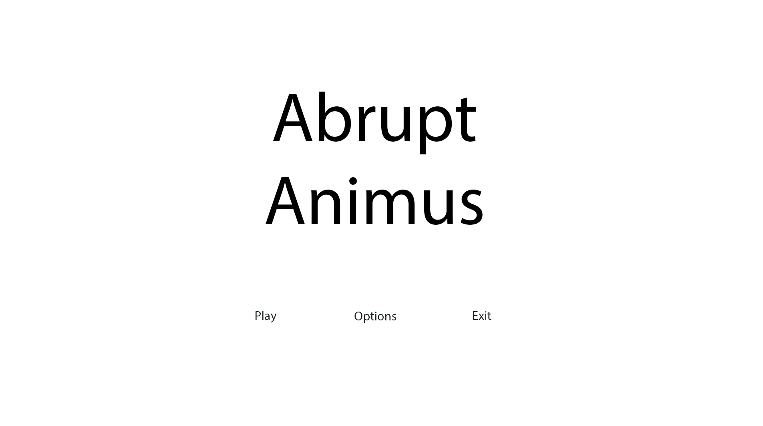

*SillyAustralian*: This design is very simplistic and does not fit the tone of the game. Abrupt Animus is supposed to be a stark and emotionally powerful game, and the use of white for the background does not make sense in this case. Perhaps it would be better to change this to a grey, and then hence the text to white.

##### Save Slot Menu:

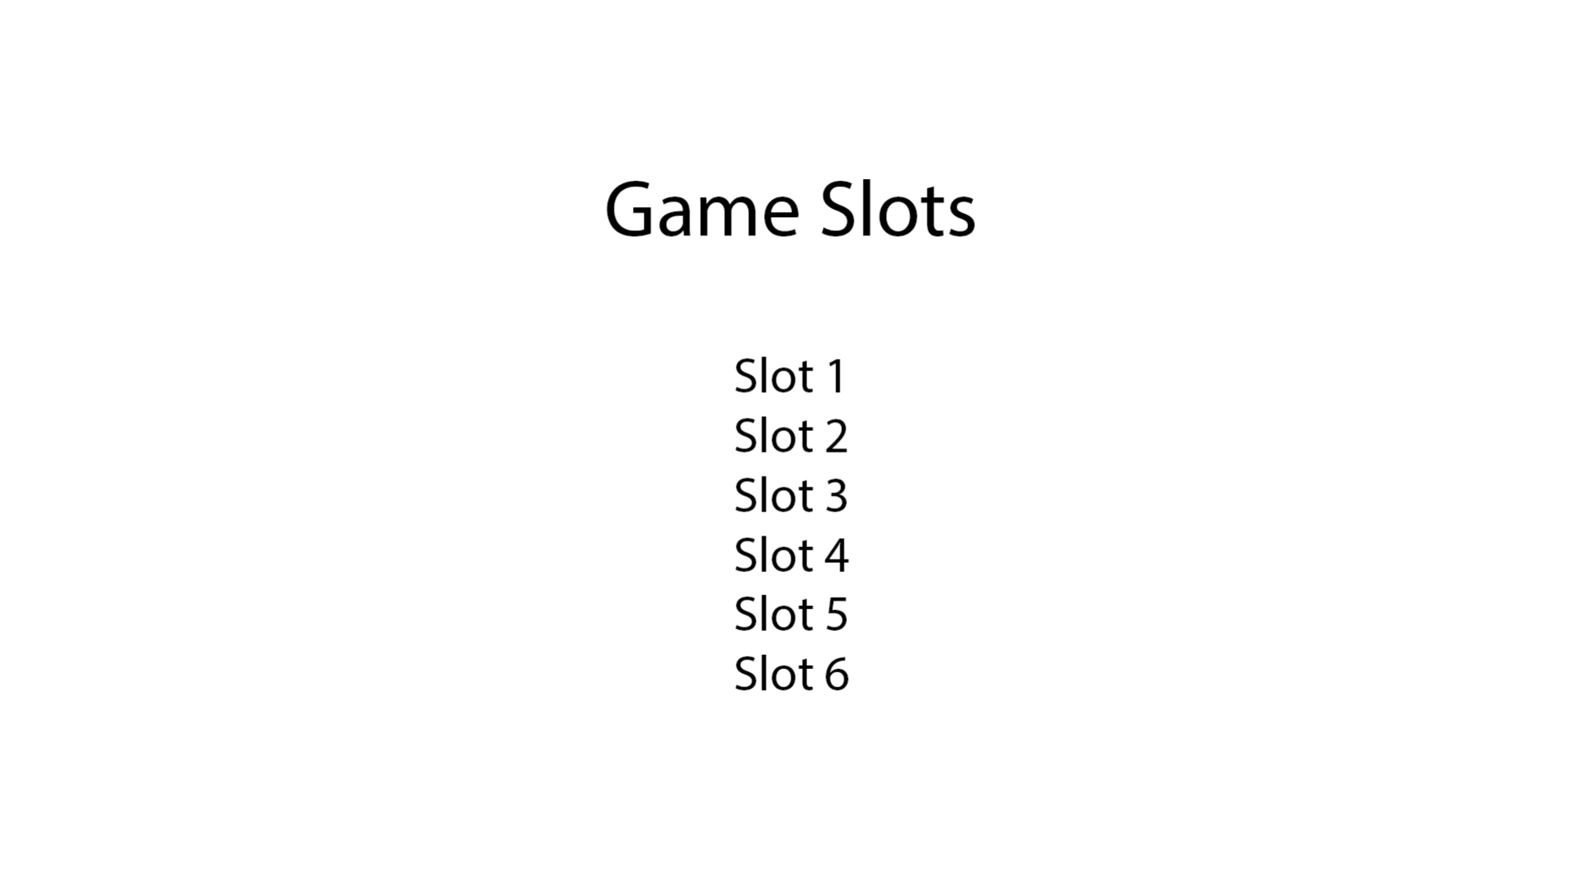

*SillyAustralian*: Similarly with the advice for the Main Menu, the background has to be changed to fit the feel of the game. Other than that, for the save slot menu, we were hoping to implement the slots as a sideways-scrolling menu instead of a list. This way, we could display some more superficial information about each save file so the player can easily recognise which save was the one they wanted. Could you instead make the slots to be black boxes that have the slot number, the current level, and the time spent in that save?

##### Game HUD:

For the Game HUD, since the elements have been placed in many different positions across many different games of the same genre, I decided it would be better to give both my stakeholders the form to complete and pass to some of their top executives. As such, I was able to receive 6 responses in total, which decided the position of these elements. The survey also contained any optional extra elements that could potentially be added.

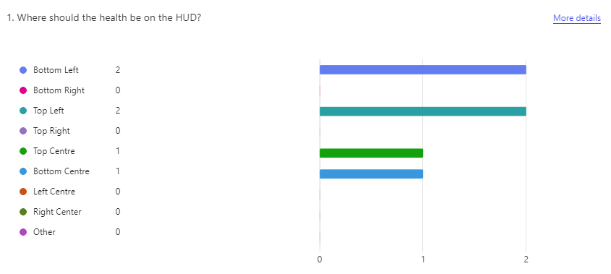

This ended with a tie between bottom left and top left, and I decided that keeping all the elements at the bottom of the screen would leave more space on the top of the screen, encouraging the player to look up and forward, and not at the ground. Hence, the health bar would be placed in the bottom left.

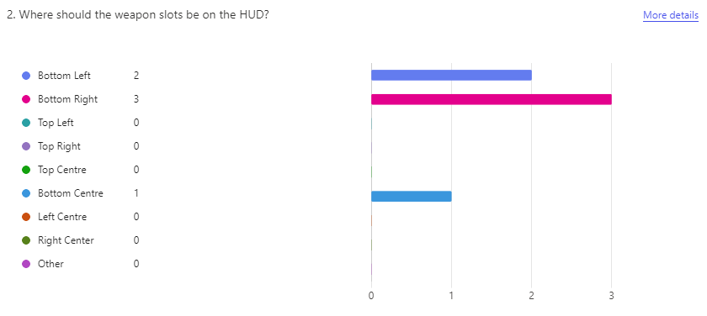

It was a clear winner that the weapon slots, meaning the currently equipped weapon and the next and previous weapons, should be placed in the bottom right, which separated the health bar and the weapon slots. This may be beneficial for the player since it does not confuse them when they need to only look at their health, which is the most important information to the player in the game.

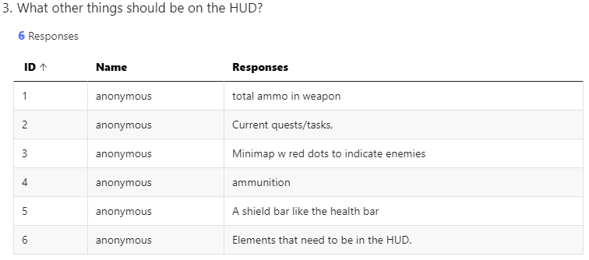

As for extra elements, response 3, 5, and 6 were not helpful, since these options were not in the original request for the game, nor was there time to implement such features. Response 2 had the potential to be useful, if time permits the inclusion of a quest system, but it is highly unlikely that would be the case. Finally, response 1 and 4 both indicated that the ammunition in the weapon should also be displayed on the HUD, and as such, these features would be displayed on the HUD, resulting in the below design:

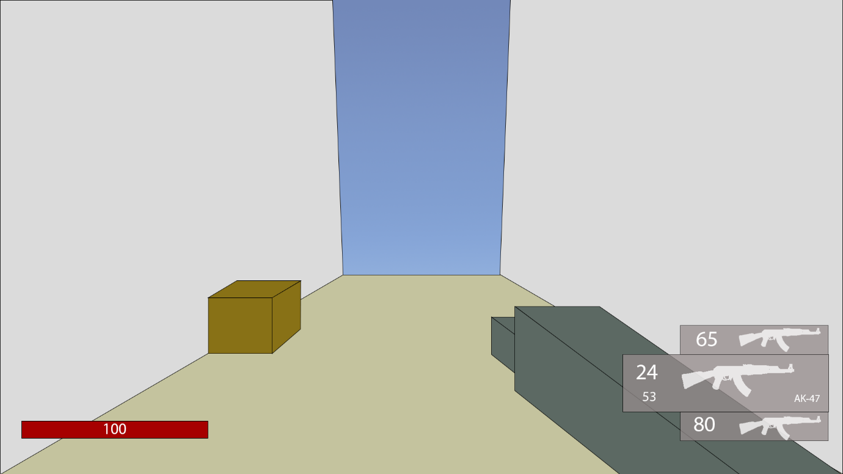

##### Choice:

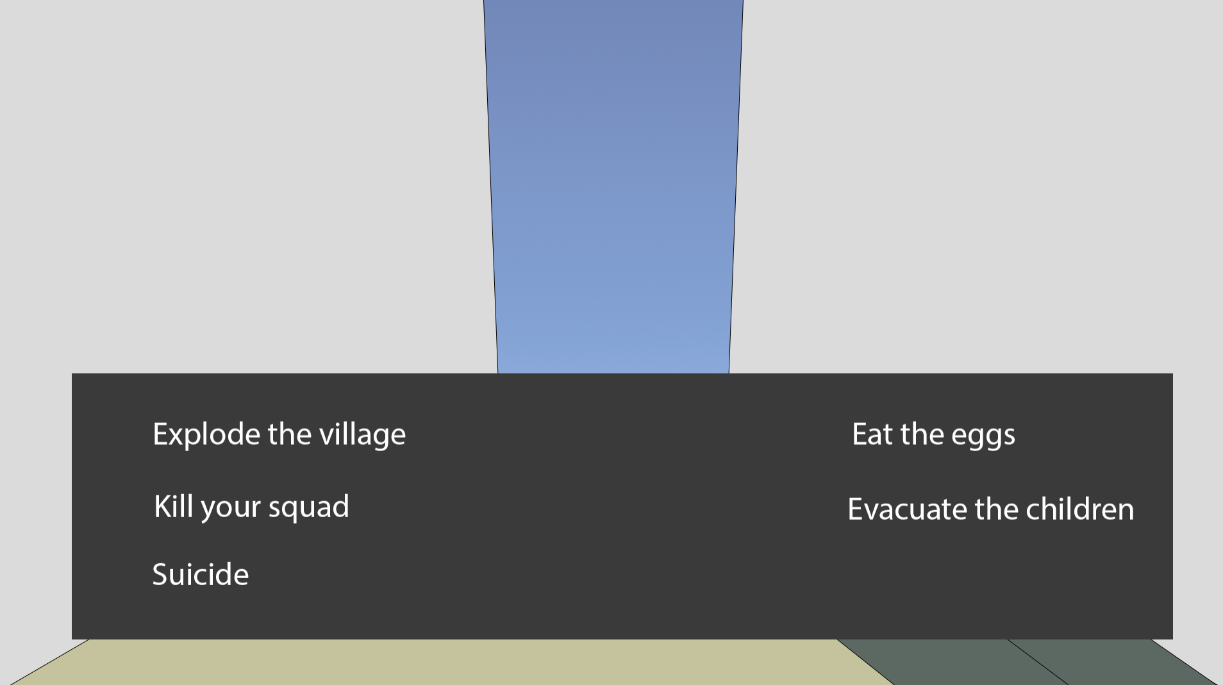

*SillyAustralian*: This design is almost ready right from the start, however, it would be better if it wasn’t completely opaque, so that the player can also plan their next moves once they have finished their choice. There also needs to be a border around the choice box to clearly mark it off from the rest of the screen and make it clear.

##### Subtitles:

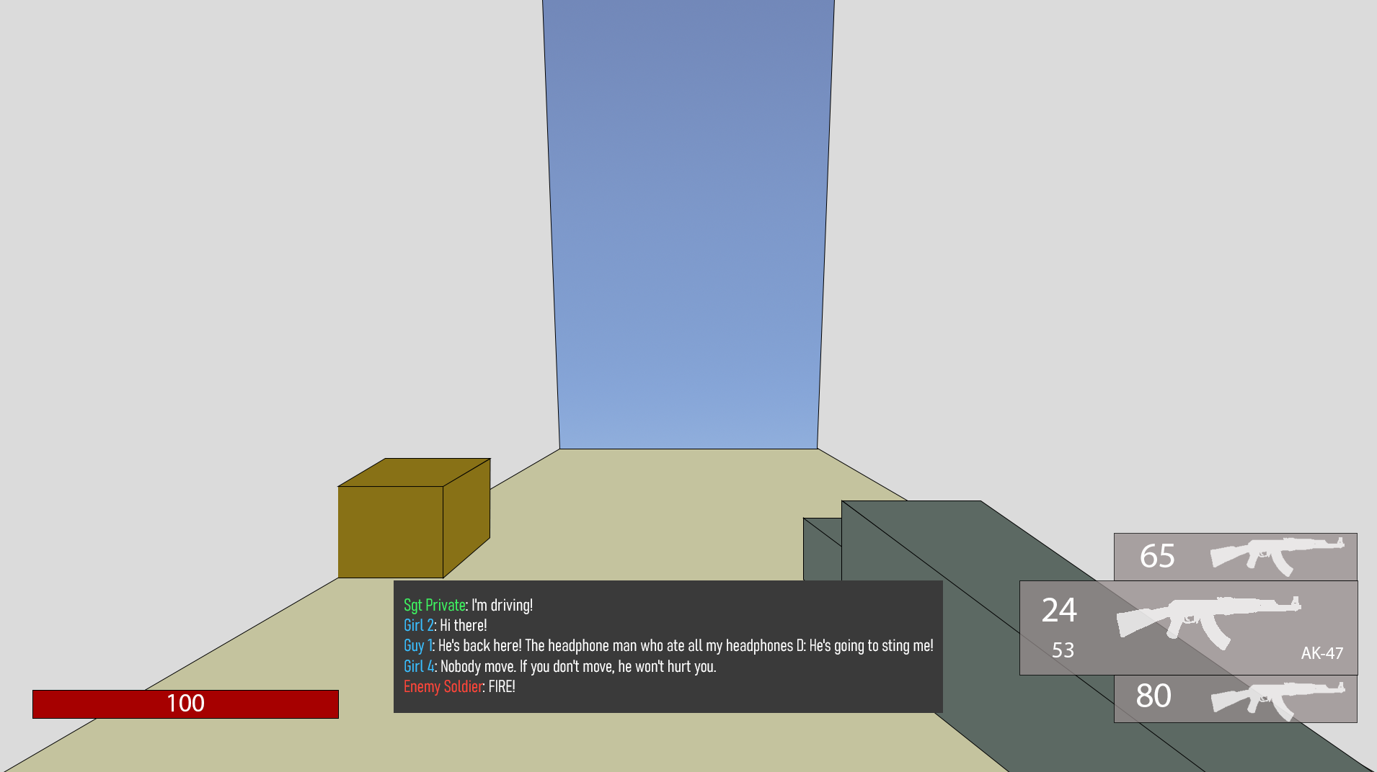

*SillyAustralian*: The subtitles suffer from the same issues as the choice menu, and as such the same changes need to be applied.

##### Pause Menu:

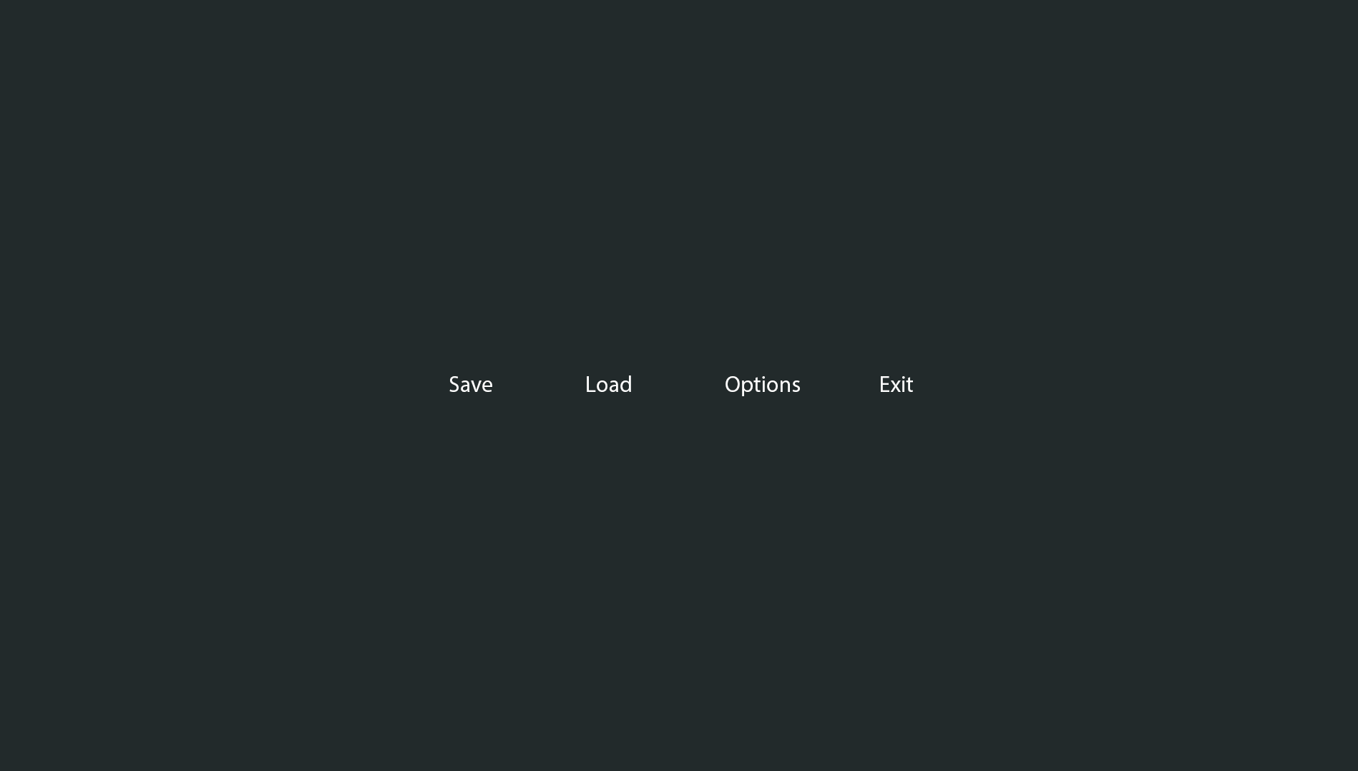

*SillyAustralian*: When in the pause menu, the player should still be able to see some of the game world, so this menu should not be a stark background, but instead it should be slightly transparent. Furthermore, this needs to have the buttons arranged vertically, with the same box background behind them.

#### 2nd:

##### Main Menu:

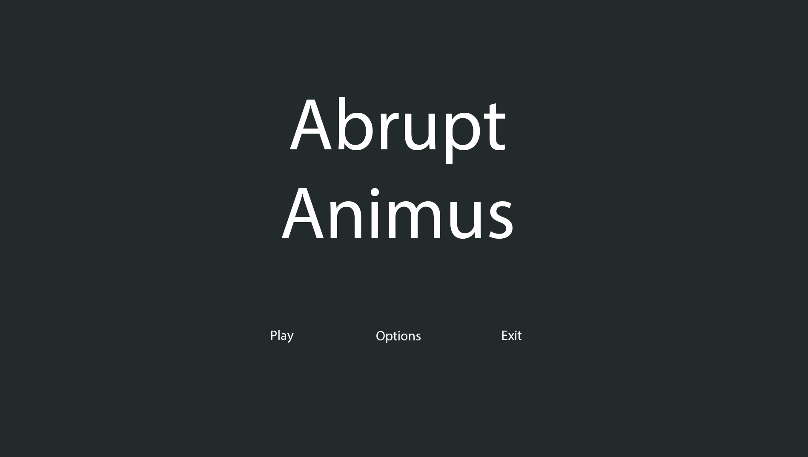

*SillyAustralian*: This is much better than the previous design, however it is now difficult to see where the buttons are. Furthermore, we wish to attract the player to playing the game, not exiting it. Maybe try changing the buttons to be vertical and adding a white background to them.

##### Save Slot Menu:

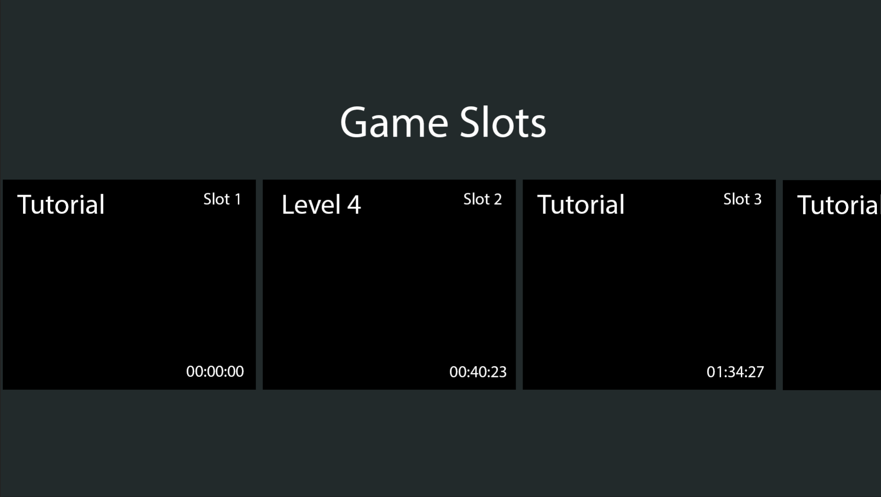

*SillyAustralian*: The text ‘Game Slots’ is far too close to the actual slots, so we would like this moved upwards. Furthermore, it seems that the buttons to make a new save and load the current save are missing, so if you could add that at the bottom of the screen, that would be much better.

##### Pause Menu:

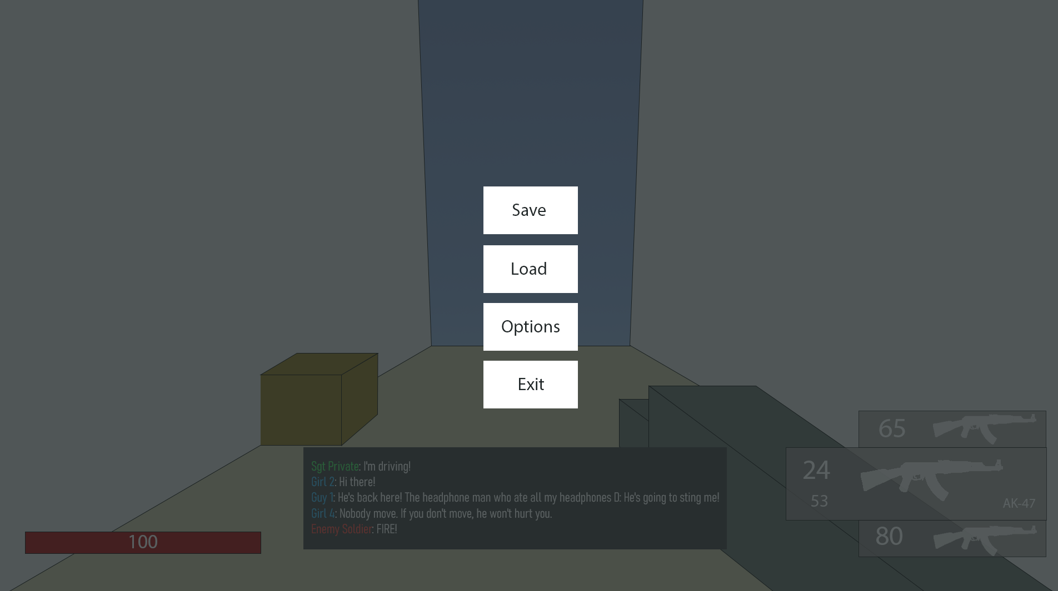

*SillyAustralian*: The only change here that is needed is that the normal game HUD needs to be turned off when the player is in the pause menu, so only the gun and environment needs to remain.

#### 3rd:

##### Main Menu:

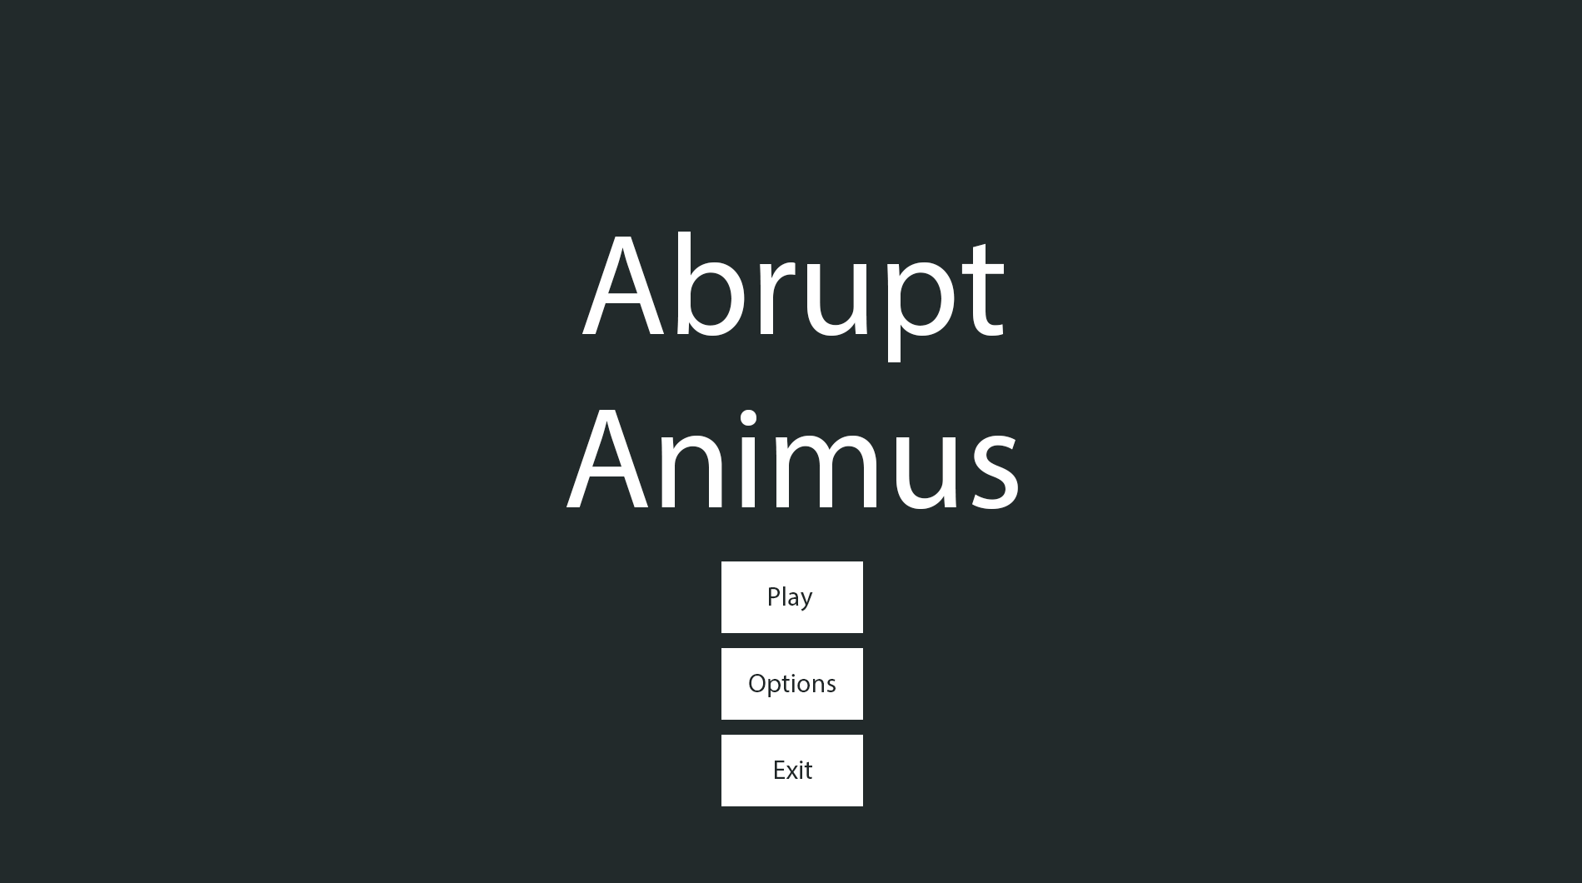

*SillyAustralian*: This is getting closer to what I had imagined in my head! Just two final points from me:

* We, as a company, have decided that we would also like the version number of the game, so could we have this in the bottom left?
* There is too much negative space at the top of the screen, so maybe we can push all the current elements upwards?

##### Save Slot Menu:

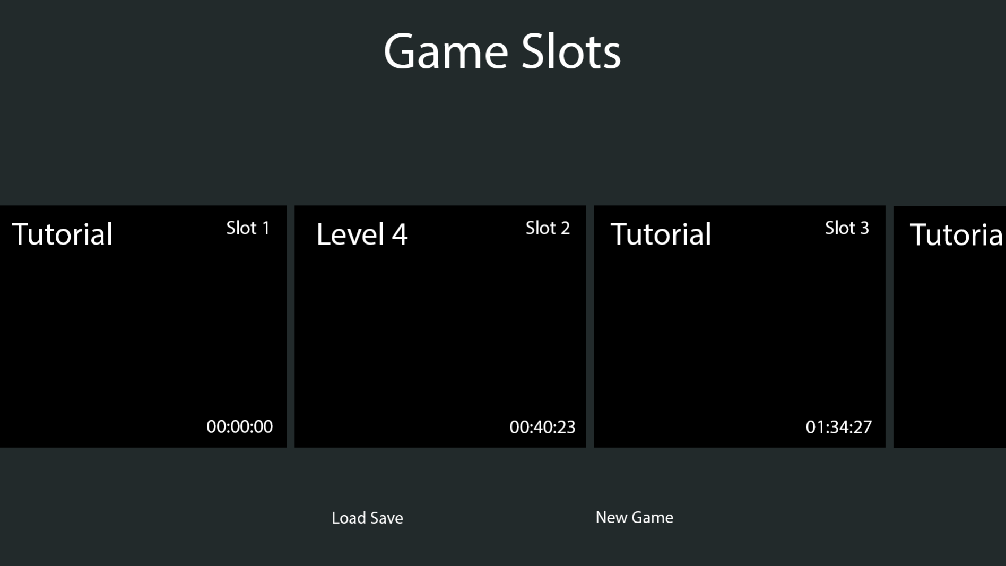

*SillyAustralian*: The buttons for the loading and creating of saves requires a background, just like the ones on the Main Menu design. There also needs to be a backdrop to the slots menu and the button panel at the bottom to make them pop out.

*Me (Eshan Fadi)*: Just thinking from an implementation point of view, I’ve realised that there would also need to be a button for reloading the save slots, so should I add that to the button panel on the left side?  
*SillyAustralian*: Hmm, I see. In that case, you should put the reload button on the right, since the ‘New Game’ button should be in the centre.

#### Final Agreed Designs:

##### Main Menu:

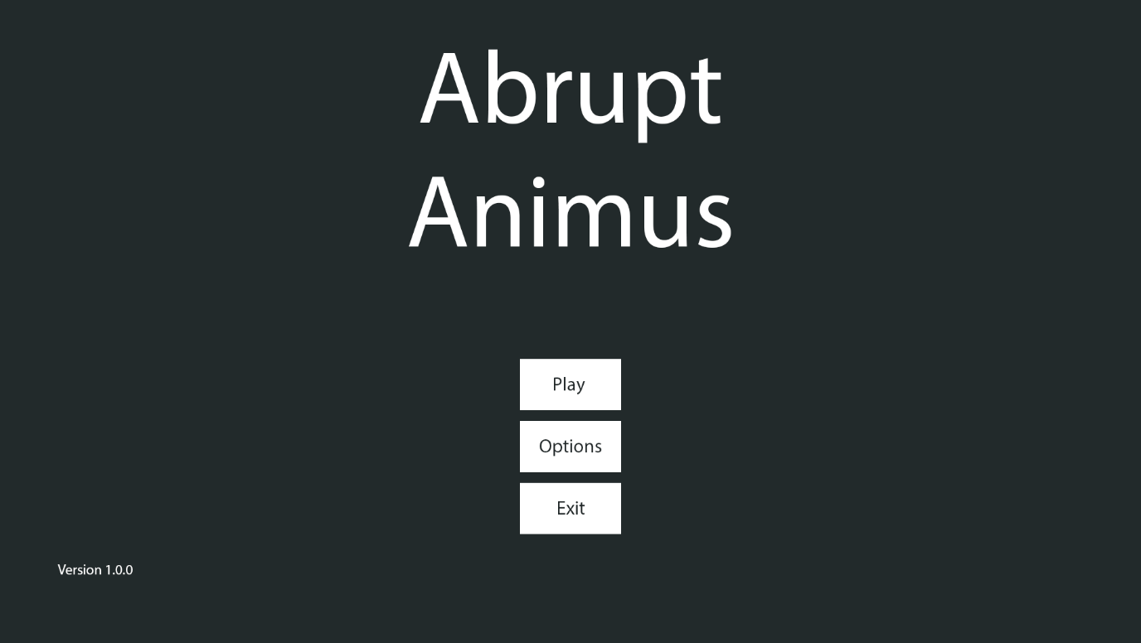

##### Save Slot Menu:

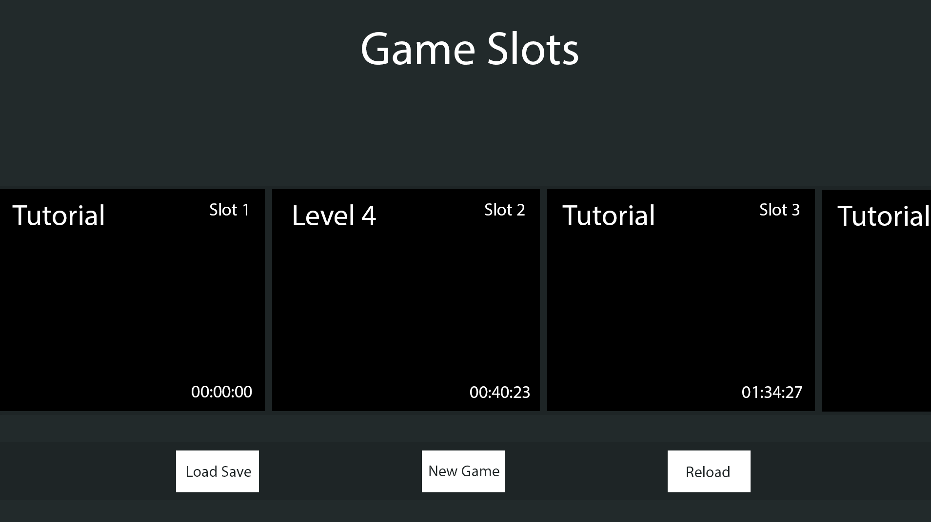

##### Game HUD:



##### Choice:

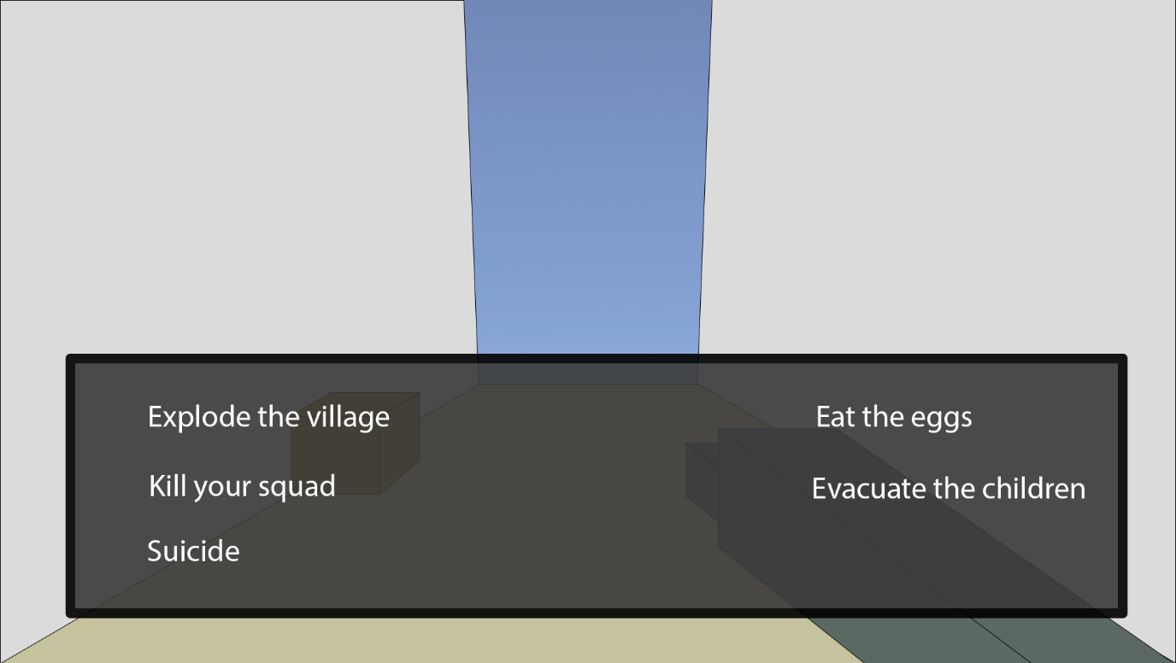

##### Subtitles:

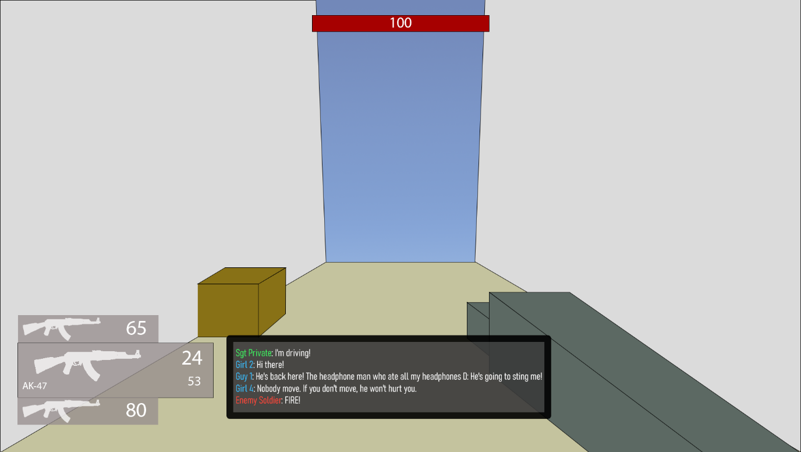

##### Pause Menu:

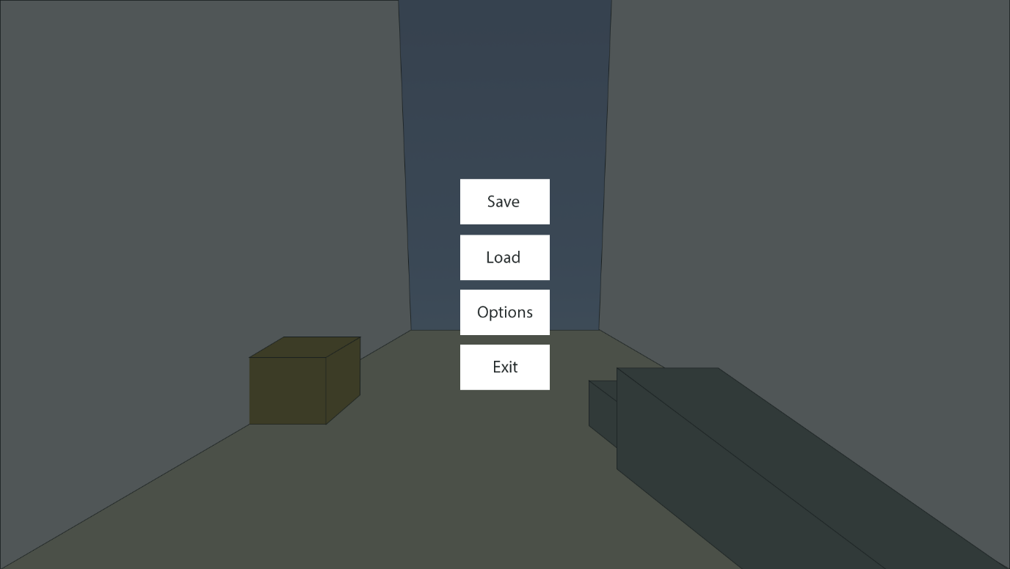

## Variables and Data Structures

|  |  |  |
| --- | --- | --- |
| Type | Name | Justification |
| Movement | | |
| Float | maxSpeed | Limits the player’s speed so that they don’t go too fast and break the game |
| Vector3 | movement | Contains the total movement of all the different movement functions, which is then applied together at once |
| Float | standingHeight | The height of the player when standing |
| Float | crouchingHeight | The height of the player when crouched |
| Bool | isGrounded | Used by the gravity and jump functions to check if the player is touching the ground |
| Float | maxSlope | Used by the collision detection function to partition collisions into floors and walls |
| Float | gravity | How fast the player should accelerate downwards |
| Float | jumpForce | The speed the player leaves the floor when jumping |
| Int | airJumpsTotal | An upgradeable value that makes sure that combined with airJumpLeft, controls the ability to jump in midair |
| Int | airJumpsLeft | Makes sure that the player can’t jump away too far |
| PlayerMovementState | movementState | The current state the player is in such as walking or crouching |
| PlayerMovementState | lastMovementState | Used by the crouching function to check whether the player has changed to crouching from a previous state to then change the player’s dimensions |
| Float | friction | A percentage of the player’s speed that is taken away per frame while on the ground |
| Float | drag | Same as friction but for in the air |
| Bool | holdCrouch | Stores the state of the key responsible for the crouch that must be held |
| Bool | toggleCrouch | Stores the state of the key that can toggle crouching |
| Bool | lastHoldCrouchState | Used to detect a change in the state of holdCrouch |
| Dialogue | | |
| Database | Dialogue | A database is the best way to store similar/linked versions of the same piece of data such as different languages of text and select the right language at the appropriate moment. See below for in depth. |
| Tree | fileTree / lineTree | A tree is the most common method for tracking information for an interpreter, and since this interpreter does not need to track variables and the like, this can be much simpler. |
| Int | choice | Tracks which option the player chose in choices |
| Int | lineNumber | Tracks what line of the file the interpreter is on |
| Dictionary<string, int> | dialogueSections | Stores the appropriate sections and the lines to jump that they start on |
| Save System | | |
| Text File | Save Lookup | This needs to be used to quickly load the last used save on a slot |
| TMP_Text | scene | A reference to the text object on the GUI that is the scene name of the save file. |
| Dictionary<string, string> | lookup | A usable form of Save Lookup for the code to use |
| List<SaveSlot> | slots | Used in the slot displaying system by the GUI after retrieving a list from the SaveSystem |
| Class | SaveSystem | A static class with functions handling saving the player’s data, loading that data into the game, and listing out the saves for external systems. |
| Class | SaveSlot | A temporary container used for the save slot GUI with basic information about a save slot to minimise memory usage. |
| Entities | | |
| Class | Entity | Handles health and damage |
| Class | PlayerEntity | Inherits Entity, allows the player to improve their maximum health |
| Class | EnemyEntity | Inheriting Entity, it implements AI searching, moving, and attacking, along with communicating with a commander. |
| Class | Drone | Inherits EnemyEntity, modifying functions to move in 3 dimensions instead of one the ground. Has far detection range and high speed but weak |
| Class | Soldier | Inherits EnemyEntity, moves on the ground with low detection range and average movement abilities and health |
| Class | Tank | Inherits EnemyEntity, moves on the ground with extremely far detection range and high health but extremely low speed |
| Float | MaxHealth | A property containing the maximum health the entity can reach |
| Float | Health | A property disclosing the current health the entity has |
| Float | DefenseMultiplier | A property that denotes how much less damage the entity takes |
| Float | HealingMultiplier | A property that is used to increase how much healing an entity will experience |
| Vector3 | searchingTarget | A location for the enemy to move towards while it is searching for the player |
| Float | MaxMoveSpeed | A property used as a limit on the PID controller’s output |
| Float | RotationSpeed | A property controlling how fast the entity rotates |
| Float | FarTargetRange | A property that is used in tandem with NearTargetRange to control midrange |
| Float | NearTargetRange | A property that is used in tandem with MaxTargetRange to control midrange |
| Float | DetectionRange | A property used to control how far the enemy can set the target |
| Float | proportionalGain | Used by the PID controller to control how fast the entity reaches the target |
| Float | derivativeGain | Used by the PID controller to control how fast the enemy slows down upon reaching the target |
| Float | integralGain | Used by the PID controller to resist any constant forces (like gravity) |
| Vector3 | lastError | Used by the PID controller to track the error for calculating the derivative |
| Vector3 | lastPosition | Used by the PID controller to track the movement for calculating the derivative |
| Vector3 | storedIntegral | Used by the PID controller to sense any continuous errors over time |
| Float | maxStoredIntegral | Used by the PID controller to limit how much error is stored |
| Weapons | | |
| String | WeaponType | An ID for the weapon, allowing it to be loaded by the save system |
| Int | TotalAmmo | The total number of shots left before more ammunition needs to be picked up |
| Int | AmmoInClip | The total number of shots left before the weapon needs to be reloaded |
| Class | Weapon | An abstract class that mandates a method Fire(), a weapon type, the ammunition left in a weapons clip, and the total ammunition a weapon has |
| Class | Gun | A ranged weapon that fires bullets, dealing damage |
| Class | Blade | A melee weapon using a collider to deal damage |
| Class | Explosive | Deals damage to all entities within its range |

### Enumerators

Enumerators are more human readable way for the states of an object. Instead of having:

if gameState == 0 then

print(“Game has ended”)

else if gameState == 1 then

print(“Game is running”)

. . .

You could instead have an enumerator which names the states and makes it easier to read and remember. It’s far easier to remember if the state is equal to running, instead of remembering that the state is equal to 5, which is running. This is hugely beneficial for maintainability which is what the primary stakeholder required – that the game was easily maintainable and could be improved by other people.

#### PlayerMovementState:

* Idle
* Crouching
* Sliding
* Walking
* Sprinting
* Boosting
* Wallrunning

#### DerivativeType:

* Velocity
* Error

#### MemberState:

* None
* Searching
* Combat
* Dead

### Databases

This project uses a few databases throughout the game to store certain predefined constants. For saving and changing variables, other types of files are used as appropriate to the industry standard, such as level data being stored within the player’s save file instead of a database.

#### Dialogue:

This database contains 2 tables that are not linked to each other through any keys: *Actor* and *Dialogue*. The *Actor* table contains only a primary ID (of type INTEGER) and the respective name of the actor to be used within the subtitles of the system. The *Dialogue* table also contains a primary ID (also of type INTEGER) and the line of dialogue in the next field. However, the field name is the name of the language that you wish to use, allowing SillyAustralian’s company to add support for many other languages if they wish to, and the underlying system will need to have support for this.

#### SceneInfo:

This is a flat file containing information about every scene, such as the start position that the player should be spawned at, whether the player should be allowed to move in this scene, and what the maximum number of enemies should be, for scoring purposes. Storing the ‘moveability’ of the player is important, as certain scenes may be UI only, and hence the player’s normal game controls should be disabled.

### Naming Conventions

For this project, I will be using the same methodologies for naming parts of the code. This will make the project easy to understand at a glance and will improve the maintainability for when the game is handed over to SillyAustralian.

* Variables / Class attributes – These will be written with camelCase, where the first word is in lowercase, and all subsequent words have the first letter capitalised. Examples include
* Classes / Methods / Functions / Procedures / Class properties – These will use PascalCase, which is also sometimes known as TitleCase with the spaces removed, and this is where all words in the name have the first letter capitalised.

## Class Diagrams

### Entities

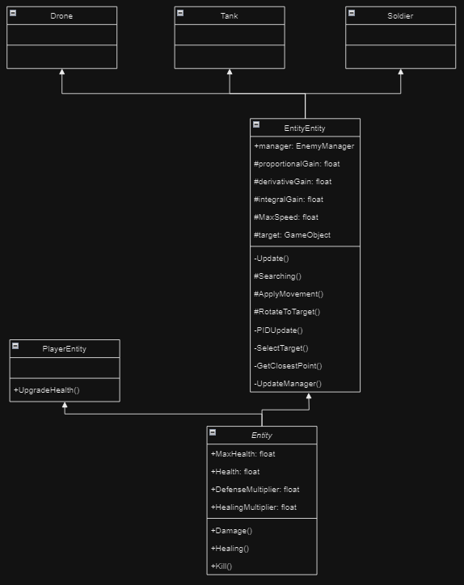

The Entity class system primarily manages the health and damage of the entity it is attached to. However, *Entity* is an abstract class used only as a framework for the PlayerEntity and EnemyEntity. The only extra functionality the player needs is to upgrade their maximum health, while EnemyEntity adds far more functionality to the base class. For enemies, it also provides the functions for its AI and communication systems. While called EnemyEntity, it will also be used for friendly entities, since they have the same use and intent, with only the range of acceptable targets being changed, such as from the Empire to Varsia (the two countries involved in the war).

The main movement the AI will use will be a PID controller, which is used in industrial applications to bring a robot system back to the target without getting stuck in a cycle. It will also be looking for entities opposing it within a cone, limited by its maximum detection range. This tried and tested method is perfect for the enemies.

### Weapons

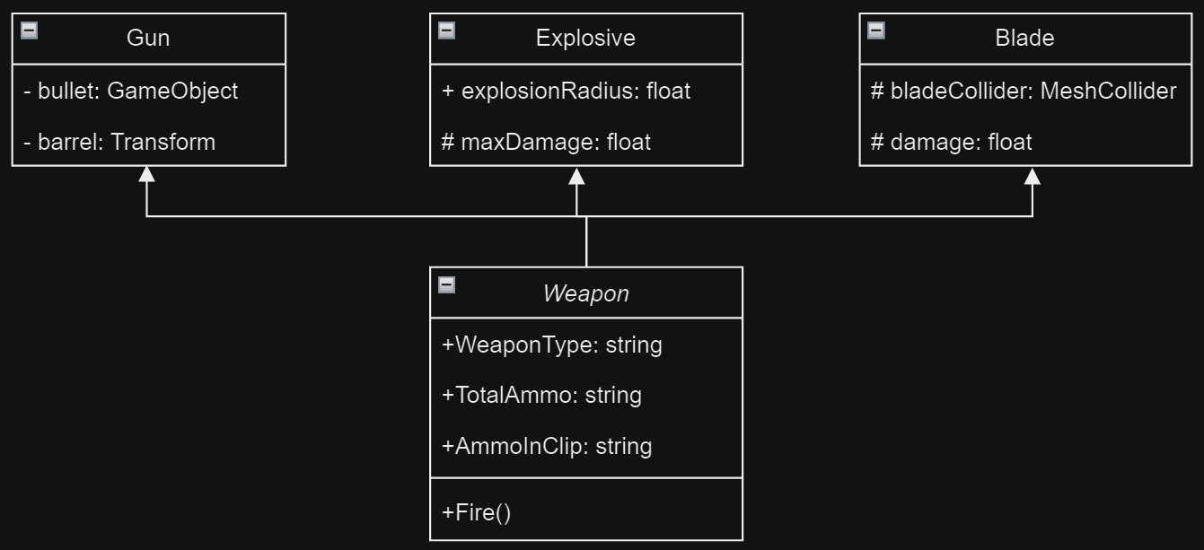

Weapons are how the damage will be dealt to both players and entities in an interactable form. *Weapon* itself is an abstract class that makes sure all following weapons have the correct fields that the save system uses to save their data, while also making sure that weapons have the same public Fire() method that will be used allow scripts that interact with the weapon to use them. This system is also useful for when SillyAustralian wishes to add in more weapons, as OOP makes it easy to add in more weapons, while retaining the previous features, and also combining different weapons for more effects.

## Iterative Tests

These tests will be used constantly during development and will also be updated for whenever new bugs are found and hence test data needs to be created for it. Each test will check for valid, boundary, and erroneous data where applicable. Valid data must pass no matter what, and similarly should boundary data. Meanwhile, erroneous data should not pass through and this may be data that is redundant and should not affect the expected output. All of the 3 tests are important as a game is likely to be pushed to its extremes in all shapes and forms during gameplay, and so to keep the player’s experience as enjoyable as possible, the number of issues and bugs that slip through must be kept to a minimum.

### Strafing

|  |  |  |  |  |  |
| --- | --- | --- | --- | --- | --- |
| Type | What data fits criteria | Justification | Expected | Actual | Comments |
| Valid | Pressing the W/A/S/D keys alone and in combinations while moving at a wall | These keys allow the player to move in 8 directions once used in the correct combinations and moving at a wall which is required to test the algorithm | The character will accelerate in the direction held until the maximum speed is reached or the direction is released |  |  |
| Boundary | Pressing opposing directions – A and D, S and W | This is possible input that a player might momentarily input as they switch directions, but since it is created from both valid inputs, but results in a different output, it should also be tested. | Combining these keys should result in no movement since they lead to movement in opposing directions |  |  |
| Erroneous | Pressing another key (e.g. M) | Keys not used for movement should not produce any movement | The player will remain still |  |  |

### Looking

|  |  |  |  |  |  |
| --- | --- | --- | --- | --- | --- |
| Type | What data fits criteria | Justification | Expected | Actual | Comments |
| Valid | Moving the mouse up and down | This is the entire input base that the player should be using for looking around | The character will look around normally |  |  |
| Boundary | Moving the mouse really far | This is to check that there is no snapping in the movement and that the system is capable of large movement values | The character will look around really fast |  |  |
| Erroneous | No movement | It is important to check that the system does not continue drifting while the player is not moving the mouse | The camera will be still |  |  |

### Boosting

|  |  |  |  |  |  |
| --- | --- | --- | --- | --- | --- |
| Type | What data fits criteria | Justification | Expected | Actual | Comments |
| Valid | Pressing the boost key | This should be the only key used for boosting, and hence should respond appropriately | The player’s speed increases by a huge amount, and then the speed cap is set |  |  |
| Erroneous | Pressing another key (e.g. M) | Keys not used for boosting should not activate it | The player will remain at their current speed |  |  |

### Jumping

|  |  |  |  |  |  |
| --- | --- | --- | --- | --- | --- |
| Type | What data fits criteria | Justification | Expected | Actual | Comments |
| Valid | Pressing the jump key on the ground | As the only input being used to jump, it is important that it works, and that it has not been affected by the double jump | The character will move upwards, then move back down, and no air jumps are used |  |  |
| Valid | Pressing the jump key in the air while moving upwards | This tests the player’s ability to double jump | The player will move upwards faster, using an air jump, and will fall back down eventually |  |  |
| Valid | The player pressing the jump key while in mid-air when they have no air jumps left | Since the player is likely to have used all their double jumps, they should no longer be able to jump in mid air | The player will continue accelerating downwards |  |  |
| Boundary | Touching a surface when the player has no air jumps left | The player will usually exhaust all their double jumps, and they need to be able to get them back | airJumpsLeft will be set to airJumpsTotal |  |  |
| Boundary | Pressing the jump key in the air while moving downwards | The player should still be able to get the full use out of their double jump without it being a waste | The player will move upwards, using an air jump, then move down |  |  |
| Erroneous | Pressing another key (e.g. M) | Since there is only one input, nothing else should cause the player to jump, and if there is, that means something is significantly broken | The player will remain still |  |  |

### Crouching

|  |  |  |  |  |  |
| --- | --- | --- | --- | --- | --- |
| Type | What data fits criteria | Justification | Expected | Actual | Comments |
| Valid | Pressing the crouch key at low speeds | This is input that the player will use, and the state needed to crouch, and hence needs to be tested appropriately | The player’s height will be shrunk |  |  |
| Valid | Pressing the crouch key at high speeds | This is input that the player will use, and the state needed to slide, and hence needs to be tested appropriately | The player’s height will be shrunk, and they will gain a small bit of speed, before slowing down |  |  |
| Boundary | Pressing the crouch key at high speeds and then again quickly | The player may use this to chain together a lot of speed and therefore should be tested corrected | The player’s height will be shrunk, and they will gain speed before returning to the standing height. |  |  |
| Erroneous | Pressing another key (e.g. M) | An input not related to the test should not affect the test | The player will remain at their standing height |  |  |

### Different crouch keys

|  |  |  |  |  |  |
| --- | --- | --- | --- | --- | --- |
| Type | What data fits criteria | Justification | Expected | Actual | Comments |
| Valid | Pressing the toggle crouch key | Each input must be tested separately to verify that they work | The player will crouch |  |  |
| Valid | Holding the hold crouch key | Each input must be tested separately to verify that they work | The player will crouch for the duration that the key is held |  |  |
| Boundary | Pressing the toggle crouch key and then the hold crouch key, and then releasing it | As was specified in the first interview, the held crouch must take priority over | The player will crouch and then uncrouch when the hold crouch key is released |  |  |
| Erroneous | Pressing another key (e.g. M) | An input not related to the test should not affect the test, and hence checks that the input system is still working as expected | The player will remain at the same height |  |  |

### Looking and strafing combined tests

|  |  |  |  |  |  |
| --- | --- | --- | --- | --- | --- |
| Type | What data fits criteria | Justification | Expected | Actual | Comments |
| Valid | Moving the mouse up and down while moving in a circle | This combines all the looking actions with all the movement options and is also covers the most typical of a player’s movement style | The character will look around and the player will move around relative the current looking direction. |  |  |
| Boundary | Moving the mouse really far while moving in a circle | This is to check that there is no snapping in the movement and that the system is capable of large movement values, while maintaining movement | The character will look around really fast and will move accordingly |  |  |
| Erroneous | No movement | It is important to check that the system does not continue drifting while the player is not moving the mouse | The camera will be still, and the player will not move |  |  |

### Fire

|  |  |  |  |  |  |
| --- | --- | --- | --- | --- | --- |
| Type | What data fits criteria | Justification | Expected | Actual | Comments |
| Valid | Pressing the fire button while there is enough ammunition remaining | This is the most common action the weapon will encounter and therefore is suitable as a valid test | The gun will fire 1 bullet |  |  |
| Boundary | Pressing the fire button while there is no ammunition remaining | It is important the system still acts accordingly when there is no ammunition in the clip remaining | The gun will reload |  |  |
| Erroneous | Pressing another key (e.g. M) | Any inputs not related to the system should not affect it | The gun will not fire |  |  |

### Reload

|  |  |  |  |  |  |
| --- | --- | --- | --- | --- | --- |
| Type | What data fits criteria | Justification | Expected | Actual | Comments |
| Valid | Pressing the reload button when there is no ammunition left in the clip, and there is enough ammunition remaining in total | This is the next most common action the weapon will encounter and therefore is suitable as a valid test | The gun will reload back to full |  |  |
| Boundary | Pressing the reload button when there is ammunition left in the clip | It is important the system still acts accordingly when the player reloads before they need to | The gun will reload back to full and only take as much ammo as needed |  |  |
| Erroneous | Pressing another key (e.g. M) | Any inputs not related to the system should not affect it | The gun will not reload |  |  |

### Swap weapon

|  |  |  |  |  |  |
| --- | --- | --- | --- | --- | --- |
| Type | What data fits criteria | Justification | Expected | Actual | Comments |
| Valid | Scrolling the scroll wheel in either direction | The player will want to change the current weapon based on the scenario and therefore this is suitable as a valid test | The selected weapon will change relative to the direction the player scrolled in |  |  |
| Boundary | Scrolling very fast in either direction | It is important the system still acts accordingly when the player may put it under stress | The currently selected weapon should change accordingly |  |  |
| Boundary | Scrolling when all the weapon slots are not filled | It can occur that all the player’s weapons slots are not filled and as such the scrolling should still respond correctly, even though this is a rare case. | The system should continue wrapping with the remaining weapons and change the weapons accordingly. |  |  |
| Erroneous | Pressing another key (e.g. M) | Any inputs not related to the system should not affect it | The current weapon will remain selected |  |  |

### Add weapon

|  |  |  |  |  |  |
| --- | --- | --- | --- | --- | --- |
| Type | What data fits criteria | Justification | Expected | Actual | Comments |
| Valid | Adding a weapon while there is space available | The player will want to change the current weapon based on the scenario and therefore this is suitable as a valid test | The weapon will be added to the list with no other weapon removed, and will swap to that weapon |  |  |
| Valid | Adding a weapon while there is no space available | The player will want to change the current weapon based on the scenario, and this is the more common way to acquire a weapon | The weapon will replace the current weapon |  |  |
| Erroneous | Pressing another key (e.g. M) | Any inputs not related to the system should not affect it | The current weapon will remain selected |  |  |

### Weapon pointing to target

|  |  |  |  |  |  |
| --- | --- | --- | --- | --- | --- |
| Type | What data fits criteria | Justification | Expected | Actual | Comments |
| Valid | Looking from a close object to a far object or vice versa | While purely cosmetic, it will provide helpful information to the player on where they are pointing | The weapon will point closer to the body of the player and then further away, pointing at the object at the centre of the screen |  |  |
| Valid | Not moving the mouse after moving it | The function should finish its last action | The weapon will finish its rotation. |  |  |
| Valid | Not moving the mouse | Since the input data is the same, the output should also be the same | The weapon will not rotate |  |  |
| Boundary | Looking from a close object to a far object or vice versa while the player is moving quickly | The function should work independent of the player’s movement, and the physics engine of Unity can get a dodgy at high speeds | The weapon will point closer to the body of the player and then further away, pointing at the object at the centre of the screen |  |  |
| Erroneous | Pressing another key (e.g. M) | Any inputs not related to the system should not affect it | The weapon will not rotate |  |  |

### Spike Testing

|  |  |  |  |  |  |
| --- | --- | --- | --- | --- | --- |
| Type | What data fits criteria | Justification | Expected | Actual | Comments |
| Valid | Running into the spike | This is a basic test for damage as well as well as verifying environmental damage and whether the player’s health is updated on the HUD | The player will take damage as is detailed, and this will be shown on the HUD | Passed |  |
| Boundary | Running into a spike with 1 HP (or enough for the next hit to kill the player) | This will test whether the kill function works | The death screen will show up | Passed |  |

### Entity Movement

|  |  |  |  |  |  |
| --- | --- | --- | --- | --- | --- |
| Type | What data fits criteria | Justification | Expected | Actual | Comments |
| Valid | The target is outside NearRange | As the most common distance for the target from the player it should work as the valid test | The entity will approach the target and then settle at some point between NearRange and FarRange |  |  |
| Boundary | The target is inside NearRange | Being very close to the target can cause the system to apply too much force and cause the entity to fly off. | The entity should move away and then return to an appropriate distance quickly |  |  |
| Boundary | The entity is at the target | The entity reaching the target is a required part of its movement while it is in the Searching state, and as such will need to be tested | The entity will not move |  |  |
| Erroneous | No target is set | This is a test for a potential error in case the target that the entity is tracking disappears and hence should be handled appropriately | The entity will not move |  |  |
| Erroneous | The target is out of reach of the entity | It is incredibly likely that the player will get somewhere that the entity will be unable to reach, and as such it should be able to handle with this | The entity will attempt to reach as close to the target as possible |  |  |

### Entity Searching

|  |  |  |  |  |  |
| --- | --- | --- | --- | --- | --- |
| Type | What data fits criteria | Justification | Expected | Actual | Comments |
| Valid | The player is in front of the entity | This is the most typical way that the player will be detected by the entity will detect the player | The entity will enter combat mode |  |  |
| Valid | The player is not in front of entity | The drone will not always see the player and as such must search as usual | The entity will continue searching and moving towards the target |  |  |
| Boundary | The player is on the edge of the entity’s view | The player might be moving quickly and only be in the drone’s view for a moment and as such this must be tested appropriately | The entity will enter combat mode |  |  |
| Boundary | The player is on the edge of the entity’s detection range | The player may attempt to escape the drone by being on the edge of its view, and hence it should still detect the player | The entity will enter combat mode |  |  |

### Entity Combat

|  |  |  |  |  |  |
| --- | --- | --- | --- | --- | --- |
| Type | What data fits criteria | Justification | Expected | Actual | Comments |
| Valid | The player is in front of the entity while it is in combat mode | This is the most typical way that the player will be detected by the entity will detect the player | The entity will fire its weapon and move away |  |  |
| Valid | The player is not in front of entity while it is in combat mode | The drone will not always see the player and as such must rotate towards them | The entity will rotate towards the player |  |  |
| Boundary | The player is on the edge of the entity’s view while it is in combat mode | The entity also needs to be able to conserve ammunition and this makes sure that they do not fire at all moments | The entity will rotate towards the player |  |  |
| Boundary | The player is on the edge of the entity’s detection range while it is in combat mode | The player may attempt to escape the drone by being on the edge of its view, and hence it should still detect the player | The entity will chase after the player and fire if possible |  |  |

### Saving and Loading

|  |  |  |  |  |  |
| --- | --- | --- | --- | --- | --- |
| Type | What data fits criteria | Justification | Expected | Actual | Comments |
| Valid | Saving a new save with others already being made | The most typical action the player will be taking is this, and therefore it should be tested properly | A new save will be created with the newest number |  |  |
| Valid | Loading a save file | It goes hand in hand with saving, and will also be a core function of the system | The save file is opened and the data is returned |  |  |
| Boundary | Saving a file when none of the directories or files exist | This is necessary to test for since this will be the state of the user’s system when they first launch the game | All the appropriate files and folders are created |  |  |
| Error | Passing a file to load that doesn’t exist | In case the lookup ends up corrupted, or the user deletes certain files, the function should not crash, and instead log the error | Error code is logged |  |  |
| Error | ‘SaveLookup.txt’ is not created | This will occur when the player opens the game for the first time, and must be handled properly | The file is created |  |  |

### Save Data Application

|  |  |  |  |  |  |
| --- | --- | --- | --- | --- | --- |
| Type | What data fits criteria | Justification | Expected | Actual | Comments |
| Valid | Normal SaveData | This is the standard action that will call | A SaveSlot list is returned with the correct information |  |  |
| Error | The weapon ID is incorrect | This may occur when the game developer puts in the incorrect ID for the prefab in the WeaponType property in the Weapon script | An error is logged, and the weapon is not loaded in. |  |  |

### Displaying Saves Normally

|  |  |  |  |  |  |
| --- | --- | --- | --- | --- | --- |
| Type | What data fits criteria | Justification | Expected | Actual | Comments |
| Valid | The ‘Saves’ folder filled with slots | The player will have at least 1 save slot on a typical opening of the game, and this should be displayed properly | The right number of saves are seen in the scroll view |  |  |
| Boundary | The ‘Saves’ folder is empty | This can occur if the player opens the game, but then closes it before creating a save | No saves are seen |  |  |

### Displaying Saves when making a new save slot

|  |  |  |  |  |  |
| --- | --- | --- | --- | --- | --- |
| Type | What data fits criteria | Justification | Expected | Actual | Comments |
| Valid | Making a new save slot when the folder (Saves) has some already | The player will have at least 1 save slot on a typical opening of the game, and this should be displayed properly | The number of save slots increases by one, and is displayed in the scroll view |  |  |
| Boundary | Making a new save slot when the folder (Saves) is empty | This will be the state of the player’s game on the first opening of the game | The new save slot is shown as the only one |  |  |

### Selecting a new menu

|  |  |  |  |  |  |
| --- | --- | --- | --- | --- | --- |
| Type | What data fits criteria | Justification | Expected | Actual | Comments |
| Valid | Selecting a new menu | This is the standard operation this system will experience and hence is suitable for a valid test | The current menu will be disabled and not interactable |  |  |
| Valid | Going back | This will make sure that the lastMenu variable is working appropriately | The previous menu will be reenabled and the current one will be disable |  |  |
| Erroneous | Requesting a menu that isn’t in the dictionary | In case the developer puts in a wrong system, the system should not crash | A debug message is logged with the error and the current menu stays up |  |  |

### Player Death

|  |  |  |  |  |  |
| --- | --- | --- | --- | --- | --- |
| Type | What data fits criteria | Justification | Expected | Actual | Comments |
| Valid | The player dying | The player is expected to die when playing the game, and hence must be tested correctly | The player’s movement stops, and they can no longer control the character, and the death screen is shown |  |  |
| Valid | Clicking to reload the game | The player will need to reload their game after they die | The previous save is loaded just like a level load, and the player regains control |  |  |

### Quitting

|  |  |  |  |  |  |
| --- | --- | --- | --- | --- | --- |
| Type | What data fits criteria | Justification | Expected | Actual | Comments |
| Valid | The button is pressed when the game is in the editor | The player will eventually want to close the game, and as such this ease-of-use method will be required. | The editor’s play state is set to false, and the preview stops |  |  |
| Valid | The button is pressed when the game is an executable | The player will eventually want to close the game, and as such this ease-of-use method will be required. | The game will close and leave the desktop |  |  |

### Loading Screen

|  |  |  |  |  |  |
| --- | --- | --- | --- | --- | --- |
| Type | What data fits criteria | Justification | Expected | Actual | Comments |
| Valid | Selecting to load a save | This will be the easiest way to test the loading screen and makes a suitable test since this tests the function that runs the screen | The current menu will be disabled, and the loading screen will come up. When the loading is completed, it will show the button with a full progress bar |  |  |
| Erroneous | Loading a scene that doesn’t exist | In case the save file is wrong, the system should not crash | A debug message is logged with the error and the current menu stays up |  |  |

### Moveability and Cursor state when loading a scene

|  |  |  |  |  |  |
| --- | --- | --- | --- | --- | --- |
| Type | What data fits criteria | Justification | Expected | Actual | Comments |
| Valid | Loading a new scene which the player can’t move in | This will be required most surely when the Main Menu is loaded in and will be the one thing every player will interact with. | The player will be unable to move, the cursor will be unlocked, the player will be in the right location, and the right menu is displayed |  |  |
| Valid | Loading a scene which the player can move in | The player will need to load into a new level as they play the game, or when they load a save, and hence this must be tested properly | The player will be able to move, the cursor will be locked, the player will be in the right location, and the right menu is displayed |  |  |

### UI Audio

|  |  |  |  |  |  |
| --- | --- | --- | --- | --- | --- |
| Type | What data fits criteria | Justification | Expected | Actual | Comments |
| Valid | Hovering over the button | The player will be hovering over buttons constantly as they decide what to click | The UIHover sound effect is played |  |  |
| Valid | Not hovering the button | On the other hand, the player may also skip certain buttons, especially when the buttons do not take up the majority of the scene. | No sound effect will be played |  |  |
| Valid | Clicking on the button | The player will always have to click a button to progress through the menus | The UISelect sound effect is played |  |  |
| Boundary | Hovering over and then off the button | Most of the time, the player will hover over a button but not click it, and as such this needs to be tested correctly | The UIHover sound effect is played once as the mouse hovers over, but not off |  |  |

### Volume Slider

|  |  |  |  |  |  |
| --- | --- | --- | --- | --- | --- |
| Type | What data fits criteria | Justification | Expected | Actual | Comments |
| Valid | Not changing the slider | Most of the time, the player will not need to change the volume of the game when they open the menu, and as such this needs to be tested | The volume remains at its current value |  |  |
| Valid | Changing the slider to any value | Typically, the player will need to set the volume to an intermediary volume for their needs | The volume will be adjusted according to the slider |  |  |
| Boundary | Moving the slider to the minimum or the maximum | The player may need to mute the game, or return it to its original value, and this should be tested | The game’s volume will be muted (if the slider is set to the minimum) or return to the normal value (if the slider is dragged to the maximum) |  |  |
| Error | Dragging the slider out of its limits | The player will not attempt to drag the slider carefully, and will typically drag it past its limits to set the minimum and maximum, and this should be tested appropriately | The slider will stay at either the minimum or maximum |  |  |

### FOV Sliders

|  |  |  |  |  |  |
| --- | --- | --- | --- | --- | --- |
| Type | What data fits criteria | Justification | Expected | Actual | Comments |
| Valid | Not changing either slider | Most of the time, the player will not need to change their FOV for either option when they open the menu, and as such this needs to be tested | The FOV and ADS FOV remains at its current value |  |  |
| Valid | Changing the FOV to any value | Typically, the player will need to set the FOV to an intermediary value for their needs | The FOV slider will be set to the correct value |  |  |
| Valid | Changing the ADS FOV to any value | Typically, the player will need to set the ADS FOV to an intermediary value for their needs | The ADS FOV slider will be set to the correct value |  |  |
| Boundary | Moving the either slider to the minimum or the maximum | While uncommon, some players may use extreme FOVs, and this should be tested | The appropriate slider will be set to either the minimum or the maximum |  |  |
| Error | Dragging either slider out of its limits | The player will not attempt to drag either slider carefully, and will typically drag it past its limits to set the minimum and maximum, and this should be tested correctly | The slider will stay at either the minimum or maximum |  |  |

### Wallrunning

|  |  |  |  |  |  |
| --- | --- | --- | --- | --- | --- |
| Type | What data fits criteria | Justification | Expected | Actual | Comments |
| Valid | Pressing forward on the wall | This is the most likely action that the player is going to do when they are on the wall, and as such, this should be the highest priority test | The player will move forward on the wall |  |  |
| Valid | Facing perpendicular to the wall | The player may want to dismount from the wall | The player will gain a speed boost as they disconnect from the wall and enter a walking state. |  |  |
| Valid | The player pressing the jump key while on the wall | Since the aim of the game is to maintain speed, the player will want to jump away from the wall instead of the other methods to maximise the speed gain | The player will dismount from the wall and gain some speed in the direction of the wall normal and upwards |  |  |
| Boundary | Slowing down on the wall below a threshold | The player may attempt to turn around on the wall, or slow down, and it makes sense for this to mean that they can no longer hold onto the wall. | The player is pushed away from the wall |  |  |
| Boundary | Pressing the jump key in the air while moving downwards on the wall | The player is still affected by gravity, if only by a little bit, so the player can end up moving downwards, which may make the jump useless. Hence this needs to be counteracted | The player will dismount from the wall and gain some speed in the direction of the wall normal and upwards |  |  |
| Erroneous | Pressing another key (e.g. M) | An input not related to the system should not affect it | The player will slow down on the wall due to friction |  |  |

### Transpiling a line

|  |  |  |  |  |  |
| --- | --- | --- | --- | --- | --- |
| Type | What data fits criteria | Justification | Expected | Actual | Comments |
| Valid | Reading normal syntax | The majority of the transpiler’s job is to deal with the syntax, and this makes sense as a valid test | The syntax will be replaced with the appropriate value |  |  |
| Valid | Reading a backslash | The transpiler must also be able to deal with an escaped character | The following character is skipped over |  |  |
| Boundary | Reading a character that is not part of the syntax | The majority of the line will be like this, but the transpiler should not interpret it as syntax | The character is passed through the system |  |  |

### Dialogue Interaction

|  |  |  |  |  |  |
| --- | --- | --- | --- | --- | --- |
| Type | What data fits criteria | Justification | Expected | Actual | Comments |
| Valid | Requesting a line | The interaction will always attempt read a normal line, and so this must be tested correctly | The line is put onto the subtitle window, which is displayed, and then fades away after 2 seconds |  |  |
| Valid | Reading a line made of multiple pieces | Certain pieces of text may need to be repeated, and this can be made easier by requesting multiple lines from the database | The lines are pieced together and put onto the subtitle window, which is displayed, and then fades away after 2 seconds |  |  |
| Boundary | Reading a second line after reading 1 | The interaction will rarely end with one click, and this needs to be handled properly | The second line is added below the first in the subtitle menu, and fades away after 2 seconds |  |  |
| Error | Requesting a line or actor that doesn’t exist in the database | The developer may forget to fill in the database appropriately, and this should be handled | An error is raised |  |  |
| Error | Reading a line that is lacking information | The developer may forget to complete the .dlg file, this must not be passed to the rest of the tokenizer | An error is raised |  |  |
| Error | Reading an unrecognised token | If the developer has not written the .dlg file properly, the tokenizer should warn them | An error is raised, specifying information on the error |  |  |

## Post Tests

While containing similar test data to the iterative tests, these tests will be run at the end of the timeframe and will be used to evaluate how the project has progressed and where it has succeeded and where it has failed. This section will be updated as more features are added. Some of these will be rated using the Likert Scale, which rates how well one agrees to the statement supplied. Some tests may not be listed here as they are the same, or contain minor edits, to the iterative tests above

### Robustness

|  |  |  |  |  |
| --- | --- | --- | --- | --- |
| Type | What data fits criteria | Justification | Expected | Actual |
| Normal | Play the game in the normal scene, with few elements | The player will typically experience the game like this, with a reasonable number of objects | The game not run below 30 fps |  |
| Intense | Playing the game in a scene with lots of entities | In case the player is chased by many enemies, the game should be able to handle this well | The game not run below 30 fps |  |

### Glitches

|  |  |  |  |  |
| --- | --- | --- | --- | --- |
| Type | Justification | Example | Severity | Steps to reproduce |
| Input | Any glitches with the player’s input will be unsatisfactory, and may frustrate the player | An input is missed |  |  |

### Strafing

|  |  |  |  |  |
| --- | --- | --- | --- | --- |
| What data fits criteria | Justification | Expected | Pass/Partial/Fail | Comments |
| Pressing the left input, then releasing | These 8 tests relate to the different valid input directions that the player can supply, and every single one should work | The player moves left and stops |  |  |
| Pressing the right input, then releasing | The player moves right and stops |  |  |
| Pressing the up input, then releasing | The player moves up and stops |  |  |
| Pressing the down input, then releasing | The player moves down and stops |  |  |
| Pressing the left and up input, then releasing | The player moves north-west and stops |  |  |
| Pressing the left and down input, then releasing | The player moves south-west and stops |  |  |
| Pressing the right and up input, then releasing | The player moves north-east and stops |  |  |
| Pressing the right and down input, then releasing | The player moves south-east and stops |  |  |
| Pressing the right and left input, then releasing | While not leading to any overall movement, it is an input the player can make that is made of completely valid inputs | The player doesn’t move |  |  |
| Pressing the up and down input, then releasing | The player doesn’t move |  |  |
| Pressing no input | Testing for the lack of inputs is also something that can happen on any frame, and must be tested correctly | The player doesn’t move |  |  |
| Pressing an unrelated key (e.g. M) | This is invalid and should not affect the strafing system, and must be dealt properly | The player doesn’t move |  |  |

### Jumping

|  |  |  |  |  |
| --- | --- | --- | --- | --- |
| What data fits criteria | Justification | Expected | Pass/Partial/Fail | Comments |
| Pressing the jump input | This is the key the player will press when they want to jump up, and so should be tested correctly | The player moves upwards |  |  |
| Pressing the jump input while in midair and moving upwards with air jumps remaining | This will test the player’s ability to double jump, which will allow the player to reach slightly further distances | The player moves upwards |  |  |
| Pressing the jump input while in midair and moving downwards | The player moves upwards |  |  |
| Pressing the jump input while in midair and moving upwards with no air jumps remaining | The player continues moving upwards that they are moving – the input is effectively ignored |  |  |
| Pressing the jump input while in midair and moving downwards with no air jumps remaining | The player continues moving downwards that they are moving – the input is effectively ignored |  |  |
| Pressing no input | Testing for the lack of inputs is also something that can happen on any frame, and must be tested correctly | The player doesn’t move |  |  |
| Pressing an unrelated key (e.g. M) | This is invalid and should not affect the jumping system, and must be dealt properly | The player doesn’t move |  |  |

### Crouching

|  |  |  |  |  |
| --- | --- | --- | --- | --- |
| What data fits criteria | Justification | Expected | Pass/Partial/Fail | Comments |
| Pressing the toggle crouch, then releasing | This is one of the keys that the player can press to crouch | The player will shrink in height |  |  |
| Pressing the hold crouch, then releasing | This is other key that the player can press to crouch, and is likely to be the more commonly used one | The player will shrink in height, and then return to the standing height |  |  |
| Pressing the toggle crouch, then releasing. Then pressing the hold crouch, and then releasing it | The player may use both inputs to crouch, and this should not lead to any conflicts | The player will shrink in height, and then return to the standing height when the hold crouch is released |  |  |
| Pressing no input | Testing for the lack of inputs is also something that can happen on any frame, and must be tested correctly | The player remains at the standing height |  |  |
| Pressing an unrelated key (e.g. M) | This is invalid and should not affect the crouching system, and must be dealt properly | The player remains at the standing height |  |  |

### Using weapons

|  |  |  |  |  |
| --- | --- | --- | --- | --- |
| What data fits criteria | Justification | Expected | Pass/Partial/Fail | Comments |
| Pressing the fire input with an equipped weapon | This is the key the player will press when they want to fire the weapon, and so should be tested correctly | The equipped weapon will fire a bullet |  |  |
| Pressing the fire input with no equipped weapon | The player may accidentally press this input, and as such this needs to be handled | Nothing will happen to the weapons |  |  |
| Pressing the swap weapon input with no weapons while facing a weapon | The player will need to do this at the start of the level, and so nothing should break when they do so | The weapon will become equipped and move to the player’s hand and be added to the list of weapons |  |  |
| Pressing the swap weapon input with some weapons while facing a weapon | The player may do this when they want to pick up more weapons | The weapon will become equipped and move to the player’s hand and be added to the list of weapons |  |  |
| Pressing the swap weapon input with as many weapons as they can hold while facing a weapon | The player may do this when they run out of ammo on their current weapon | The weapon will become equipped and replace the previously equipped weapon |  |  |
| Pressing the swap weapon input while not facing a weapon | The player may accidentally press this input, and as such this needs to be handled | Nothing happens to the weapons |  |  |
| Pressing the reload input with an equipped weapon | The player may want to reload their weapons early while they have cover and some breathing time | The currently equipped weapon reloads as much ammunition as it can |  |  |
| Pressing the reload input with an equipped weapon, but no ammunition remaining | The player may want to reload their weapons earlier, but they shouldn’t be able to in this case | Nothing happens to the weapons |  |  |
| Pressing the reload input with no equipped weapon | The player may accidentally press this input, and as such this needs to be handled | Nothing happens to the weapons |  |  |
| Pressing the zoom input with an equipped weapon, then releasing it | The player will need to zoom in when they want to have a precise shot, and so this should be tested properly | The player’s FOV zooms in, then back out. |  |  |
| Pressing the zoom input with no equipped weapon | The player may accidentally press this input, and as such this needs to be handled | Nothing happens to the weapons |  |  |
| Pressing no input | Testing for the lack of inputs is also something that can happen on any frame, and must be tested correctly | Nothing happens to the weapons |  |  |
| Pressing an unrelated key (e.g. M) | This is invalid and should not affect the jumping system, and must be dealt properly | Nothing happens to the weapons |  |  |

### Taking damage

|  |  |  |  |  |
| --- | --- | --- | --- | --- |
| What data fits criteria | Justification | Expected | Pass/Partial/Fail | Comments |
| Get hit | This should lower the player’s health, but not enough to kill them, so it should still be visible to the player | The player losses health as shown on the HUD |  |  |
| Getting hit enough to lose all of their health | This will cause the player to die, and tests the death screen as well | The player is unable to control their character, and the death screen shows up |  |  |
| Pressing ‘Load’ on the death screen | The player will most definitely want to do this when they die, and should be tested properly | The game will reload the player’s save data and the player will be able to play once again |  |  |

### Saving

|  |  |  |  |  |
| --- | --- | --- | --- | --- |
| What data fits criteria | Justification | Expected | Pass/Partial/Fail | Comments |
| Pressing any save button | The player will want to save their current progress and not lose it, and this should work well | A new save file is created on the player’s computer |  |  |
| Making a new save slot | The player may want to replay the game at some point completely fresh, and this should allow them to make completely fresh experience | A new save slot folder is created on the player’s computer, along with a new basic save |  |  |
| Pressing any load button | The player will most definitely want to load their save when they get stuck or in other situations | The game will reload the player’s save data and the player will be able to play once again |  |  |
| Selecting to load a slot in the slot menu | The player will want to load into a save slot when the open the game and so this must be handled properly | The game will load the save with a loading screen, and load into the correct level |  |  |

### Dialogue

|  |  |  |  |  |
| --- | --- | --- | --- | --- |
| What data fits criteria | Justification | Expected | Pass/Partial/Fail | Comments |
| Pressing the interact key when facing a dialogue object | This is the key the player will press when they want to interact with the dialogue, and so should be tested correctly | A new dialogue line is displayed in the subtitle box that shows up |  |  |
| Pressing the interact key when not facing a dialogue object | The system should consider this an invalid input since the input should mean nothing when not facing an interactable | Nothing happens |  |  |
| Pressing the interact key when the next line is an if statement that passes | This will test whether the system can handle reading flags | The variable is read, and the line number jumps to the section |  |  |
| Pressing the interact key when the next line is an if statement that fails | This will test whether the system can handle reading flags | Only the line number increments |  |  |
| Pressing the interact key when the next line is an assignment statement | This will test whether the system can handle setting flags | The variable is set in the save data flags |  |  |
| Pressing the interact key when the next line is a choice statement | This will test whether the system can handle choices properly, and respond appropriately | The choice menu shows up with each choice available to the player in a grid pattern |  |  |
| Pressing no input | Testing for the lack of inputs is also something that can happen on any frame, and must be tested correctly | The player doesn’t move |  |  |
| Pressing an unrelated key (e.g. M) | This is invalid and should not affect the dialogue system, and must be dealt properly | Nothing happens |  |  |

### Entity behaviour

|  |  |  |  |
| --- | --- | --- | --- |
| What data fits criteria | Justification | Likert Scale | Comments |
| The enemy successfully searches and find me | The enemies will need to search for the player, which will make the experience better for the player, since they can attempt to avoid the sight of the enemy |  |  |
| The enemy successfully targets and chases me | The enemy needs to be able to turn towards and chase after the player to be a potential threat to them. |  |  |
| Once targeted, the enemy successfully fires at me. | For the enemy to be a threat to the player, and encourage the intended behaviour, it needs to fight against the player |  |  |
| The friendly entities follow the player successfully | Friendly entities are useful to the player only when they are able to reach the same destination as the player, and this requires that they follow the player |  |  |
| The neutral entities run away successfully | Entities that cannot fight should constantly attempt to run from any opposition, signalling to the player that they are not to be fought |  |  |
| The friendly entities help the player when fighting | The purpose of the friendly entities is to fight alongside the player, which needs them to fire against the enemies |  |  |

### Usability Tests

These tests will test how easy it is to navigate the menus and see elements on them.

|  |  |  |  |
| --- | --- | --- | --- |
| Statement | Justification | Likert Scale | Comments |
| The main menu is easy to navigate | This is the first screen that player will see when the open the game, and so it should be as easy to use as possible |  |  |
| The slot menu is easy to navigate | This is one of the more important menus that the player may interact with and as such it should not be difficult to navigate |  |  |
| The pause menu is easy to navigate | The player will have the ability to do quite a lot during the game while accessing this menu, so anything that makes this menu difficult could lead to a frustrating experience |  |  |
| The death menu is easy to navigate | The player is likely to visit this menu quite often, and so it should be as simple as possible to allow them to leave it as fast as possible |  |  |
| The options menu is easy to navigate | The player will have a lot of control within this menu and so this menu should be usable and simple to use |  |  |
| I can see my health on the HUD clearly. | The player should be able to see their health easily since this is an important part of the game and the player may be in danger if they can’t see it |  |  |
| The health does not obstruct my view of the game | Conversely, if the health is too large, then the player will not be able to see the game’s world and may be in more danger |  |  |
| I can see my current weapon on the HUD | The player should be able to see what weapon they have equipped and any information about that weapon |  |  |
| I can see the previous and next weapons on the HUD | The player should also be able to see what weapons they may be changing too as this also important information |  |  |

# Development

## Prototype 1

### Input Detection

To handle the detection of many different actions from many different input sources, I will be using Unity’s built-in Input System package. Within this, I can set up different input maps, such as ‘Player’, and each of these maps have different actions, such as ‘Fire’, and ‘Jump’. I can easily assign to each of these actions multiple different input types that activate them. Actions are a special version of an event, which is a way for functions to be run when something happens. So, when the user presses one the inputs, the related action emits a signal to all the event’s subscribers (the term for functions listening for the event), which all activate simultaneously. This is how the game senses the inputs.

Since multiple input maps can have actions that are enabled with the same inputs, only one input map must be enabled at any time, and the same instance of the input map must be used across all scripts. To follow this criterion, a script called PlayerManager.cs exists, of which one of its functions is to instantiate a new set of inputs and enable the Player input map the moment the game starts. The reference to this map is public, meaning any class wishing to get the inputs of the user needs only reference this variable. Similarly, if the map needs to be changed, such as one used to handle UI, any script can do so, and it will permeate across all, making sure that no unintended actions occur when the player is intending to do something else.

Testing input maps

### Movement

Movement is the most important aspect, and as such, a lot of time has been spent implementing many aspects of the movement. I originally started with a rigidbody method. This works in tandem with the built-in Physics system of Unity where all movement inputs are applied with forces to the player. First, we define many variables that are required, such as the maximum walking speed, the friction, and the current movement state, among others.

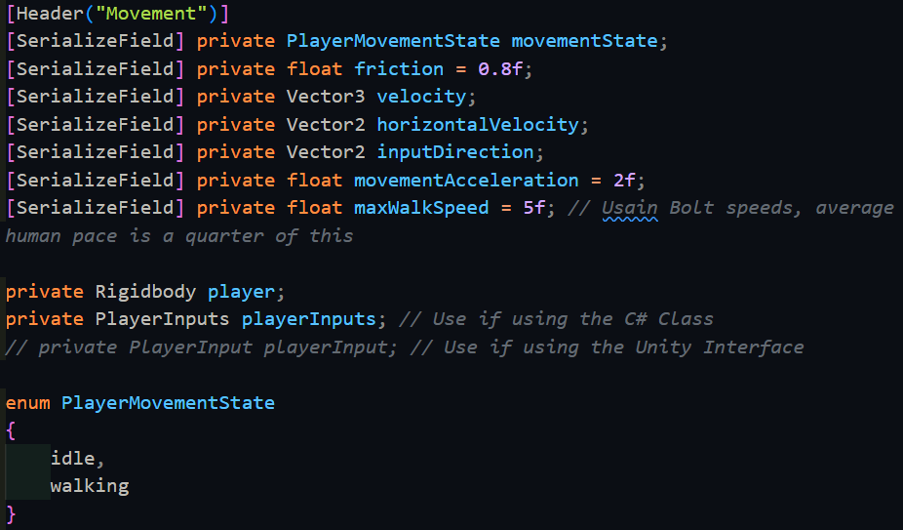

When the object is initialised, we need to fetch the player’s rigidbody, along with enabling the player’s inputs. Also, at the start of the game, since the player is not moving, they are idle and so this must be set as well.

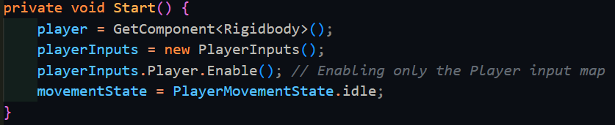

After that, we begin the code for what happens every frame (in Update() ). This includes retrieving the player’s velocity and copying it to an internal variable, along with deciding what the player’s movement state is. Then we need to take the movement inputs, decide the required movement amount, then apply friction. Furthermore, we need to make sure to limit the player’s speed, and then finally send the resulting change to the Physics system.

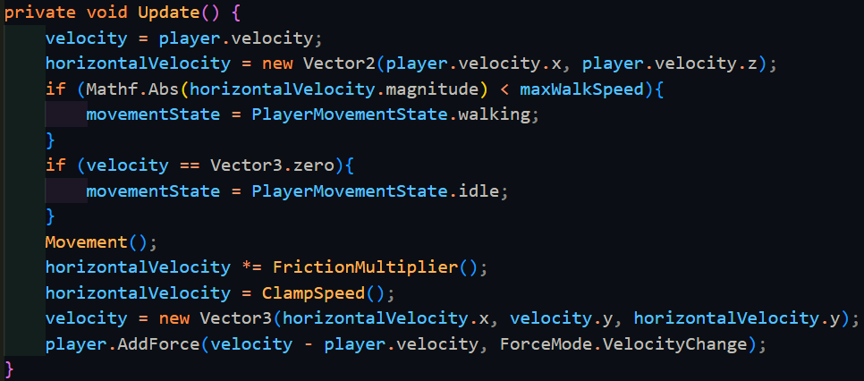

You have to make sure to take the absolute of the ground velocity’s magnitude (horizontalVelocity.magnitude) when comparing it to the maxWalkSpeed. FrictionMultiplier() is a relatively simple function, as it is only an if statement. Multiplying the output to a vector will result in the remaining velocity if friction was applied.

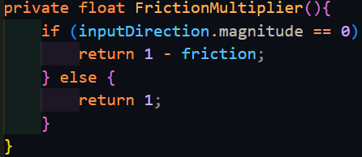

Similarly, ClampSpeed() is also simple, this time being a switch case statement, since all it checks against is the enumerator I made earlier.

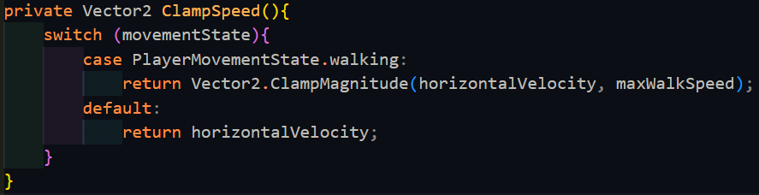

It uses the built-in function Vector2.ClampMagnitude, which scales the first argument (a Vector2) such that if it is higher than the second argument, it makes the vector smaller until it reaches the second argument. In case the state reached is not recognised, by default the vector is returned to not mess with it.

Finally, Movement() is the most complicated function out of all of these. So long as the player’s wants to move, it will calculate how fast they should be accelerated, and the resulting displacement changed in the time of the last frame. However, it may be that the player wants to move in a direction that they are currently not moving in, and as such these 2 directions need to be smoothly interpolated.

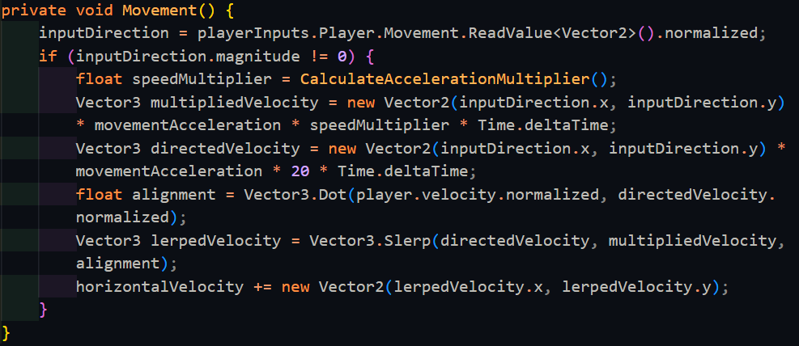

The function internally calls CalculateAccelerationMultiplier() which also uses the enumerator in a switch case statement to return an appropriate acceleration. This also calls a function that is an equation for how much speed should be gained.

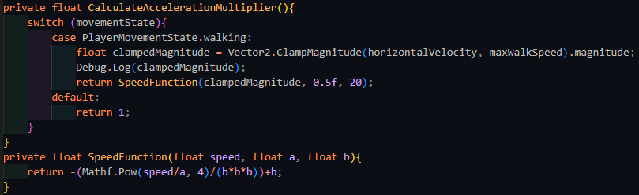

This works completely fine, and there were no bugs with this setup, and as such I attempted to speed this up. This is because Mathf.Pow is an extremely slow function for my needs, due to there being lots of overhead in case it needs to handle non-integer powers. Since I only need to do a predetermined, integer amount of exponentiation, I can rewrite my own quick function to do this with multiplication, which is much faster.

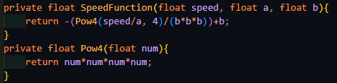

|  |  |  |  |  |  |
| --- | --- | --- | --- | --- | --- |
| Type | What data fits criteria | Justification | Expected | Actual | Comments |
| Valid | Pressing the W/A/S/D keys alone and in combinations | These keys allow the player to move in 8 directions once used in the correct combinations | The character will accelerate in the direction held until the maximum speed is reached or the direction is released | Passed |  |
| Boundary | Pressing opposing directions – A and D, S and W | This is possible input that a player might momentarily input as they switch directions, but since it is created from both valid inputs, but results in a different output, it should also be tested. | Combining these keys should result in no movement since they lead to movement in opposing directions | Passed |  |
| Erroneous | Pressing another key (e.g. M) | Keys not used for movement should not produce any movement | The player will remain still | Passed |  |

At this point, I was ready to move onto Jumping, and hence Gravity. Both of these required knowing about if the player was on the floor or not: one cannot jump if they are in the air (note I am implementing only jumping right now, double jump comes later), and it is faster and a better experience to only apply gravity when the player is not on the ground, otherwise the physics system will have to work overtime trying to make sure you don’t fall through the floor. While rigidbodies in Unity do have a built-in toggle to allow them to have gravity or not, it is better to manually implement gravity with my own constant to better control how the player feels in the game.

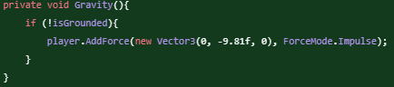

For this to work, however, we need to find out if the player is on the ground or not. Since finding out if the player is on the ground requires interacting with the Physics system, many of the following built-in functions will be from the Physics library, such as the first typical method of using Physics.CheckSphere(). This queries the physics system on whether there is a collision within a specified sphere, defined by radius and centre.

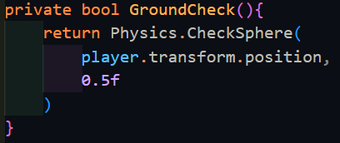

This code seemed to work fine, as when it was run, it did return true when the player was on the ground. To test if it worked when not on the ground, I needed to implement jumping, which should consist of applying a force upwards on the player if they are grounded. With this, we define a new float called jumpForce which we can control in the inspector of Unity.

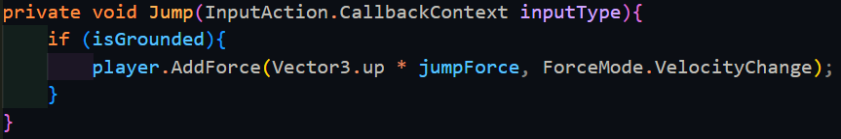

|  |  |  |  |  |  |
| --- | --- | --- | --- | --- | --- |
| Type | What data fits criteria | Justification | Expected | Actual | Comments |
| Valid | Pressing the jump key | As the only input being used to jump, it is important that it works | The character will move upwards, then move back down | Failed: The player continued moving upwards and not coming back down afterwards | The function might be sensing the player all the time instead of ignoring it |
| Erroneous | Pressing another key (e.g. M) | Since there is only one input, nothing else should cause the player to jump, and if there is, that means something is significantly broken | The player will remain still | Passed |  |

Upon binding this function to the Jump action being performed with playerInputs.Player.Jump.performed += Jump, pressing the jump key does indeed cause the player to start rising at a certain speed. Unfortunately, you can still continue jumping infinitely, showing there is indeed a bug with GroundCheck(). Upon closer inspection, the query is sensing that it is inside of the player, and hence that is why it is returning true all the time. Consulting the Unity documentation, CheckSphere() has an overload that takes an optional layer mask, which will exclude objects on those layers from being sensed.

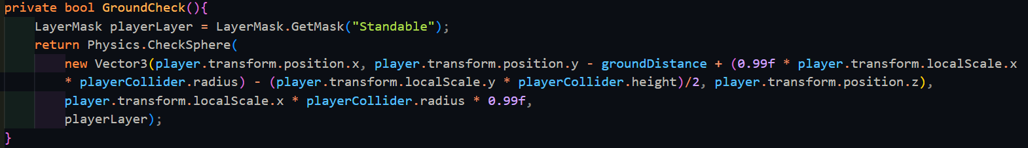

While this is fine, grabbing the layer mask every single time GroundCheck() is run is extremely inefficient and would hurt the player’s performance. Since the value of playerLayer never changes either from scene to scene, it is more efficient to grab the reference once at the start of the game when the script is first run, within the Start() function.

|  |  |  |  |  |  |
| --- | --- | --- | --- | --- | --- |
| Type | What data fits criteria | Justification | Expected | Actual | Comments |
| Valid | Pressing the jump key | As the only input being used to jump, it is important that it works | The character will move upwards, then move back down | Passed |  |
| Erroneous | Pressing another key (e.g. M) | Since there is only one input, nothing else should cause the player to jump, and if there is, that means something is significantly broken | The player will remain still | Passed |  |

The next feature to work on is Boost. This should allow the player to multiplicatively gain speed, so that when they are at higher speeds, they gain a higher boost, encouraging the player to maintain speed. Boost requires that the player’s velocity is simply added back onto itself, with the appropriate multiplication. This new state needs to be added to the PlayerMovementState enum, but it need not be added to the acceleration function, since allowing the player to accelerate at such a high speed will make it difficult to manage their speed effectively. This will also need to be added to the if statement for FrictionMultiplier().

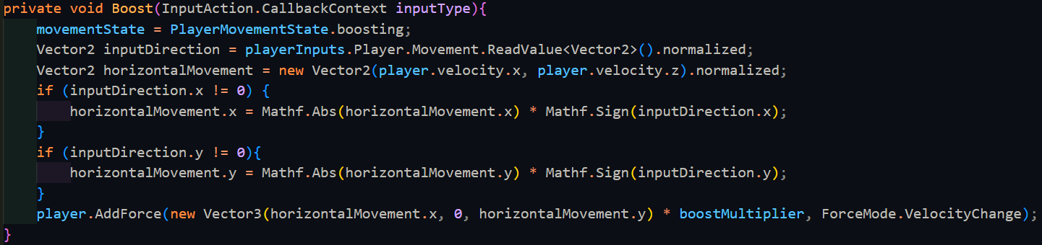

The player’s currently velocity is taken into account and then transformed around to point in the direction that is wanted by the player, so long as that input direction is not 0.

|  |  |  |  |  |  |
| --- | --- | --- | --- | --- | --- |
| Type | What data fits criteria | Justification | Expected | Actual | Comments |
| Valid | Pressing Q | This should be the only key used for boosting, and hence should respond appropriately | The player’s speed increases by a huge amount | Partially | Friction causes boosted speed to be lost far too quickly, or impossible to get past a certain speed. |
| Erroneous | Pressing another key (e.g. M) | Keys not used for boosting should not activate it | The player will remain at their current speed | Passed |  |

While boosting, it typically occurs that the player loses the speed that they gained far too quickly, such that it becomes irrelevant to use past a certain speed. While this could be advantageous, the limit is far too low and not enjoyable to utilise boosting at all. While it is still completely usable, for the player’s experience, I think it would be better to reduce the amount of friction that the player so that they can maintain the speed far easier and for longer. However, I will leave this decision up to the stakeholders:

Stakeholders: Hmm, I do see your point. I think the best solution is indeed your solution, so feel free to change the friction while the player is boosting.

Me: If so, how much should I reduce the friction by?

Stakeholders: Try out a fifth of the friction and I’ll test it out and see how it feels, and then we shall narrow it down from there.

|  |  |
| --- | --- |
| Friction for boost (percentage of normal friction) | Stakeholder comments |
| 20% | This still feels like it is not allowing the player to use the full potential of boost, this needs to go lower. |
| 15% | This feels better than the previous one but it still needs a bit of perfecting. Try going lower. |
| 10% | It feels even better this time! Just to make sure that there isn’t a better one, you should make it just a bit lower and I shall see from there. |
| 5% | Yes, the previous one was the best, this is too little friction, and the player doesn’t noticeably slow down at all. |

Now that I have reached a suitable value for the friction while boosting, I could test it appropriately, since any potential bugs found along the way could potentially be a problem from the specific value of the friction.

|  |  |  |  |  |  |
| --- | --- | --- | --- | --- | --- |
| Type | What data fits criteria | Justification | Expected | Actual | Comments |
| Valid | Pressing Q | This should be the only key used for boosting, and hence should respond appropriately | The player’s speed increases by a huge amount | Failed: the player went through a wall | The game may not be sensing the collision because the player is moving too fast |
| Erroneous | Pressing another key (e.g. M) | Keys not used for boosting should not activate it | The player will remain at their current speed | Passed |  |

The player passing through the wall was one of the most simultaneously difficult and simple issues I have encountered so far. I spent far too long trying to find a solution to this problem, consulting Unity forums and Stack Overflow. As such, I consulted my stakeholder on whether to make the player slower, or to rewrite the movement from the ground up using an alternative I found in my research.

#### Interview

Stakeholder: This is a very drastic solution to the problem. While I absolutely do not want to make the player slower as this is what makes the game fun, this could lose you a lot of time on this project, and as such I will need to cut back on some features.

Me: I have already spent a while trying to fix this and without severely limiting and reducing the player’s experience, I cannot currently see any other way to get around this. The new method will not be as good as the current one, and it may be more difficult to implement, but it is a fix, nonetheless.

Stakeholders: I see. In that case, I’d like to cut back on the weapons and the entities’ AI as these are secondary things that we decided on. Feel free to omit implementing the blades and the explosive weapons, and making the entities be on the player side, or even alert a manager. These are all secondary in face of the movement – the primary genre of this game.

Stakeholder Signature:

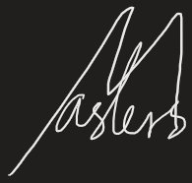

[------------------------------------------------------------------------------------------------------------]

The algorithm that I found is a standard in the industry for dealing with a dynamic object colliding with static objects such as wall. It is called Collide and Slide, where its job is in the name – it collides the object with another and slides it across the other’s surface. Certain functions I have already written can be maintained, only needing minor fixes here and there to fit with the controller, that does not use a rigidbody in the same format. Movement() was changed to instead to manually change the velocity off the rigidbody, which is affected by the aforementioned algorithm.

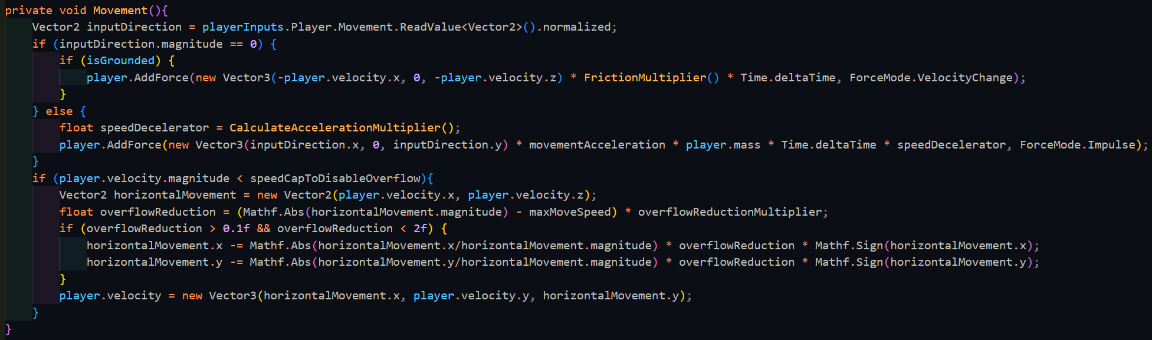

This time, movement handles the player going over the maxSpeed differently: if the player is below a certain speed, it multiplies the overflow speed by an amount which is subtracted from the current speed to slowly reduce the player’s velocity back to the maximum speed. However, if the player is moving above a certain speed cap, the player is deemed as boosting, and the overflow is not reduced. The player also only feels friction once they let go of the movement keys, to make it easier for the player to reach the maximum speed.

|  |  |  |  |  |  |
| --- | --- | --- | --- | --- | --- |
| Type | What data fits criteria | Justification | Expected | Actual | Comments |
| Valid | Pressing the W/A/S/D keys alone and in combinations | These keys allow the player to move in 8 directions once used in the correct combinations | The character will accelerate in the direction held until the maximum speed is reached or the direction is released | Passed |  |
| Boundary | Pressing opposing directions – A and D, S and W | This is possible input that a player might momentarily input as they switch directions, but since it is created from both valid inputs, but results in a different output, it should also be tested. | Combining these keys should result in no movement since they lead to movement in opposing directions | Passed | Importantly, this also leads to the player slowing down, as they should. |
| Erroneous | Pressing another key (e.g. M) | Keys not used for movement should not produce any movement | The player will remain still | Passed |  |

To go hand in hand with this, CollideAndSlide() corrects the player’s velocity as they approach a collider. It predicts where the player will be on the next frame, and if the player collides with something, it will calculate where the player should end up after colliding with that object.

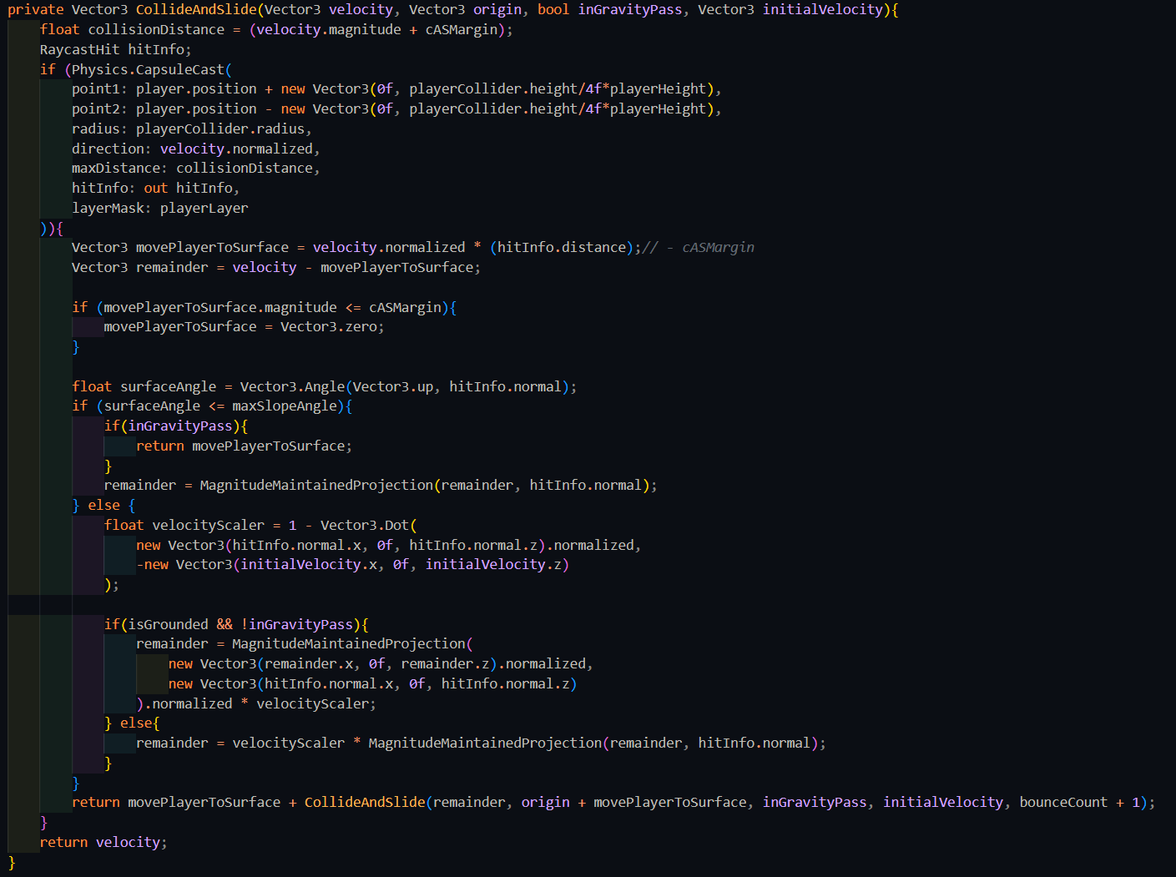

CollideAndSlide() is a recursive algorithm, being called on the remaining velocity every time it collides with something. Collisions are detected with a CapsuleCast, which is similar to a RayCast, except it shoots a capsule instead, which is the same shape as the player. If a collision is detected, the player’s extra velocity is rotated to be parallel with the collider’s normal, of which a percentage is taken away based on how much rotation is required, which is calculated with the dot product. Rotation is done via MagnitudeMaintainedProjection(), which simply stores the magnitude of the vector, then uses Vector3.ProjectOnPlane() to project it and finally sets the magnitude back to the original. The total of the required velocity to move the player to the surface and the speed for any further movements was returned back, via calling the algorithm again. This recursive nature is stopped when there was no collision.

|  |  |  |  |  |  |
| --- | --- | --- | --- | --- | --- |
| Type | What data fits criteria | Justification | Expected | Actual | Comments |
| Valid | Pressing the W/A/S/D keys alone and in combinations while moving at a wall | These keys allow the player to move in 8 directions once used in the correct combinations and moving at a wall which is required to test the algorithm | The character will accelerate in the direction held until the maximum speed is reached or the direction is released | Failed: Unity ran into maximum recursion depth of 100 | Mostly likely comes from there being no maximum bounce count and the algorithm just continuously calling itself as it bounces in a corner |
| Boundary | Pressing opposing directions – A and D, S and W | This is possible input that a player might momentarily input as they switch directions, but since it is created from both valid inputs, but results in a different output, it should also be tested. | Combining these keys should result in no movement since they lead to movement in opposing directions | Passed | Importantly, this also leads to the player slowing down, as they should. |
| Erroneous | Pressing another key (e.g. M) | Keys not used for movement should not produce any movement | The player will remain still | Passed |  |

To counteract the infinite recursion, maxBounceCount was added to the function, along with a tracker for how deep the algorithm has gone so far.



|  |  |  |  |  |  |
| --- | --- | --- | --- | --- | --- |
| Type | What data fits criteria | Justification | Expected | Actual | Comments |
| Valid | Pressing the W/A/S/D keys alone and in combinations while moving at a wall | These keys allow the player to move in 8 directions once used in the correct combinations and moving at a wall which is required to test the algorithm | The character will accelerate in the direction held until the maximum speed is reached or the direction is released | Failed: The player slowed down as they approached the wall instead of continuing along the path at the correct speed | Could be caused by the percentage loss being incorrectly applied or there being errors between using normalised and unnormalized vectors |

While the error of the stack overflowing was solved, the player now slows down as they approach the wall, which is completely unintended behaviour. However, while scouring the code for what could be causing this, I discovered that rigidbodies had a setting that changed how they detect collisions.



This setting was what I needed to solve the original problem, and which would cause the first code to work correctly when the player was moving at high speeds. This setting has 4 different options:

* Discrete – The least computationally intensive option, but also the least accurate, shown well as it was causing the error the first version of this script was experiencing
* Continuous – This sweeps the object from the location at the start of the frame to the end position and detects if there are any collisions with static objects (e.g. walls) in the sweep, and deals with it appropriately. Does not work with objects that move or rotate
* Continuous Dynamic – Works similarly to continuous except it also queries the other moving entities to see if there is a collision with them as well. Does not work with objects that rotate themselves
* Continuous Speculative – Works differently to the other continuous collision detection methods, thereby making it faster but less accurate. It increases an object’s AABB (axis-aligned minimum bounding box) to include the start and end position, then detecting any collisions within that zone. Well known to occasionally detect false collisions and cause havoc. Does work with objects that have rotated themselves.

Out of all these options, the one that I need to use is Continuous Dynamic collision detection, which also allows me to use the original code.

#### Interview

Me: I’ve discovered a method for me that would allow me to fix and use the original code, which so far has less errors and issues than the current implementation. Is it fine for me to use that instead?

Stakeholder: Yes, in that case, go back to the old code, such that we can save time that way. However, is it possible for you to make the original movement feel less slippery while the player is not boosting? I noticed it was not the most responsive due to it, which is hurting the player’s experience.

Stakeholder Signature:



[------------------------------------------------------------------------------------------------------------]

Now that I have returned to the original code, I need to improve the movement function. Furthermore, this movement does not necessarily allow for multiple movement states such as crouching and sprinting. Due to this, the code was edited to instead use a target which is the player’s intended direction and to then work out how much extra speed the player needs to reach that speed. This speed is then projected onto the surface that the player is currently on, with its magnitude maintained. This movement then has a certain acceleration applied, and then friction is applied appropriately. The advantage of doing things like this means that all movement works the exact same way, and the only thing that needs to be changed is the current state’s max speed in the switch statement within MaxSpeed(), and the acceleration multiplier which is handled in a similar way with CalculateAccelerationMultiplier(). In this way, the things that change between states are handled externally to the function and hence the function’s core can stay the same way with as little if statements as possible to slow the program down.

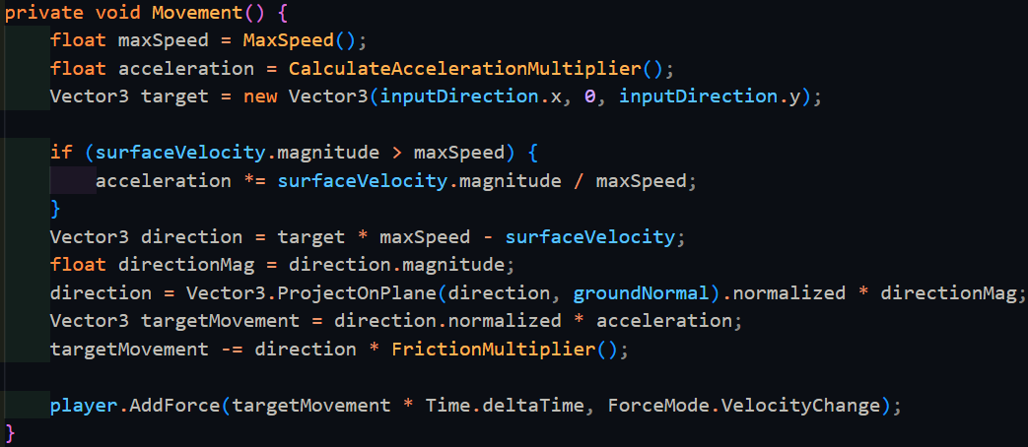

|  |  |  |  |  |  |
| --- | --- | --- | --- | --- | --- |
| Type | What data fits criteria | Justification | Expected | Actual | Comments |
| Valid | Pressing the W/A/S/D keys alone and in combinations while moving at a wall | These keys allow the player to move in 8 directions once used in the correct combinations and moving at a wall which is required to test the algorithm | The character will accelerate in the direction held until the maximum speed is reached or the direction is released | Passed |  |
| Boundary | Pressing opposing directions – A and D, S and W | This is possible input that a player might momentarily input as they switch directions, but since it is created from both valid inputs, but results in a different output, it should also be tested. | Combining these keys should result in no movement since they lead to movement in opposing directions | Passed |  |
| Erroneous | Pressing another key (e.g. M) | Keys not used for movement should not produce any movement | The player will remain still | Passed |  |

With the original movement problem solved, I could now move onto looking as this is equally integral to the player’s movement set, and therefore this might break other sections of the code. Different parts of looking need to interact with different objects. Looking side-to-side can be done by rotating the player’s body on the y-axis (vertical axis) as one would do similarly in reality, however, looking up and down is done by moving your head which is separate from the body. Similarly, the whole body should not rotate when looking up and down, and only the camera should move up and down.

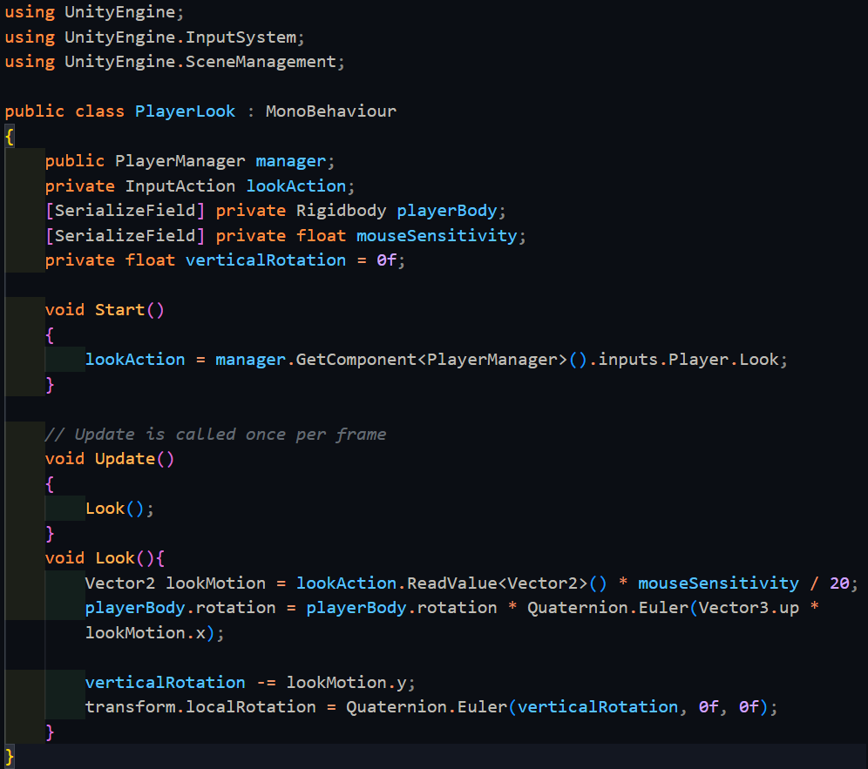

The only purpose of Start() is to retrieve the look action from the manager. The rest of the looking code exists within Update, since it needs to be updated every frame. The look action is a 2D Vector, containing the change horizontally and vertically. The horizontal direction is mapped directly to the vertical rotation of the body, while the vertical direction does not already have a value storing its rotation, so we need to add this in manually. Since this script is placed onto the camera object, transform.localRotation is used instead of referencing the camera directly to save on memory.

|  |  |  |  |  |  |
| --- | --- | --- | --- | --- | --- |
| Type | What data fits criteria | Justification | Expected | Actual | Comments |
| Valid | Moving the mouse up and down | This is the entire input base that the player should be using for looking around | The character will look around normally | Failed: the mouse went off the screen | The cursor needs to be locked to the game window |
| Boundary | Moving the mouse really far | This is to check that there is no snapping in the movement and that the system is capable of large movement values | The character will look around really fast | Failed: the player was able to look upside down, which can disorient them | This might be caused by not stopping the angle from going past 90 degrees up and down |
| Erroneous | No movement | It is important to check that the system does not continue drifting while the player is not moving the mouse | The camera will be still | Passed |  |

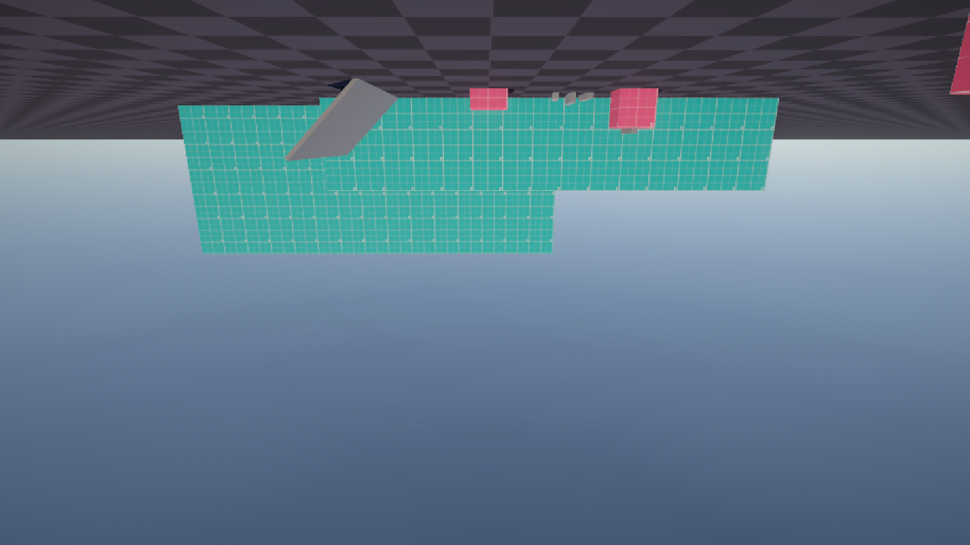

*(The player looking upside down)*

There was an unforeseen error where the player was able to look past the top and bottom and continue looking upside down. This is most likely caused by the fact that the vertical rotation was not clamped between -90 and 90 degrees. This can be fixed via this line below:

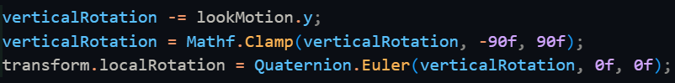

Now, this is clamped between -90˚ and 90˚ to make sure that the player does not continue looking and end up backwards, theoretically breaking their neck.

|  |  |  |  |  |  |
| --- | --- | --- | --- | --- | --- |
| Valid | Moving the mouse up and down | This is the entire input base that the player should be using for looking around | The character will look around normally | Passed |  |

The next error now needs to be solved: the player’s mouse continues to move off the screen since it is not constrained within the window. This is a distraction and inconvenient when the player clicks, so Cursor.lockState is set to Locked.

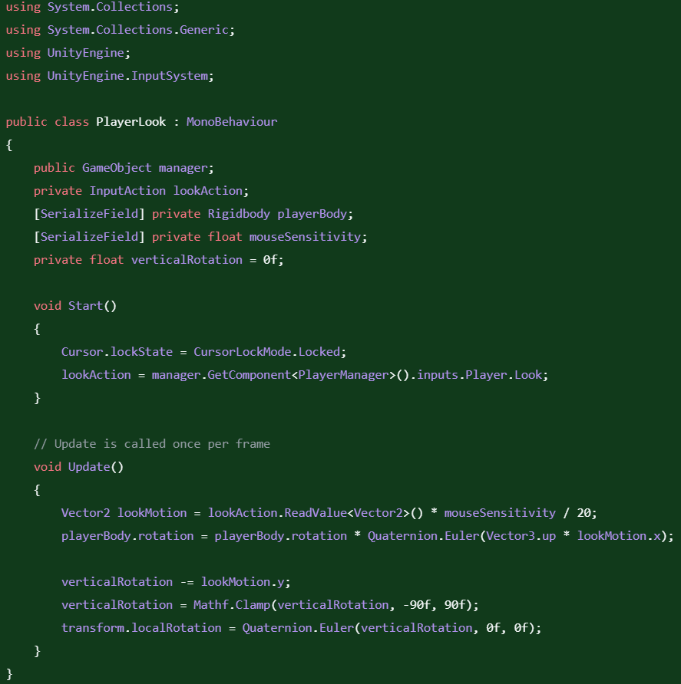

|  |  |  |  |  |  |
| --- | --- | --- | --- | --- | --- |
| Boundary | Moving the mouse really far | This is to check that there is no snapping in the movement and that the system is capable of large movement values | The character will look around really fast | Passed |  |

Now that the system is finished, I tested it again with all the tests again, to make sure none of the fixes broke anything.

|  |  |  |  |  |  |
| --- | --- | --- | --- | --- | --- |
| Type | What data fits criteria | Justification | Expected | Actual | Comments |
| Valid | Moving the mouse up and down and side to side | This is the entire input base that the player should be using for looking around | The character will look around normally | Passed |  |
| Boundary | Moving the mouse really far in any direction | This is to check that there is no snapping in the movement and that the system is capable of large movement values | The character will look around really fast | Passed |  |
| Erroneous | No movement | It is important to check that the system does not continue drifting while the player is not moving the mouse | The camera will be still | Passed |  |

Looking alone worked fine, and now I needed to test it with movement together.

|  |  |  |  |  |  |
| --- | --- | --- | --- | --- | --- |
| Type | What data fits criteria | Justification | Expected | Actual | Comments |
| Valid | Moving the mouse up and down while moving in a circle | This combines all the looking actions with all the movement options and is also covers the most typical of a player’s movement style | The character will look around and the player will move around relative the current looking direction. | Failed: the player moved around independent of their facing angle. | Most likely caused by the movement script writing global direction instead of local directions. |
| Boundary | Moving the mouse really far while moving in a circle | This is to check that there is no snapping in the movement and that the system is capable of large movement values, while maintaining movement | The character will look around really fast and will move accordingly | Failed: Encountered the same error as the valid data |  |
| Erroneous | No movement | It is important to check that the system does not continue drifting while the player is not moving the mouse | The camera will be still, and the player will not move | Passed |  |

This error seems to be caused because the code was adding force to the rigidbody according to the global axis, and not the local axis which is what I thought it was doing. If it was adding to the local axis, then everything would work fine, since the rotation to the body would be applied after. To remedy this, we need to rotate the target (which is the player’s input) to face the body’s current direction. The player’s body rotation is stored as a quaternion, which can be used to rotate a vector.



|  |  |  |  |  |  |
| --- | --- | --- | --- | --- | --- |
| Type | What data fits criteria | Justification | Expected | Actual | Comments |
| Valid | Moving the mouse up and down while moving in a circle | This combines all the looking actions with all the movement options and is also covers the most typical of a player’s movement style | The character will look around and the player will move around relative the current looking direction. | Passed |  |
| Boundary | Moving the mouse really far while moving in a circle | This is to check that there is no snapping in the movement and that the system is capable of large movement values, while maintaining movement | The character will look around really fast and will move accordingly | Passed |  |
| Erroneous | No movement | It is important to check that the system does not continue drifting while the player is not moving the mouse | The camera will be still, and the player will not move | Passed |  |

Since all the tests passed, I asked my stakeholders about the system and see if anything else was needed to be added.

Stakeholder: Hmm, playing this version of the movement is alright, but I feel like the player doesn’t turn around fast enough, nor do they start moving fast enough. Is it possible to make them move faster at the beginning or when turning around?

To allow the player to do these things, we need to calculate the how different the current movement and the opposing movement is, which can be done with the dot product. If both vectors have a magnitude of 1 (which is true for all normalized vectors), then the dot product returns a value that is negative when the vectors are in directions that opposing each other. This can be used with an if statement to boost the acceleration of the player. To solve the player moving slowly at the beginning, we can work out check if the speed is lower than a certain amount and hence double the acceleration.

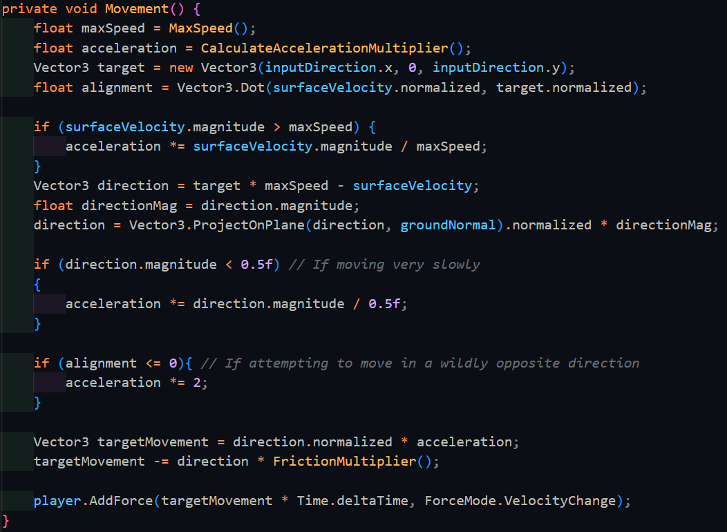

|  |  |  |  |  |  |
| --- | --- | --- | --- | --- | --- |
| Type | What data fits criteria | Justification | Expected | Actual | Comments |
| Valid | Moving the player from rest | This is one of the requirements of what the stakeholder recently requested and hence needs to be checked appropriately | The player will accelerate faster than before | Passed |  |
| Valid | Moving the player in a completely opposing direction than they are currently moving | This is another requirement that the stakeholder recently requested | The player should change to the opposing direction much faster than before | Passed |  |
| Erroneous | No change in the current movement | It is important to check that the system has not changed how it performs | The player will continue moving in the same way | Passed |  |

Next, I decided it would be better to make the game more performant by utilising the built in Physics system to tell the player controller when it is grounded or not. When a collider collides with something, Unity automatically calls OnCollisionEnter() and OnCollisionStay() on all scripts that the object has attached. When this collider stops colliding with an object, Unity automatically calls OnCollisionExit() in the same way. All these functions have a list of the collision points relative to the centre of the player passed in as a parameter. We can simply go through each of these and figure out if the contact’s normal is far shallow enough to be a floor.

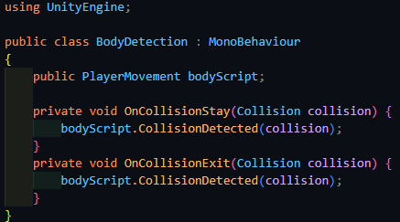

(This script is attached to the body directly ^)

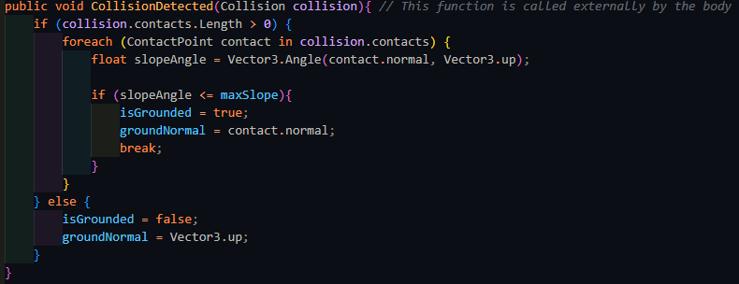

If there are no contacts, then player is in midair, and hence not grounded at all. To test this, the player will jump.

|  |  |  |  |  |  |
| --- | --- | --- | --- | --- | --- |
| Type | What data fits criteria | Justification | Expected | Actual | Comments |
| Valid | Pressing the jump key | When the player jumps, they are no longer in the air, and I can check the state of isGrounded | isGrounded will be false. | Passed |  |
| Boundary | Standing on the ground next to a wall | One of the contacts will be on the ground, while another is on a wall, and the game may get confused with this | isGrounded will be true | Passed |  |
| Erroneous | Pressing another key (e.g. M) | This should keep the player on the ground | isGrounded will be true | Passed |  |

With this, I have made sure that game is running much more efficiently, and now I can add a further feature of crouching. Crouching is an action where the player will both move at a slower speed, and while also shrink in height. To shrink the player’s height, we can manually change the player collider’s height to a smaller size that is more appropriate.

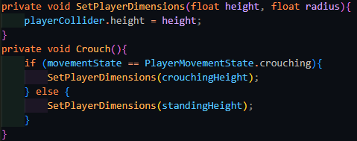

|  |  |  |  |  |  |
| --- | --- | --- | --- | --- | --- |
| Type | What data fits criteria | Justification | Expected | Actual | Comments |
| Valid | Pressing the crouch key | This is input that the player will use, and hence needs to be tested appropriately | The player’s height will be shrunk | Partial: the player did decrease in height, but in mid air | The player shrunk around their centre instead of their base |
| Erroneous | Pressing another key (e.g. M) | An input not related to the test should not affect the test | The player will remain at their standing height | Passed |  |

Upon crouching, the player does indeed shrink in size, but unfortunately, they shrink in midair and end up falling to the ground. This can be solved by finding the distance required to move the player down after the shrink, or back up after they stop crouching, and then taking this away from the player’s current y-position. This value needs to be halved since I only need the part of the shrunk height that is downwards from the centre of the player. To do all of this, I also need to store the height before the change

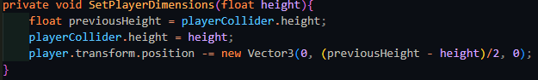

|  |  |  |  |  |  |
| --- | --- | --- | --- | --- | --- |
| Type | What data fits criteria | Justification | Expected | Actual | Comments |
| Valid | Pressing the crouch key | This is input that the player will use, and hence needs to be tested appropriately | The player’s height will be shrunk | Passed |  |

Next, I can implement the ability to crouch with either a toggle crouch or with a crouch key that must be held. Following the algorithm that was designed earlier and testing as such:

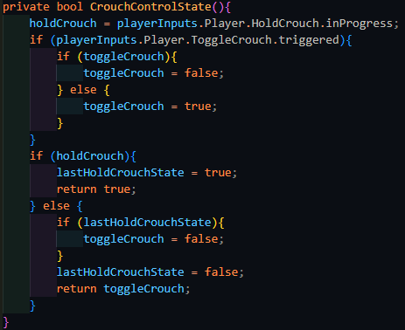

|  |  |  |  |  |  |
| --- | --- | --- | --- | --- | --- |
| Type | What data fits criteria | Justification | Expected | Actual | Comments |
| Valid | Pressing the toggle crouch key | Each input must be tested separately to verify that they work | The player will crouch | Passed |  |
| Valid | Holding the hold crouch key | Each input must be tested separately to verify that they work | The player will crouch for the duration that the key is held | Passed |  |
| Boundary | Pressing the toggle crouch key and then the hold crouch key, and then releasing it | As was specified in the first interview, the held crouch must take priority over | The player will crouch and then uncrouch when the hold crouch key is released | Passed |  |
| Erroneous | Pressing another key (e.g. M) | An input not related to the test should not affect the test, and hence checks that the input system is still working as expected | The player will remain at the same height | Passed |  |

However, looking at the code, I realised that the toggleCrouch if statement was simple enough to instead use the C# ternary operator instead, which can compress 1 line if else statements.



Taking a look at the code from this view, however, I realised that it was simpler to invert the current state of toggleCrouch, increasing the efficiency of the algorithm even further.



|  |  |  |  |  |  |
| --- | --- | --- | --- | --- | --- |
| Type | What data fits criteria | Justification | Expected | Actual | Comments |
| Valid | Pressing the toggle crouch key | Each input must be tested separately to verify that they work | The player will crouch | Passed |  |
| Valid | Holding the hold crouch key | Each input must be tested separately to verify that they work | The player will crouch for the duration that the key is held | Passed |  |
| Boundary | Pressing the toggle crouch key and then the hold crouch key, and then releasing it | As was specified in the first interview, the held crouch must take priority over | The player will crouch and then uncrouch when the hold crouch key is released | Passed |  |
| Erroneous | Pressing another key (e.g. M) | An input not related to the test should not affect the test, and hence checks that the input system is still working as expected | The player will remain at the same height | Passed |  |

### Miscellaneous

To measure the performance of the game, I decided to add an on-screen element to measure how many frames are being run per second (FPS). The higher the FPS of the game, the better it is running since less calculations are done per frame, and hence the easier it is to run. The simplest way to do this was to follow this equation $f=\frac{1}{T}$, where the frequency is the FPS, and T (the time period) is how long each frame took to run. This value can be updated every frame.

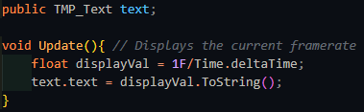



*(The FPS counter in the game)*

However, this noticeably has a problem – the value changes to quickly to get an accurate reading of what it is and as such it might be better to use a method which averages the FPS across the game.

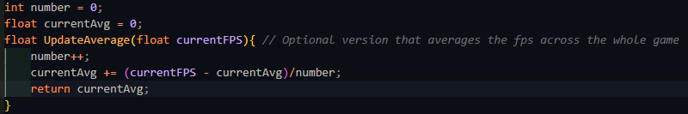

This version instead stores how many frames have gone by, and what the current average is, it can then work out how much the average would change based on the current FPS and then update the average.

While this works well, as the game goes on longer and longer, the average becomes less sensitive to the current FPS as each progressive value has less and less of an impact on the whole. As such, I decided to scrap this version since the player is expected to play the game for periods of time longer than 10 minutes, whereas the average FPS becomes useless at around 30 seconds. Instead, to help with debugging the game, I added an option for the current FPS to be logged to the debug file instead.

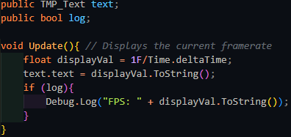

While this works ok, I noticed a noticeable decrease in the FPS when this option was used, and the player’s original framerate was extremely high. This makes sense as writing to a file is quite the intensive operation, and as such this logging facility should be used as sparingly as possible, but exists as a useful option when the game’s FPS is lower, since at FPS lower than 200, the IO operation required to write to the debug file takes less time than the rest of the game by a long margin.

### End of prototype tests

#### Strafing

|  |  |  |  |  |  |
| --- | --- | --- | --- | --- | --- |
| Type | What data fits criteria | Justification | Expected | Actual | Comments |
| Valid | Pressing the W/A/S/D keys alone and in combinations while moving at a wall | These keys allow the player to move in 8 directions once used in the correct combinations and moving at a wall which is required to test the algorithm | The character will accelerate in the direction held until the maximum speed is reached or the direction is released | Passed |  |
| Boundary | Pressing opposing directions – A and D, S and W | This is possible input that a player might momentarily input as they switch directions, but since it is created from both valid inputs, but results in a different output, it should also be tested. | Combining these keys should result in no movement since they lead to movement in opposing directions | Passed |  |
| Erroneous | Pressing another key (e.g. M) | Keys not used for movement should not produce any movement | The player will remain still | Passed |  |

#### Looking

|  |  |  |  |  |  |
| --- | --- | --- | --- | --- | --- |
| Type | What data fits criteria | Justification | Expected | Actual | Comments |
| Valid | Moving the mouse up and down | This is the entire input base that the player should be using for looking around | The character will look around normally | Passed |  |
| Boundary | Moving the mouse really far | This is to check that there is no snapping in the movement and that the system is capable of large movement values | The character will look around really fast | Passed |  |
| Erroneous | No movement | It is important to check that the system does not continue drifting while the player is not moving the mouse | The camera will be still | Passed |  |

#### Boosting

|  |  |  |  |  |  |
| --- | --- | --- | --- | --- | --- |
| Type | What data fits criteria | Justification | Expected | Actual | Comments |
| Valid | Pressing Q | This should be the only key used for boosting, and hence should respond appropriately | The player’s speed increases by a huge amount | Passed |  |
| Erroneous | Pressing another key (e.g. M) | Keys not used for boosting should not activate it | The player will remain at their current speed | Passed |  |

#### Jumping

|  |  |  |  |  |  |
| --- | --- | --- | --- | --- | --- |
| Type | What data fits criteria | Justification | Expected | Actual | Comments |
| Valid | Pressing the jump key | As the only input being used to jump, it is important that it works | The character will move upwards, then move back down | Passed |  |
| Erroneous | Pressing another key (e.g. M) | Since there is only one input, nothing else should cause the player to jump, and if there is, that means something is significantly broken | The player will remain still | Passed |  |

#### Crouching

|  |  |  |  |  |  |
| --- | --- | --- | --- | --- | --- |
| Type | What data fits criteria | Justification | Expected | Actual | Comments |
| Valid | Pressing the crouch key | This is input that the player will use, and hence needs to be tested appropriately | The player’s height will be shrunk | Passed |  |
| Erroneous | Pressing another key (e.g. M) | An input not related to the test should not affect the test | The player will remain at their standing height | Passed |  |

#### Different crouch keys

|  |  |  |  |  |  |
| --- | --- | --- | --- | --- | --- |
| Type | What data fits criteria | Justification | Expected | Actual | Comments |
| Valid | Pressing the toggle crouch key | Each input must be tested separately to verify that they work | The player will crouch | Passed |  |
| Valid | Holding the hold crouch key | Each input must be tested separately to verify that they work | The player will crouch for the duration that the key is held | Passed |  |
| Boundary | Pressing the toggle crouch key and then the hold crouch key, and then releasing it | As was specified in the first interview, the held crouch must take priority over | The player will crouch and then uncrouch when the hold crouch key is released | Passed |  |
| Erroneous | Pressing another key (e.g. M) | An input not related to the test should not affect the test, and hence checks that the input system is still working as expected | The player will remain at the same height | Passed |  |

#### Looking and strafing combined tests

|  |  |  |  |  |  |
| --- | --- | --- | --- | --- | --- |
| Type | What data fits criteria | Justification | Expected | Actual | Comments |
| Valid | Moving the mouse up and down while moving in a circle | This combines all the looking actions with all the movement options and is also covers the most typical of a player’s movement style | The character will look around and the player will move around relative the current looking direction. | Passed |  |
| Boundary | Moving the mouse really far while moving in a circle | This is to check that there is no snapping in the movement and that the system is capable of large movement values, while maintaining movement | The character will look around really fast and will move accordingly | Passed |  |
| Erroneous | No movement | It is important to check that the system does not continue drifting while the player is not moving the mouse | The camera will be still, and the player will not move | Passed |  |

### Interview

Me: I’ve finished implementing the basic movement options and I’ve confirmed that there are no errors with them. Should I now move onto the entity system and the player’s ability to damage them?

SillyAustralian: First, let me try the game so far. If everything is ok, then you can move onto those features.

[Henry Masters proceeded to play the prototype in its current state]

SillyAustalian: Ok, everything is fine here. It is ok to move onto the weapon interaction and entity system. As previously discussed, due to the setbacks that have occurred, you do not need to implement anything other than a gun for the weapon system, and u do not need to make the entities communicate with any other entity, including the manager.

Stakeholder Signature:



## Prototype 2

### Interacting with weapons

Weapon interaction will begin with 1 weapon.

To begin interacting with weapons, first I need to make a weapon. Weapon will be an abstract class that contains information that is applicable or can be made applicable to all types of weapons and Fire() which will be used to activate the weapon. The properties that are applicable are:

* The type of the weapon, which will function as an ID
* The total ammunition that the weapon has
* The amount left in the clip if applicable
* The capacity of the weapon’s clip

Weapon is a class that must be made abstract, and hence all the internal properties will be abstract as well. These will have default values, since not every child class will need to overwrite the values.



However, attempting to do this will cause an error since abstract functions (C# properties act as variables that are functions under the surface) cannot have anything within them. As such, these need to be defined as virtual instead, which is a special keyword in C# that allows a function to be overridden while containing a base implementation.

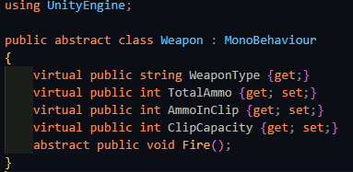

Next, a gun will have a type of bullet that it will fire, that will deal a certain amount of damage, and it will also have a barrel where the bullet is fired from. Importantly, the bullet itself is the thing that will be dealing the damage, not the gun itself. This way, the class can be reused for other weapons which will keep the codebase smaller and easier to maintain, since there will be only 1 bullet that can deal damage to entities.

Bullet is a class that will have 1 purpose: to check whether it will hit an entity, and if it does, to deal damage to it. As such, its contents are relatively simple in comparison:

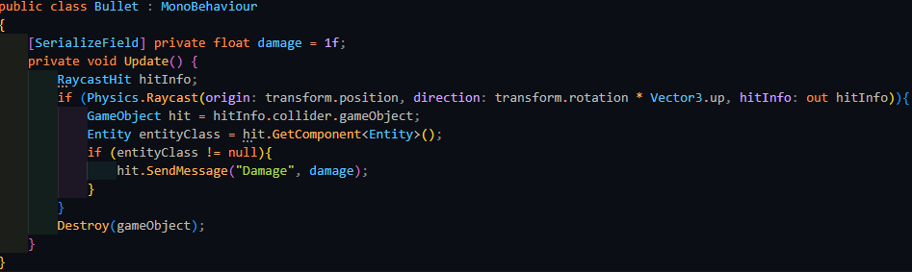

Once the bullet has performed its task, it destroys itself, keeping memory consumption low, and making the game as easy to run as possible. To fire said bullet, the gun will first check there is enough ammunition remaining, and if so, it will instantiate a bullet entity. Afterwards, it will then subtract 1 from both TotalAmmo and AmmoInClip.

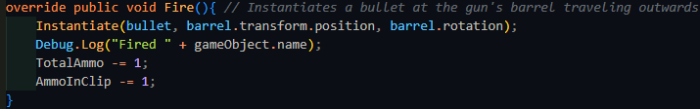

On the other side of the system, the player’s input needs to be read and passed through to the weapon. This is done by subscribing a pass-through method to the correct input action, which upon activation, will call the relevant action on the gun.

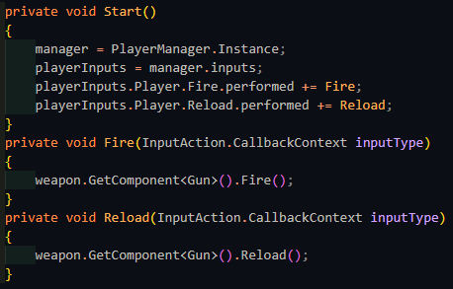

|  |  |  |  |  |  |
| --- | --- | --- | --- | --- | --- |
| Type | What data fits criteria | Justification | Expected | Actual | Comments |
| Valid | Pressing the fire button while there is enough ammunition remaining | This is the most common action the weapon will encounter and therefore is suitable as a valid test | The gun will fire 1 bullet | Passed |  |
| Boundary | Pressing the fire button while there is no ammunition remaining | It is important the system still acts accordingly when there is no ammunition in the clip remaining | The gun will not fire | Passed |  |
| Erroneous | Pressing another key (e.g. M) | Any inputs not related to the system should not affect it | The gun will not fire | Passed |  |

However, once the gun runs out of ammunition, the player needs to reload it. Since the player has limited ammunition, this needs to be taken into account when reloading. The player could also attempt to reload in the middle of a clip, and hence only the excess should be topped up.

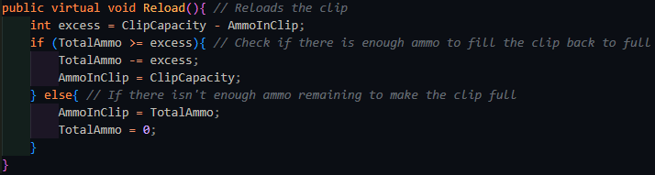

|  |  |  |  |  |  |
| --- | --- | --- | --- | --- | --- |
| Type | What data fits criteria | Justification | Expected | Actual | Comments |
| Valid | Pressing the reload button when there is no ammunition left in the clip, and there is enough ammunition remaining in total | This is the next most common action the weapon will encounter and therefore is suitable as a valid test | The gun will reload back to full | Passed |  |
| Boundary | Pressing the reload button when there is ammunition left in the clip | It is important the system still acts accordingly when the player reloads before they need to | The gun will reload back to full and only take as much ammo as needed | Passed |  |
| Erroneous | Pressing another key (e.g. M) | Any inputs not related to the system should not affect it | The gun will not reload | Passed |  |

To implement zooming, the game needs to take control of the camera’s field of view. If the camera has a lower field of view, it can see less things at one time, but since this lower number of objects takes up more space on the screen, it gives the effect of having zoomed in. Meanwhile, doing the opposite will have the effect of zooming out. By binding zoom to the action being triggered, the player can toggle between zooming in and out, by setting this value on the camera.

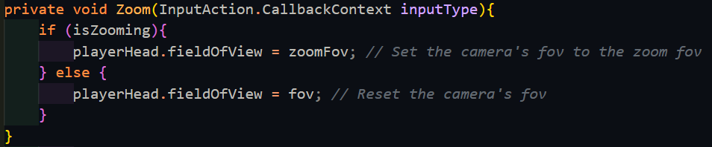

|  |  |  |  |  |  |
| --- | --- | --- | --- | --- | --- |
| Type | What data fits criteria | Justification | Expected | Actual | Comments |
| Valid | Pressing the zoom button and then pressing it again | While the player may not use this action a lot, this is the only way to enable it and disable it, therefore making this suitable as a valid test | The player’s view will zoom in – focus on a smaller area, and then back out | Passed |  |
| Valid | Pressing the zoom button and then moving the mouse around | The player will most likely want to look around while zooming in as well, hence this must be tested as well | The player’s view will zoom in and then move around appropriately | Failed – the view was uncontrollable from moving too fast | The sensitivity needs to change when |
| Erroneous | Pressing another key (e.g. M) | Any inputs not related to the system should not affect it | The player’s view will remain the same | Passed |  |

When the player had zoomed in, it became much harder to control the view accurately, and as such, it is necessary to turned down the sensitivity of the mouse while

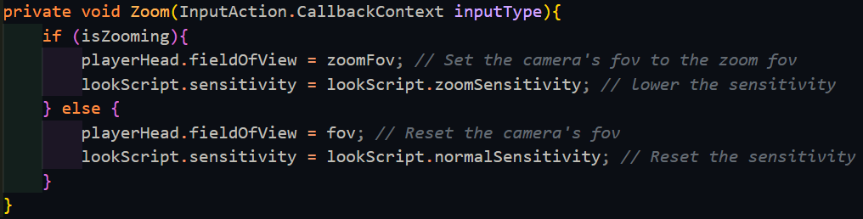

|  |  |  |  |  |  |
| --- | --- | --- | --- | --- | --- |
| Type | What data fits criteria | Justification | Expected | Actual | Comments |
| Valid | Pressing the zoom button and then moving the mouse around | The player will most likely want to look around while zooming in as well, hence this must be tested as well | The player’s view will zoom in and then move around appropriately | Passed |  |

Extending this current system to use 4 weapons instead of 1, as was requested can be done by creating 4 weapon slots like below and a tracker of which slot is currently active:

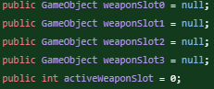

This can then be paired with a switch statement to access each slot.

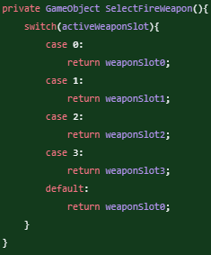

Swapping between slots requires changing activeWeaponSlot and the standard key that is used to do this is the scroll wheel. The scroll wheel returns a float value, although this is only -1.0 and 1.0, indicating the direction the that scroll wheel is moving in. Therefore, this can be casted to an integer with no backlash. The current weapon needs to be deactivated, and then the newly selected weapon needs to be enabled. If the player continues scrolling in the same direction, the value should wrap around to the start.

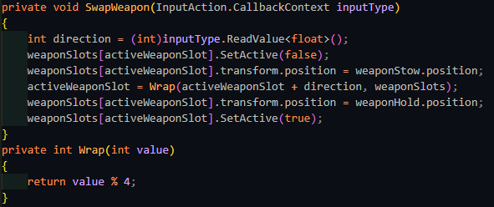

|  |  |  |  |  |  |
| --- | --- | --- | --- | --- | --- |
| Type | What data fits criteria | Justification | Expected | Actual | Comments |
| Valid | Scrolling the scroll wheel in either direction | The player will want to change the current weapon based on the scenario and therefore this is suitable as a valid test | The selected weapon will change relative to the direction the player scrolled in | Failed: When scrolling backwards, the weapon did not change once it reached the first weapon | MOD likely does not work the same when comparing a negative number and a positive one |
| Boundary | Scrolling very fast in either direction | It is important the system still acts accordingly when the player may put it under stress | The currently selected weapon should change accordingly | Failed: Same as the above error |  |
| Boundary | Scrolling when all the weapon slots are not filled | It can occur that all the player’s weapons slots are not filled and as such the scrolling should still respond correctly, even though this is a rare case. | The system should continue wrapping with the remaining weapons and change the weapons accordingly. | Failed: Reached a NullReference Exception when the empty slot was reached and the same error as the above when scrolling in reverse | Nothing is stopping Wrap() from accessing the empty variables |
| Erroneous | Pressing another key (e.g. M) | Any inputs not related to the system should not affect it | The current weapon will remain selected | Passed |  |

The problem caused by scrolling in reverse is caused due to the MOD operator, as -1 MOD 4 does not loop round to 3. To counteract this, you must add on the number that you are performing MOD with, which in this case, is 4. This offsets the negative number and is cancelled out for the positive numbers by MOD.

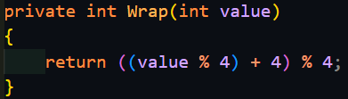

However, this only works when all the player’s weapon slots are filled. If any weapon slot is empty, such as in a tutorial or elsewhere, this throws a NullReferenceException. The next way of creating 4 weapon slots could be done with an array since the maximum number of weapons has already been predetermined.

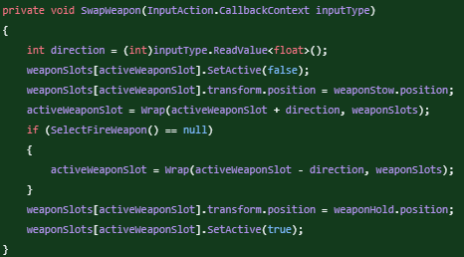

Adding an extra check for if the returned output of SelectFireWeapon() is null (meaning that there is no weapon in that slot) does indeed work for when there are only 2 or 3 weapons in all the slots. However, when there is only 1 or even no weapons equipped, this fails again, and adding an extra exception for when there is only 1 weapon is not the correct approach either. Instead, the best solution is to have weaponSlots be a list, and to stop adding elements to it once it reaches the limit which is 4. This way, Wrap() can be modified to wrap with the current length.



|  |  |  |  |  |  |
| --- | --- | --- | --- | --- | --- |
| Type | What data fits criteria | Justification | Expected | Actual | Comments |
| Valid | Scrolling the scroll wheel in either direction | The player will want to change the current weapon based on the scenario and therefore this is suitable as a valid test | The selected weapon will change relative to the direction the player scrolled in | Passed |  |
| Boundary | Scrolling very fast in either direction | It is important the system still acts accordingly when the player may put it under stress | The currently selected weapon should change accordingly | Passed |  |
| Boundary | Scrolling when all the weapon slots are not filled | It can occur that all the player’s weapons slots are not filled and as such the scrolling should still respond correctly, even though this is a rare case. | The system should continue wrapping with the remaining weapons and change the weapons accordingly. | Passed |  |
| Erroneous | Pressing another key (e.g. M) | Any inputs not related to the system should not affect it | The current weapon will remain selected | Passed |  |

To go hand in hand with this, adding weapons to the current arsenal works very similarly. First a RayCast is performed, and if the hit object has the “Weapon” tag, then that weapon is added to the arsenal. If all the weapon slots are full, then the weapon in the current slot is replaced. On the other hand, if there is space remaining, then activeWeaponSlot is pointed to the next available slot, and the weapon is simply added to the list.

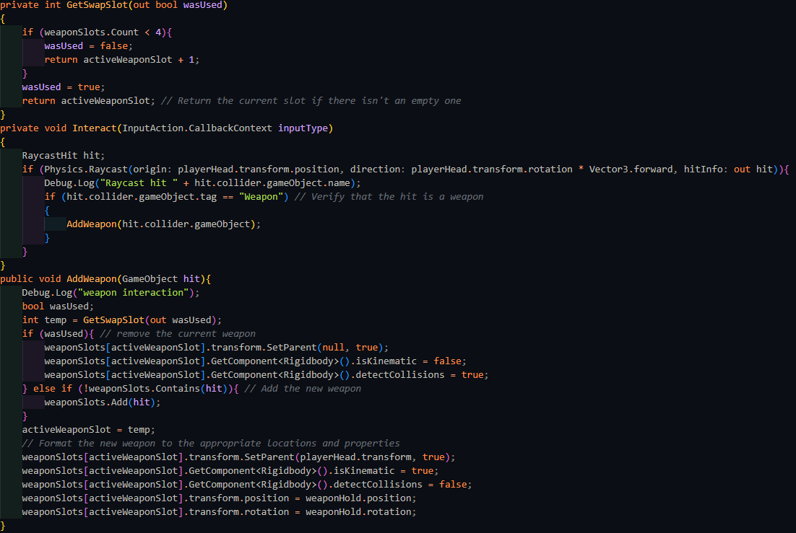

|  |  |  |  |  |  |
| --- | --- | --- | --- | --- | --- |
| Type | What data fits criteria | Justification | Expected | Actual | Comments |
| Valid | Adding a weapon while there is space available | The player will want to change the current weapon based on the scenario and therefore this is suitable as a valid test | The weapon will be added to the list with no other weapon removed, and will swap to that weapon | Passed |  |
| Valid | Adding a weapon while there is no space available | The player will want to change the current weapon based on the scenario, and this is the more common way to acquire a weapon | The weapon will replace the current weapon | Passed |  |
| Erroneous | Pressing another key (e.g. M) | Any inputs not related to the system should not affect it | The current weapon will remain selected | Passed |  |

### Entities (Damage)

The most basic feature of this system is that it handles the health of the object that it is attached to. All entities will have a current health value that upon being initialised will be set to the maximum health. All entities will have 3 base functions:

* Damage() – Mentioned above, Damage() is what is called by all objects that need to damage an entity. Entities will also have a defence multiplier that will decrease the amount of damage they take.
* Healing() – These allow the entity to heal. While it won’t be used on most entities, it is still useful to have underneath in case SillyAustralian wishes to use it for any special entity types
* Kill() – This is absolutely required to remove the entity once their health has reached zero. It is also useful for debugging purposes and for special events if required. Leaving this as a separate function leaves as much functionality remaining for any potential uses or upgrades to the system.

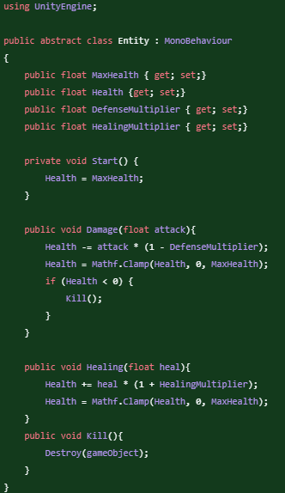

To appropriately test the damage, it was easiest to make a spike – an object that deals damage on contact to the entity. To do so, I can leverage the code that the bullet uses to check whether it has collided with something but modified to use OnCollisionEnter() instead.

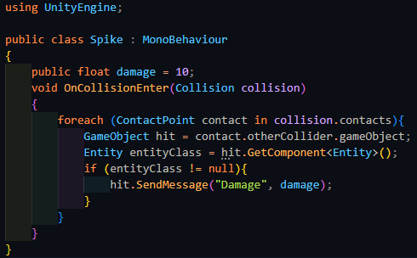

|  |  |  |  |  |  |
| --- | --- | --- | --- | --- | --- |
| Type | What data fits criteria | Justification | Expected | Actual | Comments |
| Valid | Running into the spike | This is a basic test for damage as well as well as verifying environmental damage | The player will take damage as is detailed | Passed |  |
| Boundary | Running into a spike with 1 HP (or enough for the next hit to kill the player) | This will test whether the kill function works | The player will disappear from the scene, and nothing will be visible on the screen | Failed: received null reference exception |  |



This exception seems to occur because the kill function is looking for the GameObject that it is attached to. While from first glances the code seems like it should work, it turns out it is specifically looking for the Entity class to be attached to an object, which isn’t attached to any class. The current one that is attached is PlayerEntity, which is a different class than Destroy() is expecting. As such, the contents of Entity.Kill() need to be copied into PlayerEntity to test Kill() appropriately.

|  |  |  |  |  |  |
| --- | --- | --- | --- | --- | --- |
| Type | What data fits criteria | Justification | Expected | Actual | Comments |
| Boundary | Running into a spike with 1 HP (or enough for the next hit to kill the player) | This will test whether the kill function works | The player will disappear from the scene, and nothing will be visible on the screen | Passed |  |

Now that the base functions have been tested and verified, the next step is to make the enemies. Importantly, the secondary function of the system is to control how the enemy functions. The enemy will have 3 states: Searching, Combat, and None. The two that matter are Searching and Combat, where the enemy has tasks that they must perform.

While the enemy is in the Searching state, they will move towards a randomly decided target. Once this target has been reached, the next target will be determined and then the enemy will move towards it. If the enemy detects the player at any moment, then the enemy will switch over to the Combat state, where it will follow behind the player. If the enemy is facing the player, then it will fire the weapon that is attached to it, dealing damage to the player if the bullet strikes them.

Implementing the enemy movement can done in a similar manner to the player and will only need a few modifications to work with the slightly different input style. The bulk of the code works the same as the player’s, while the only notable change being at which point it will attempt to move away from the player.

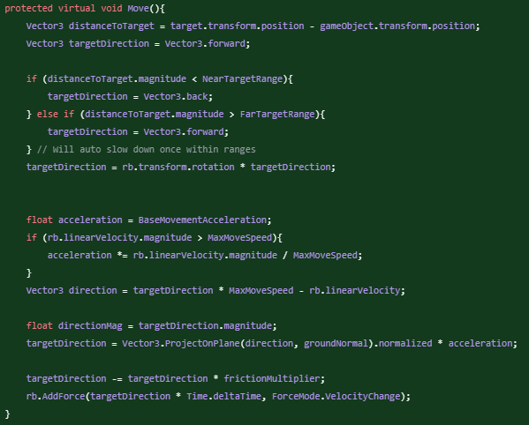

To test the system, I will be using a small sphere that does not have a collider on it to visually identify if the entity accurately reaches the target.

|  |  |  |  |  |  |
| --- | --- | --- | --- | --- | --- |
| Type | What data fits criteria | Justification | Expected | Actual | Comments |
| Valid | The target is outside NearRange | As the most common distance for the target from the player it should work as the valid test | The entity will approach the target and then settle at some point between NearRange and FarRange | Failed: The entity shoots past either range and returns back and oscillates like so | The entity is unable to slow itself down appropriately and dampen as it approaches its target |
| Boundary | The target is inside NearRange | Being very close to the target can cause the system to apply too much force and cause the entity to fly off. | The entity should move away and then return to an appropriate distance quickly | Failed: settled into the same issue as above | Same as above |
| Boundary | The entity is at the target | The entity reaching the target is a required part of its movement while it is in the Searching state, and as such will need to be tested | The entity will not move | Passed |  |
| Erroneous | No target is set | This is a test for a potential error in case the target that the entity is tracking disappears and hence should be handled appropriately | The entity will not move | Passed |  |
| Erroneous | The target is out of reach of the entity | It is incredibly likely that the player will get somewhere that the entity will be unable to reach, and as such it should be able to handle with this | The entity will attempt to reach as close to the target as possible | Passed |  |

Once again, researching an appropriate way to fix the problem landed me upon a better solution, of which was used in many industries, such as robotics and machinery. To work out whether this was the better option, I needed to consult my stakeholder.

#### Interview

Me: I would like to change how the enemy works as the current solution seems to be inefficient and as it is early enough, changing it to a much better solution would benefit in the long run, while solving the current problem in a much better manner.

Stakeholder: I understand, and considering you still have some time left, it should be fine for you to reimplement this system in this newer method that you think will be more efficient.

Stakeholder Signature:



This better method is a PID controller. PID, standing for Proportional-Integral-Derivative, aims to get a current value to a target value, while making sure that it does not get stuck in a loop, oscillating around the target value. This is achieved with the derivative term, which resists the change, slowing down the overshoot that would occur, eventually making sure that the target value would be reached. The only situation where this wouldn’t occur would be if the system was experiencing a constant force, such as gravity, in which case it would end up settling around a value that was offset from the target. The integral component will sense this error and slowly accumulate it to push the current value back up to the target, while also controlling how responsive the system is. However, a typical PID controller will only work on a single value, so it is repeated 3 times for each of the respective dimensions with the appropriate values, and then the magnitude of the final vector is clamped to the maxMoveSpeed so that the entity does not move extremely fast.

The most difficult direction for the PID controller is the vertical direction, specifically on the drone, since this will require control of all the components of the system and as such, it will be used to test the system. The special feature of the drone is that it should not be limited by gravity, and so the controller has to fight against gravity, which will need the integral component of the system as mentioned above, which is typically not used by many people implementing one of these controllers.

The main downside to a PID controller is that it needs to be tuned appropriately, of which the values change between different entities. This can take time and as such, I will not be tuning it until it is confirmed that there are no errors with the system.

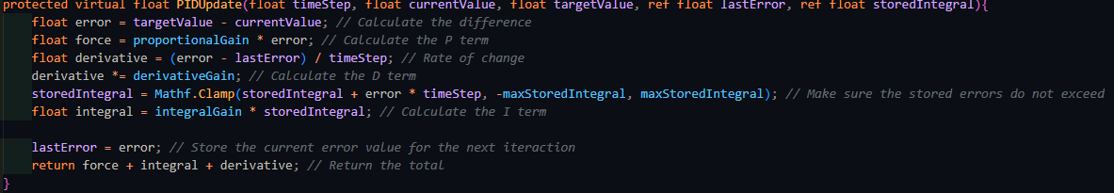

Above is the standard basic code for a PID controller, where each term is calculated individually and then summed together.

|  |  |  |  |  |  |
| --- | --- | --- | --- | --- | --- |
| Type | What data fits criteria | Justification | Expected | Actual | Comments |
| Valid | The target is outside NearRange | As the most common distance for the target from the player it should work as the valid test | The entity will approach the target and then settle at some point between NearRange and FarRange | N/A | Not applicable without tuning the system |
| Boundary | The target is inside NearRange | Being very close to the target can cause the system to apply too much force and cause the entity to fly off. | The entity should move away and then return to an appropriate distance quickly | N/A | Not applicable without tuning the system |
| Boundary | The entity is at the target | The entity reaching the target is a required part of its movement while it is in the Searching state, and as such will need to be tested | The entity will not move | Failed: DivideByZero exception | The change in error being zero is likely causing an error |
| Erroneous | No target is set | This is a test for a potential error in case the target that the entity is tracking disappears and hence should be handled appropriately | The entity will not move, no exception will be raised | Passed |  |
| Erroneous | The target is out of reach of the entity | It is incredibly likely that the player will get somewhere that the entity will be unable to reach, and as such it should be able to handle with this | The entity will attempt to reach as close to the target as possible | N/A |  |



When the target is at the same location as the enemy entity, the calculation for the derivative leads to a DivideByZeroException As such this needs to be checked beforehand. I will also take this opportunity to add a different method for calculating the error via the current position of the entity, and to check whether to use one or the other, I will be using an enumerator, as this helps with maintainability.

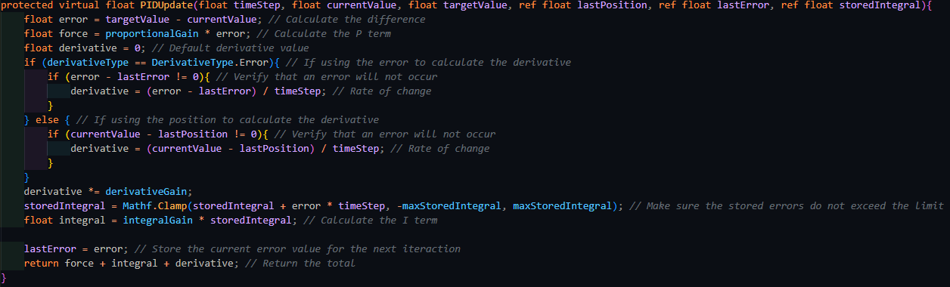

|  |  |  |  |  |  |
| --- | --- | --- | --- | --- | --- |
| Type | What data fits criteria | Justification | Expected | Actual | Comments |
| Valid | The target is outside NearRange | As the most common distance for the target from the player it should work as the valid test | The entity will approach the target and then settle at some point between NearRange and FarRange | N/A | Not applicable without tuning the system |
| Boundary | The target is inside NearRange | Being very close to the target can cause the system to apply too much force and cause the entity to fly off. | The entity should move away and then return to an appropriate distance quickly | N/A | Not applicable without tuning the system |
| Boundary | The entity is at the target | The entity reaching the target is a required part of its movement while it is in the Searching state, and as such will need to be tested | The entity will not move | Passed |  |
| Erroneous | No target is set | This is a test for a potential error in case the target that the entity is tracking disappears and hence should be handled appropriately | The entity will not move, no exception will be raised | Passed |  |
| Erroneous | The target is out of reach of the entity | It is incredibly likely that the player will get somewhere that the entity will be unable to reach, and as such it should be able to handle with this | The entity will attempt to reach as close to the target as possible | N/A |  |

Interestingly, when the target changes, the derivative term skyrockets, and this is likely to cause an error when the function is linked to the movement of the entity. As such, whenever the target changes, the entity will make sure that it skips over calculating the derivative for that frame.

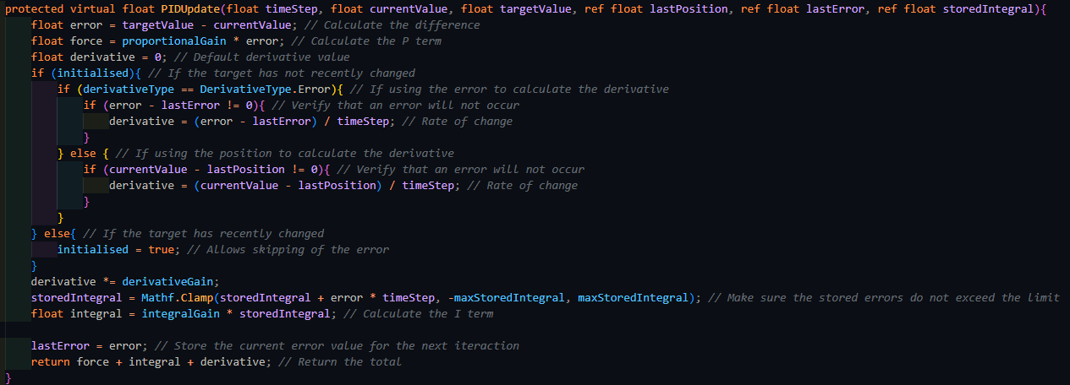

|  |  |  |  |  |  |
| --- | --- | --- | --- | --- | --- |
| Type | What data fits criteria | Justification | Expected | Actual | Comments |
| Valid | The target is outside NearRange | As the most common distance for the target from the player it should work as the valid test | The entity will approach the target and then settle at some point between NearRange and FarRange | N/A | Not applicable without tuning the system |
| Boundary | The target is inside NearRange | Being very close to the target can cause the system to apply too much force and cause the entity to fly off. | The entity should move away and then return to an appropriate distance quickly | N/A | Not applicable without tuning the system |
| Boundary | The entity is at the target | The entity reaching the target is a required part of its movement while it is in the Searching state, and as such will need to be tested | The entity will not move | Passed |  |
| Erroneous | No target is set | This is a test for a potential error in case the target that the entity is tracking disappears and hence should be handled appropriately | The entity will not move, no exception will be raised | Passed |  |
| Erroneous | The target is out of reach of the entity | It is incredibly likely that the player will get somewhere that the entity will be unable to reach, and as such it should be able to handle with this | The entity will attempt to reach as close to the target as possible | N/A |  |

Now that there are no exceptions raised, I can now train the drone correctly. This will be done by using a target and setting its position as the searchingTarget for the controller.

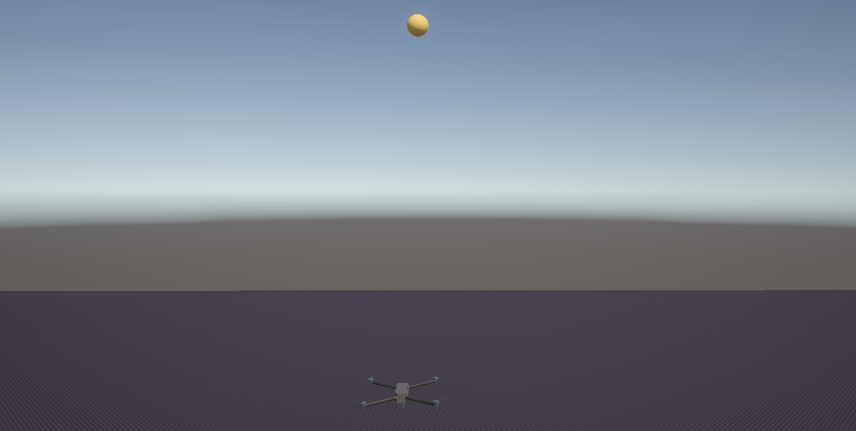

*(The drone and the target)*

To apply the movement for each direction, the PID function is called on each component, and then passed to a Vector3 to combine it together. This is finally applied to the rigidbody. For debugging purposes, each of the axis of movement can be drawn with a ray, along with the total of all of them.

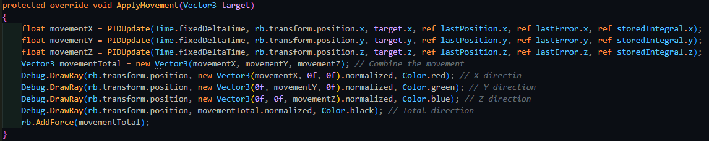

The proper way to train a controller is by tuning each component in order. First, the proportional term is raised until the controller is considered stable – when the oscillations in its movement very slowly decrease. If they grow, then the controller is considered unstable. Next, the integral term is raised until the controller becomes unstable. Finally, the derivative term is raised to an acceptable level, where the controller still responds quickly but does not overshoot its target. Training a controller takes a long time since changes can take a while to propagate properly.

However, trying to train it is extremely difficult, and it seemed like any changes that were occurring were not causing any effect in how unstable the controller was. Scanning through the code, the problem seems to be caused by the below code.



By default, Rigidbody.AddForce() uses the Impulse mode, which applies an instantaneous force. This is likely causing an issue to the system, and this needs to be changed to the VelocityChange mode like below.



With this change, the controller is much easier to train properly. At this point, I can add on the maximum move speed and the maximum stored integral.

|  |  |  |  |  |  |
| --- | --- | --- | --- | --- | --- |
| Type | What data fits criteria | Justification | Expected | Actual | Comments |
| Valid | The target is outside NearRange | As the most common distance for the target from the player it should work as the valid test | The entity will approach the target and then settle at some point between NearRange and FarRange | Passed |  |
| Boundary | The target is inside NearRange | Being very close to the target can cause the system to apply too much force and cause the entity to fly off. | The entity should move away and then return to an appropriate distance quickly | Passed |  |
| Boundary | The entity is at the target | The entity reaching the target is a required part of its movement while it is in the Searching state, and as such will need to be tested | The entity will not move | Passed |  |
| Erroneous | No target is set | This is a test for a potential error in case the target that the entity is tracking disappears and hence should be handled appropriately | The entity will not move, no exception will be raised | Passed |  |
| Erroneous | The target is out of reach of the entity | It is incredibly likely that the player will get somewhere that the entity will be unable to reach, and as such it should be able to handle with this | The entity will attempt to reach as close to the target as possible | N/A |  |

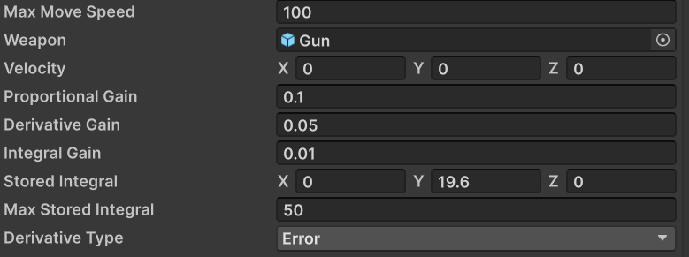

*(The values for the drone)*

The next function that can be added is the ability for the entity to select its next target. This can be produced by randomly selecting a point in a sphere around the player, which can be made by randomly generating a float for each axis.

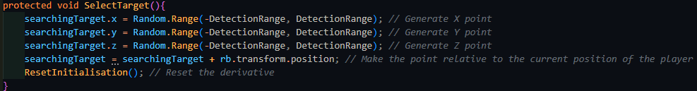

Testing whether this function works correctly or not is based upon whether the entity behaves properly afterwards. Witnessing the drone move, 2 issues became obvious:

* Firstly, the drone would continue moving upwards. While it may also move downwards, it would still move too far from the ground, or from the nearest piece of level geometry.
* The selected target is sometimes not accessible to the entity, since it is behind an object.

To fix the first problem, the entity needs to check where the closest point is. Unity does have a built-in function to work out the distance between the closest point on 2 colliders, and this can be combined with Physics.OverlapSphere() to find all the colliders in a certain range from the entity.

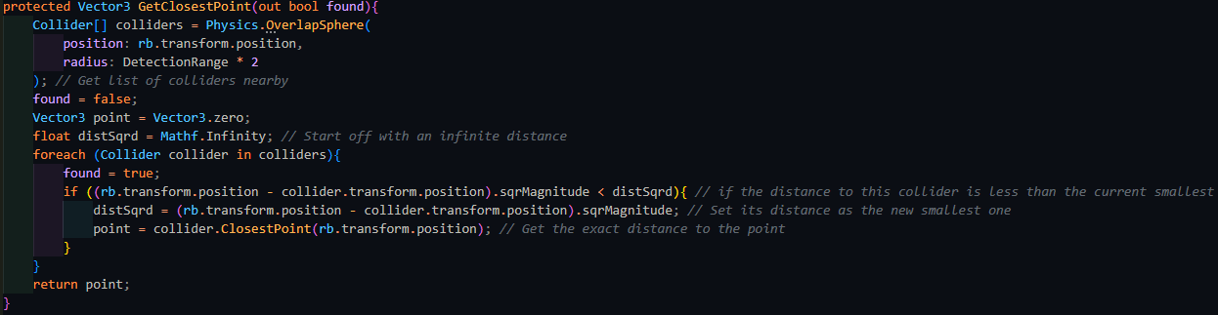

Using the square of the distance is a minor optimisation since the square root is an expensive thing to calculate and hence minimising the number of times I need to calculate it, the faster the game is. This is fine to do since the usage of distSqrd is only for comparing with other distances. Since the square of 1 distance will always be larger than another distance that is smaller, nothing breaks from doing this.

This function can then be incorporated into SelectTarget() like below:

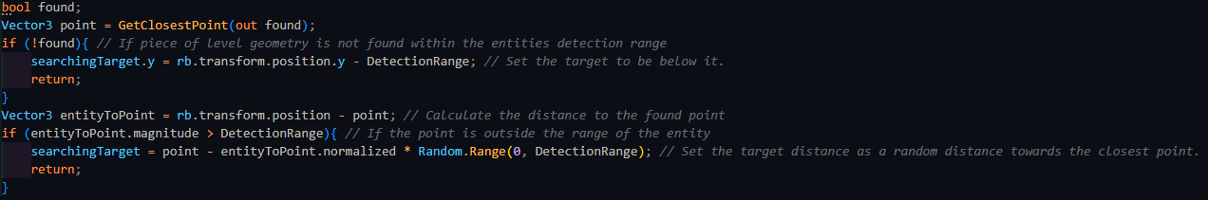

To solve the second problem, a raycast is required to check whether the drone can make it to the target from the current position, and if not, the target just needs to be rechecked. I will also take this opportunity to add a check in to make sure that the target is not too close to the entity.

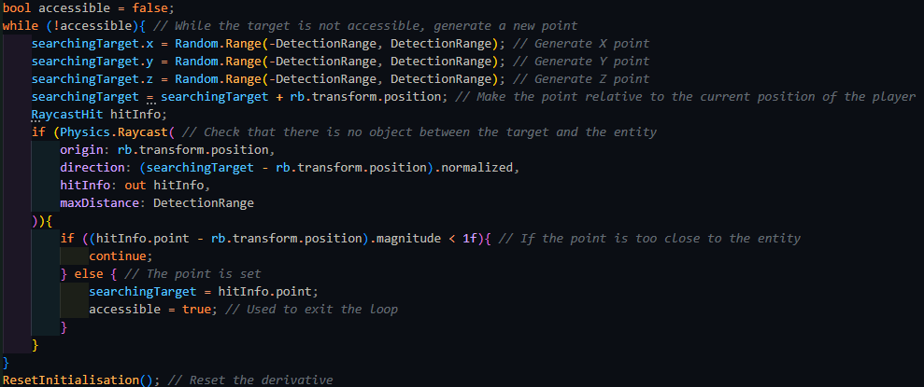

Retesting the search target again leads to no visual errors in the entity’s behaviours, which means the next thing to add was the ability to search for the player. Searching is typically done via firing multiple raycasts out in the direction that you want to search. These are also typically shot out in an arc to cover a wider range. Furthermore, since the rays get shot out quite far, the distance between the ends of 2 neighbouring rays can be far more than the width of the player, and as such more rays need to be fired, and the angle between the rays needs to be decreased. To calculate the angle, I need to divide the viewing angle, which is 90 degrees, with the length of the arc formed by the 2 furthest rays. This arc length can be rounded to the next integer to work out how many rays are required. These values are then calculated once when the entity is initialised.

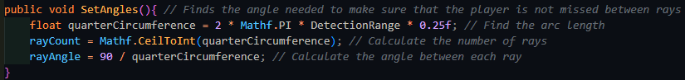

Firing each ray can be done sequentially and if any of these rays connect with a target, then the target is set, and the entity enters combat mode.

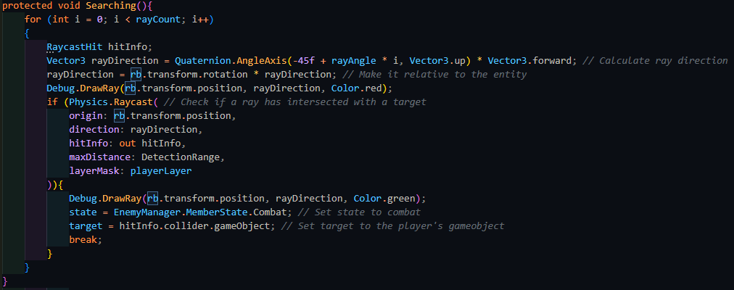

The entity also needs to rotate towards its target to make sure that it is searching for its location properly. This can be done by finding the direction towards the target and converting this into a rotation. Finally, the current rotation and the intended one can be interpolated between to add some leniency for the player. This makes it possible for the player to get around the entity and avoid getting hit.

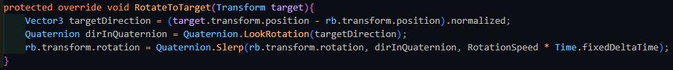

|  |  |  |  |  |  |
| --- | --- | --- | --- | --- | --- |
| Type | What data fits criteria | Justification | Expected | Actual | Comments |
| Valid | The player is in front of the entity | This is the most typical way that the player will be detected by the entity will detect the player | The entity will enter combat mode | Passed |  |
| Valid | The player is not in front of entity | The drone will not always see the player and as such must search as usual | The entity will continue searching and moving towards the target | Passed |  |
| Boundary | The player is on the edge of the entity’s view | The player might be moving quickly and only be in the drone’s view for a moment and as such this must be tested appropriately | The entity will enter combat mode | Passed |  |
| Boundary | The player is on the edge of the entity’s detection range | The player may attempt to escape the drone by being on the edge of its view, and hence it should still detect the player | The entity will enter combat mode | Passed |  |

The next state of the entity that needs to be handled is the combat state. In this, the movement target needs to be set some distance away from the player. This distance will be the midpoint between the FarRange and NearRange. When the entity’s weapon is able to fire at the player, the entity will call Fire() on the weapon to deal damage to it.

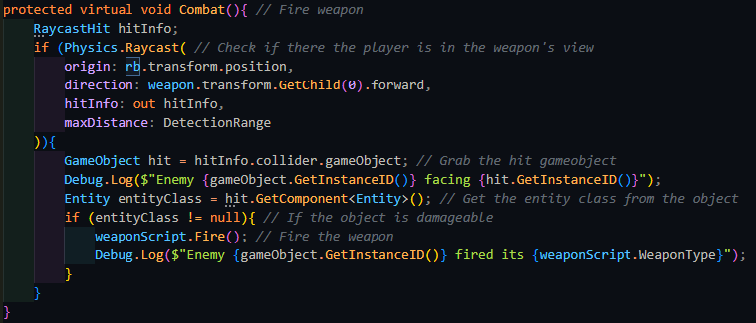

|  |  |  |  |  |  |
| --- | --- | --- | --- | --- | --- |
| Type | What data fits criteria | Justification | Expected | Actual | Comments |
| Valid | The player is in front of the entity while it is in combat mode | This is the most typical way that the player will be detected by the entity will detect the player | The entity will fire its weapon and move away | Passed |  |
| Valid | The player is not in front of entity while it is in combat mode | The drone will not always see the player and as such must rotate towards them | The entity will rotate towards the player | Passed |  |
| Boundary | The player is on the edge of the entity’s view while it is in combat mode | The entity also needs to be able to conserve ammunition and this makes sure that they do not fire at all moments | The entity will rotate towards the player | Passed |  |
| Boundary | The player is on the edge of the entity’s detection range while it is in combat mode | The player may attempt to escape the drone by being on the edge of its view, and hence it should still detect the player | The entity will chase after the player and fire if possible | Passed |  |

### End of prototype tests

#### Entity Movement

|  |  |  |  |  |  |
| --- | --- | --- | --- | --- | --- |
| Type | What data fits criteria | Justification | Expected | Actual | Comments |
| Valid | The target is outside NearRange | As the most common distance for the target from the player it should work as the valid test | The entity will approach the target and then settle at some point between NearRange and FarRange |  |  |
| Boundary | The target is inside NearRange | Being very close to the target can cause the system to apply too much force and cause the entity to fly off. | The entity should move away and then return to an appropriate distance quickly |  |  |
| Boundary | The entity is at the target | The entity reaching the target is a required part of its movement while it is in the Searching state, and as such will need to be tested | The entity will not move |  |  |
| Erroneous | No target is set | This is a test for a potential error in case the target that the entity is tracking disappears and hence should be handled appropriately | The entity will not move |  |  |
| Erroneous | The target is out of reach of the entity | It is incredibly likely that the player will get somewhere that the entity will be unable to reach, and as such it should be able to handle with this | The entity will attempt to reach as close to the target as possible |  |  |

#### Entity Searching

|  |  |  |  |  |  |
| --- | --- | --- | --- | --- | --- |
| Type | What data fits criteria | Justification | Expected | Actual | Comments |
| Valid | The player is in front of the entity | This is the most typical way that the player will be detected by the entity will detect the player | The entity will enter combat mode |  |  |
| Valid | The player is not in front of entity | The drone will not always see the player and as such must search as usual | The entity will continue searching and moving towards the target |  |  |
| Boundary | The player is on the edge of the entity’s view | The player might be moving quickly and only be in the drone’s view for a moment and as such this must be tested appropriately | The entity will enter combat mode |  |  |
| Boundary | The player is on the edge of the entity’s detection range | The player may attempt to escape the drone by being on the edge of its view, and hence it should still detect the player | The entity will enter combat mode |  |  |

#### Entity Combat

|  |  |  |  |  |  |
| --- | --- | --- | --- | --- | --- |
| Type | What data fits criteria | Justification | Expected | Actual | Comments |
| Valid | The player is in front of the entity while it is in combat mode | This is the most typical way that the player will be detected by the entity will detect the player | The entity will fire its weapon and move away |  |  |
| Valid | The player is not in front of entity while it is in combat mode | The drone will not always see the player and as such must rotate towards them | The entity will rotate towards the player |  |  |
| Boundary | The player is on the edge of the entity’s view while it is in combat mode | The entity also needs to be able to conserve ammunition and this makes sure that they do not fire at all moments | The entity will rotate towards the player |  |  |
| Boundary | The player is on the edge of the entity’s detection range while it is in combat mode | The player may attempt to escape the drone by being on the edge of its view, and hence it should still detect the player | The entity will chase after the player and fire if possible |  |  |

### Interview

Stakeholder: Upon trying out the new system, I think it is a little monotonous and frustrating for the player to have to reload every time they want to fire the weapon. The weapon should instead automatically reload if the player attempts to fire it when there is no ammunition remaining. Furthermore, I’ve realised that having to toggle the zoom action is monotonous, and as such it should be enabled while the player is holding down the button. Finally, it is a little difficult to tell what the player is firing at, so the current weapon needs to point towards the target.

Stakeholder Signature:



## Prototype 3

### Automatically Reloading

To fulfil the stakeholder’s request of making the weapon automatically reload, the gun needs to check if there is no ammo remaining when the player requests it to fire, and if so, it needs to reload the weapon.

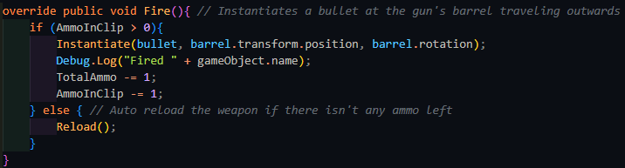

|  |  |  |  |  |  |
| --- | --- | --- | --- | --- | --- |
| Type | What data fits criteria | Justification | Expected | Actual | Comments |
| Valid | Pressing the fire button while there is enough ammunition remaining | This is the most common action the weapon will encounter and therefore is suitable as a valid test | The gun will fire 1 bullet | Passed |  |
| Boundary | Pressing the fire button while there is no ammunition remaining | It is important the system still acts accordingly when there is no ammunition in the clip remaining | The gun will reload | Passed |  |
| Erroneous | Pressing another key (e.g. M) | Any inputs not related to the system should not affect it | The gun will not fire | Passed |  |

Stakeholder: Yes, this is much better. This way the player will be able to play more fluidly and easier. You can move onto the next system.

Stakeholder Signature:



### Held Zoom

To fulfil the stakeholder’s request of making the zoom action not toggled, but instead held, the check needs to be changed to checking whether the button is being currently held. The function then needs to be run every frame within the Update() loop, instead of being activated on the input being detected.

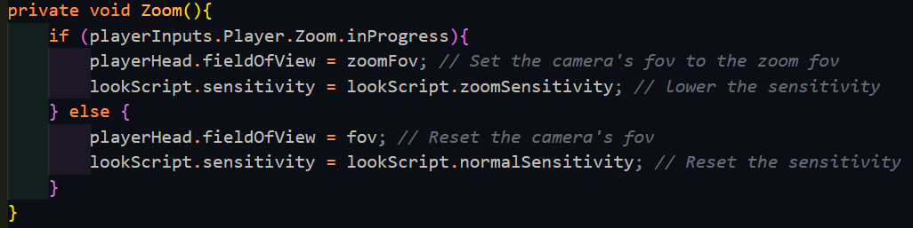

|  |  |  |  |  |  |
| --- | --- | --- | --- | --- | --- |
| Type | What data fits criteria | Justification | Expected | Actual | Comments |
| Valid | Pressing the fire button while there is enough ammunition remaining | This is the most common action the weapon will encounter and therefore is suitable as a valid test | The gun will fire 1 bullet | Passed |  |
| Boundary | Pressing the fire button while there is no ammunition remaining | It is important the system still acts accordingly when there is no ammunition in the clip remaining | The gun will reload | Passed |  |
| Erroneous | Pressing another key (e.g. M) | Any inputs not related to the system should not affect it | The gun will not fire | Passed |  |

Stakeholder: Yes, this makes it a lot faster to change from zooming in to back out, which is a lot nicer to play as instead.

Stakeholder Signature:



### Weapon point to target

To make it more obvious what the player will hit when firing their weapon, the weapon will point towards the point that they will hit. To make it look better and not just snapping, the weapon will rotate towards the target quickly but smoothly. This can be done with Quaternion.Slerp() which spherically interpolates between 2 vectors, which are the current facing direction and the vector from the gun to the aiming location.

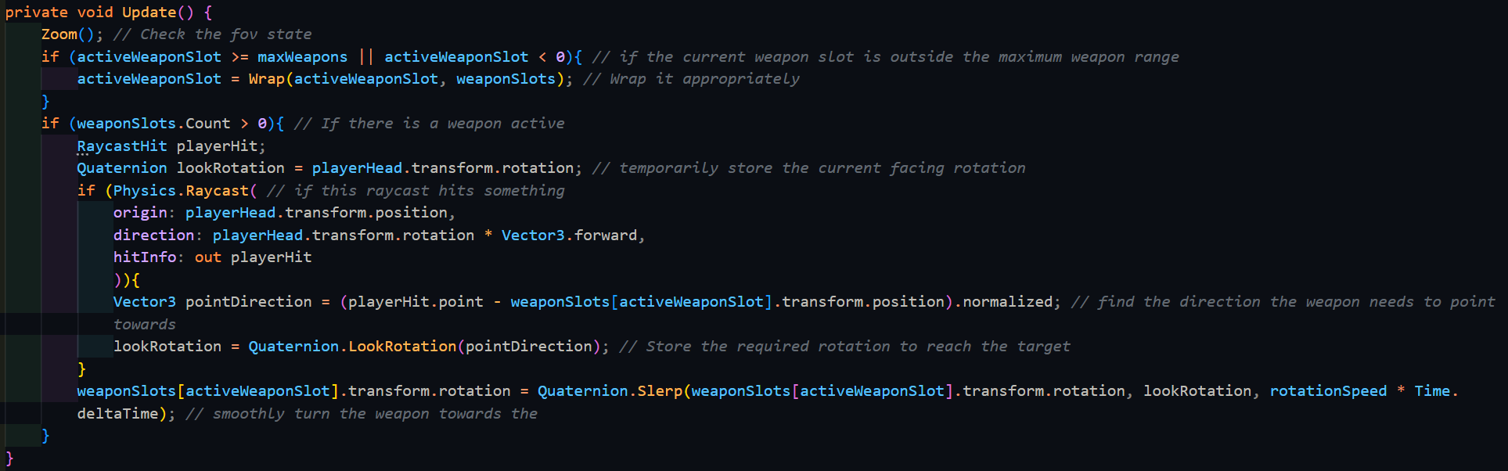

|  |  |  |  |  |  |
| --- | --- | --- | --- | --- | --- |
| Type | What data fits criteria | Justification | Expected | Actual | Comments |
| Valid | Looking from a close object to a far object or vice versa | While purely cosmetic, it will provide helpful information to the player on where they are pointing | The weapon will point closer to the body of the player and then further away, pointing at the object at the centre of the screen | Passed |  |
| Valid | Not moving the mouse after moving it | The function should finish its last action | The weapon will finish its rotation. | Passed |  |
| Valid | Not moving the mouse | Since the input data is the same, the output should also be the same | The weapon will not rotate | Passed |  |
| Boundary | Looking from a close object to a far object or vice versa while the player is moving quickly | The function should work independent of the player’s movement, and the physics engine of Unity can get a dodgy at high speeds | The weapon will point closer to the body of the player and then further away, pointing at the object at the centre of the screen | Failed: the weapon kept pointing towards the player | The physics system seems to be returning an incorrect result; therefore, the player should be masked out |
| Erroneous | Pressing another key (e.g. M) | Any inputs not related to the system should not affect it | The weapon will not rotate | Passed |  |

At high speeds, it seems that the physics system of Unity is detecting that the object that the player is pointing at the player, and to fix this the weapon needs to exclude the player pointing at themselves, and this can be done with a layer mask. Within Physics.Raycast(), the optional layerMask argument specifies what the raycast should include in the results, contrary to the typical use of a LayerMask object. Coincidentally, Unity does not have an overload of Physics.Raycast() that only takes an origin, direction, LayerMask, and returns data about its output to a referenced variable. The closest function that contains all these parameters also includes a maximum distance field, but this can be made irrelevant by passing in infinity as the maximum distance like below:

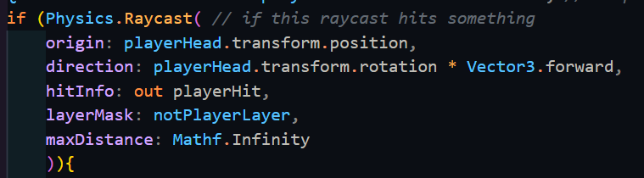

|  |  |  |  |  |  |
| --- | --- | --- | --- | --- | --- |
| Type | What data fits criteria | Justification | Expected | Actual | Comments |
| Boundary | Looking from a close object to a far object or vice versa while the player is moving quickly | The function should work independent of the player’s movement, and the physics engine of Unity can get a dodgy at high speeds | The weapon will point closer to the body of the player and then further away, pointing at the object at the centre of the screen | Passed |  |

Stakeholder: While subtle, this does add a much-needed touch to the weapon’s behaviour. You may move onto the next system, since this one has been finalised.

Stakeholder Signature:



### Saving and Loading System

To begin the save system, there first needs to be data that can be stored. All of this save data will be stored in a file that is formatted as a JSON, which is a very useful system to describe and store the contents of an object in a text-based format. While there are other formats such as the XML format, Unity has built in support for the JSON format with the Newtonsoft.Json library that is built into the engine. This allows both the serialization class and the deserialization of a file back into an object instance.

The data that the player would want to store is everything about their current state. This can be split into different sections, such as data related to the player, data related to story events, and data related to the level highscores. The player specific data includes:

* The level that they are in
* Their health
* Their maximum health
* Their position
* Their velocity
* Their rotation (in both looking directions)
* Their currently equipped weapons
* The currently selected weapon
* The amount of time the player has played in that save

The data that is related to story events is completely arbitrary, and hence only the underlying system needs to be in place to save it. Accessing this data will come later in development and the same goes for the level highscores. These 3 types of data are kept as their own classes, which are all instantiated into another class called SaveData. This is the class that is serialized into the file and is a one-stop location for all the information that anything in the system needs.

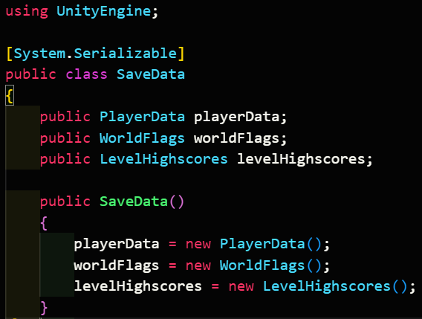

Each of these classes will have constructors that initialise them with default data, which will be used when the player wants to make a new save. However, for the player’s position and velocity, along with their rotation, things get a bit more difficult. This is because the built-in Vector3 and Quaternion classes are not marked as serializable and hence cannot be written to a file. Therefore, I need to make versions of them that can be serialized, and this is done by taking the only the important components and copying them into an appropriate structure. Extra operations need to be added for the implicit casting operators, which helps to improve maintainability by making them as easy to use.

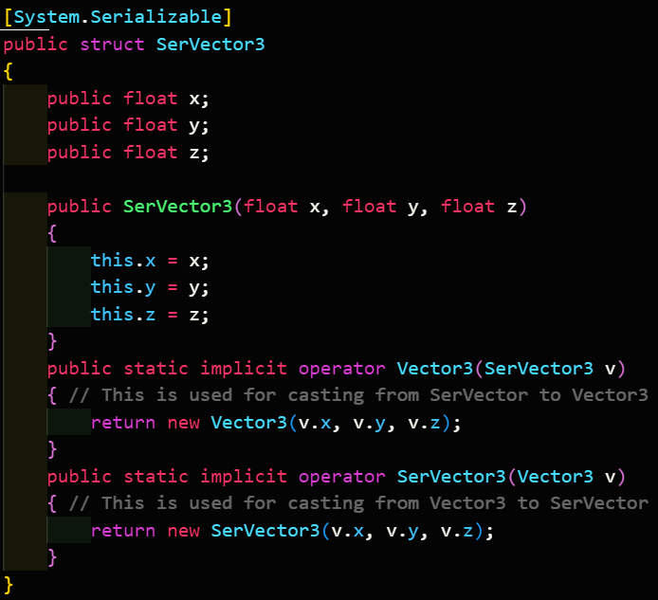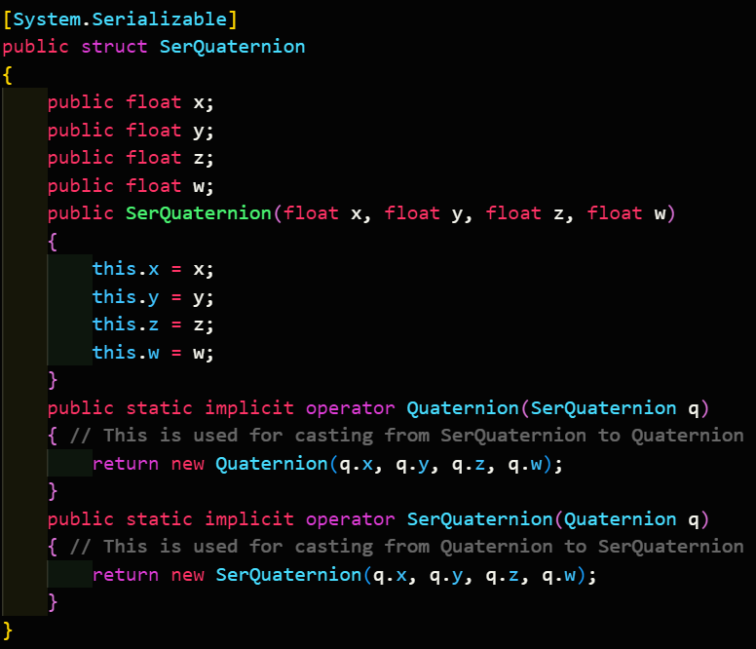

These are then used within PlayerData.

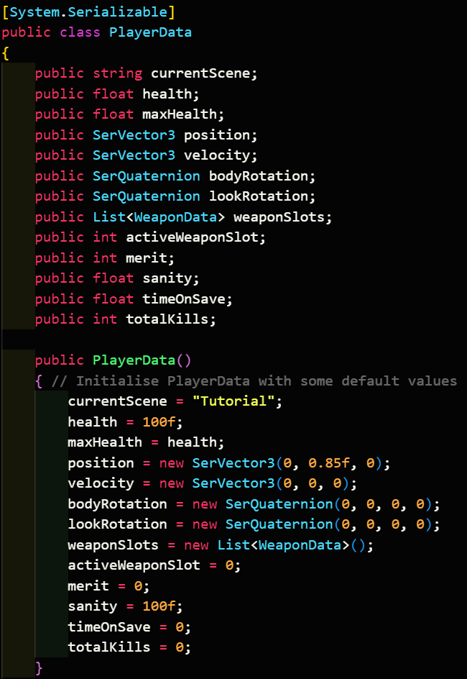

Since there will only be a maximum of 4 weapons, weaponSlots is initialised as an array to keep the memory usage as low as possible. To update the save file, the game manager needs to pass through a reference to the player to the data, at which point the system will read the relevant values it needs.

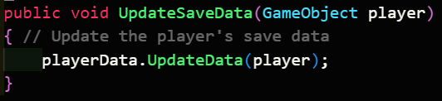

These values span from different parts of the game, although the majority are from scripts that are attached to the player’s GameObject as components. These can be retrieved, and then the public variables can be accessed properly.

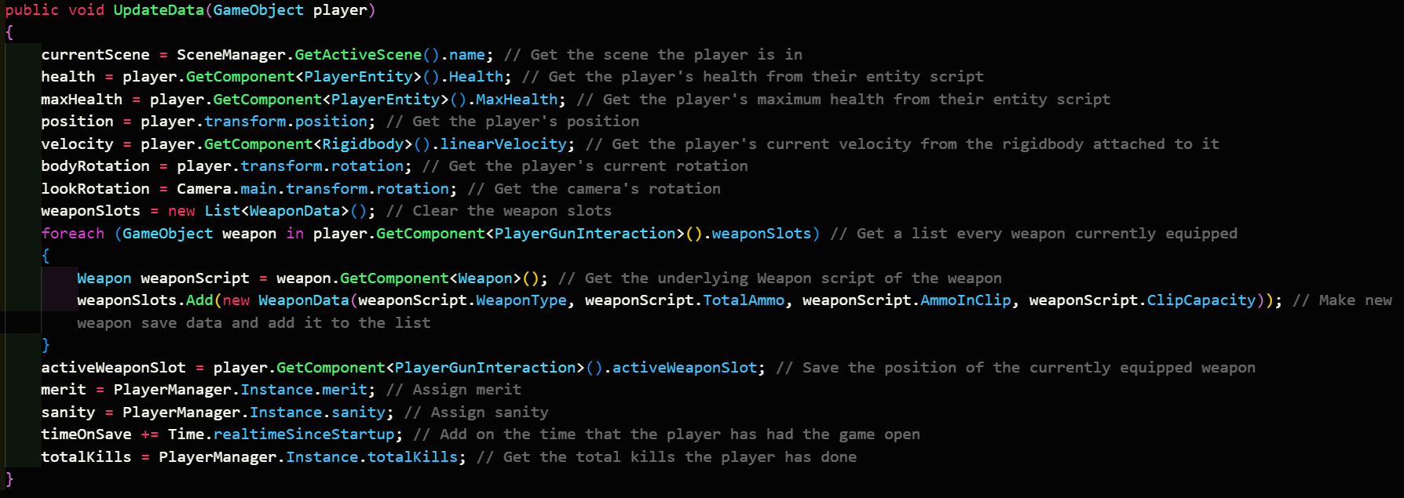

However, handling weapons are different, since the GameObject class is not a serializable one, and if it was, it would cause a lot of unnecessary data to be stored in the player’s save file. As such, only the information stored in the abstract Weapon class is written down, in a second temporary format which only has these properties. Since this is marked as serializable, this can be added to the file, and then a separate system can work out what prefabricated object (prefab for short) needs to be loaded into the player’s weapon slots.

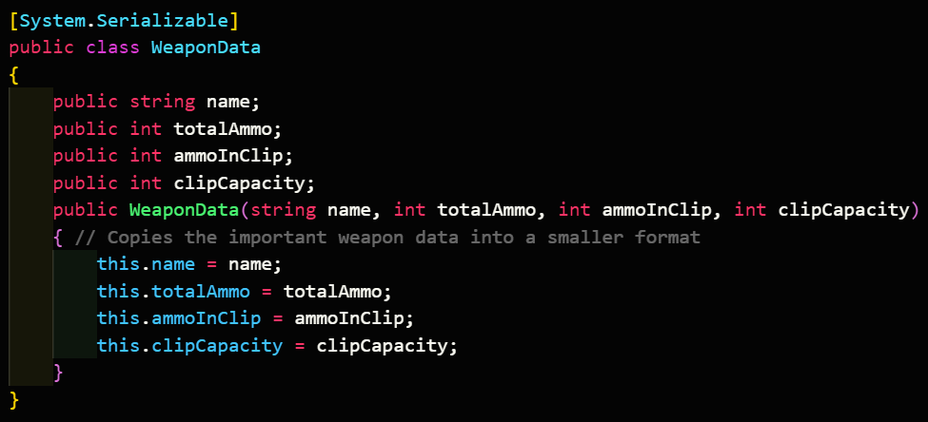

Now that the data has been stored in a serializable class, this class next needs to be turned into JSON, and then written as a file. All saves have to be stored in a location where the saves will not be deleted or moved by the system, and Unity has a built-in location for this, referenced by Application.persistentDataPath. Using the Path library, I can create a folder path that will contain the saves in the right place.

There are 2 types of saves:

* Auto – these are automatic ones done by the game every time a level ends, or when a checkpoint is reached.
* Manual – these are made whenever the player manually clicks save in the pause menu.

Furthermore, the player will have access to as many slots as they want, their own storage providing. As such, each save needs to reference the slot it is in, along with the type of save it is, allowing for a much easier experience whenever the saves needed to be accessed manually through the folder structure, which would look like below:

.

└─── Saves

├─── Slot1

│ └─── Auto

│ ├─── Slot1Auto1.dat

│ ├─── Slot1Auto2.dat

│ ├─── Slot1Auto3.dat

│ …

│ └─── Manual

│ ├─── Slot1Manual1.dat

│ ├─── Slot1Manual2.dat

│ ├─── Slot1Manual3.dat

│ …

├─── Slot2

│ └─── Auto

│ ├─── Slot2Auto1.dat

│ ├─── Slot2Auto2.dat

│ ├─── Slot2Auto3.dat

│ …

│ └─── Manual

│ ├─── Slot2Manual1.dat

│ ├─── Slot2Manual2.dat

│ ├─── Slot2Manual3.dat

│ …

├─── Slot3

│ └─── Auto

│ ├─── Slot3Auto1.dat

│ ├─── Slot3Auto2.dat

│ ├─── Slot3Auto3.dat

│ …

│ └─── Manual

│ ├─── Slot3Manual1.dat

│ ├─── Slot3Manual2.dat

│ ├─── Slot3Manual3.dat

│ …

…

This repeatable pattern can be used to sort the files in one of the directories, resulting in the most recent save being last in the list. Using regular expressions, I can retrieve the save number, at which point I can increment it to finish making the name for the new save. The next step is to write the file and save it. This can be done with a StreamWriter, which will also create the file in the process. The prepared SaveData is now serialized using JsonConvert.SerializeObject(), and to help with maintainability, the JSON is indented. At this point, the player’s data has been saved, but the function is not yet over. When the player needs to select a game slot, the game needs to know which save file the player last used, and hence, there needs to be a file that stores this information. This file will be stored in the same directory as the top-level ‘Saves’ folder.

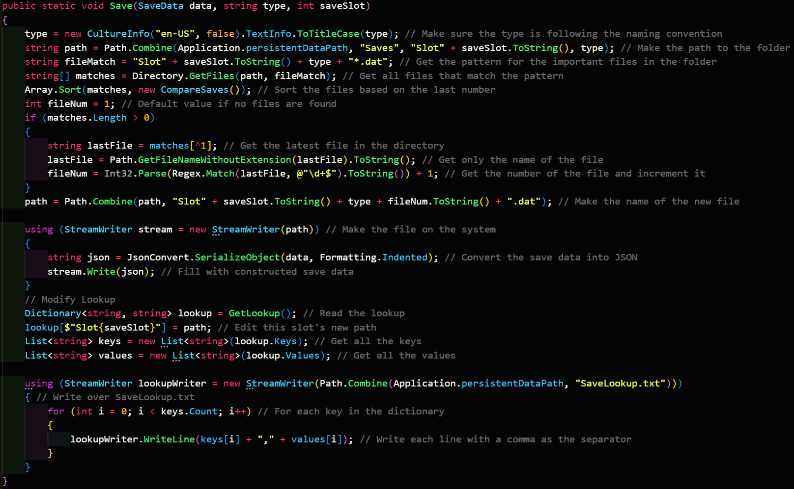

The internals of SaveLookup.txt is a representation of the data stored within a dictionary, of which this file is parsed in and out of when the code needs to use it. This keeps the file size at a minimum, and as such, lowers the requirements of the game. When accessing this file, each line must be separated into the key and value. This separator is a comma, since it is one of the few separator characters that doesn’t show up in the full line (folder names may have spaces/underscores/dashes, and the drive letter will have a colon in it).

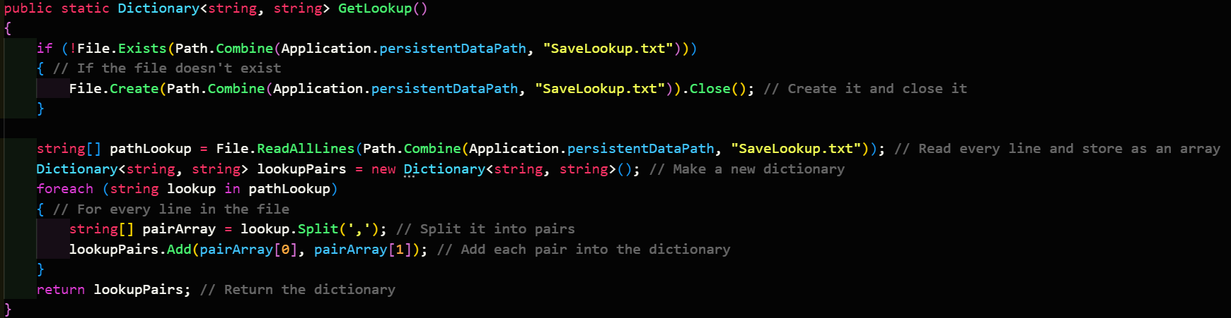

Once the dictionary has been formed, the relevant slot has the path to the file edited, and then SaveLookup.txt is rewritten.

The opposite action to saving is loading the data and is far simpler in comparison. Loading a file does not need to edit the lookup, nor does it need to sort and search through directories. This leads to the internals of Load() being relatively simple, containing a StreamReader to open the file, and a call for JsonConvert.DeserializeObject() to convert back into SaveData.

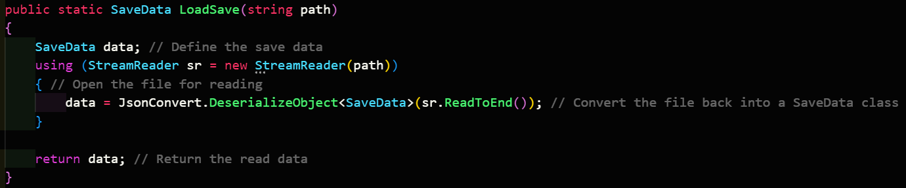

To call all of this code, elements of the game will call a representative function in the game manager which will handle any inputs or assignments. The first of these functions is SaveGame(), which first updates the save data, and then requests that the system saves it. Further functions will be added later.

|  |  |  |  |  |  |
| --- | --- | --- | --- | --- | --- |
| Type | What data fits criteria | Justification | Expected | Actual | Comments |
| Valid | Saving a new save with others already being made | The most typical action the player will be taking is this, and therefore it should be tested properly | A new save will be created with the newest number | Partial: works fine until the 10th save is made, at which point it is overwritten every time | Strings are sorted differently that integers, and hence needs to be changed |
| Valid | Loading a save file | It goes hand in hand with saving, and will also be a core function of the system | The save file is opened and the data is returned | Passed |  |
| Boundary | Saving a file when none of the directories or files exist | This is necessary to test for since this will be the state of the user’s system when they first launch the game | All the appropriate files and folders are created | Passed |  |
| Error | Passing a file to load that doesn’t exist | In case the lookup ends up corrupted, or the user deletes certain files, the function should not crash, and instead log the error | Error code is logged | Failed: No code to pass it through to the log | Needs a check to see if the file exists first |
| Error | ‘SaveLookup.txt’ is not created | This will occur when the player opens the game for the first time, and must be handled properly | The file is created | Passed |  |

When strings are compared, they are compared alphabetically. Since this doesn’t include numbers, the system also sorts it according to a per-digit alphabetic system, where 1 comes before 10, which comes before 2. This means that when the files are sorted, the last file that comes is number 9, even though 10 already exists. When the file is made, it overwrites 10, as it has the same name. To combat this, Array.Sort() does allow a custom comparison function to be passed through. This comparer must be of a certain type, and therefore a small class must be implemented to handle this – CompareSaves. This inherits from IComparer<T>, where T is the specific type string (leading to the inherited class being IComparer<string>). The only requirement of the parent class is that the Compare method is given an implementation, where it takes in 2 arguments, which are the 2 elements being compared. The function must return an integer, this being either 1, 0, or -1, for when the first element is greater, the same as the second, or smaller than the second element respectively. To compare them, I can use the same method that was used to get the number of the file ending earlier – regular expressions. The particular expression that I am using is ‘\d+$’, which selects consecutive digits as 1 string, while reading backwards from the end of the string to improve efficiency.

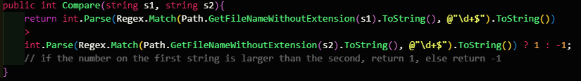

This can then be used on both of the inputs and then compare to find out which one is larger. There is no need to check if they are the same, as the resulting output is incremented anyway.



To solve the second problem, I only need to check if the file exists beforehand, and to log an error if it doesn’t.

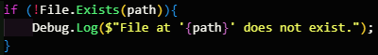

|  |  |  |  |  |  |
| --- | --- | --- | --- | --- | --- |
| Type | What data fits criteria | Justification | Expected | Actual | Comments |
| Valid | Saving a new save with others already being made | The most typical action the player will be taking is this, and therefore it should be tested properly | A new save will be created with the newest number | Passed |  |
| Error | Passing a file to load that doesn’t exist | In case the lookup ends up corrupted, or the user deletes certain files, the function should not crash, and instead log the error | Error code is logged | Passed |  |

The next thing to add is the ability to list out all of the saves, so that when I come to build the GUI, it can leverage this functionality. Listing out the saves requires reading the lookup file and creating a temporary container, which I shall call SaveSlot, which contains the important information about the file. Importantly, it must also check that the top-level ‘Saves’ folder exists, since on the player’s first time opening the game, the folder will not exist. If the folder does not exist, then it needs to create that folder, and then return an empty list, just like if the lookup is empty. If the folder does exist, then every folder within it, which will be all of the slots, must be taken into a list, where it is then used to get the path to the most recent save in that slot. This is then used to create a new SaveSlot, which will contain:

* The slot’s number
* The path to the save file
* The current scene name
* The time spent in the save

This is all the important information that will be shown in the GUI, as is according to the design of that screen. To retrieve this information, each slot will load their respective saves and access the data and then close it. This is why SaveSlot stores the path and not the actual SaveData, since doing it like this means that game minimises the amount of SaveData open, which could become extremely large as SillyAustralian fills the game with more events and levels. Once this is all completed, the finalised list is then returned at the end.

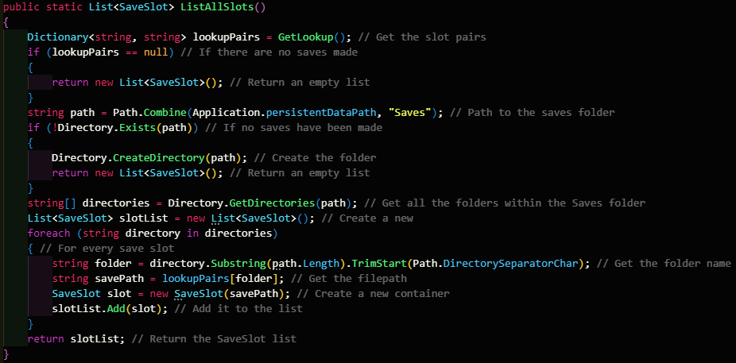

|  |  |  |  |  |  |
| --- | --- | --- | --- | --- | --- |
| Type | What data fits criteria | Justification | Expected | Actual | Comments |
| Valid | The ‘Saves’ folder filled with slots | The player will have at least 1 save slot on a typical opening of the game | A SaveSlot list is returned with the correct information | Passed |  |
| Boundary | The ‘Saves’ folder is empty | This can occur if the player opens the game, but then closes it before creating a save | An empty SaveSlot list is returned | Passed |  |
| Error | The folder ‘Saves’ is not created | This will occur on opening the game for the first time, and as such must be handled properly | ‘Saves’ is created | Passed |  |

Since this works properly, the code necessary to run the GUI needs to be implemented now. This code will use ListAllSlots() and then assign this data to the appropriate slots on a prefab, which would mimic the design made above. These elements are placed in a certain order, which allows them to be accessed using the transform.GetChild() method, provided you know the index that they are in the inspector.

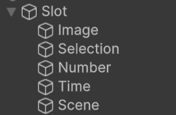

This results in the below layout:

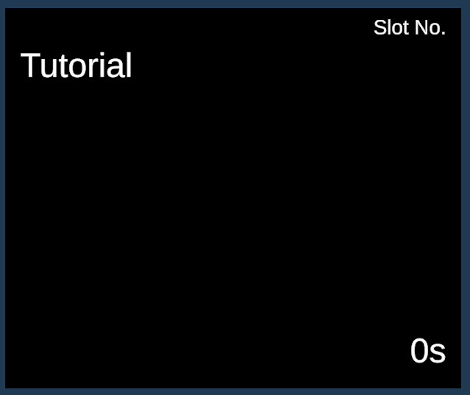

To access these, first the prefab must be instantiated into an object, and the reference to the prefab is stored so that its children components can have their values set in order. The whole process is repeated for each slot in the returned list, which are all added to the Scroll View UI object in Unity. This must also be run when the script is initialised so it will be ready when the player opens this menu upon opening the game.

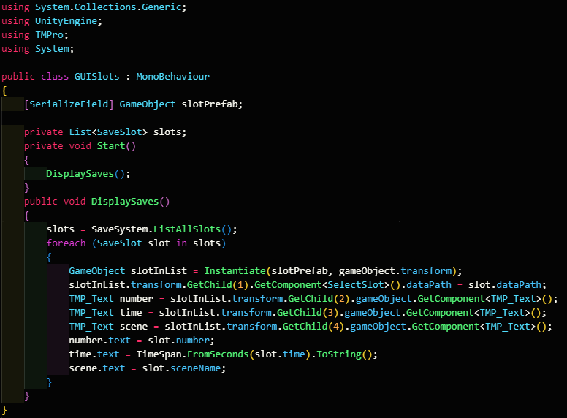

|  |  |  |  |  |  |
| --- | --- | --- | --- | --- | --- |
| Type | What data fits criteria | Justification | Expected | Actual | Comments |
| Valid | The ‘Saves’ folder filled with slots | The player will have at least 1 save slot on a typical opening of the game, and this should be displayed properly | The right number of saves are seen in the scroll view | Passed |  |
| Boundary | The ‘Saves’ folder is empty | This can occur if the player opens the game, but then closes it before creating a save | No saves are seen | Passed |  |

To allow the player to make a new save slot, there are a few things the system needs to do, similarly, to creating a save. The first check is to check if the top-level ‘Saves’ folder exists, and if it doesn’t, it needs to be created. The internals of the folder are sorted to check what the new slot number is, using the same code as before. Then, the potential directory of the slot needs to be checked to not exist, since if it already does, then something has gone wrong with the system. Provided it doesn’t already exist, the folder is created and within it, the ‘Auto’ and ‘Manual’ folders are created as well. The first save file is then created and written within, at which point the lookup is edited by appending the necessary string to the file.

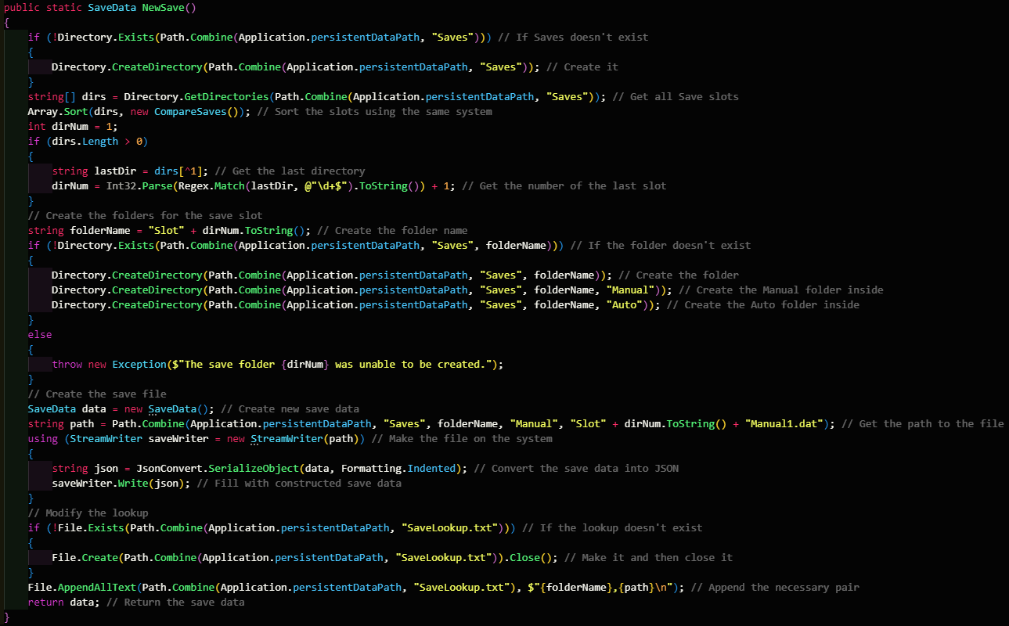

|  |  |  |  |  |  |
| --- | --- | --- | --- | --- | --- |
| Type | What data fits criteria | Justification | Expected | Actual | Comments |
| Valid | Making a new save slot when the folder (Saves) has some already | The player will have at least 1 save slot on a typical opening of the game, and this should be displayed properly | The number of save slots increases by one, and is displayed in the scroll view | Partial: the entire list was appended on, leading to duplicated slots | Caused by not removing the previous slots in the menu |
| Boundary | Making a new save slot when the folder (Saves) is empty | This will be the state of the player’s game on the first opening of the game | The new save slot is shown as the only one | Passed |  |

This display is caused by DisplaySaves not first deleting all the slots in the GUI before remaking them, and as such this tweak is needed. Importantly, the for loop needs to run in reverse to make sure that there are no NullReference errors.

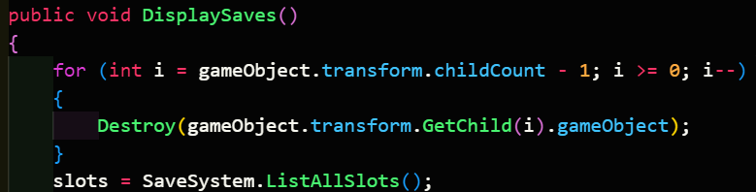

|  |  |  |  |  |  |
| --- | --- | --- | --- | --- | --- |
| Type | What data fits criteria | Justification | Expected | Actual | Comments |
| Valid | Making a new save slot when the folder (Saves) has some already | The player will have at least 1 save slot on a typical opening of the game, and this should be displayed properly | The number of save slots increases by one, and is displayed in the scroll view | Passed |  |

Both saving and loading works, but the system itself isn’t exactly finished. This is because the data needs to be actually applied to the game itself, where the data is spread around everywhere. This is done via the game’s manager, which takes in the save data that had been selected and reads and applies each value to the right locations, such as the health to the player’s Entity script. Once again, the main difficulty comes from the weaponry, since the ID of the object can’t easily be used to get the prefab GameObject that has it.

This can be solved with the Addressables package that comes with Unity. It can be used to load in an object at any moment, provided you know the name of the object, and that object is marked as addressable. The package will handle the finding of the object in the game files, which is much better than having another script store references to all of the different weapons. Disadvantages of trying to do it with a script instead include:

* Every weapon must be loaded in if a GameObject reference is used, otherwise this will be marked as null and not work.
* If the path to the weapon prefab is stored instead, this will end up failing when the game is built since Unity changes the paths and name of assets when it compresses them into different locations and formats. This can be combated by using the StreamingAssets folder instead, but this increases the size of the game overall since these objects are not compressed and hence is not preferable.

The main downside of using this combination of the Addressables package and the ID of the object is that the prefab name is required to be the same as the ID of the object. This may cause some issues for Henry Master’s company, and as such I confirmed if this was ok before implementing this.

#### Interview

Stakeholder: Don’t worry about this downside, we were planning to do the same anyway as this makes managing the items far easier on our end.

Stakeholder Signature:



Since I have the go-ahead on implementing the system like so, the first step is to add the weapons to the package’s watch, along with the folders that they are in as a backup.



With the system now having acknowledged the prefabs, I can go through each of the WeaponData in the save and use the ID to load in the object. Importantly, this will also be done with the asynchronous version of the method, to make sure that if the player has a more powerful computer, they will be able to take advantage of its capabilities. This also allows the intensive loading operation to take place in the background and let the rest of the game load in.

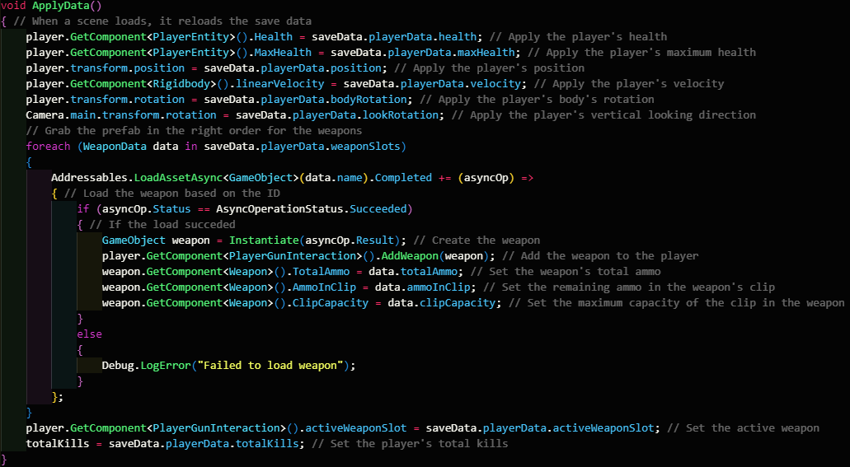

|  |  |  |  |  |  |
| --- | --- | --- | --- | --- | --- |
| Type | What data fits criteria | Justification | Expected | Actual | Comments |
| Valid | Normal SaveData | This is the standard action that will call | A SaveSlot list is returned with the correct information | Passed |  |
| Error | The weapon ID is incorrect | This may occur when the game developer puts in the incorrect ID for the prefab in the WeaponType property in the Weapon script | An error is logged, and the weapon is not loaded in. | Passed |  |

### Menus and level transitions

The player will have to interact with many menus as they are playing the game. In Unity, UI elements are placed onto Canvas elements, and these can be disabled to hide the elements on that Canvas. To handle this behaviour, a separate dedicated manager can be created for this, which I shall call it ‘MenuManager’. It will store a reference to every single Canvas in the game in a dictionary, with its name being the key to access it. This will allow for much faster access to the different Canvas objects, especially when SillyAustralian adds more in their own development.

The main problem this system has to solve is the fact that the references to the Canvas’ may exist in other scenes, and as such the system has to be able to handle the inability to fetch the reference to every single Canvas. To start with, all the Canvas objects are attempted to be fetched using GameObject.Find(). However, the code below causes a InvalidOperationException error to occur.



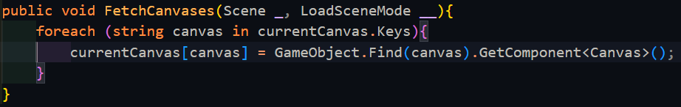

Upon consulting the C# documentation, when the contents of a dictionary change, this operation will fail, since Dictionary.Keys does not return a copy of the keys but is in fact a reference to the actual set of keys. This error is therefore returned as a warning in case the user removed a key from the dictionary. To fix it, we need to force C# to return a copy rather than a reference by using ToList(), which does what we want due to the data structure casting.

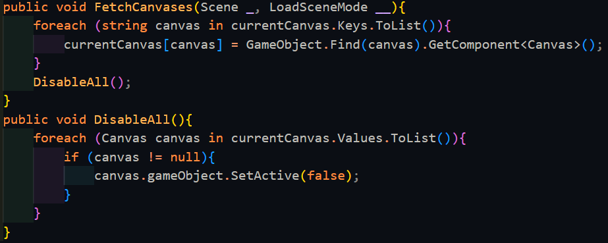

This error would also have shown up in DisableAll() which resets all canvases as a just-in-case for if any canvases where left enabled in between scene changes.

 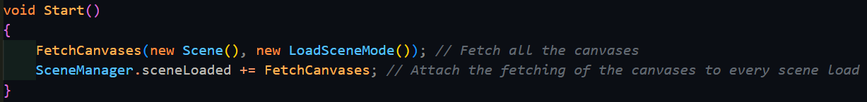

This error seems to be caused by FetchCanvasi() being run in Start(). This might be because Start(), against what I previously thought, is running before the scene actually loads fully. However, upon moving this to Update(), the error still persisted. A Debug.Log() was added to see which Canvas was causing the error, and it turned out to be ‘Slots’, which had been set to be inactive. Consulting the documentation, I discovered that GameObject.Find() will not return an inactive object, and this was causing the error. In fact, there exists no built-in function within Unity that will return inactive objects, and as such I have to make my own function using the object list in the scene data:

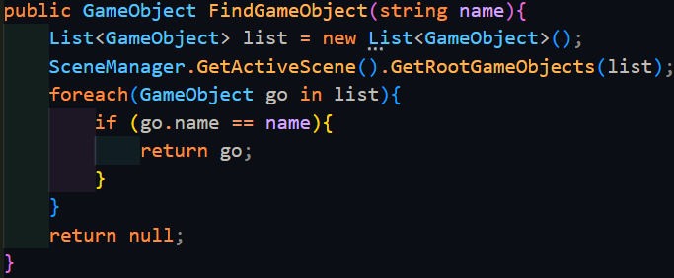

It functions similarly to GameObject.Find() but is more inefficient as it goes through the scene data. However, nonetheless it should help with the issue.

Indeed, it gets past ‘Slots’, which was previously causing the issue, but then gets stuck again at ‘Pause’. This is because ‘Pause’ is an object that has been marked as DontDestroyOnLoad, meaning that it does not exist in any of the following scene’s data. The typical way to grab references to objects that are marked as DontDestroyOnLoad is to have passed a manual reference in the Unity Inspector, but this is not feasible in this scenario.

Instead, I came up with a better solution, using the CanvasGroup component. This allows you to hide and show objects without disabling it. It also allows you to control whether a canvas is interactable or not, which means the Dictionary would have to be modified to use a tuple as well to store whether a menu should be interactable or not (this is needed because of the player’s HUD).

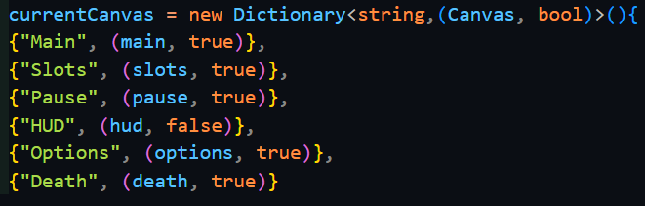

This slightly modified dictionary now stores the Canvas as part of a tuple with the intractability state of the Canvas stored as well. This is necessary for on-screen elements, such as the HUD, that the player should not be able to click. This requires slight refactoring of the code to allow for changes in the dictionary.

The way other system interact with the menu manager is by calling either ChangeMenu() or GoBack(). ChangeMenu() requires the name of the menu that needs to be switched to, and importantly, it disables the ability for the Canvas to block the mouse movement inputs and the mouse click inputs, along with setting the alpha for that Canvas to 0, making it invisible. lastMenu is now updated to store the value of currentMenu. Next, the new menu is set to be visible by setting its alpha to 1. If the Canvas has been marked as interactable, then it is allowed to detect and hence block the mouse’s inputs and movements from passing through to anything else in the game. Finally, it sets the current menu to the one that had been passed as an argument.

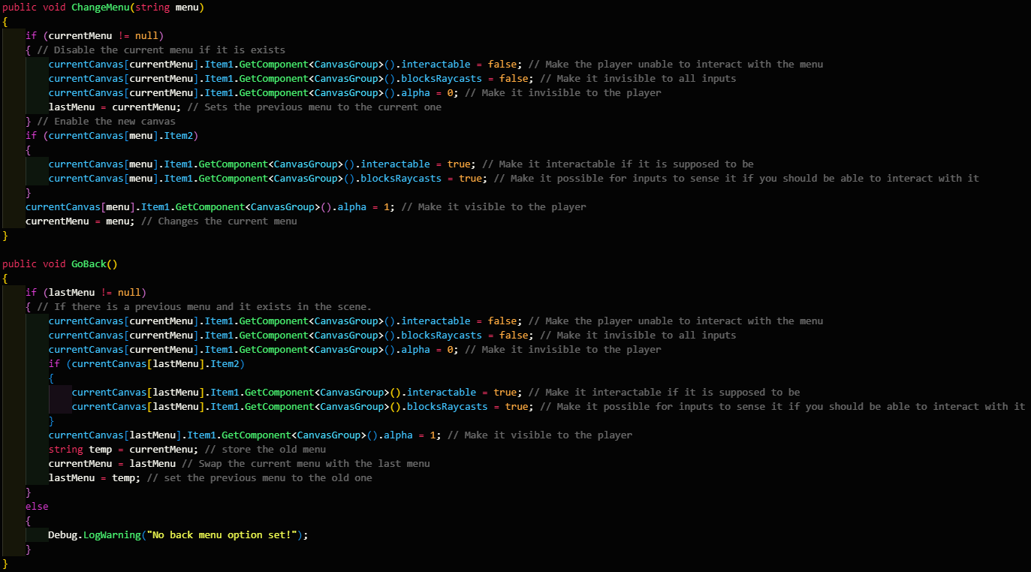

The above code has a minor issue, in that GoBack() shares a lot of duplicate code with ChangeMenu(). The only major changes are that menu is replaced with lastMenu, and that lastMenu and currentMennu are swapped at the end. This leads to an optimisation where lastMenu is passed as the argument for ChangeMenu(). ChangeMenu() will then disable the currently activated Canvas, and then enable the Canvas named by lastMenu. ChangeMenu() has swapped the values of lastMenu and currentMenu, and the only reason this works is that the parameter acts as a copy for the last menu. Since there are 3 variables, of which are arranged in the right order, it is possible to swap the 2 relevant variables.

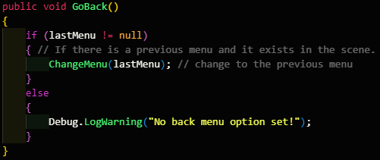



However, ChangeMenu() and GoBack() both have a problem, which leads to the error above. This occurs because, by default, the string object cannot be set to null. But a string can be set to be empty, and I can scan for this instead. Then to double down on the problem, I can add a check in to see whether the Canvas in that dictionary now equals null, since when the object unloads any references to it are replaced with null.



Another optimisation can be made to minimise the amount of if statements required. Since only the Canvases that were supposed to be interactable are set to be interactable, I can set this state of the canvas to be equivalent to the value in the dictionary.



To test both of these functions, they will be activated by buttons on the screen that will call the relevant menu that they want to be activated.

|  |  |  |  |  |  |
| --- | --- | --- | --- | --- | --- |
| Type | What data fits criteria | Justification | Expected | Actual | Comments |
| Valid | Selecting a new menu | This is the standard operation this system will experience and hence is suitable for a valid test | The current menu will be disabled and not interactable | Passed |  |
| Valid | Going back | This will make sure that the lastMenu variable is working appropriately | The previous menu will be reenabled and the current one will be disable | Passed |  |
| Erroneous | Requesting a menu that isn’t in the dictionary | In case the developer puts in a wrong system, the system should not crash | A debug message is logged with the error and the current menu stays up | Failed: no code was written to handle this |  |

To handle the error, we need to validate the input handed into the function against all keys in the dictionary.



|  |  |  |  |  |  |
| --- | --- | --- | --- | --- | --- |
| Type | What data fits criteria | Justification | Expected | Actual | Comments |
| Erroneous | Requesting a menu that isn’t in the dictionary | In case the developer puts in a wrong menu, the system should not crash | A debug message is logged with the error and the current menu stays up | Passed |  |

The death screen will be activated when the player dies and hence will have slightly different requirements surrounding it. On the screen, it will allow the player to load their most recent save, which has already been implemented. However, to stop the player moving and continuing with their game, the player’s controls will be disconnected from the movement controller. The player’s Entity script will recognise when the player has died, and instead of destroying the player’s game object, it will disable the Player input map, which contains all the controls for playing the game normally.

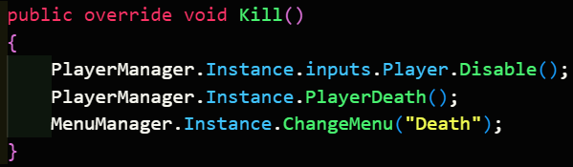

It will then tell the game manager that the player has died, which changes the player’s movement state to be dead, which will set the player's velocity to 0, effectively freezing its movement.



Finally, the current menu is changed to the death screen. When the player clicks the button to reload their game, it will run through the normal process, changing the current movement state to idle at the end of it to allow the player to move again.

|  |  |  |  |  |  |
| --- | --- | --- | --- | --- | --- |
| Type | What data fits criteria | Justification | Expected | Actual | Comments |
| Valid | The player dying | The player is expected to die when playing the game, and hence must be tested correctly | The player’s movement stops, and they can no longer control the character, and the death screen is shown | Passed |  |
| Valid | Clicking to reload the game | The player will need to reload their game after they die | The previous save is loaded just like a level load, and the player regains control | Passed |  |

On the main menu and on the pause menu, the player will also have the ability to quit the game. Quitting the game depends on whether the game is built or still within the editor. When within the editor, the play state of the editor needs to be set to false, while when the game is an executable instead, Application.Quit() needs to be called instead, which relates to the process-kill system call. To avoid any potential errors with variables or functions not existing in either state, a preprocessor directive can be added. These are symbols which are used by C# to mark or do certain things while the file is being compiled. In this scenario, if the compiler is being run within the Unity Editor, the play state being set to false will be the only line of code inside Quit(); otherwise, the system call will be the only code inside Quit().

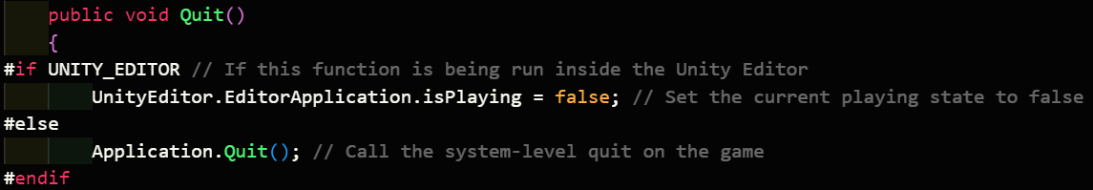

|  |  |  |  |  |  |
| --- | --- | --- | --- | --- | --- |
| Type | What data fits criteria | Justification | Expected | Actual | Comments |
| Valid | The button is pressed when the game is in the editor | The player will eventually want to close the game, and as such this ease-of-use method will be required. | The editor’s play state is set to false, and the preview stops | Passed |  |
| Valid | The button is pressed when the game is an executable | The player will eventually want to close the game, and as such this ease-of-use method will be required. | The game will close and leave the desktop | Passed |  |

The player should also be able to see their health on the HUD, which consists of only a slider. At maximum health, the slider will be full, while at any other value, the slider will be as full as the proportion of health remaining. For ease-of-use, there will also be a number on top dictating the amount of health remaining.

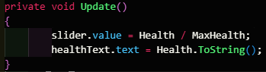

|  |  |  |  |  |  |
| --- | --- | --- | --- | --- | --- |
| Type | What data fits criteria | Justification | Expected | Actual | Comments |
| Valid | Running into the spike | This is a basic test for damage as well as well as verifying environmental damage and whether the player’s health is updated on the HUD | The player will take damage as is detailed, and this will be shown on the HUD | Passed |  |
| Boundary | Running into a spike with 1 HP (or enough for the next hit to kill the player) | This will test whether the kill function works | The death screen will show up | Passed |  |

This system works fine for most of the UI elements in the game, but there is one exception to this that needs to be handled by itself – the level loading screen. This is only enabled when a new scene needs to load in and takes priority over every other screen. The difficulty that needs to be handled with it is that displaying a loading bar should not stop the level itself from loading, and therefore one of them has to run asynchronously. Unity does have a built-in variation of its LoadScene() function that loads a scene asynchronously, that being LoadSceneAsync(). However, just calling this function with the name of the level and then updating the progression value will not allow the change to be visible on the player’s screen. If I did do this, then the surrounding function will wait for it to complete. Instead, I need to wrap it in a function that will also be asynchronous, and in the version of C# that Unity uses, this can be done by defining a function’s return type as an IEnumerator. This way, it is marked to hand back control flow to the rest of the program and then come back to where it was afterwards. Doing it like this is better than instead running this code inside of the Update() function as the progress of the scene being loaded may change as the other scripts are being run, and as such the progress of the scene being loaded will not be accurate when run through Update().

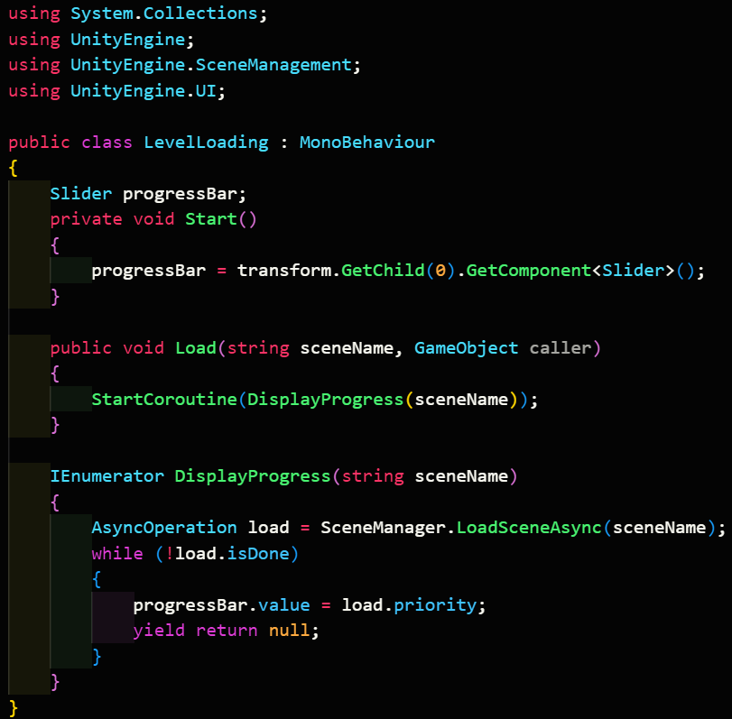

To run this function, the button links to a separate function in the game manager. Within this, it first checks whether the scene exists. If it does, all the Canvas objects are disabled, following which, the loading screen is enabled. Once enabled, the scene is requested to load, passing program flow to the coroutine. If the scene did not exist, an error is logged instead for a developer to view.

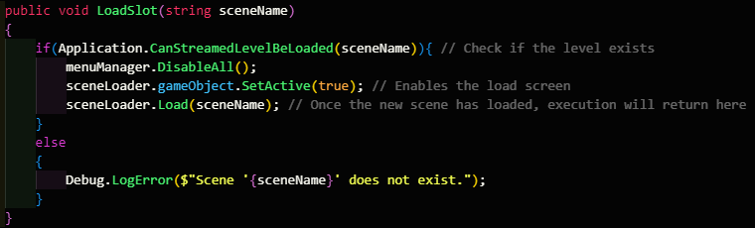

Testing this function is quite difficult as I do not have any scenes that are difficult enough to load that they need more than a frames worth of time. As such, I sourced one of my own models that was extremely dense in the number of polygons it had. Then, by duplicating this many times, the scene would gain many polygons, which would slow down the loading of the scene. This would emulate a larger, much fuller scene, and with this I was able to test it correctly.

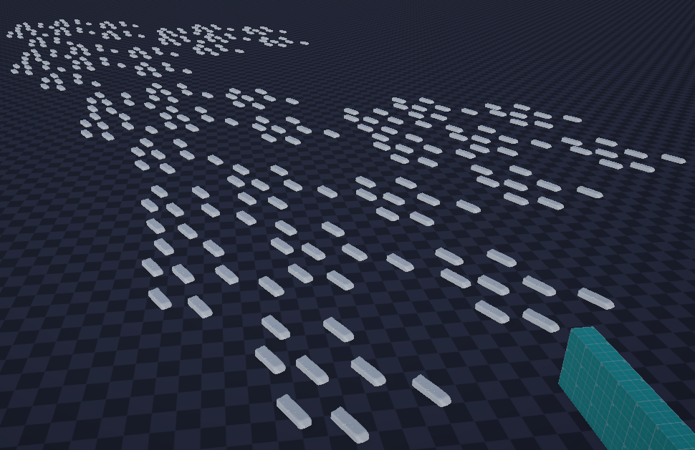

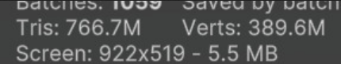

*(The number of rubbers placed as an attempt to slow down the scene, as well as the polygon count)*

|  |  |  |  |  |  |
| --- | --- | --- | --- | --- | --- |
| Type | What data fits criteria | Justification | Expected | Actual | Comments |
| Valid | Selecting to load a save | This will be the easiest way to test the loading screen and makes a suitable test since this tests the function that runs the screen | The current menu will be disabled, and the loading screen will come up | Partial: the progress bar did not reach one, stopping at 90% instead |  |
| Erroneous | Loading a scene that doesn’t exist | In case the save file is wrong, the system should not crash | A debug message is logged with the error and the current menu stays up | Passed |  |



According to the documentation, the progress of the load will never reach 1, as it is split into 2 sections: the first 90% is loading the assets of the level, while the last 10% is the unloading of the current level and replacing it with the new one. Unloading the current level includes the loading screen itself, so we need to change the progress value shown on the slider to being 1 when load.progress is at 0.9. This can be done by simply diving the progress by 0.9, resulting in the necessary scaling.

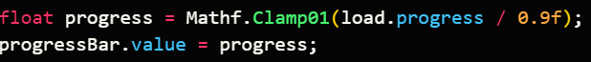

Mathf.Clamp01() makes sure that the value provided is between 0 and 1, and this makes sure that just in case the value for load.progress goes above 0.9, the value does not break the slider.

|  |  |  |  |  |  |
| --- | --- | --- | --- | --- | --- |
| Type | What data fits criteria | Justification | Expected | Actual | Comments |
| Valid | Selecting to load a save | This will be the easiest way to test the loading screen and makes a suitable test since this tests the function that runs the screen | The current menu will be disabled, and the loading screen will come up | Partial: the progress bar did not reach one, stopping at 90% instead |  |

Another thing that needs to be taken into account with switching scenes is the state of each scene. Within certain scenes, the player may not be allowed to move in straight away and this needs to be set before the player gains control. Scenes will also have a start position and a UI screen that needs to be open first, and all these pieces of information will be kept within a database. Each of these properties are stored in separate fields, where the primary key is the scene name.

To start with, I had to learn how to use SQL in C#. The database did not need to be hosted online, and as such SQLite was a perfectly usable solution of the SQL dialects. It was also an advantage to use this since I had some experience with using this in Python before and was a somewhat well-used solution in Unity projects. However, the drawback is that SQLite was overall the least-used SQL dialect, as many flock to using MySQL instead. However, the many variations in syntax and its main use as a multi-user access database system is not a capability I require. In fact, SQLite is extremely useful in being lightweight, and its main use is for small applications such as this game.

Having decided on a dialect to use, I searched around for how this was implemented within Unity or C#. Unity contains a plugin within it called Mono.Data.Sqlite and combined with System.Data from C#, I could create database connections using the IDbConnection interface and send commands using the IDbCommand interface.

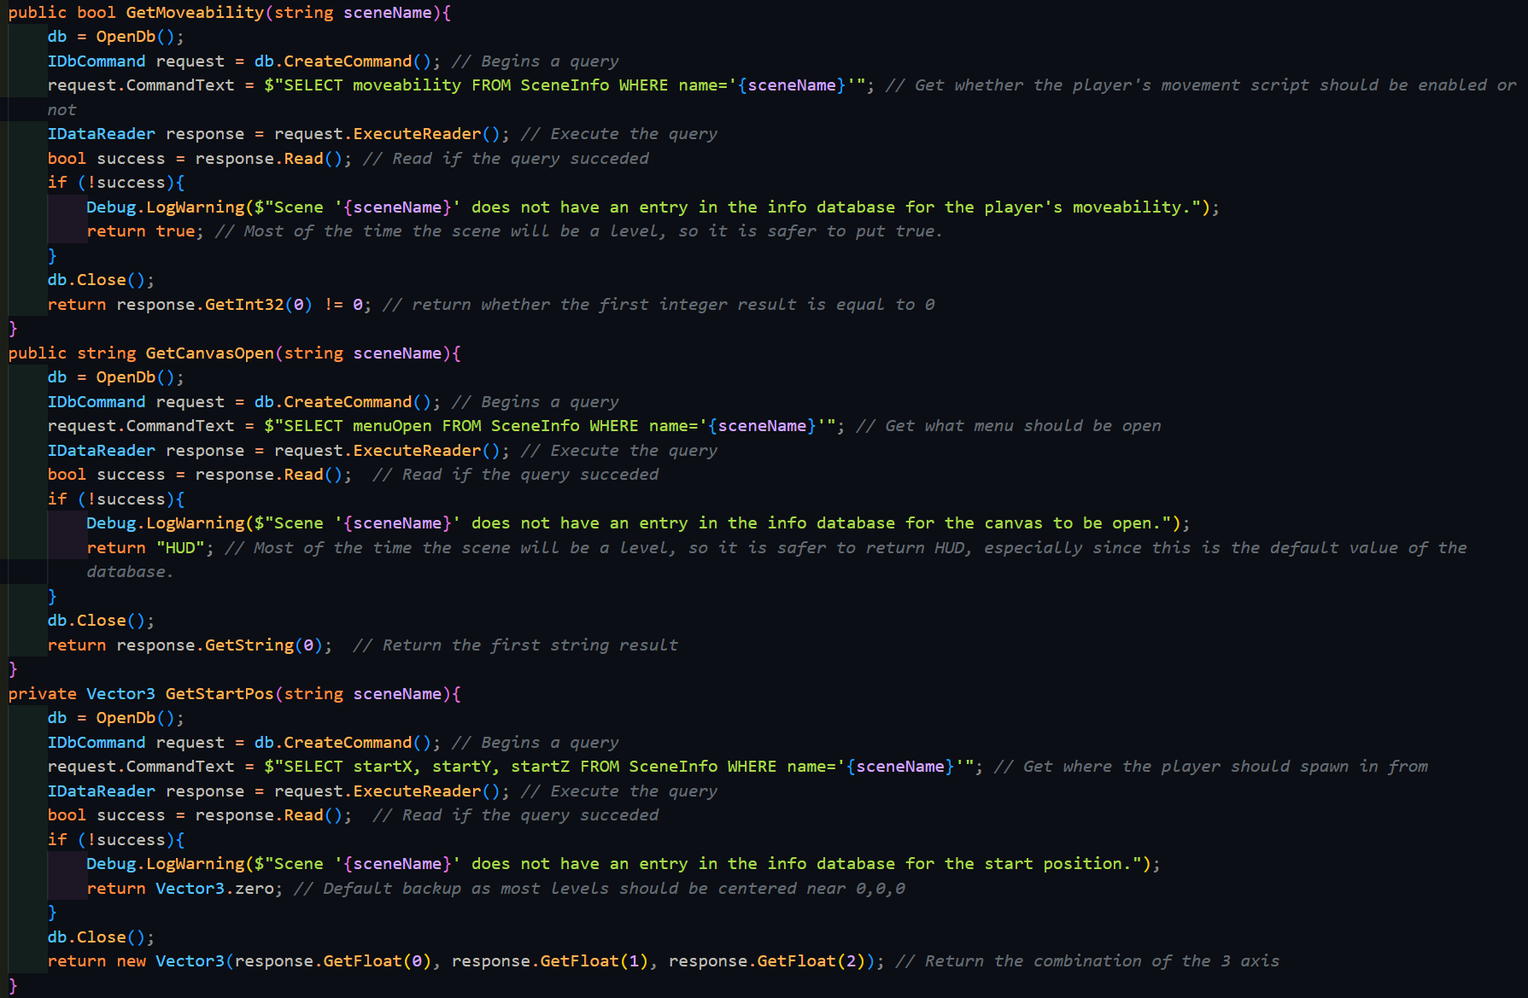

This first run through can be optimised to have a general query function that takes in the scene name and the field that the function needs to select, which also handles connecting to the database. Then the other functions are replaced as wrapper functions that feed this querying function and then read the right type of data from the response or report the correct error message.

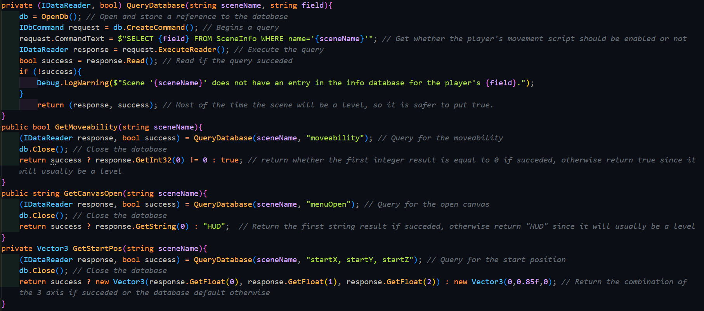

With this change, the function for setting the cursor state can be modified to also check the moveability of the player like below:

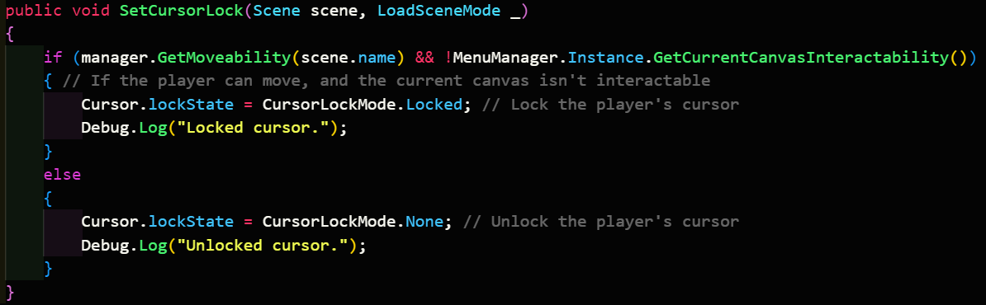

|  |  |  |  |  |  |
| --- | --- | --- | --- | --- | --- |
| Type | What data fits criteria | Justification | Expected | Actual | Comments |
| Valid | Loading a new scene which the player can’t move in | This will be required most surely when the Main Menu is loaded in and will be the one thing every player will interact with. | The player will be unable to move, the cursor will be unlocked, the player will be in the right location, and the right menu is displayed | Passed |  |
| Valid | Loading a scene which the player can move in | The player will need to load into a new level as they play the game, or when they load a save, and hence this must be tested properly | The player will be able to move, the cursor will be locked, the player will be in the right location, and the right menu is displayed | Passed |  |

### Miscellaneous

#### Referencing the Game Manager

This is a minor change that was used to further optimise the code. Originally, the game manager was an object that could easily be referenced beforehand in each scene just by dragging the reference in the inspector. However, once multiple scenes were added, the manager was changed to an object that was only created once, then persisted between the scene changes. Because of this, the inspector reference no longer worked, since the object would not exist in most scenes before the scene was loaded. As such, GameObject.Find() was first used as such to find the Game Manager object.

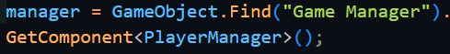

GameObject.Find() is useful, however not every single object required to use it, since some other objects would also be taken along in the scene change, such as the player or certain UI elements. Therefore, you must first check if the manager reference is null, and if it is, fetch the reference.

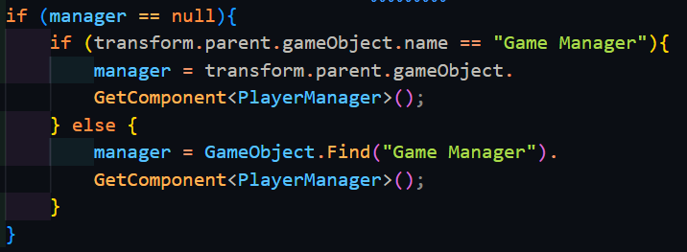

GameObject.Find() is a very simple solution to the problem, but it comes with a few drawbacks, of which the main ones are that it is extremely slow (it uses a linear search to find the object) and it uses a string to reference the name of the object which is susceptible to typos. Therefore, the even better solution to reducing the time spent searching for the Game Manager is to not search for it at all and make it a static reference. This works since only 1 Game Manager exists in memory at any time and therefore no problems will occur. This method is called a Singleton and is commonly used for manager objects.

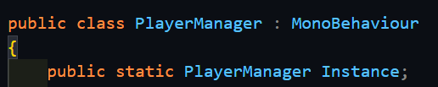

First the public reference is defined within the script, and then any script referencing the manager needs only to reference it like below.



This is the best solution since everything is baked into the code beforehand, which is the most efficient solution.

#### Referencing the camera

While reading the Unity documentation, I discovered that Unity has a built-in static reference to the main camera. Since this project only uses 1 camera (the one for the player) it was easier, faster, and more efficient to use Camera.main instead of finding a reference to it, either by assigning it in the inspector or using GameObject.Find().

### End of prototype tests

#### Saving and Loading

|  |  |  |  |  |  |
| --- | --- | --- | --- | --- | --- |
| Type | What data fits criteria | Justification | Expected | Actual | Comments |
| Valid | Saving a new save with others already being made | The most typical action the player will be taking is this, and therefore it should be tested properly | A new save will be created with the newest number | Passed |  |
| Valid | Loading a save file | It goes hand in hand with saving, and will also be a core function of the system | The save file is opened and the data is returned | Passed |  |
| Boundary | Saving a file when none of the directories or files exist | This is necessary to test for since this will be the state of the user’s system when they first launch the game | All the appropriate files and folders are created | Passed |  |
| Error | Passing a file to load that doesn’t exist | In case the lookup ends up corrupted, or the user deletes certain files, the function should not crash, and instead log the error | Error code is logged | Passed |  |
| Error | ‘SaveLookup.txt’ is not created | This will occur when the player opens the game for the first time, and must be handled properly | The file is created | Passed |  |

#### Save Data Application

|  |  |  |  |  |  |
| --- | --- | --- | --- | --- | --- |
| Type | What data fits criteria | Justification | Expected | Actual | Comments |
| Valid | Normal SaveData | This is the standard action that will call | A SaveSlot list is returned with the correct information | Passed |  |
| Error | The weapon ID is incorrect | This may occur when the game developer puts in the incorrect ID for the prefab in the WeaponType property in the Weapon script | An error is logged, and the weapon is not loaded in. | Passed |  |

#### Displaying Saves Normally

|  |  |  |  |  |  |
| --- | --- | --- | --- | --- | --- |
| Type | What data fits criteria | Justification | Expected | Actual | Comments |
| Valid | The ‘Saves’ folder filled with slots | The player will have at least 1 save slot on a typical opening of the game, and this should be displayed properly | The right number of saves are seen in the scroll view | Passed |  |
| Boundary | The ‘Saves’ folder is empty | This can occur if the player opens the game, but then closes it before creating a save | No saves are seen | Passed |  |

#### Displaying Saves when making a new save slot

|  |  |  |  |  |  |
| --- | --- | --- | --- | --- | --- |
| Type | What data fits criteria | Justification | Expected | Actual | Comments |
| Valid | Making a new save slot when the folder (Saves) has some already | The player will have at least 1 save slot on a typical opening of the game, and this should be displayed properly | The number of save slots increases by one, and is displayed in the scroll view | Passed |  |
| Boundary | Making a new save slot when the folder (Saves) is empty | This will be the state of the player’s game on the first opening of the game | The new save slot is shown as the only one | Passed |  |

#### Moveability and Cursor state when loading a scene

|  |  |  |  |  |  |
| --- | --- | --- | --- | --- | --- |
| Type | What data fits criteria | Justification | Expected | Actual | Comments |
| Valid | Loading a new scene which the player can’t move in | This will be required most surely when the Main Menu is loaded in and will be the one thing every player will interact with. | The player will be unable to move, the cursor will be unlocked, the player will be in the right location, and the right menu is displayed | Passed |  |
| Valid | Loading a scene which the player can move in | The player will need to load into a new level as they play the game, or when they load a save, and hence this must be tested properly | The player will be able to move, the cursor will be locked, the player will be in the right location, and the right menu is displayed | Passed |  |

### Interview

Stakeholder: Most of these systems are perfect and do not need any more work. However, I would like the loading screen to have a button, and until this button is clicked, it will not go to the next level. Also, an extra feature that I would like implemented is an options menu, which allows the player to change the volume of the game, as well as the camera’s FOV

Stakeholder Signature:



## Prototype 4

### Button to loading screen

To implement this change, a particular flag on the loading function needs to be set, specifically allowSceneActivation, which disables the action of the scenes being swapped. This changes the necessary test in the while loop, from checking if load.isDone == true to if progressBar.value < 1. This is necessary since isDone never gets set to true allowSceneActivation is set to false, but this doesn’t mean that the check can’t be load.progress < 0.9. The reason for using the progress bar’s value instead is that due to the function being an IEnumerator, it may reach the done state before the progress bar is updated fully, and therefore the player may not see a full progress bar by the time the function exits. It is also necessary to change the yield statement to wait until the end of the frame to prevent a well-known crash caused by IEnumerators.

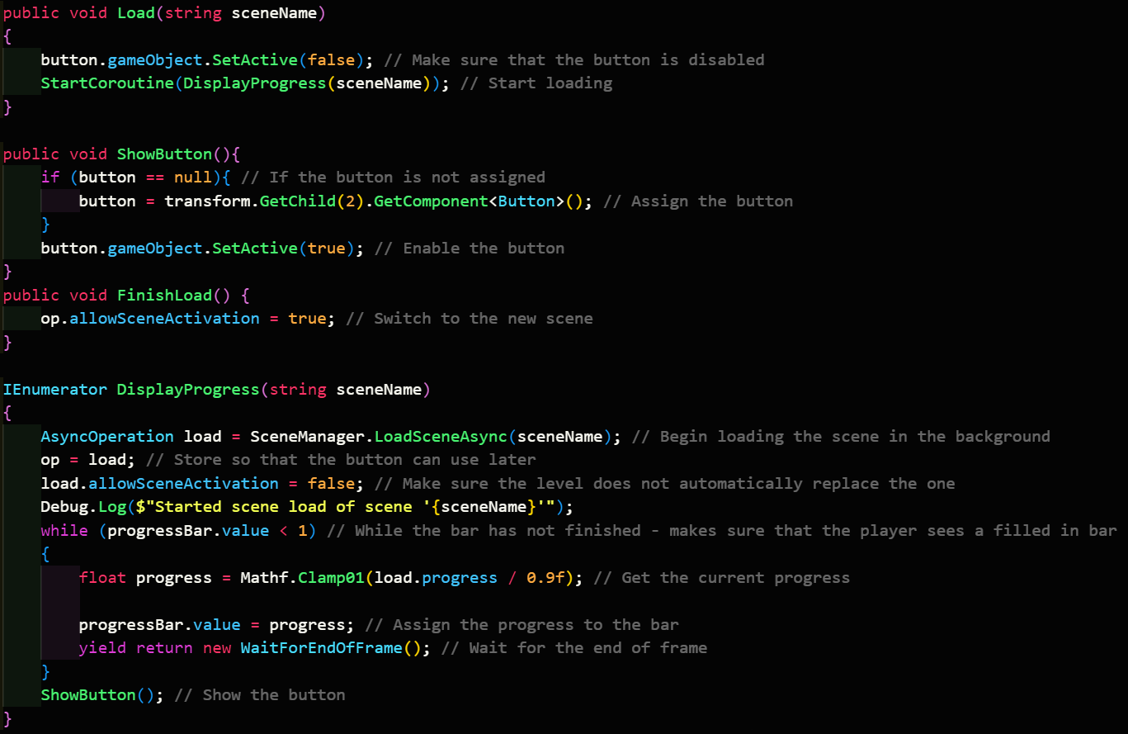

When running this, after the first iteration, the script would lose the reference to the slider object. After much debugging, I was unable to find the reason for this, but it seemed to happen after the yield statement. As such, I placed the below check to fetch the reference if it were to be lost, and this solved the NullReferenceException that would occur from trying to read a value from the slider when the script couldn’t find the object to read from.



|  |  |  |  |  |  |
| --- | --- | --- | --- | --- | --- |
| Type | What data fits criteria | Justification | Expected | Actual | Comments |
| Valid | Selecting to load a save | This will be the easiest way to test the loading screen and makes a suitable test since this tests the function that runs the screen | The current menu will be disabled, and the loading screen will come up. When the loading is completed, it will show the button with a full progress bar | Passed |  |
| Erroneous | Loading a scene that doesn’t exist | In case the save file is wrong, the system should not crash | A debug message is logged with the error and the current menu stays up | Passed |  |



*(The screen when the level has finished loading)*

#### Interview

Stakeholder: This is better since it allows players time to rest between levels and not have to be at the computer constantly if they need to go somewhere else temporarily due to the worry of the level starting without them. Feel free to move on now.

Stakeholder Signature:



### Audio

Handling audio in the game is not that difficult, consisting mainly of using the built-in functions to play particular audio clips through a mixer object, which requires some setup within Unity itself. Importantly, for organisation, it is best to split audio into the different channels, and hence types, that they may run through, such as sound effects going through the SFX channel. The common channel that this gets routed through in the end is the Master channel which is applied last on top of every channel together and is typically used to control the volume of the game.

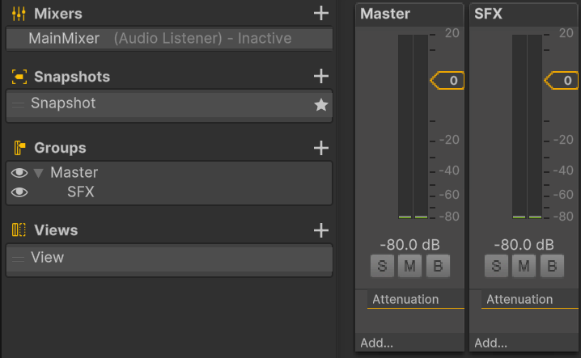

In Unity, audio files are played using an object with the ‘Audio Source’ component attached to it. By making this object into a prefab, it makes the process of playing these sound effects much easier than before. The Audio Source component must have the playOnAwake property set to true for this system to work.

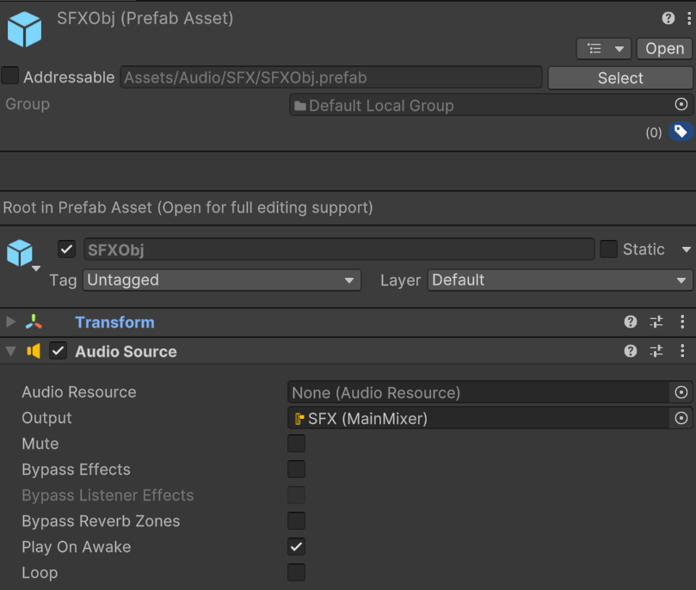

All requests to play sound effects are then passed through the audio manager, which then instantiates the prefab at the location specified by the script, and assigns the clip to the object, allowing it to play. This object is then destroyed once the clip is finished to reduce the load on the system.

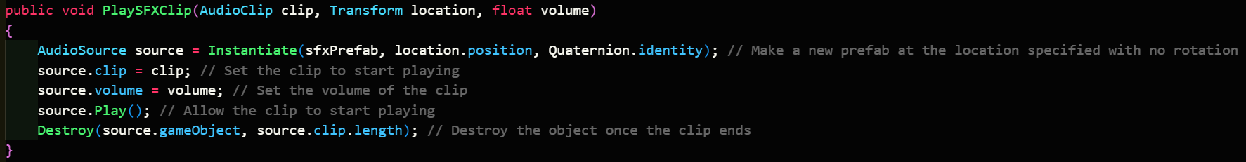

To test this system, I needed both a script to request the playing of sounds, along with sound effects to go alongside them.

To make these sound effects, I used a program I found called ChipTone. There were many other options, but this was the most user-friendly one that I found, that also allowed the easy generation of these sounds as required.

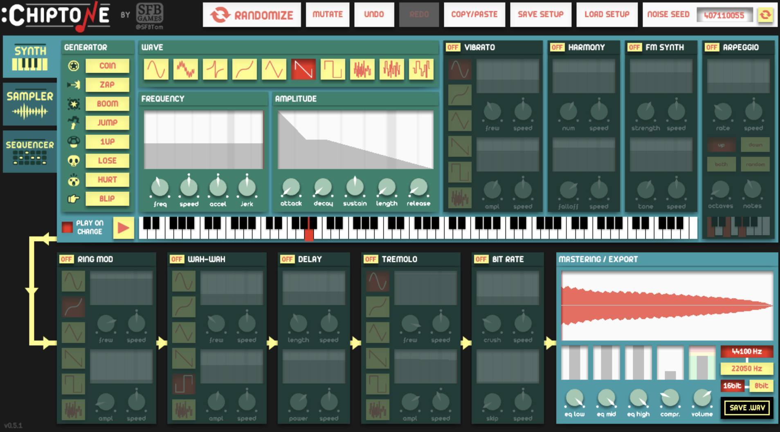

The 2 sounds that I created was one for hovering over a UI button and one for selecting/clicking the UI button. These are added to the Addressables package’s watch and then can be loaded when the script begins.

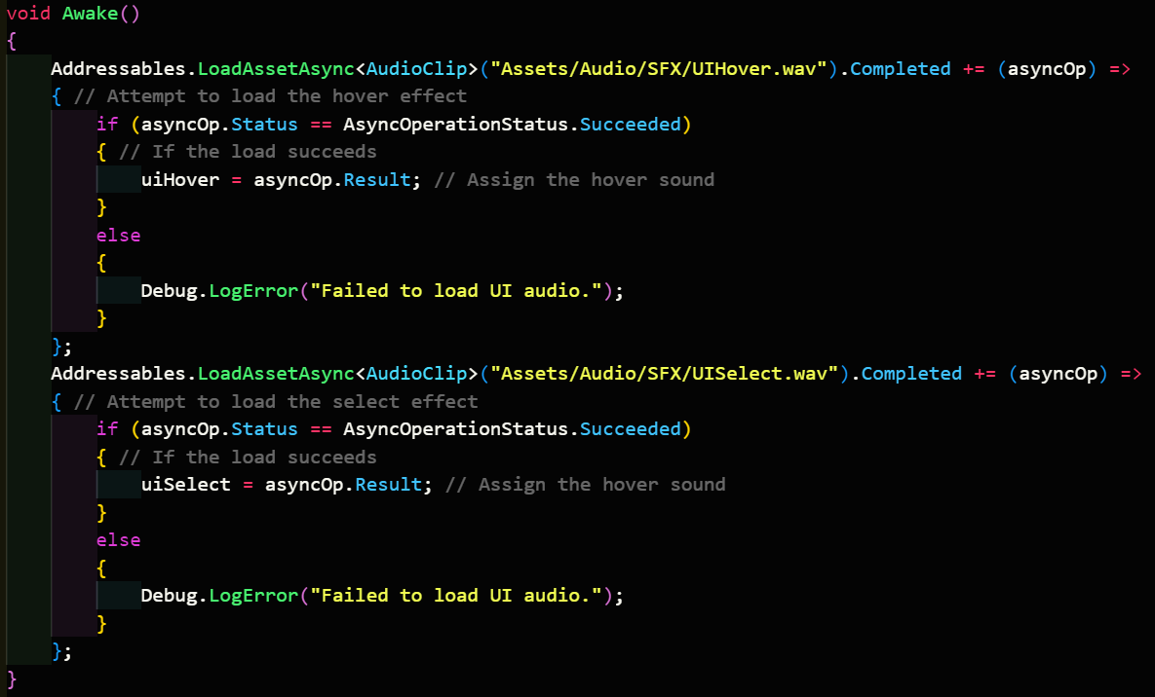

To run the hover sound effect, this script needs to play the SFX when the button is hovered over, which is automatically run by OnPointerEnter.

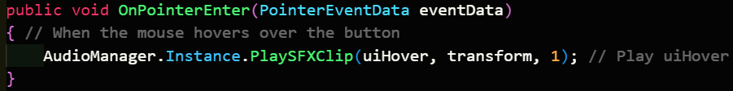

Conversely, handling the click sound requires first listening to the onClick event fired by the button when it is pressed.

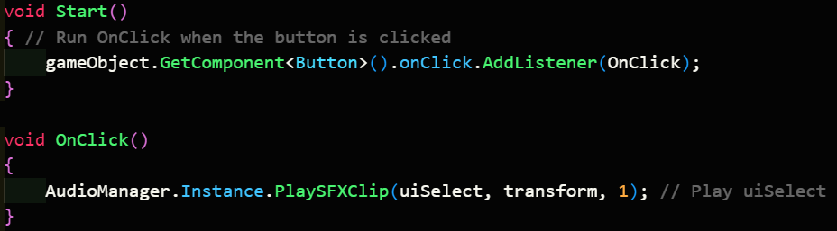

|  |  |  |  |  |  |
| --- | --- | --- | --- | --- | --- |
| Type | What data fits criteria | Justification | Expected | Actual | Comments |
| Valid | Hovering over the button | The player will be hovering over buttons constantly as they decide what to click | The UIHover sound effect is played | Passed |  |
| Valid | Not hovering the button | On the other hand, the player may also skip certain buttons, especially when the buttons do not take up the majority of the scene. | No sound effect will be played | Passed |  |
| Valid | Clicking on the button | The player will always have to click a button to progress through the menus | The UISelect sound effect is played | Passed |  |
| Boundary | Hovering over and then off the button | Most of the time, the player will hover over a button but not click it, and as such this needs to be tested correctly | The UIHover sound effect is played once as the mouse hovers over, but not off | Passed |  |

### Options

One of the settings that I am putting in the options menu are the volume controls for the master channel. This requires exposing the volume of the master channel in the mixer settings, and the name I have given it is masterVolume. This variable can be set via a slider on the UI, which will update this value when it is changed.

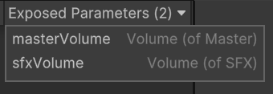

The code will be split into 2 parts, one in AudioManager, and another in Options, which is a script which calls the relevant external functions on other scripts. This menu will read the value of the slider, which goes between 0 and 1, and then use that to interpolate between -80 decibels (which is considered to be the mute option) and 0 decibels, which is the standard volume. This is then passed to SetMasterVolume() on AudioManager.



The manager only needs to set the exposed parameter using mixer.SetFloat(), with the supplied volume.

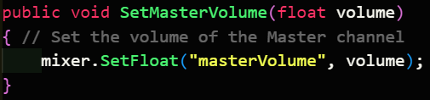

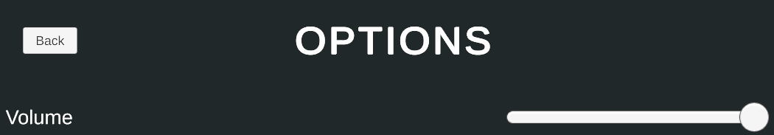

*(The volume slider in the menu)*

|  |  |  |  |  |  |
| --- | --- | --- | --- | --- | --- |
| Type | What data fits criteria | Justification | Expected | Actual | Comments |
| Valid | Not changing the slider | Most of the time, the player will not need to change the volume of the game when they open the menu, and as such this needs to be tested | The volume remains at its current value | Passed |  |
| Valid | Changing the slider to any value | Typically, the player will need to set the volume to an intermediary volume for their needs | The volume will be adjusted according to the slider | Passed |  |
| Boundary | Moving the slider to the minimum or the maximum | The player may need to mute the game, or return it to its original value, and this should be tested | The game’s volume will be muted (if the slider is set to the minimum) or return to the normal value (if the slider is dragged to the maximum) | Passed |  |
| Error | Dragging the slider out of its limits | The player will not attempt to drag the slider carefully, and will typically drag it past its limits to set the minimum and maximum, and this should be tested appropriately | The slider will stay at either the minimum or maximum | Passed |  |

The other setting that I will implement as an example is the ability to change the FOV when the player is moving around. This will also use a slider; however, I discovered that I could change the minimum and maximum value of the slider in the inspector. To decide what the minimum and maximum FOV should be, I consulted SillyAustralian:

#### Interview

SillyAustralian: The typical values that games use for the camera’s FOV range between 10 and 120, so do those as well so that players have a standard that they are comfortable with. As the default value, make this around 70. Finally, make sure the player can change the FOV for when they are zoomed in as well, and have this have the same range as the normal FOV. Call it ADS for Aim-Down-Sights.

These values can be put into the slider’s settings:

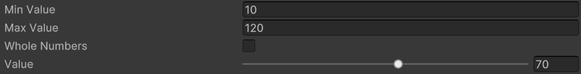

When the sliders are changed, they will call a function in the Options menu, which will set the relevant values in the player’s weapon interaction script, which have now been marked as public.

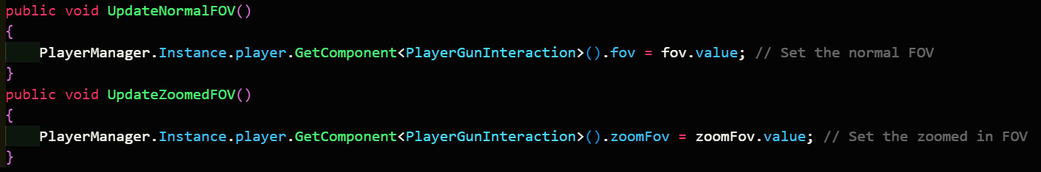

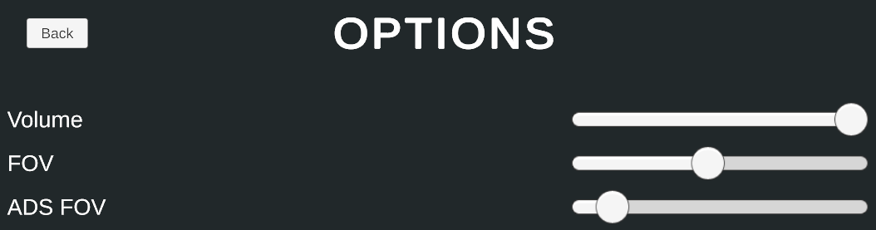

*(The final Options menu)*

|  |  |  |  |  |  |
| --- | --- | --- | --- | --- | --- |
| Type | What data fits criteria | Justification | Expected | Actual | Comments |
| Valid | Not changing either slider | Most of the time, the player will not need to change their FOV for either option when they open the menu, and as such this needs to be tested | The FOV and ADS FOV remains at its current value | Passed |  |
| Valid | Changing the FOV to any value | Typically, the player will need to set the FOV to an intermediary value for their needs | The FOV slider will be set to the correct value | Passed |  |
| Valid | Changing the ADS FOV to any value | Typically, the player will need to set the ADS FOV to an intermediary value for their needs | The ADS FOV slider will be set to the correct value | Passed |  |
| Boundary | Moving the either slider to the minimum or the maximum | While uncommon, some players may use extreme FOVs, and this should be tested | The appropriate slider will be set to either the minimum or the maximum | Passed |  |
| Error | Dragging either slider out of its limits | The player will not attempt to drag either slider carefully, and will typically drag it past its limits to set the minimum and maximum, and this should be tested correctly | The slider will stay at either the minimum or maximum | Passed |  |

### Movement

At this point, I can now implement the movement features that were of secondary priority: the special options. The first one I could implement is sliding, which first requires checking if the player is moving above the walking speed. If they are, and then they start crouching, then they enter a sliding state, which has lower friction and control. The player also gains a slight boost in the first second of sliding. To implement this boost, the acceleration function will be tweaked slightly. When they start sliding, the current time is recorded and each frame, the difference between the current time and the stored time is calculated. If this difference is below a certain value, then the acceleration value is higher. Otherwise, the acceleration value is extremely low. This limiting value needs to be decided by SillyAustralian:

#### Interview

SillyAustralian: This initial boost should only be there for a very short amount of time. This amount of time should be a tenth of a second, as it ensures that anyone playing at the minimum acceptable frame rate of 30 fps will be able to experience the boost for a few frames.

Stakeholder Signature:



This feature can be put into code like below, where startedSliding is set upon the state change.

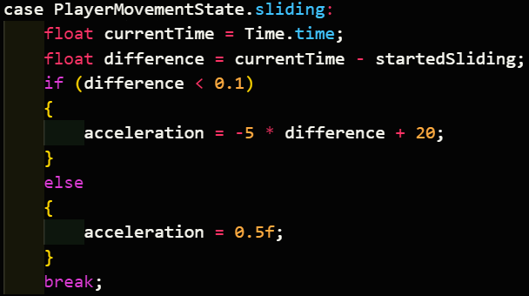

|  |  |  |  |  |  |
| --- | --- | --- | --- | --- | --- |
| Type | What data fits criteria | Justification | Expected | Actual | Comments |
| Valid | Pressing the crouch key at low speeds | This is input that the player will use, and the state needed to crouch, and hence needs to be tested appropriately | The player’s height will be shrunk | Passed |  |
| Valid | Pressing the crouch key at high speeds | This is input that the player will use, and the state needed to slide, and hence needs to be tested appropriately | The player’s height will be shrunk, and they will gain a small bit of speed, before slowing down | Partial: the player gained infinite speed | Need to set a sliding cap |
| Boundary | Pressing the crouch key at high speeds and then again quickly | The player may use this to chain together a lot of speed and therefore should be tested corrected | The player’s height will be shrunk, and they will gain speed before returning to the standing height. | Passed |  |
| Erroneous | Pressing another key (e.g. M) | An input not related to the test should not affect the test | The player will remain at their standing height | Passed |  |

At the moment however, the player is able to gain an infinite amount of speed since there is no strict maximum sliding speed. The maximum sliding speed that the player can play depends on what speed they started sliding, since the player can enter this state at any point. Therefore, the maximum speed that the player can reach is not a set value. To combat this, the player will not experience a speed cap while they are still experiencing the initial boost, after which point the speed that they reach becomes the maximum speed that they can reach.

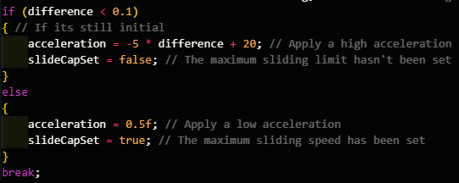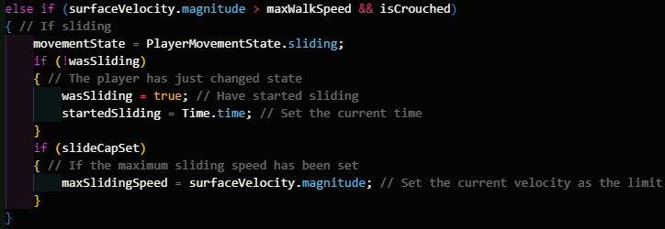

|  |  |  |  |  |  |
| --- | --- | --- | --- | --- | --- |
| Type | What data fits criteria | Justification | Expected | Actual | Comments |
| Valid | Pressing the crouch key at low speeds | This is input that the player will use, and the state needed to crouch, and hence needs to be tested appropriately | The player’s height will be shrunk | Passed |  |
| Valid | Pressing the crouch key at high speeds | This is input that the player will use, and the state needed to slide, and hence needs to be tested appropriately | The player’s height will be shrunk, and they will gain a small bit of speed, before slowing down | Passed |  |
| Boundary | Pressing the crouch key at high speeds and then again quickly | The player may use this to chain together a lot of speed and therefore should be tested corrected | The player’s height will be shrunk, and they will gain speed before returning to the standing height. | Passed |  |
| Erroneous | Pressing another key (e.g. M) | An input not related to the test should not affect the test | The player will remain at their standing height | Passed |  |

I also noted that the same issue exists with boosting, as past a certain point, the amount of speed gained is not able to be counteracted with the friction that they experience. To calculate the maximum speed that the player can reach when boosting, I can add together the initial velocity, and the total velocity gained from the boost. The initial velocity can then be stored to add an extra check into deciding whether the player is walking or not, since if the player starts boosting below the walking or sprinting speed, the game should not automatically transfer them to that state.

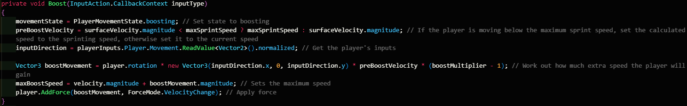

|  |  |  |  |  |  |
| --- | --- | --- | --- | --- | --- |
| Type | What data fits criteria | Justification | Expected | Actual | Comments |
| Valid | Pressing the boost key | This should be the only key used for boosting, and hence should respond appropriately | The player’s speed increases by a huge amount, and then the speed cap is set | Passed |  |
| Erroneous | Pressing another key (e.g. M) | Keys not used for boosting should not activate it | The player will remain at their current speed | Passed |  |

Then next special movement technique is double jump, which requires 2 more variables: airJumpsLeft and airJumpsTotal. airJumpsLeft will track how many more times the player can jump in mid-air, while the airJumpsTotal will be used to reset airJumpsLeft. Deciding whether to use a double jump or not requires the use of an if statement, where the condition is based on if the player is on the ground or not. If they are, they can jump normally, but if they aren’t, then they consume a double jump. This also means that an extra check is required before that if the player is moving downwards, they must gain enough vertical speed to completely counteract this downwards movement to make sure that the double jump is effective.

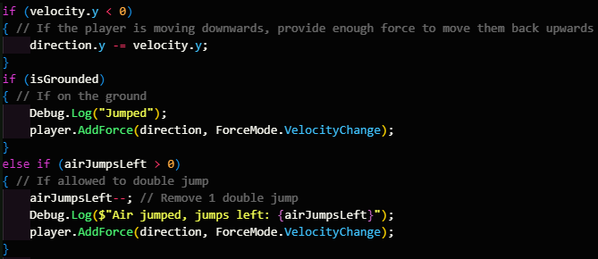

When the player touches something, they regain all of their air jumps, encouraging them to make contact with a wall or the ground at some point.

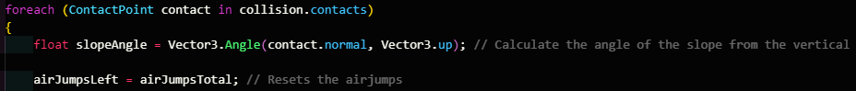

|  |  |  |  |  |  |
| --- | --- | --- | --- | --- | --- |
| Type | What data fits criteria | Justification | Expected | Actual | Comments |
| Valid | Pressing the jump key on the ground | As the only input being used to jump, it is important that it works, and that it has not been affected by the double jump | The character will move upwards, then move back down, and no air jumps are used | Passed |  |
| Valid | Pressing the jump key in the air while moving upwards | This tests the player’s ability to double jump | The player will move upwards faster, using an air jump, and will fall back down eventually | Passed |  |
| Valid | The player pressing the jump key while in mid-air when they have no air jumps left | Since the player is likely to have used all their double jumps, they should no longer be able to jump in mid air | The player will continue accelerating downwards | Passed |  |
| Boundary | Touching a surface when the player has no air jumps left | The player will usually exhaust all their double jumps, and they need to be able to get them back | airJumpsLeft will be set to airJumpsTotal | Passed |  |
| Boundary | Pressing the jump key in the air while moving downwards | The player should still be able to get the full use out of their double jump without it being a waste | The player will move upwards, using an air jump, then move down | Passed |  |
| Erroneous | Pressing another key (e.g. M) | Since there is only one input, nothing else should cause the player to jump, and if there is, that means something is significantly broken | The player will remain still | Passed |  |

As I was looking through the code and reading some of Unity’s forums, I discovered that it was incorrect to use Rigidbody.AddForce() outside of FixedUpdate() since it is something that works with the physics system. This can cause errors and issues when the framerate does not match the tick rate of the physics engine (this is set to 50 ticks per second by default) and the usual player will normally be running the game at frame rates that almost never match exactly 50 fps. Therefore, I created a property called movement. This stores the total movement that all the functions want to apply to the player’s body, weighted based upon the time it took for that frame. This is then applied each time FixedUpdate() is applied and then reset to 0. All functions will exist within Update(), which runs every frame, and record the player’s movement. The exemption to this is gravity, which can run every physics tick instead, since the player’s input does not affect it.

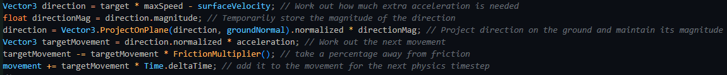

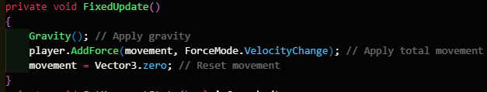

Another optimisation I noticed was the number of variables in the movement function. Originally, to calculate the amount of movement required, 3 variables are used to store the movement at different stages. However, all 3 are not needed, since the difference in the values do not do anything. Instead, only 1 variable is used, and I was able to rewrite these lines of code to use only target instead of target, targetMovement, and direction. This reduces the amount of memory the game uses, reducing the system requirements.

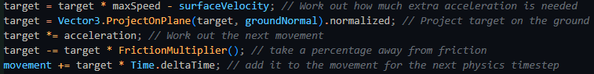

Aside from these optimisations, I also moved onto implementing the ability to run on walls. Wallrunning will use the same sort of underlying math as the rest of the movement functions, but it will be slightly tweaked to move on a wall. Firstly, CollisionDetected() needs to be edited to include a few more variables, which allow it to decide whether the player is on the floor or on a wall. This is done by iterating through every contact point and working out the angle, and if this angle is not too steep, then the player is on the ground, and the function decides that the player is grounded and ends there, storing the normal of the ground for use within Movement(). However, if there is a point that is too steep, then the function marks that the player is touching a wall object. If the player is not grounded after every point, then the player is stuck on the wall, and they are set to be wallrunning, with the normal of the wall being stored for later use.

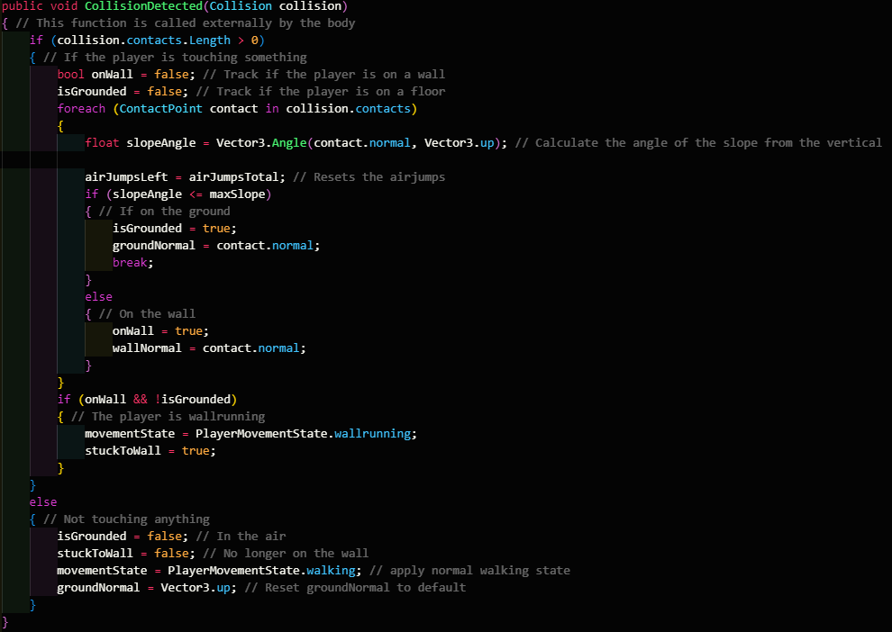

As mentioned, Wallrun() will contain similar code to Movement(), running some extra checks first beforehand, and using the normal of the wall instead of the floor. These checks include if the player is attempting to move away from the wall, and if the player is moving far too slow on the wall. In either case, the player is kicked off the wall with an extra boost of speed. This makes sure that the player doesn’t accidentally reattach to the same wall and make them unable to move into any other state. The player is then set to the walking state as a default state.

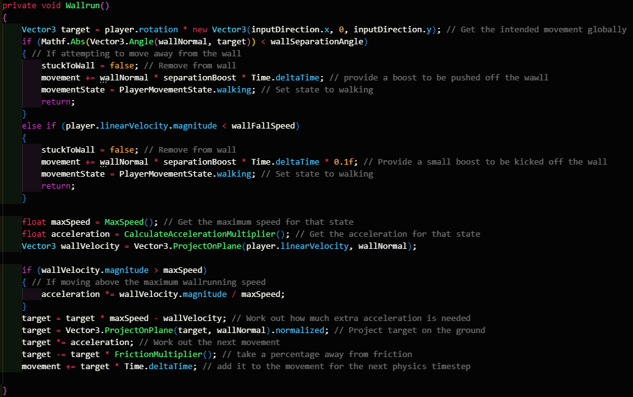

The player will also have lower gravity while on the wall, and this will need to be taken into account in the gravity function.

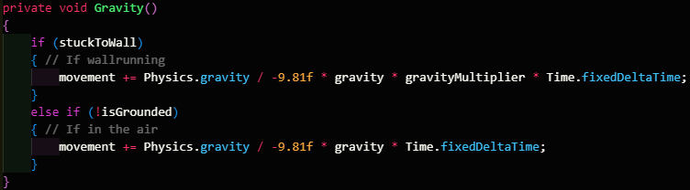

Finally, when on the wall, pressing the jump input should allow the player to be kicked away from the wall, with a boost parallel to the wall normal.

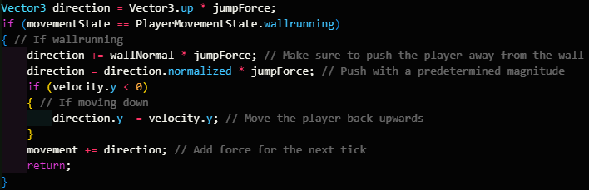

|  |  |  |  |  |  |
| --- | --- | --- | --- | --- | --- |
| Type | What data fits criteria | Justification | Expected | Actual | Comments |
| Valid | Pressing forward on the wall | This is the most likely action that the player is going to do when they are on the wall, and as such, this should be the highest priority test | The player will move forward on the wall | Passed |  |
| Valid | Facing perpendicular to the wall | The player may want to dismount from the wall | The player will gain a speed boost as they disconnect from the wall and enter a walking state. | Passed |  |
| Valid | The player pressing the jump key while on the wall | Since the aim of the game is to maintain speed, the player will want to jump away from the wall instead of the other methods to maximise the speed gain | The player will dismount from the wall and gain some speed in the direction of the wall normal and upwards | Passed |  |
| Boundary | Slowing down on the wall below a threshold | The player may attempt to turn around on the wall, or slow down, and it makes sense for this to mean that they can no longer hold onto the wall. | The player is pushed away from the wall | Passed |  |
| Boundary | Pressing the jump key in the air while moving downwards on the wall | The player is still affected by gravity, if only by a little bit, so the player can end up moving downwards, which may make the jump useless. Hence this needs to be counteracted | The player will dismount from the wall and gain some speed in the direction of the wall normal and upwards | Passed |  |
| Erroneous | Pressing another key (e.g. M) | An input not related to the system should not affect it | The player will slow down on the wall due to friction | Passed |  |

### End of prototype tests

#### UI Sounds

|  |  |  |  |  |  |
| --- | --- | --- | --- | --- | --- |
| Type | What data fits criteria | Justification | Expected | Actual | Comments |
| Valid | Hovering over the button | The player will be hovering over buttons constantly as they decide what to click | The UIHover sound effect is played | Passed |  |
| Valid | Not hovering the button | On the other hand, the player may also skip certain buttons, especially when the buttons do not take up the majority of the scene. | No sound effect will be played | Passed |  |
| Valid | Clicking on the button | The player will always have to click a button to progress through the menus | The UISelect sound effect is played | Passed |  |
| Boundary | Hovering over and then off the button | Most of the time, the player will hover over a button but not click it, and as such this needs to be tested correctly | The UIHover sound effect is played once as the mouse hovers over, but not off | Passed |  |

#### Volume Slider

|  |  |  |  |  |  |
| --- | --- | --- | --- | --- | --- |
| Type | What data fits criteria | Justification | Expected | Actual | Comments |
| Valid | Not changing the slider | Most of the time, the player will not need to change the volume of the game when they open the menu, and as such this needs to be tested | The volume remains at its current value | Passed |  |
| Valid | Changing the slider to any value | Typically, the player will need to set the volume to an intermediary volume for their needs | The volume will be adjusted according to the slider | Passed |  |
| Boundary | Moving the slider to the minimum or the maximum | The player may need to mute the game, or return it to its original value, and this should be tested | The game’s volume will be muted (if the slider is set to the minimum) or return to the normal value (if the slider is dragged to the maximum) | Passed |  |
| Error | Dragging the slider out of its limits | The player will not attempt to drag the slider carefully, and will typically drag it past its limits to set the minimum and maximum, and this should be tested appropriately | The slider will stay at either the minimum or maximum | Passed |  |

#### FOV Slider

|  |  |  |  |  |  |
| --- | --- | --- | --- | --- | --- |
| Type | What data fits criteria | Justification | Expected | Actual | Comments |
| Valid | Not changing either slider | Most of the time, the player will not need to change their FOV for either option when they open the menu, and as such this needs to be tested | The FOV and ADS FOV remains at its current value | Passed |  |
| Valid | Changing the FOV to any value | Typically, the player will need to set the FOV to an intermediary value for their needs | The FOV slider will be set to the correct value | Passed |  |
| Valid | Changing the ADS FOV to any value | Typically, the player will need to set the ADS FOV to an intermediary value for their needs | The ADS FOV slider will be set to the correct value | Passed |  |
| Boundary | Moving the either slider to the minimum or the maximum | While uncommon, some players may use extreme FOVs, and this should be tested | The appropriate slider will be set to either the minimum or the maximum | Passed |  |
| Error | Dragging either slider out of its limits | The player will not attempt to drag either slider carefully, and will typically drag it past its limits to set the minimum and maximum, and this should be tested correctly | The slider will stay at either the minimum or maximum | Passed |  |

#### Sliding

|  |  |  |  |  |  |
| --- | --- | --- | --- | --- | --- |
| Type | What data fits criteria | Justification | Expected | Actual | Comments |
| Valid | Pressing the crouch key at low speeds | This is input that the player will use, and the state needed to crouch, and hence needs to be tested appropriately | The player’s height will be shrunk | Passed |  |
| Valid | Pressing the crouch key at high speeds | This is input that the player will use, and the state needed to slide, and hence needs to be tested appropriately | The player’s height will be shrunk, and they will gain a small bit of speed, before slowing down | Passed |  |
| Boundary | Pressing the crouch key at high speeds and then again quickly | The player may use this to chain together a lot of speed and therefore should be tested corrected | The player’s height will be shrunk, and they will gain speed before returning to the standing height. | Passed |  |
| Erroneous | Pressing another key (e.g. M) | An input not related to the test should not affect the test | The player will remain at their standing height | Passed |  |

#### Boosting

|  |  |  |  |  |  |
| --- | --- | --- | --- | --- | --- |
| Type | What data fits criteria | Justification | Expected | Actual | Comments |
| Valid | Pressing the boost key | This should be the only key used for boosting, and hence should respond appropriately | The player’s speed increases by a huge amount, and then the speed cap is set | Passed |  |
| Erroneous | Pressing another key (e.g. M) | Keys not used for boosting should not activate it | The player will remain at their current speed | Passed |  |

#### Double Jumping

|  |  |  |  |  |  |
| --- | --- | --- | --- | --- | --- |
| Type | What data fits criteria | Justification | Expected | Actual | Comments |
| Valid | Pressing the jump key on the ground | As the only input being used to jump, it is important that it works, and that it has not been affected by the double jump | The character will move upwards, then move back down, and no air jumps are used | Passed |  |
| Valid | Pressing the jump key in the air while moving upwards | This tests the player’s ability to double jump | The player will move upwards faster, using an air jump, and will fall back down eventually | Passed |  |
| Valid | The player pressing the jump key while in mid-air when they have no air jumps left | Since the player is likely to have used all their double jumps, they should no longer be able to jump in mid air | The player will continue accelerating downwards | Passed |  |
| Boundary | Touching a surface when the player has no air jumps left | The player will usually exhaust all their double jumps, and they need to be able to get them back | airJumpsLeft will be set to airJumpsTotal | Passed |  |
| Boundary | Pressing the jump key in the air while moving downwards | The player should still be able to get the full use out of their double jump without it being a waste | The player will move upwards, using an air jump, then move down | Passed |  |
| Erroneous | Pressing another key (e.g. M) | Since there is only one input, nothing else should cause the player to jump, and if there is, that means something is significantly broken | The player will remain still | Passed |  |

#### Wallrunning

|  |  |  |  |  |  |
| --- | --- | --- | --- | --- | --- |
| Type | What data fits criteria | Justification | Expected | Actual | Comments |
| Valid | Pressing forward on the wall | This is the most likely action that the player is going to do when they are on the wall, and as such, this should be the highest priority test | The player will move forward on the wall | Passed |  |
| Valid | Facing perpendicular to the wall | The player may want to dismount from the wall | The player will gain a speed boost as they disconnect from the wall and enter a walking state. | Passed |  |
| Valid | The player pressing the jump key while on the wall | Since the aim of the game is to maintain speed, the player will want to jump away from the wall instead of the other methods to maximise the speed gain | The player will dismount from the wall and gain some speed in the direction of the wall normal and upwards | Passed |  |
| Boundary | Slowing down on the wall below a threshold | The player may attempt to turn around on the wall, or slow down, and it makes sense for this to mean that they can no longer hold onto the wall. | The player is pushed away from the wall | Passed |  |
| Boundary | Pressing the jump key in the air while moving downwards on the wall | The player is still affected by gravity, if only by a little bit, so the player can end up moving downwards, which may make the jump useless. Hence this needs to be counteracted | The player will dismount from the wall and gain some speed in the direction of the wall normal and upwards | Passed |  |
| Erroneous | Pressing another key (e.g. M) | An input not related to the system should not affect it | The player will slow down on the wall due to friction | Passed |  |

### Interview

SillyAustralian: All of these systems are working very well! However, do note that there is very little time remaining to the deadline, and moving forward, we would only like you to have the single line interpretation of the dialogue system fully implemented, so that we can have a minimum working demo of this it for us to build upon. There is unlikely to be any extra time for any other features so you can leave it at that.

Stakeholder Signature:



## Prototype 5

### Dialogue

Implementing the dialogue system to fulfil all its requirements was incredibly difficult and arduous. To be able to easily add multiple languages, the best solution to this would be to have every single dialogue line in a database, where the different fields are the different languages. All one would need was the record ID and the related language, and the correct line of dialogue would be loaded.

The interactions will be stored in external files with the extension of .dlg, where the flow of lines will be marked with special syntax, of which will be stored in 2 locations: some within the line data in the database, and others within the .dlg file itself. Within the line itself, the syntax is:

* _ which denotes the text surrounded by them to be in italics
* * which denotes the text surrounded by them to be in bold
* < and > surround colour information about the text written in hexadecimal (#FFFFFF) like “<#FFFFFF example> where “example” will be in white.
* \ is the escape character, allowing any of the above characters to be displayed, so long as it is preceded by it

For the .dlg file, the syntax varies more, since rather than styling the text, it instead defines the flow of the lines:

* Dialog sections are marked with [], which is how the dialog will be able to jump, and change based on variables. Dialog sections won’t naturally progress to each other unless a -> is used to go to the next section, allowing the last section to continue forever.
* Choices for the player are marked with | at the beginning, and the first choice is used as the title of the choice. These set a local ‘choice’ variable to the number of the choice, which can then by checked and jumped to after. After each choice, a comma is there to indicate another choice is there, except for the last one, signifying it is the last choice.
* Variables will be how the dialog will react to external events. To mark a variable-based line, it will be preceded by @. This will prompt the game to check for that relevant value being set in the save file. If the condition is fulfilled, then the dialog will go to the dialog section that is labelled after the -> that succeeds the condition. Otherwise, it will go to the next line. Chaining together many of these will allow an if-else-like behaviour. If a variable is on a line by itself, it can be assigned to a value. Variables can also be assigned values similarly, instead using ’=’ to set the value, and no -> will be required after.
* To request each line of dialog, the line is prefaced with an actor ID, followed by :: then the line ID. The actor IDs are labelled with #Ax and the line IDs are labelled with #Lx, where the x in both is the record ID in the database for each of them.

As you might have noticed, this would require me to create a custom parser for all of this, along with managers for the subtitles and databases. Using similar code to the databases above, I could implement this. I would need two databases, one for storing the entire list of actors, and another for storing the dialogue lines. Having all the actors in a database would make the parser easier to construct, since it would not need to be aware beforehand of which scene and interaction it was in – it could be easily generalised to handle all situations. A separate manager would be responsible for assigning the actors to the actual characters in the scene, but this would be included in the scene data making this a worthwhile option. I first started off by making a way to create the database and table connection, resulting in the below code:

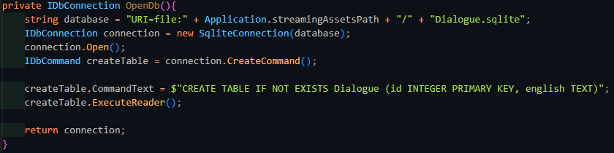

This code makes a reference to the StreamingAssets folder of Unity, which is how developers are able to include files unchanged with the build of their application. Usually when a file is included, it is serialized to make it easier and faster to load into memory. This also means that the format of the file changes, so it may no longer be possible to access it like you may have before. The way around this is StreamingAssets, which is where all the databases and .dlg files will exist. This version of the code does not take into account the different ways that different OS define paths to files, nor does it take into account that multiple different databases exist. To handle the different databases, and the different names for the columns, the function was changed to have two parameters: a string databaseName, and an array of strings that contained the columns. To handle the array, a string had to be made that combined the whole array into 1 string.

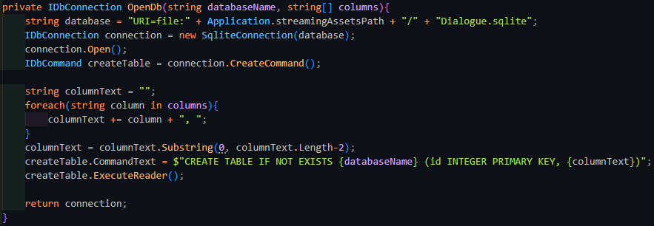

The for loop would iterate over each string in the array, and add it to the already combined total, along with a comma and a space to separate the different fields. The last field does not need a comma after it, so the last 2 characters will be cut off by taking a substring from the start of columnText, to 2 before the end of it.

To then fix the issue of the different OS, instead of concatenating strings together, I could use the Path class from System.IO which has a function that automatically stiches together a path with the appropriate connectors. I also discovered that C# had range slicing for substrings like Python did, and the code was far shorter to use, and as such I would be using the range operator going forward. To simplify the access of opening the actor or dialogue database to external classes, 2 public functions were made to fill in the required data into the OpenDb function.

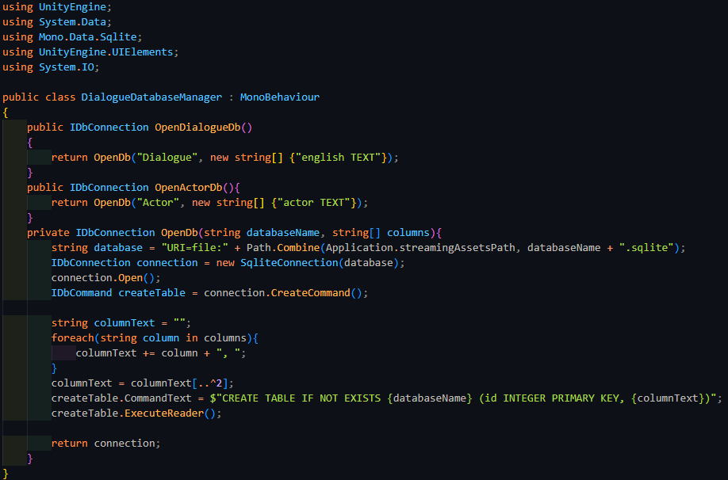

Now that other scripts could easily setup a connection with the dialogue or actor database, it was time to start implementing the .dlg files. When the program had to go through the file, it first needed to preprocess it and find where the dialog sections were on the lines of the file. This also needed me to be able to read the text within the file.

Unity has a built-in asset type called TextAsset, and the useful property of it was that the text could easily be extracted from within it with a single property. Writing code to sift through the lines and add it to a list of the line number and dialog section name was not terribly difficult.

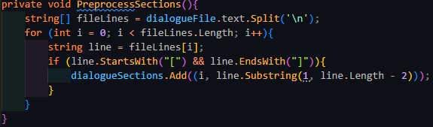

It consists of just a simple for loop, checking whether the end and start of a line had square brackets, the defining feature of dialog section headers. The code was extremely simple, but only if the .dlg file was to be recognised as a TextAsset. Unity unfortunately, was unable to do so, even with many attempts, including attempting to write a ScriptedImporter for the filetype.

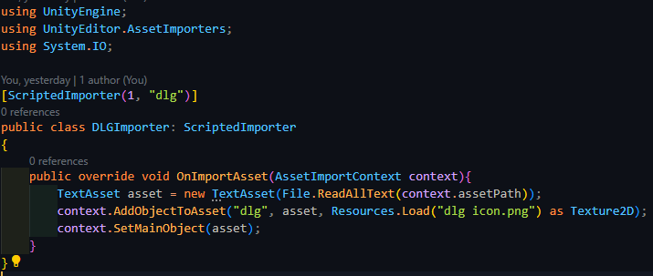

This was standard code to do the following, albeit without the icon (this was added as an easier check to see if the file was imported correctly), but unfortunately it would not work. Even after scouring for a solution to this problem, none were found, and as such I had to go for the less memory-efficient and slightly worse approach of using the C# method to open and reading file contents – StreamReader. While the File class exists, it turns out to be far slower to StreamReader on its own, and as such I went with the below changed code to accommodate StreamReader.

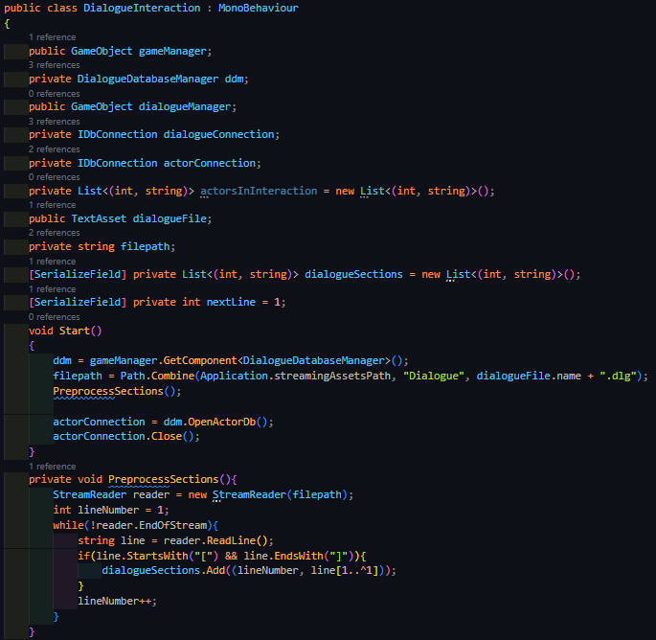

The new code is very similar to the previous, but has a custom counter instead, and reads off a new line using StreamReader.ReadLine(). It stops when the reader detects it has reached the end of the file.

The next part of this system that I will implement is the ability to convert between the syntax of the dialogue line in the database, and the Rich Text format used by Unity in text objects on the UI. This can be done by iterating through every character in the string and replacing certain characters with the appropriate alternate version. If the character it comes across is not part of the registered syntax, then it skips over it. Similarly, if it comes across a ‘\’, then it will skip over the next character as well.

While this works for the closing tag of the colour markings, a little bit more effort will be needed for the starting colour tag and the italics and bold markings. When reading the starting colour tag, the transpiler will cut out a substring of the line to read the following hex code of the colour. It is important that ++i is used instead of i++ to skip over the hashtag as the pre-increment shortcut and the post-increment shortcut differ in the values returned. i++ will return the current value and then increment it after the compiler has moved onto the next line (when it has passed a semi-colon), while ++i will return the current value incremented, not waiting for the next semi-colon. While this seems like they would have performance differences, the C# compiler when allowed to perform optimisations will optimise them to have the same run-time, leading to no performance decreases from using one or another. The substring can then be put into <color=> to form the final tag used by the Rich Text system, and the length of the hex code is skipped.

To handle bolding and italicising, the transpiler will keep track of whether it is has yet to reach the first italic or bold symbol out of the pair. If it reaches one, it puts in the appropriate opening tag and inverts the tracking variable. If it has already come across one and it comes across another, then it will place the opposing tag, and inverts that tracking variable.

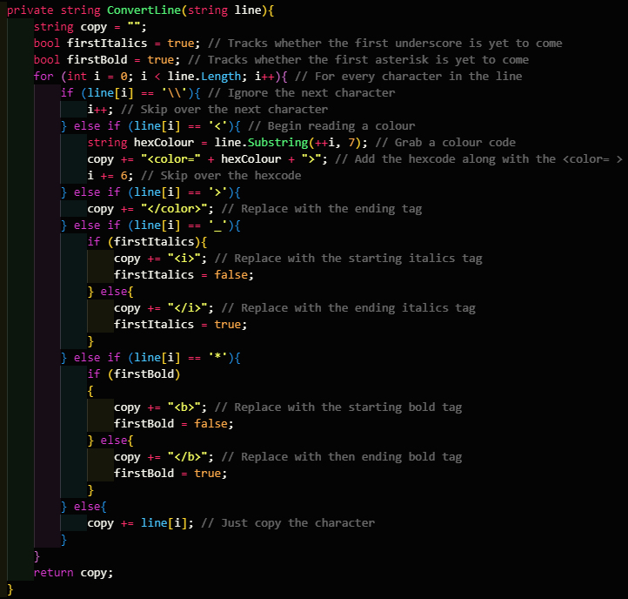

|  |  |  |  |  |  |
| --- | --- | --- | --- | --- | --- |
| Type | What data fits criteria | Justification | Expected | Actual | Comments |
| Valid | Reading normal syntax | The majority of the transpiler’s job is to deal with the syntax, and this makes sense as a valid test | The syntax will be replaced with the appropriate value | Passed |  |
| Valid | Reading a backslash | The transpiler must also be able to deal with an escaped character | The following character is skipped over | Passed |  |
| Boundary | Reading a character that is not part of the syntax | The majority of the line will be like this, but the transpiler should not interpret it as syntax | The character is passed through the system | Passed |  |



*(The testing output successfully formatted as Rich Text.)*

To move onto the tokenizer, the first thing that must be done is design a tree node data structure. Tokenizers will have a tree that allows them to navigate each token appropriately, since some tokens may have their own children. The tree node needs to have a list of its children, along with a dictionary of values assigned to it. It also has a simple method to add a type, which will be used constantly by the tokenizer, along with a method to retrieve the type.

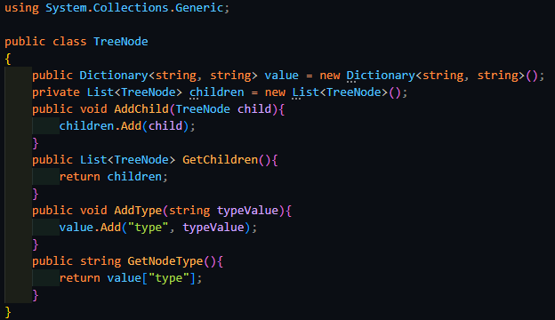

The tokenizer begins by checking if the file reader is null, and if it is, it makes a new StreamReader for the .dlg file. It then needs to skip over the lines that have already been read in the file, as it keeps a track of what line the interaction is on. Once it has skipped over the lines, it creates a new TreeNode called fileTree, which is necessary if the current line being read is a choice node, since multiple lines will need to be read instead of 1. Then so long as the file has not reached its end, the tokenizer will take the current line, convert it into a byte array so it can be used inside a MemoryStream object, which is then passed into another StreamReader. It checks whether the line’s length is below 3, since if line only has 3 characters, then there is no way it has enough information to be an entire line. This is because the minimum length a line can be comes about with the jump syntax which is 2 characters long. However, it also needs a section header afterwards, which is required to be at least 1 character long. Therefore, the minimum line length is 3. After this check, it makes a new TreeNode called lineTree, which tracks the tokens in a line, but does not inherently carry any information itself, and then adds this as a child of fileTree. The tokenizer will then create tokens from the line, after which it will then check if the last node has a type of ‘choice’. If so, then if this node does not also have ‘end’ in its dictionary, then the tokenizer must not return and continue onto the next line. It will then read the next line, checking that the next line both exists and is not a dialogue section header. If this is true, then the line number is incremented, and the current line is set to the line that was just read. If the node was not a choice node, the tokenizer then exists the loop and returns the fileTree.

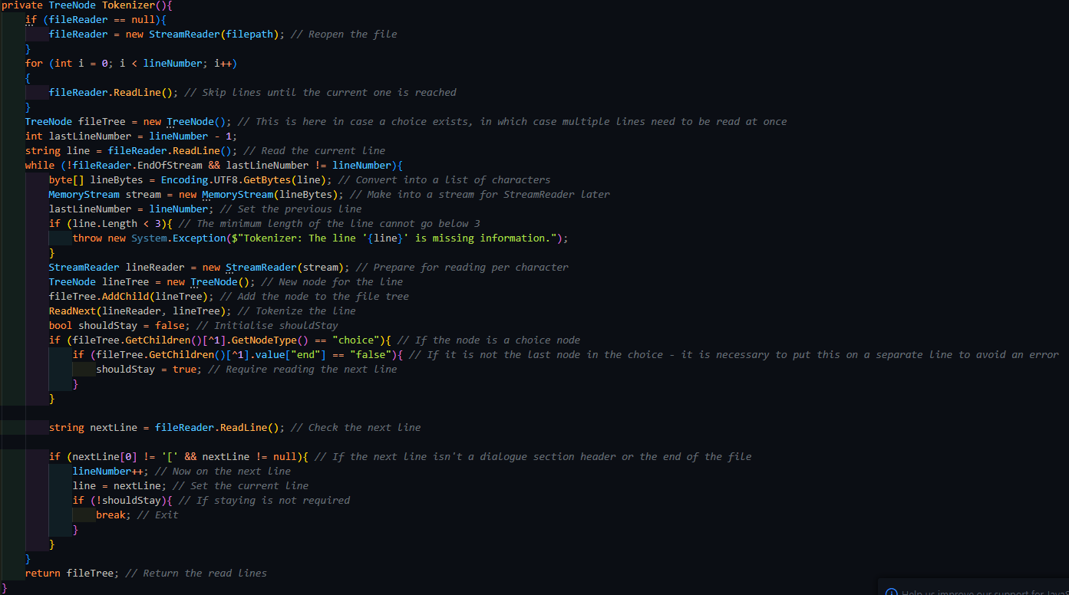

ReadNext() is essentially a dispatcher function, reading the next character in the line and deciding based on the character, it will decide what relevant function it needs to call to make a new token. It reads a new character using ReadChar(), which internally skips over spaces using the ASCII code of the character. Once a non-space character has been reached, it will attempt to cast it into a character, and it will return it. This might fail if there are no more characters left to read, in which case the read character will be equal to -1. If this is the case, it will return an error.

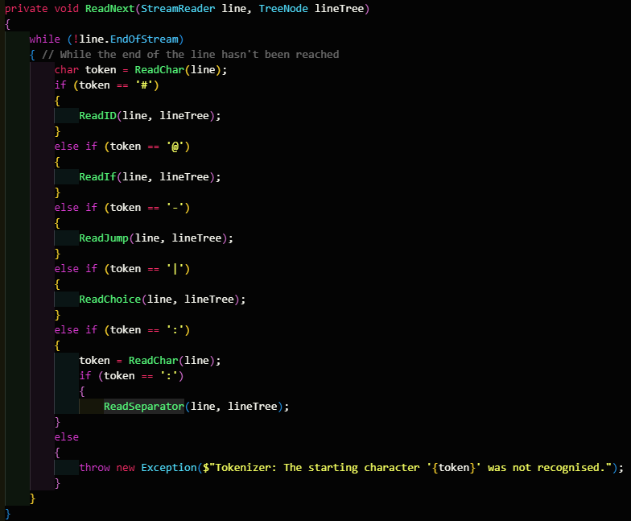

One of the functions it dispatches is ReadID(), which is called when the read character is a hashtag. It reads of an extra character and then knows that the next characters will be a number, which it dispatches ReadNumber() to handle. It stores the output into id, and then makes a new TreeNode, adding it to the line’s list of children. If the extra character that was read was an A, then the node is an actor. If it was an L, then the node is a line. If it was neither, then it raises an error, since it cannot understand what the type is supposed to be. After assigning the type to the node, it then adds id to the dictionary, using the key ‘id’.

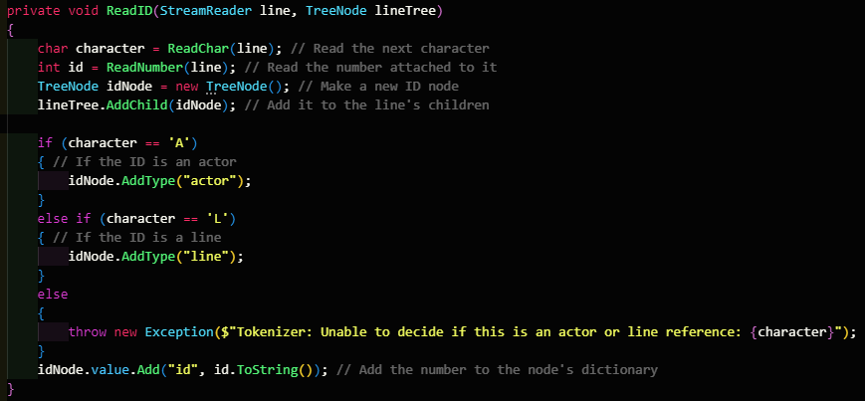

Internally, ReadNumber() peeks the next character using PeekChar() and checks whether the read character is a number. PeekChar() functions similarly to ReadChar(), but instead of consuming the character, it leaves it in the stream. If the peeked character is a number, then it reads it properly and appends it to the number as a string. When it finally reaches a character that isn’t a number, it will then attempt to parse the number into an integer, which it will promptly return.

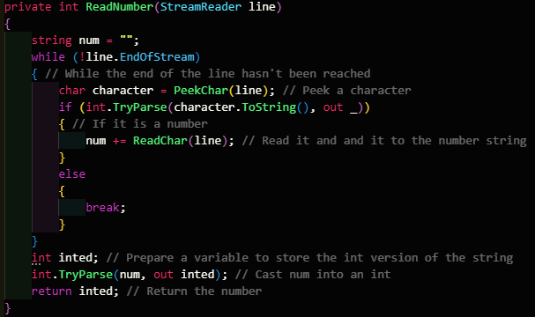

I realised that this code could be optimised. Since num was already confirmed to contain only numbers, there was no need to try to parse. Instead, int.Parse() could be used instead, saving an extra 32-bit number, and reducing the game’s memory footprint.



The other dispatcher functions work similarly, reading off the extra characters they need, and making a new node that stores the important information, after which, this node is added to the line’s child list. The only exception is ReadIf(), which must read a variable and an operator first before deciding what to do next. Both of these dispatched functions will make a node and add it as a child of ifNode. The next character is then checked whether it is a number or a letter; if it is a number, then ReadNumber() reads it and adds it as a child of ifNode. If it is a variable, ReadVariable() reads it off instead.

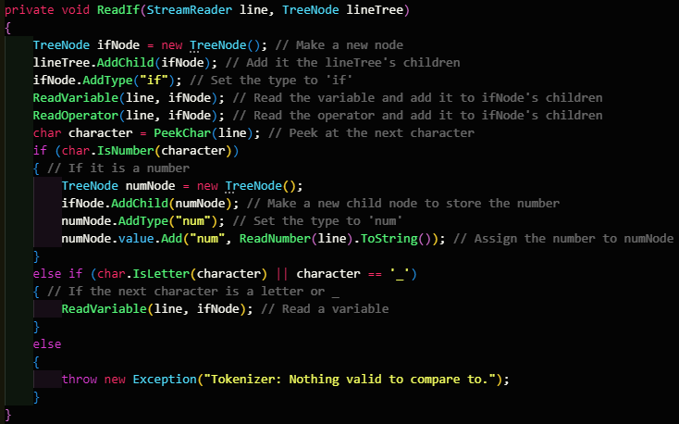

After the line has been tokenized in its entirety, it will then pass the output to Analyzer(), which will read the contents and will do the actual interpretation. First, it will find out how many dialogue lines are needed to be fetched and also make a version for the return value of Analyzer(). It will then analyse each child of fileTree, which requires analysing each child element within the line.

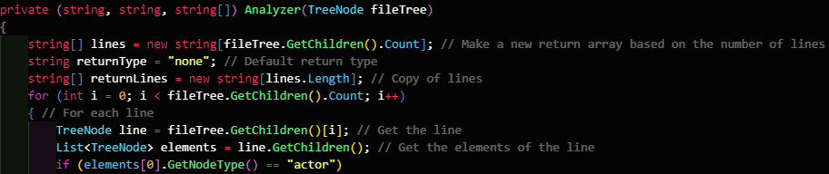

If the first node is an actor, the second node is a separation marker, and the third node is a line node, then returnType is ‘line’. This means only 1 line should be returned and as such all the lines need to be analysed properly, by querying the database and converting the output in LineAnalysis(). LineAnalysis() will return only 1 string, since it concatenates all the lines supplied to it. Just before it returns the line, it also removes the trailing space that will be there.

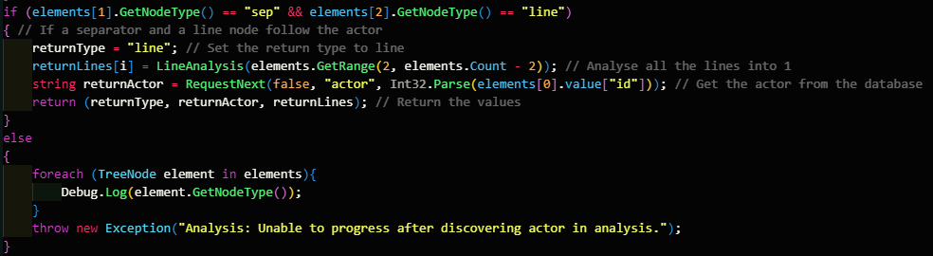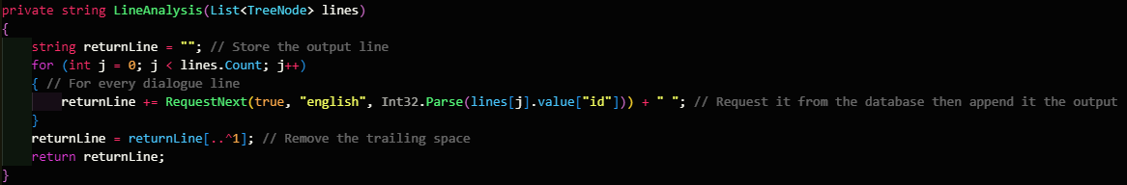

If the first node is instead a jump statement, returnType will be set to true to signal to the parent function, RequestNextLine(), that another line will need to be read. It will then use JumpToSection() to set lineNumber to the new line that the interpreter needs to start at.

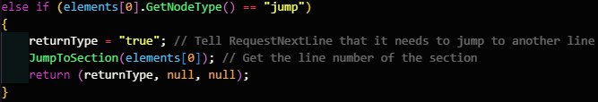

JumpToSection() simply checks the dictionary, dialogueSections, for the correct line number, and proceeds to the next line.

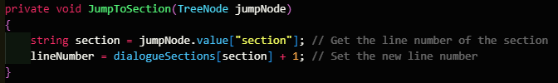

If the node is an if statement, then Analyzer() may need to signal that another line is needed. It first reads the third element, which is guaranteed to be a variable, and AnalyseIf() will hand the correcting parsing of this. If the if node is instead signalling that it is assigning a variable, the variable is retrieved. This variable may be choice, which is the internal marker for the node, in which case, the value calculated at the start of AnalyseIf() will be assigned to it. However, most likely, the variable is likely to be one in the save data, in which case, the game manager needs to use to request the assignment of the variable.

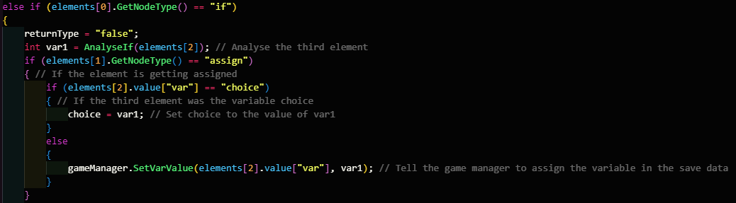

The game manager uses a special C# feature called reflection to work out which variable of the save data it is supposed to assign, based upon the name of the variable it is given. Reflection works by reading the metadata of the source code and attempts to find the relevant property from there. If the variable is found within the source code of WorldFlags, then saveData.worldFlags has the value set to the supplied variable.

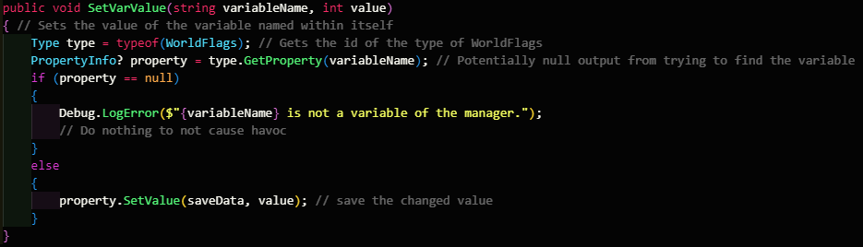

If the node is instead a comparison, then the other variable, which is the 4 one in the list, will be compared to the other in EvalComparison(), which is a switch statement based upon the operator supplied. The output of EvalComparison() will either be true or false, denoting whether the expression passed or failed. If it passed, then the jump node is read, and returnType is set to true, along with the new line number being fetched with JumpToSection().

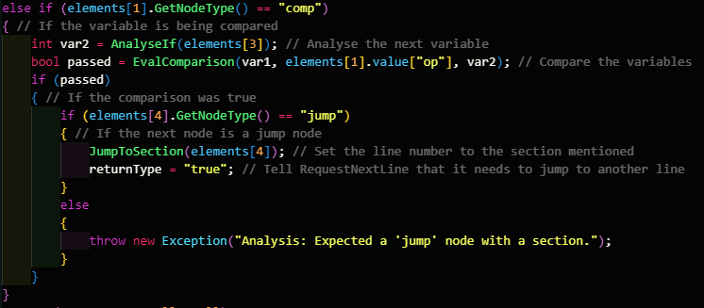

Within AnalyseIf(), the function checks whether the node supplied is a variable or a number. If it is variable, and it is ‘choice’, then the interaction specific variable is set. However, if it is not, then the game manager is contacted to retrieve the value of the variable from the save data.

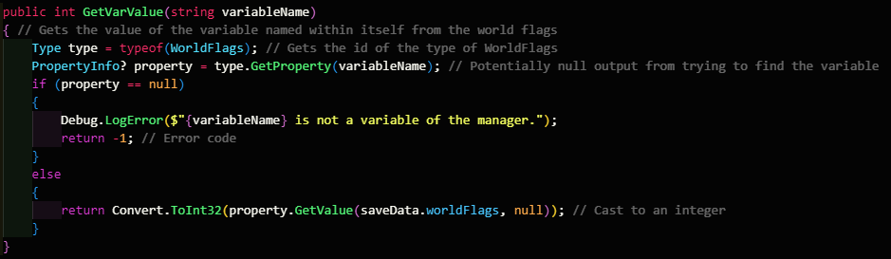

If the node is a number instead, then it is parsed and returned as such. This finalises the interpreter, but to call all this code, the interaction object first needs to receive an interaction request, which is handled with PlayerGunInteraction. That script already checks if the player is attempting to interact with a weapon, and so an extra check is added to check if the weapon is interactable. All interactable objects that aren’t weapons will inherit from the Interactable class, which sets the GameObject that it is assigned to have the Interact tag, while also defining an abstract Interact method. DialogueInteraction implements this method by retrieving a new line. If the output of the interpreter is of the type ‘line’, then it sent to the dialogue manager.

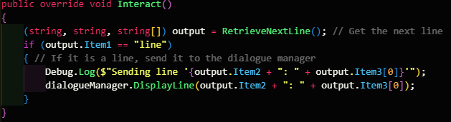

The dialogue manager contains a reference to the subtitle text object, and a list of the lines displayed on it. Each time a new line needs to be displayed, it checks whether the maximum lines has been reached, and if it has, it removes the first one and stops the fade-out timer that is attached to it, which automatically removes the line after a set amount of time.

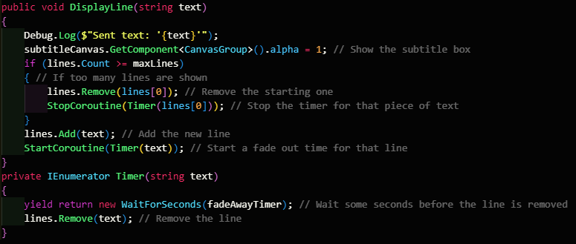

I consulted SillyAustralian on the time it should take for the line to fade away:

#### Interview

SillyAustralian: The text in the subtitle box should fade away after 2 seconds and should also remain visible in the pause menu. Also note that the deadline is almost up, so finish the testing for this feature and leave it at that.

Stakeholder Signature:



The final thing to touch up on was what the dialogue manager had to do every frame, which was assigning the contents of the subtitle window, or hiding it if no text was there. This is done with a for loop which pieces together the string that will be shown inside the UI element.

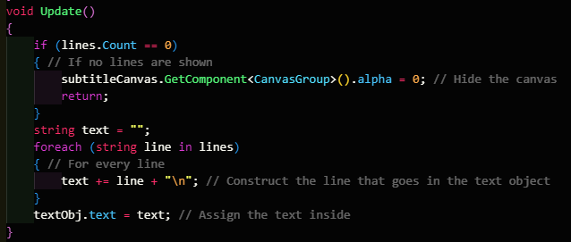

|  |  |  |  |  |  |
| --- | --- | --- | --- | --- | --- |
| Type | What data fits criteria | Justification | Expected | Actual | Comments |
| Valid | Requesting a line | The interaction will always attempt read a normal line, and so this must be tested correctly | The line is put onto the subtitle window, which is displayed, and then fades away after 2 seconds | Passed |  |
| Valid | Reading a line made of multiple pieces | Certain pieces of text may need to be repeated, and this can be made easier by requesting multiple lines from the database | The lines are pieced together and put onto the subtitle window, which is displayed, and then fades away after 2 seconds | Passed |  |
| Boundary | Reading a second line after reading 1 | The interaction will rarely end with one click, and this needs to be handled properly | The second line is added below the first in the subtitle menu, and fades away after 2 seconds | Failed: the interpreter skipped a line | Caused by skipping the lines incorrectly |
| Error | Requesting a line or actor that doesn’t exist in the database | The developer may forget to fill in the database appropriately, and this should be handled | An error is raised | Passed |  |
| Error | Reading a line that is lacking information | The developer may forget to complete the .dlg file, this must not be passed to the rest of the tokenizer | An error is raised | Passed |  |
| Error | Reading an unrecognised token | If the developer has not written the .dlg file properly, the tokenizer should warn them | An error is raised, specifying information on the error | Passed |  |

When reading multiple lines, the tokenizer is skipping lines. This can be solved by closing the file each time the tokenizer finishes, since the problem is caused by the StreamReader still being in memory when the tokenizer is run again. The best way to do this is the using statement, which automatically closes the file when outside it.



|  |  |  |  |  |  |
| --- | --- | --- | --- | --- | --- |
| Type | What data fits criteria | Justification | Expected | Actual | Comments |
| Boundary | Reading a second line after reading 1 | The interaction will rarely end with one click, and this needs to be handled properly | The second line is added below the first in the subtitle menu, and fades away after 2 seconds | Passed |  |

### End of prototype tests

#### Transpiling a line

|  |  |  |  |  |  |
| --- | --- | --- | --- | --- | --- |
| Type | What data fits criteria | Justification | Expected | Actual | Comments |
| Valid | Reading normal syntax | The majority of the transpiler’s job is to deal with the syntax, and this makes sense as a valid test | The syntax will be replaced with the appropriate value | Passed |  |
| Valid | Reading a backslash | The transpiler must also be able to deal with an escaped character | The following character is skipped over | Passed |  |
| Boundary | Reading a character that is not part of the syntax | The majority of the line will be like this, but the transpiler should not interpret it as syntax | The character is passed through the system | Passed |  |

#### Dialogue Interaction

|  |  |  |  |  |  |
| --- | --- | --- | --- | --- | --- |
| Type | What data fits criteria | Justification | Expected | Actual | Comments |
| Valid | Requesting a line | The interaction will always attempt read a normal line, and so this must be tested correctly | The line is put onto the subtitle window, which is displayed, and then fades away after 2 seconds | Passed |  |
| Valid | Reading a line made of multiple pieces | Certain pieces of text may need to be repeated, and this can be made easier by requesting multiple lines from the database | The lines are pieced together and put onto the subtitle window, which is displayed, and then fades away after 2 seconds | Passed |  |
| Boundary | Reading a second line after reading 1 | The interaction will rarely end with one click, and this needs to be handled properly | The second line is added below the first in the subtitle menu, and fades away after 2 seconds | Passed |  |
| Error | Requesting a line or actor that doesn’t exist in the database | The developer may forget to fill in the database appropriately, and this should be handled | An error is raised | Passed |  |
| Error | Reading a line that is lacking information | The developer may forget to complete the .dlg file, this must not be passed to the rest of the tokenizer | An error is raised | Passed |  |
| Error | Reading an unrecognised token | If the developer has not written the .dlg file properly, the tokenizer should warn them | An error is raised, specifying information on the error | Passed |  |

### Interview

SillyAustralian: Reading a line with an actor works well, including the optional extra of reading the multiple lines from the database in one line. Nothing else needs to be added.

Stakeholder Signature:



# Evaluation

## Evaluative Testing

Since the game is in a playable state, these tests will all be completed by both stakeholders and also filled in by them, unless specified otherwise.

### Robustness

These tests will make sure that the game fulfils the minimum hardware requirements, and this will be possible to test since SillyAustralian runs a game development company. These companies have access to many machines that fulfil different expected hardware combinations and some of these that follow the typical hardware detailed in the success criteria will be used to run these tests. Making sure that the game never dips below 30 fps will be achieved using the logging option in the FPS counter, which can be analysed afterwards to make sure the game doesn’t dip far below 30.

|  |  |  |  |  |
| --- | --- | --- | --- | --- |
| Type | What data fits criteria | Justification | Expected | Actual |
| Normal | Play the game in the normal scene, with few elements | The player will typically experience the game like this, with a reasonable number of objects | The game not run below 30 fps | Pass – The game typically ran at 1600 fps |
| Intense | Playing the game in a scene with lots of entities | In case the player is chased by many enemies, the game should be able to handle this well | The game not run below 30 fps | Pass – The game typically ran at 1250 fps |

#### Evidence – Normal

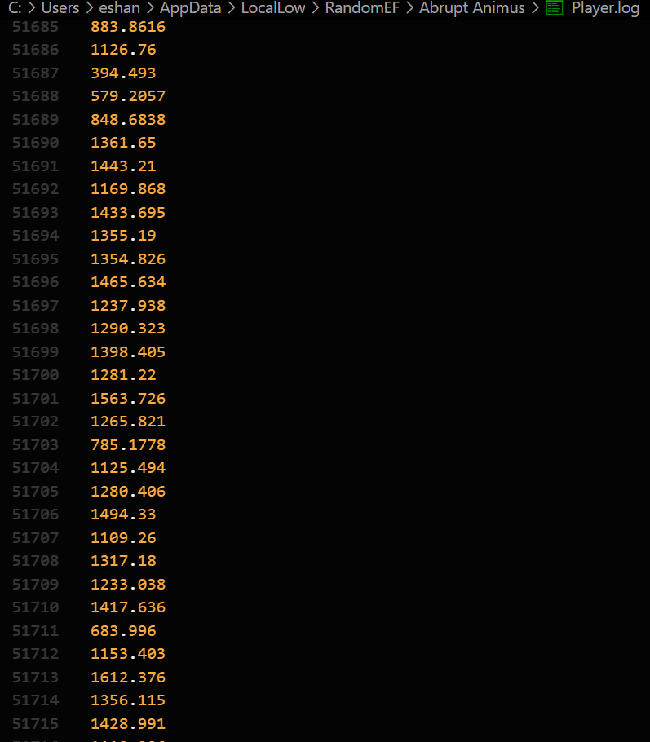

#### Evidence – Intense

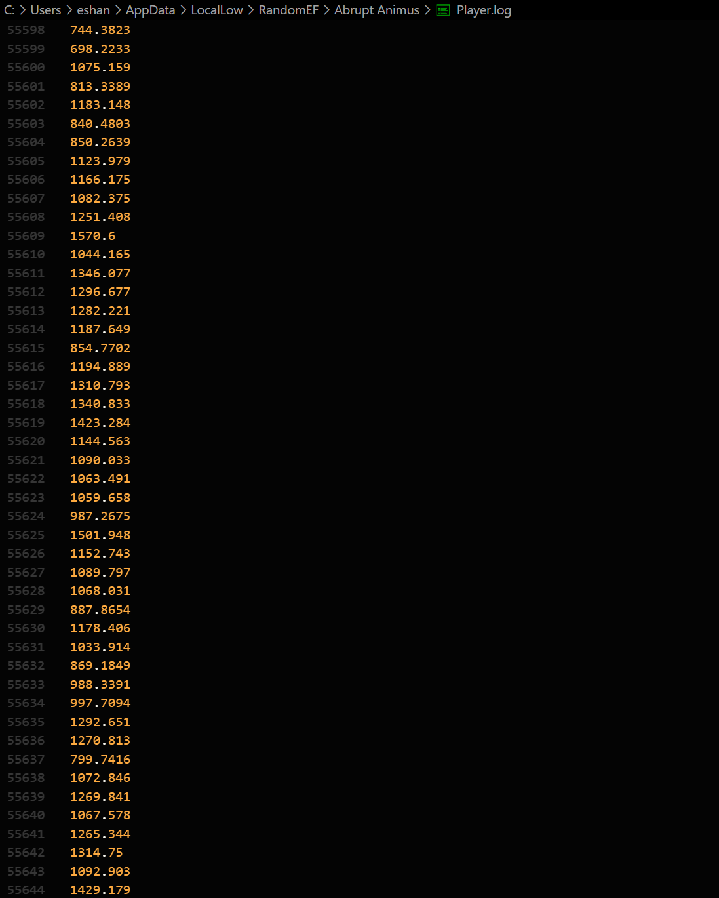

### Glitches

The tests make sure that the player does not have a frustrating experience and will all be completed by the CEO of DrunkDriving, Amarveer Flora. These will be marked with the severity, from mild, to medium, to severe, and finally game-breaking.

|  |  |  |  |  |
| --- | --- | --- | --- | --- |
| Type | Justification | Example | Severity | Steps to reproduce |
| Input | Any glitches with the player’s input will be unsatisfactory, and may frustrate the player | The movement is jittery when the playing is not holding any input | Mild | Press any strafing input and then don’t press another |
| Loading | Any glitches that affect the loading of the game can cause unpleasant results | When loading a save, any weapons that the player picked up in the world respawn | Mild | Pick up a weapon in the current levels, save, and then load again |
| UI | Glitches that affect the UI can range from being an inconvenience to game breaking | The HUD disappears when the player uses load within the pause menu; it can be fixed by opening and closing the pause menu | Medium | Open the pause menu, press load |
| Dialogue | Glitches that deal with the dialogue system can be very difficult to debug, but do not tend to break the game | The system sometimes reads the dialogue section as a line and fails | Mild | Have an if statement that fails with a dialogue section header right after |

#### Jittery movement

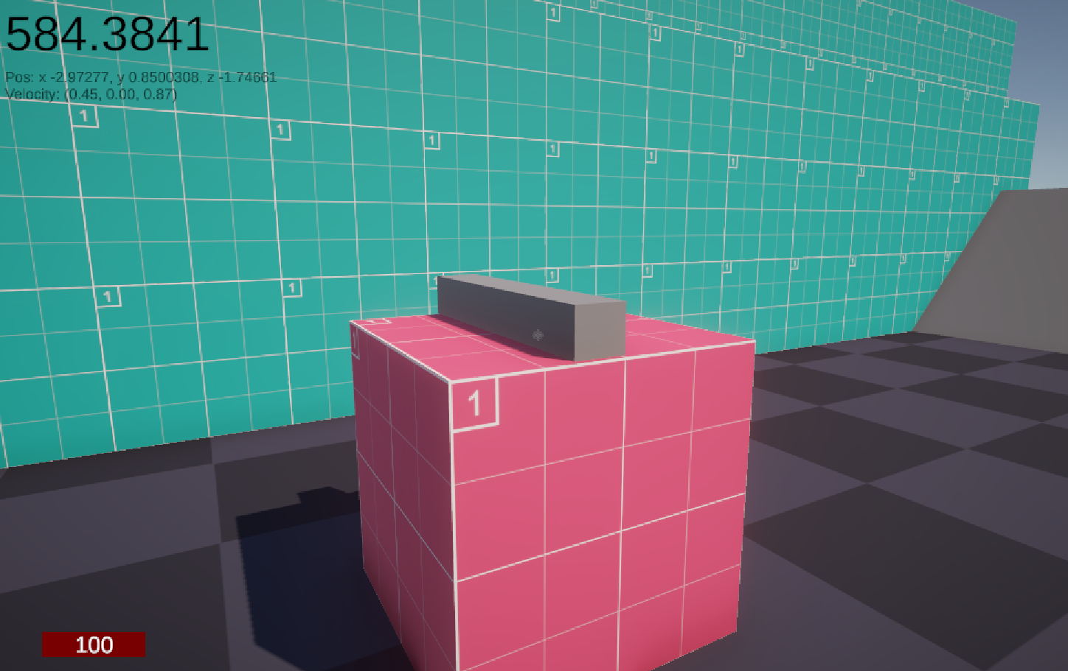

*(The player still has a small amount of velocity despite not holding any input for the past couple of seconds, see in the top left)*

This bug is somewhat annoying for the player’s experience but only affects them when there are no inputs applied, which is why this has been marked as being of mild severity. This issue exists with one of the functions related to movement, such as FrictionMultiplier() and its use in Movement(), which can be fixed in the future. This will affect the player’s experience and could potentially change many properties with how the player moves, therefore meaning it should be one of the first bugs to be fixed.

#### Weapon duplication

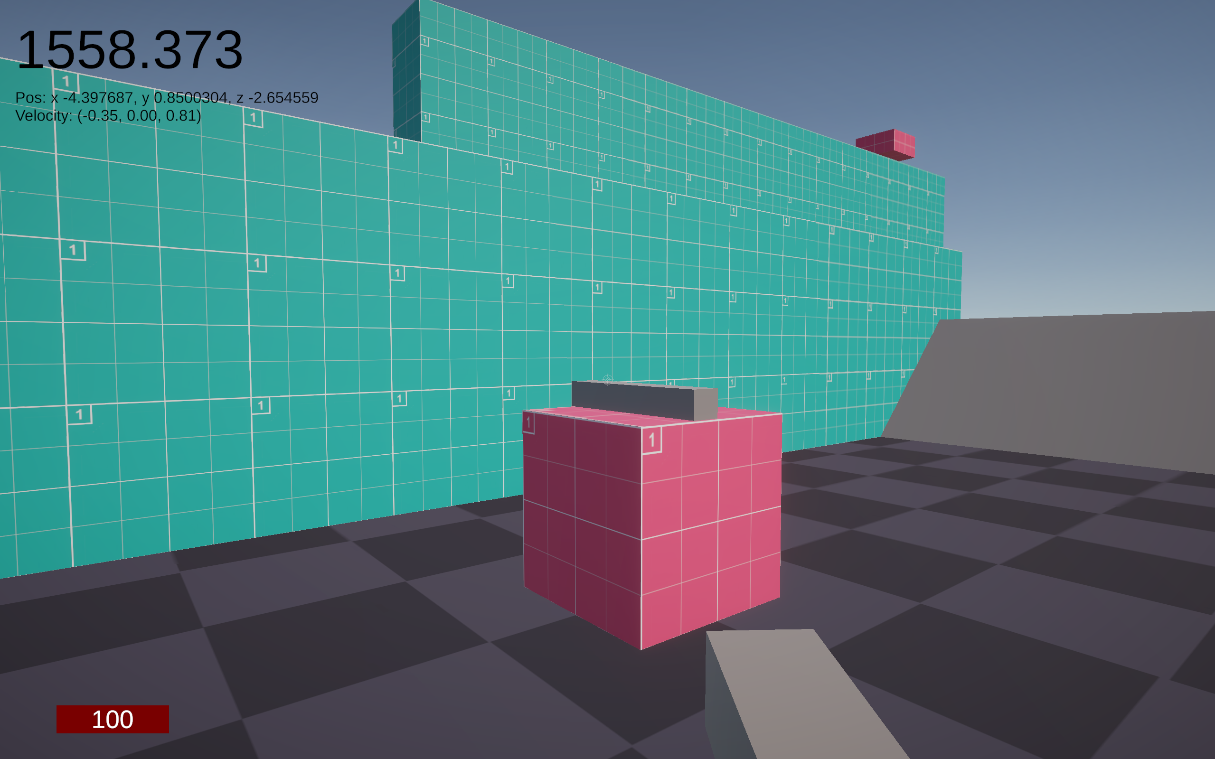

*(The player has already picked up the weapon in the centre, as it is the one the player is currently holding)*

Caused by the loading progression and the way the save system works, this glitch is classified as mild severity, since it does not hinder the player’s experience. In fact, it does the opposite – it gives the player more weapons to use. This is unintended, however, and has hence been classified as a mild bug by Amarveer Flora. To solve this, every weapon in the scene needs to be given a unique ID and be given to the player’s weapon slots instead of the weapons being instantiated. This would require a minor rework of the save system and the contents of ApplyData(), which is where the weapons are given to the player.

#### HUD Disappearance

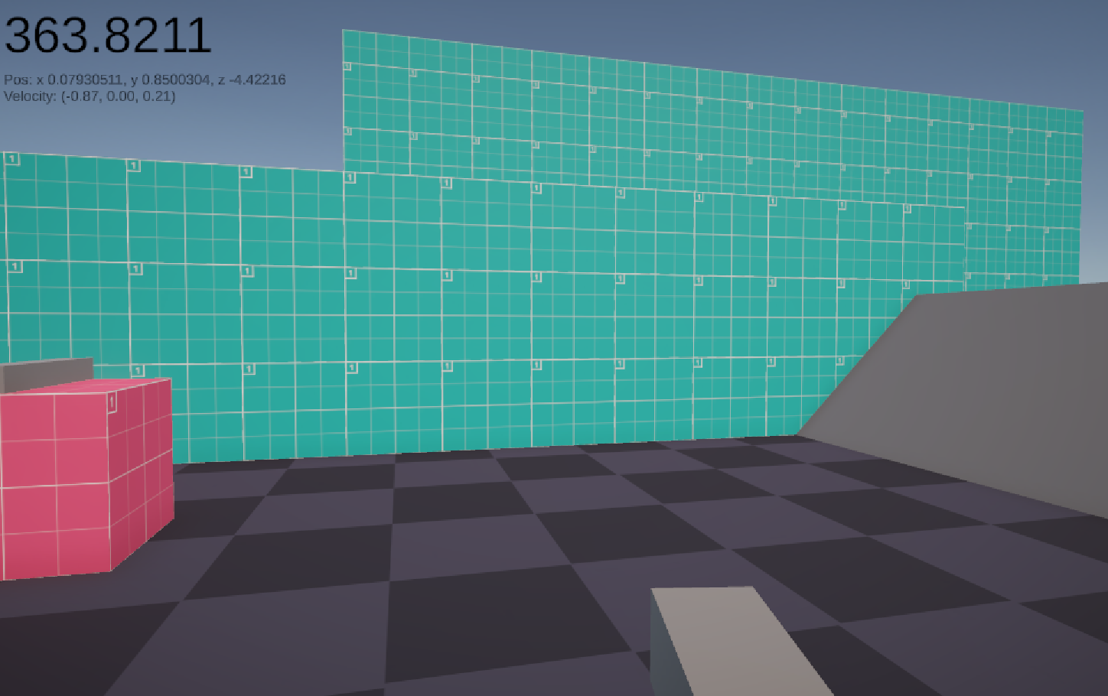

*(The HUD has disappeared)*

This one has been marked as medium severity due to it hindering the player’s ability to see important information in the game. It seems to be caused by the action of reloading the scene, which leads to the HUD not being re-enabled. It was originally disabled when the pause menu was selected, which was itself disabled by the reloading of the level. MenuManager may be changing the currently opened menu before the scene is reloaded, which would close any open menu automatically. A scene reload does also not incur the SceneManager.sceneLoaded event, which would tell the game manager to open the correct menu. Moving forward, fixing this would require some changes to the activation order of the scripts. Interestingly, the HUD can be returned by opening the pause menu and then closing it, which brings it back due to the HUD being the last opened menu in the records of MenuManager. Due to this, the issue was only marked as medium severity and not severe, since the player is able to reopen the menu if they open the pause menu.

#### Dialogue if skip

When the dialogue script has an if statement whose outcome results in false, the interpreter will typically move forwards in the script, resulting in the line number being incremented. However, when this new line is a dialogue section header, the interpreter will fail due to the characters used to signify a section header is not recognised by the tokenizer, and hence the following parts of the interpreter. This is a mild issue, since it requires the interpreter to recognise the symbol and either move back a line or forward a line depending on where it is in the script. This can be added in the future by SillyAustralian’s team and should not be that difficult of a fix. This has led to the bug being marked as a mild bug, especially since it only activates when the player reaches that point and does not hinder the player’s ability to play the game normally, nor does it crash it.

### Strafing

Tests for strafing will be evaluated using the floor, which will have a prototype texture across it. This prototype texture will accurately mark 1 metre intervals upon it. It can also be secondarily verified using the position shown in the debug screen in the top left corner. The HUD was disabled for these tests.

|  |  |  |  |  |
| --- | --- | --- | --- | --- |
| What data fits criteria | Justification | Expected | Pass/Partial/Fail | Comments |
| Pressing the left input, then releasing | These 8 tests relate to the different valid input directions that the player can supply, and every single one should work | The player moves left and stops | Pass |  |
| Pressing the right input, then releasing | The player moves right and stops | Pass |  |
| Pressing the up input, then releasing | The player moves up and stops | Pass |  |
| Pressing the down input, then releasing | The player moves down and stops | Pass |  |
| Pressing the left and up input, then releasing | The player moves north-west and stops | Pass |  |
| Pressing the left and down input, then releasing | The player moves south-west and stops | Pass |  |
| Pressing the right and up input, then releasing | The player moves north-east and stops | Pass |  |
| Pressing the right and down input, then releasing | The player moves south-east and stops | Pass |  |
| Pressing the right and left input, then releasing | While not leading to any overall movement, it is an input the player can make that is made of completely valid inputs | The player doesn’t move | Pass |  |
| Pressing the up and down input, then releasing | The player doesn’t move | Pass |  |
| Pressing no input | Testing for the lack of inputs is also something that can happen on any frame, and must be tested correctly | The player doesn’t move | Pass |  |
| Pressing an unrelated key (e.g. M) | This is invalid and should not affect the strafing system, and must be dealt properly | The player doesn’t move | Pass |  |

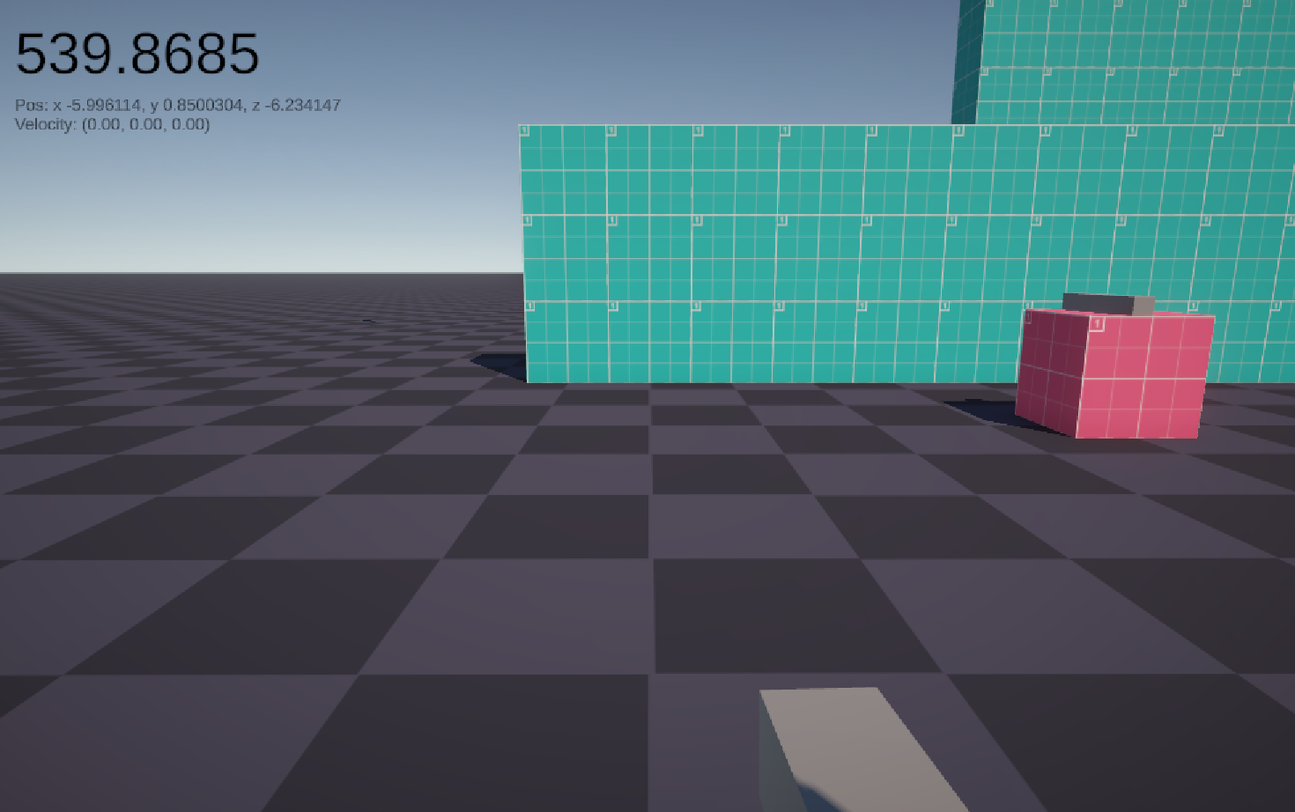

*(The player starts here)*

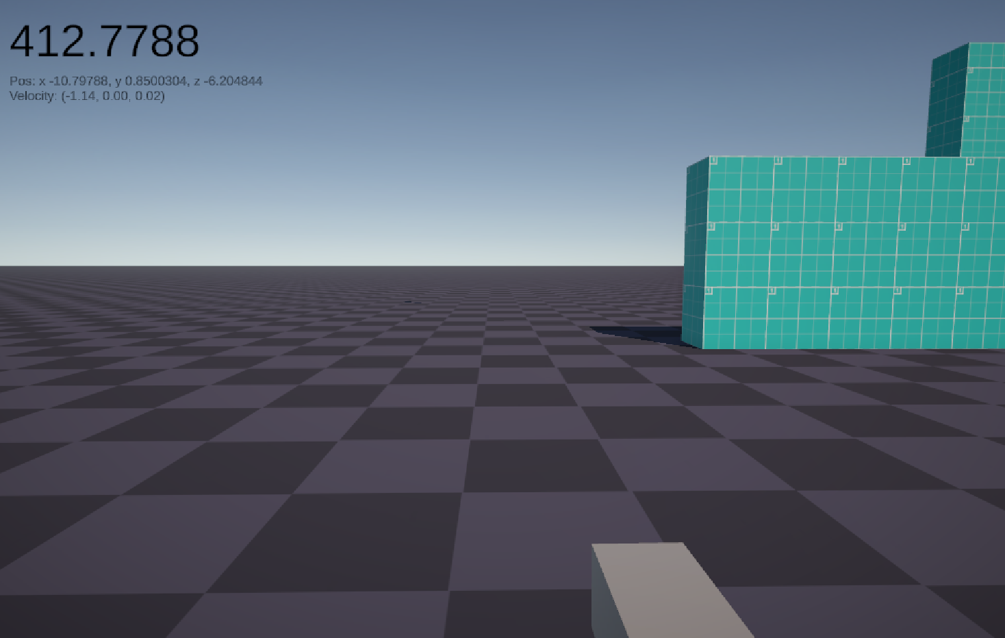

*(Moving left)*

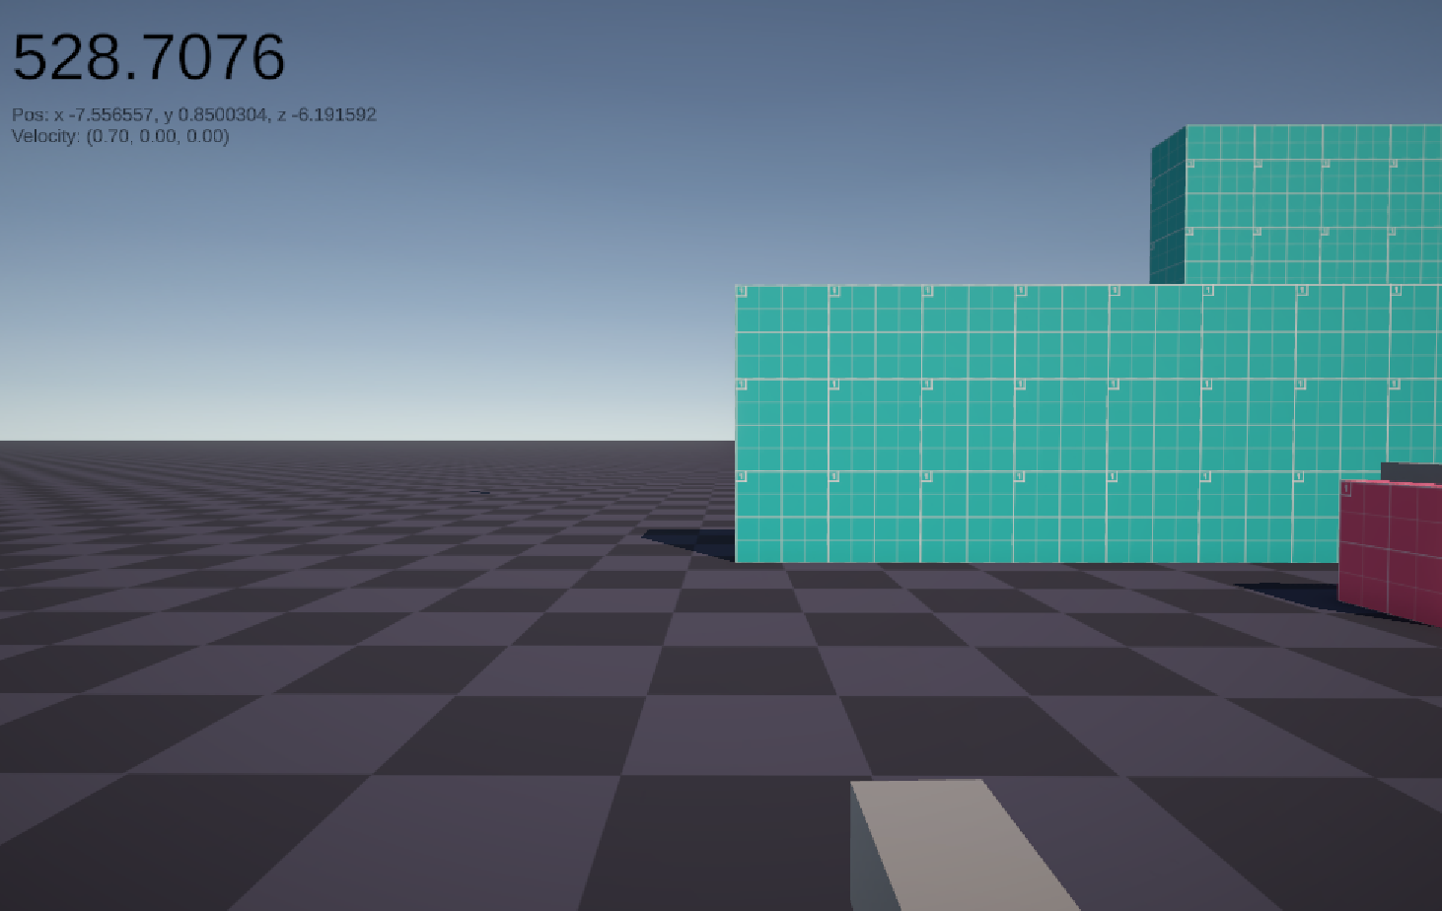

*(Moving right)*

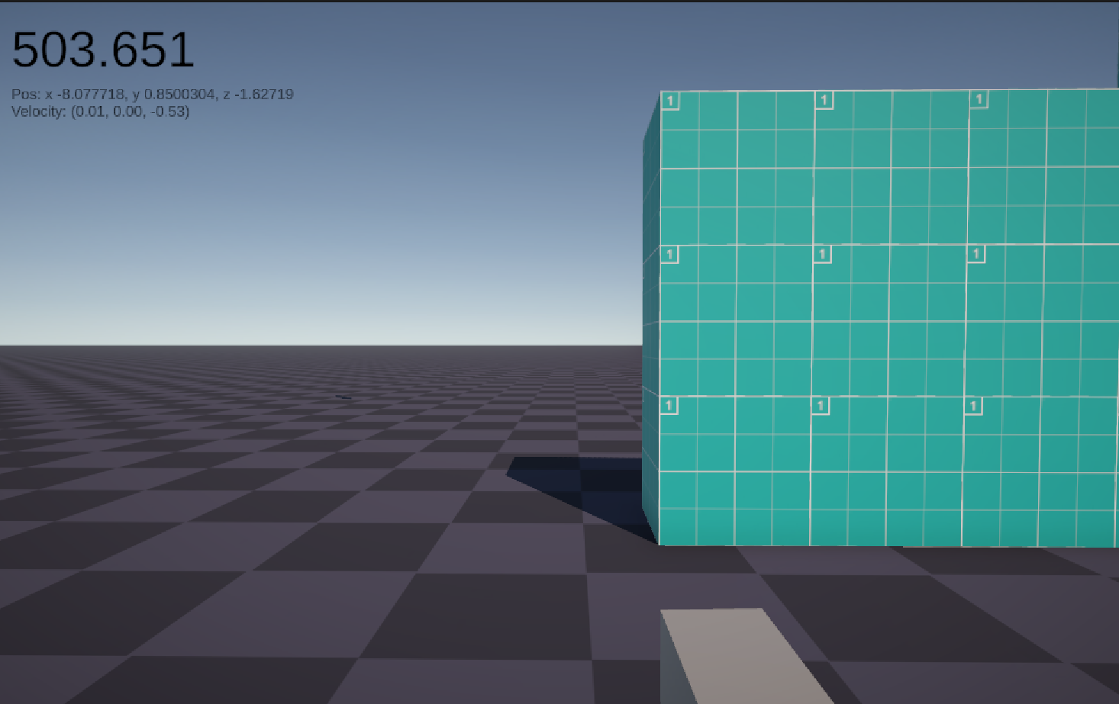

*(Moving forwards)*

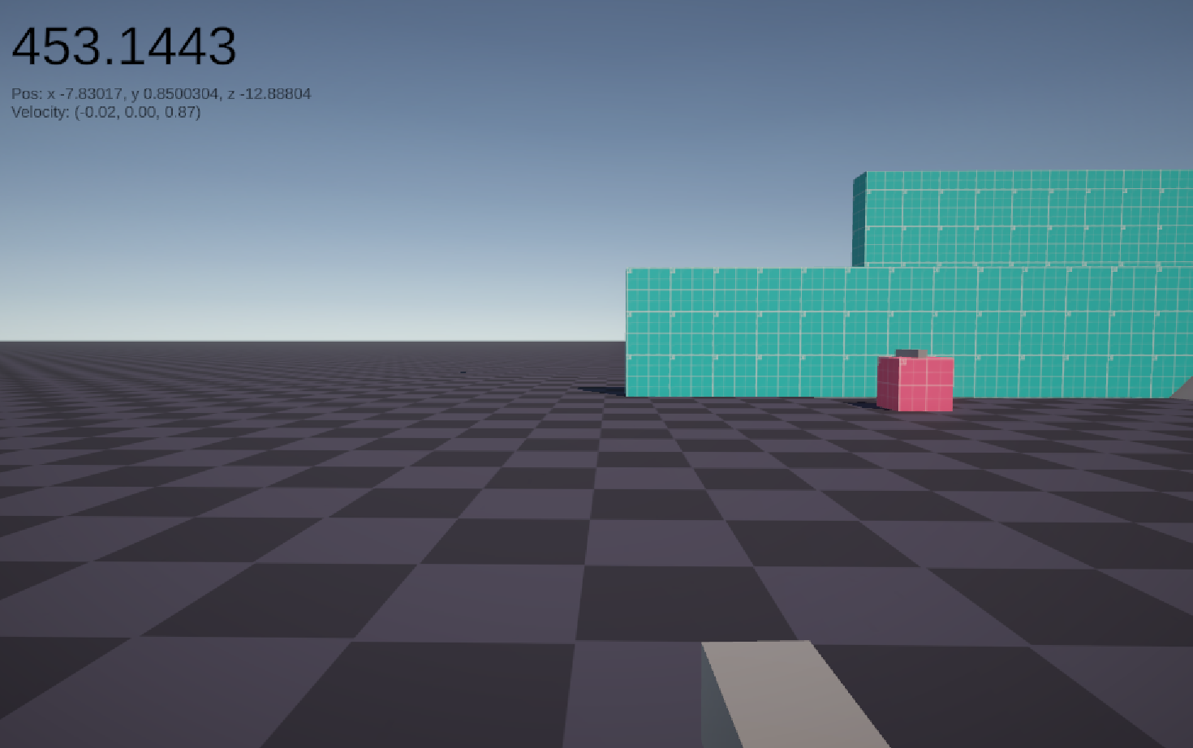

*(Moving backwards)*

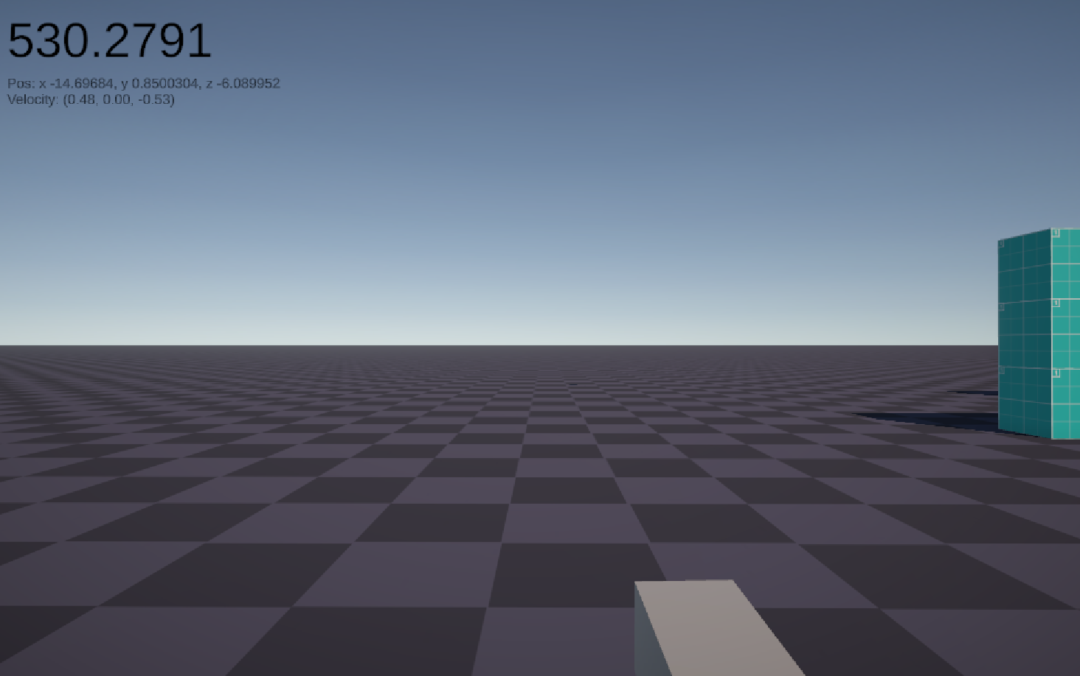

*(Moving north-west)*

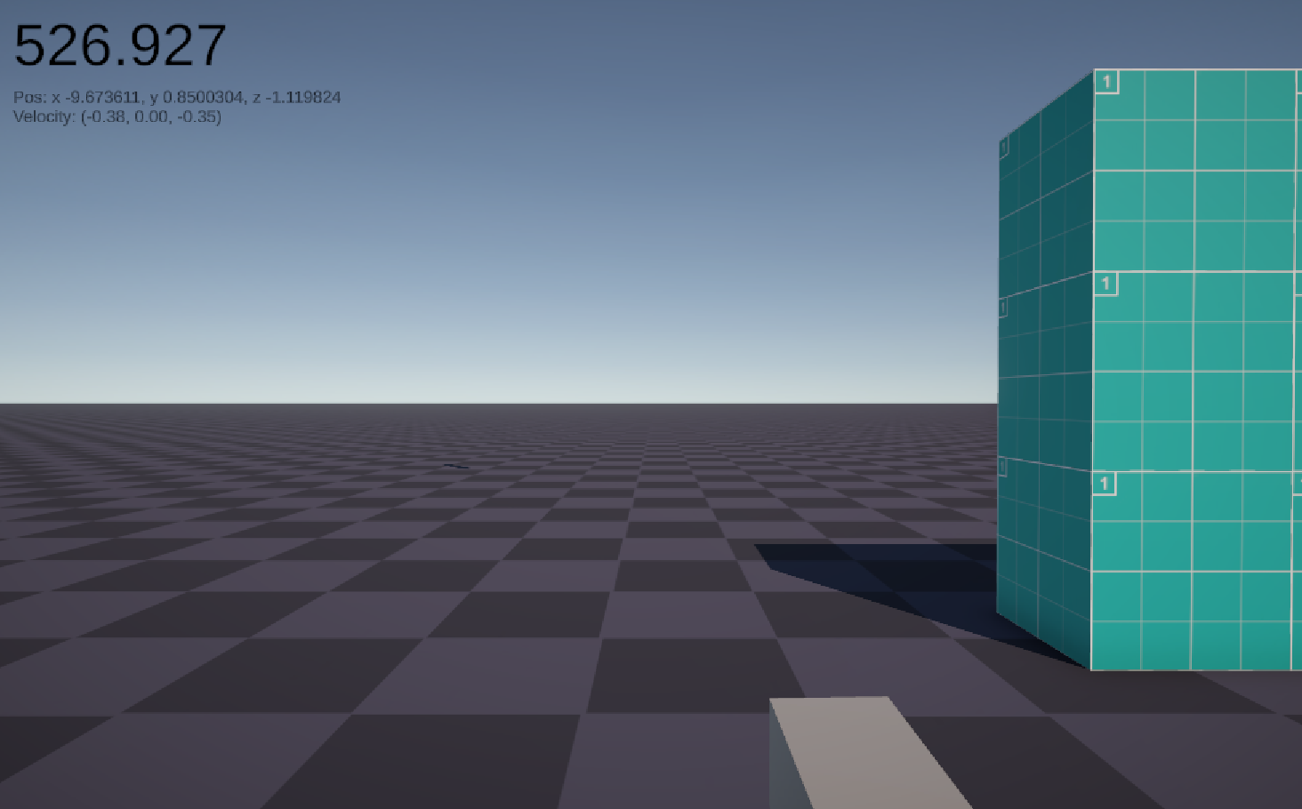

*(Moving north-east)*

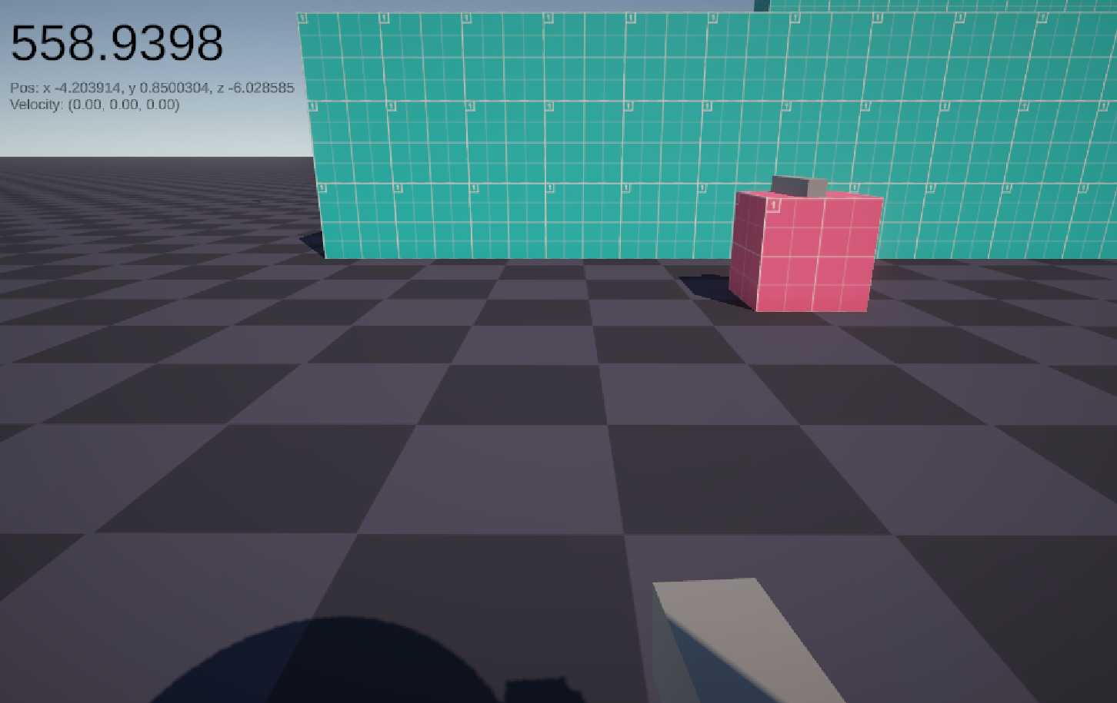

*(Moving south-east)*

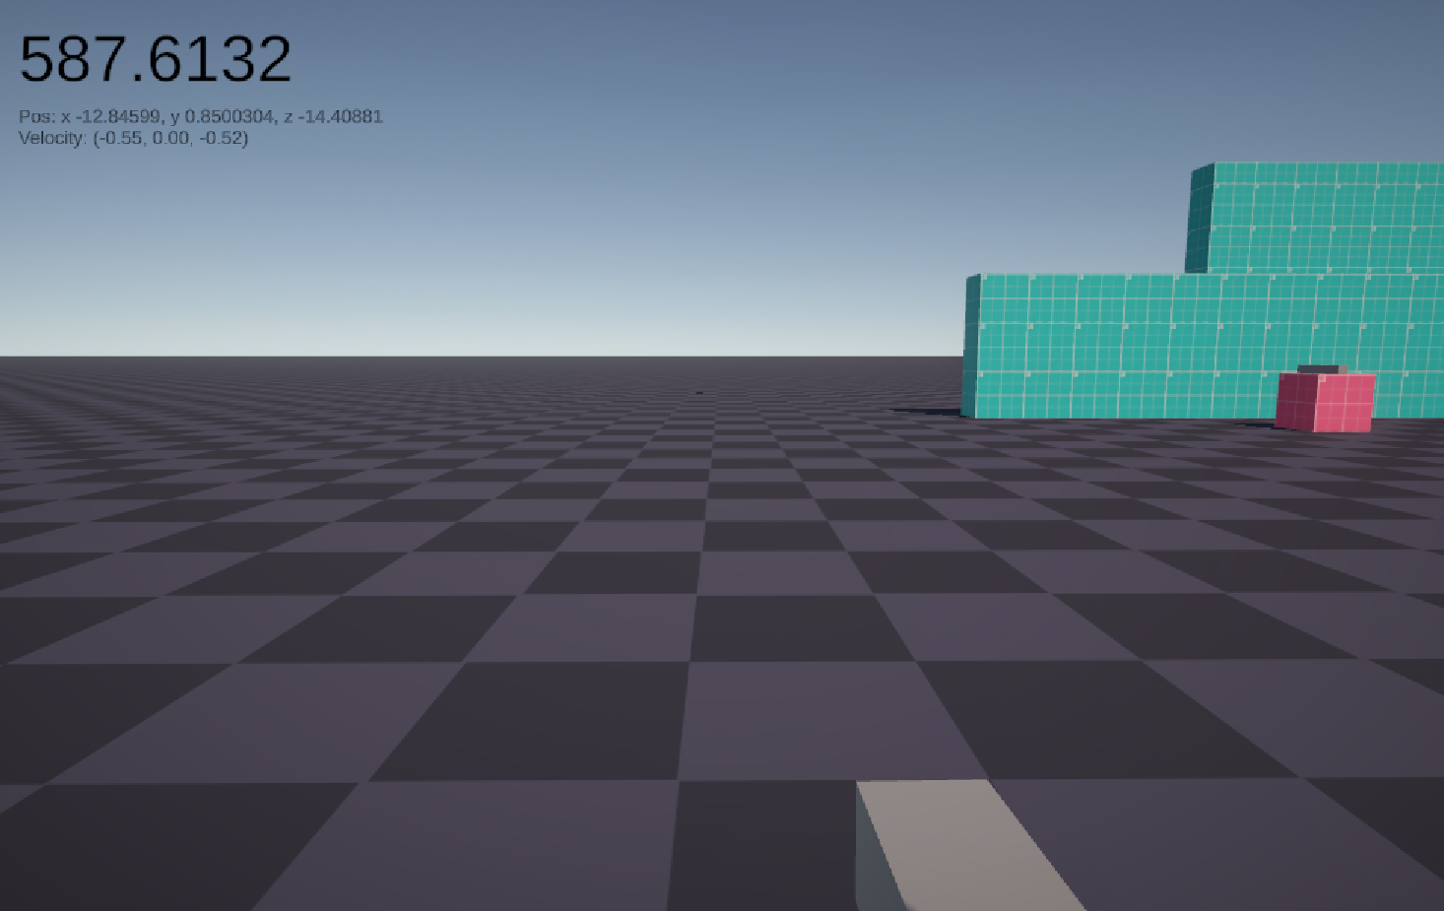

*(Moving south-west)*

### Jumping

Tests for jumping will be evaluated using a wall, which will have a prototype texture across it. This prototype texture will accurately mark 1 metre intervals upon it. It can also be secondarily verified using the position shown in the debug screen in the top left corner. The HUD was disabled for these tests.

|  |  |  |  |  |
| --- | --- | --- | --- | --- |
| What data fits criteria | Justification | Expected | Pass/Partial/Fail | Comments |
| Pressing the jump input | This is the key the player will press when they want to jump up, and so should be tested correctly | The player moves upwards | Pass |  |
| Pressing the jump input while in midair and moving upwards with air jumps remaining | This will test the player’s ability to double jump, which will allow the player to reach slightly further distances | The player moves upwards | Pass |  |
| Pressing the jump input while in midair and moving downwards | The player moves upwards | Pass |  |
| Pressing the jump input while in midair and moving upwards with no air jumps remaining | The player continues moving upwards that they are moving – the input is effectively ignored | Pass |  |
| Pressing the jump input while in midair and moving downwards with no air jumps remaining | The player continues moving downwards that they are moving – the input is effectively ignored | Pass |  |
| Pressing no input | Testing for the lack of inputs is also something that can happen on any frame, and must be tested correctly | The player doesn’t move | Pass |  |
| Pressing an unrelated key (e.g. M) | This is invalid and should not affect the jumping system, and must be dealt properly | The player doesn’t move | Pass |  |

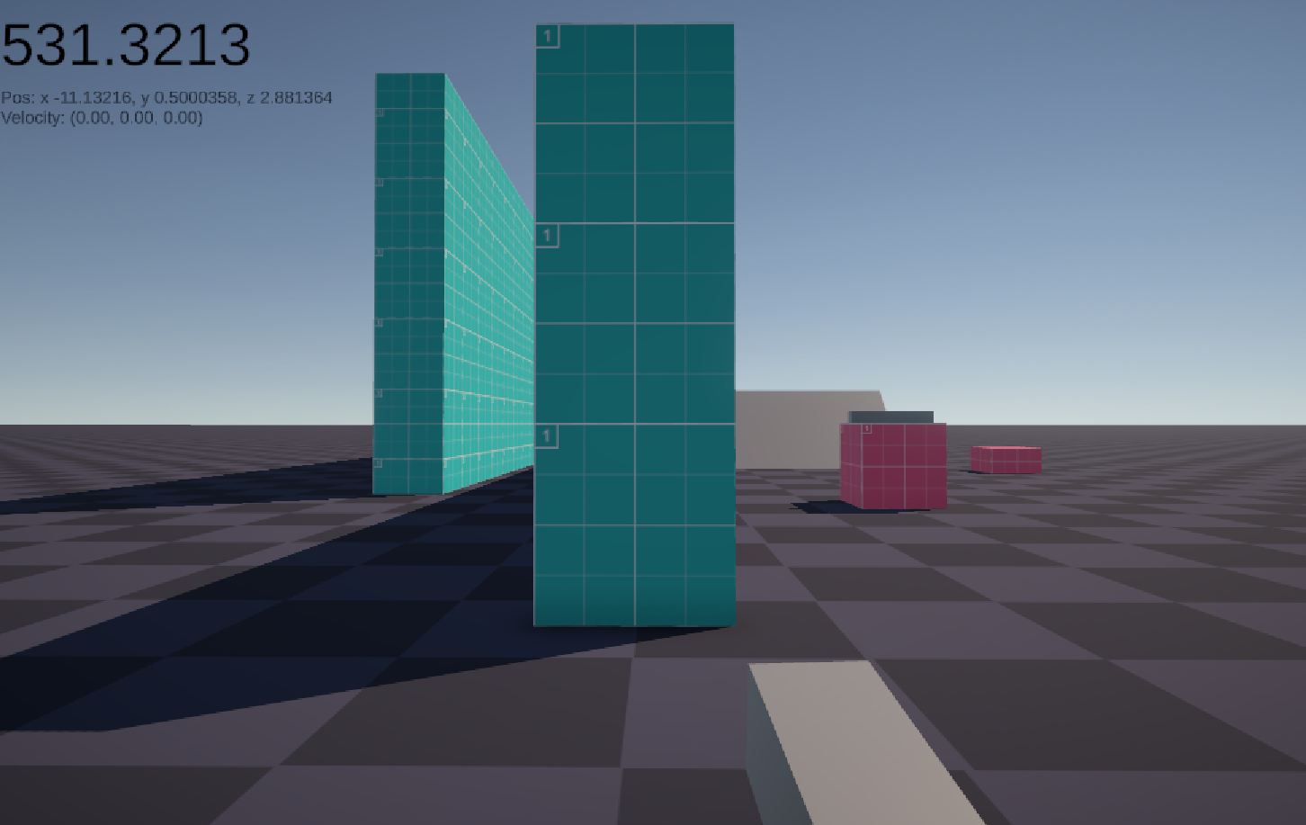

*(The player starts on the ground)*

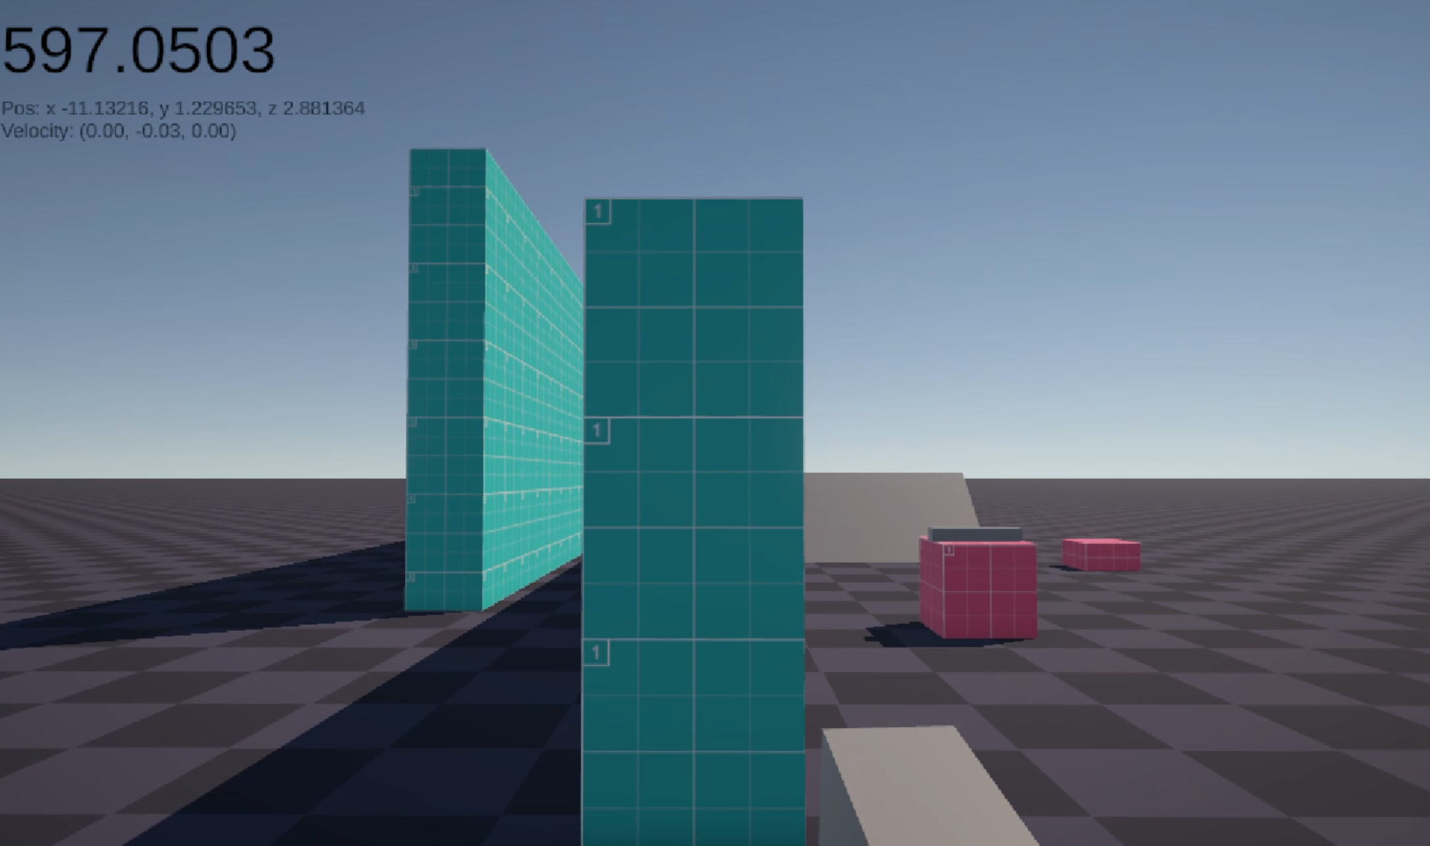

*(The player jumps)*

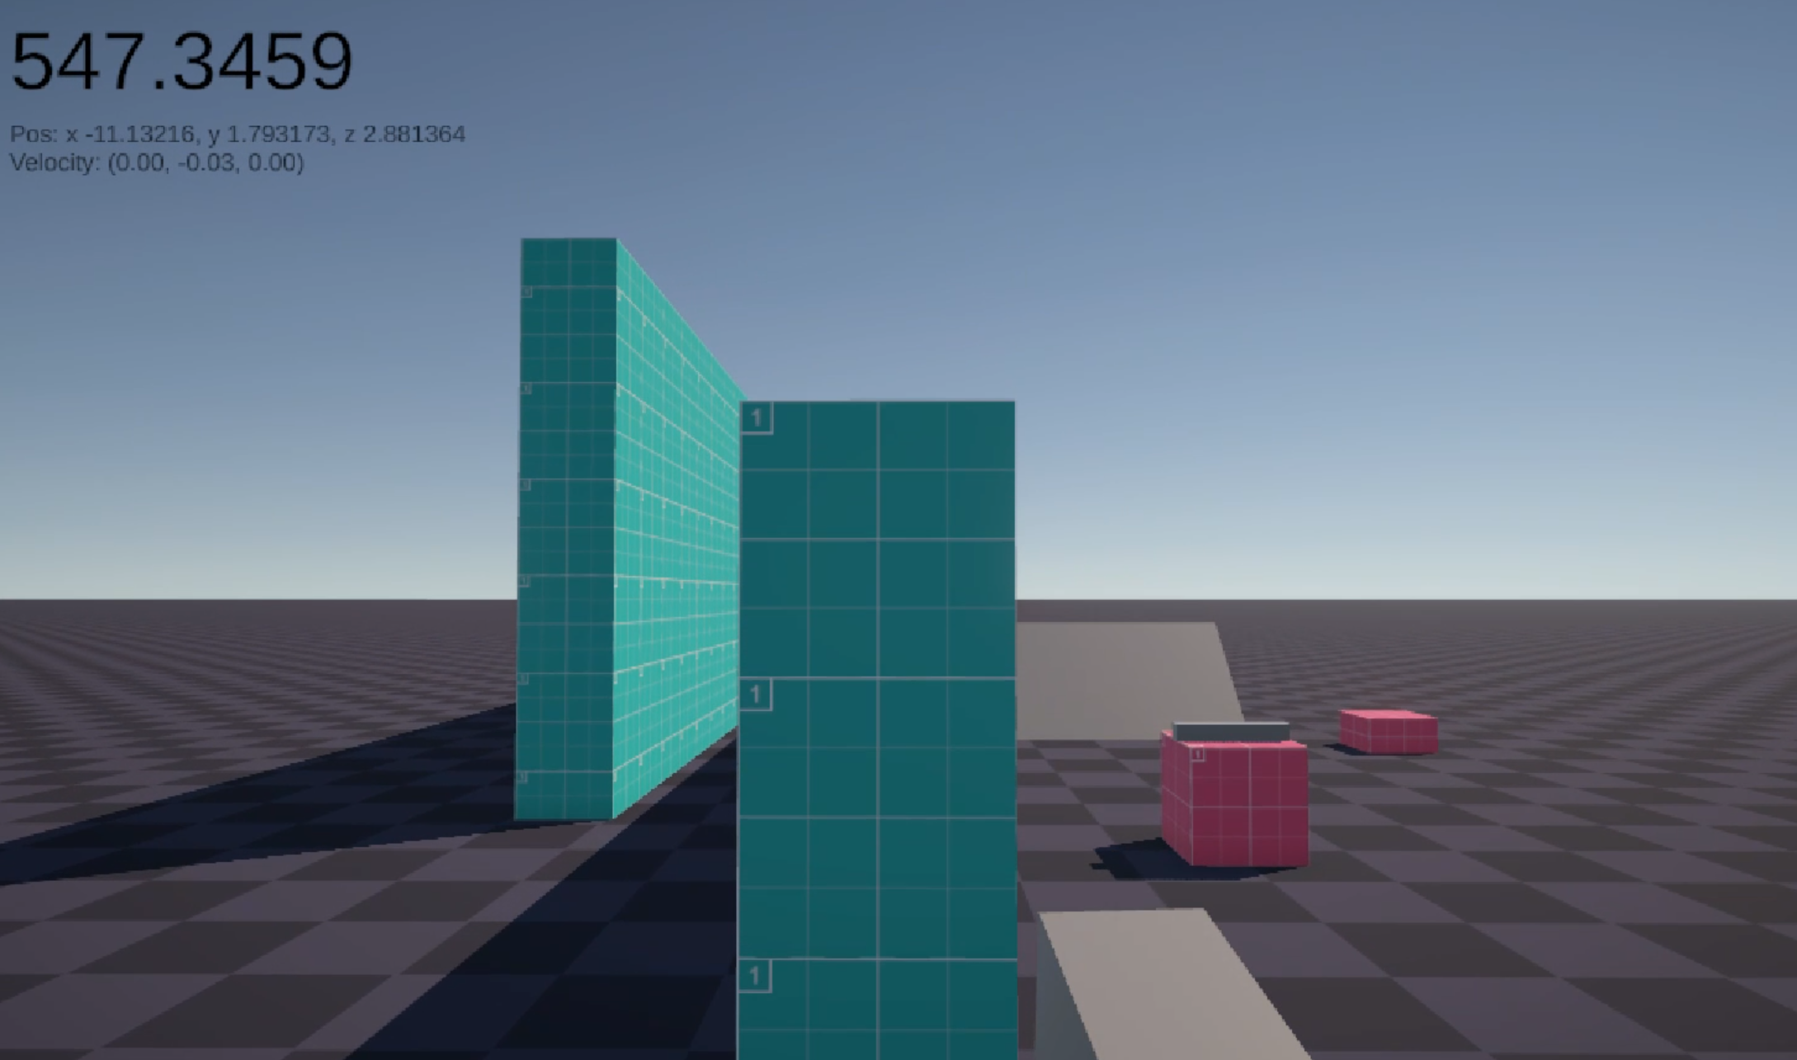

*(The player double jumps)*

### Crouching

Tests for crouching will be evaluated using the same wall as the jumping tests. It can also be secondarily verified using the position shown in the debug screen in the top left corner. The HUD was disabled for these tests.

|  |  |  |  |  |
| --- | --- | --- | --- | --- |
| What data fits criteria | Justification | Expected | Pass/Partial/Fail | Comments |
| Pressing the toggle crouch, then releasing | This is one of the keys that the player can press to crouch | The player will shrink in height | Pass |  |
| Pressing the hold crouch, then releasing | This is other key that the player can press to crouch, and is likely to be the more commonly used one | The player will shrink in height, and then return to the standing height | Pass |  |
| Pressing the toggle crouch, then releasing. Then pressing the hold crouch, and then releasing it | The player may use both inputs to crouch, and this should not lead to any conflicts | The player will shrink in height, and then return to the standing height when the hold crouch is released | Pass |  |
| Pressing no input | Testing for the lack of inputs is also something that can happen on any frame, and must be tested correctly | The player remains at the standing height | Pass |  |
| Pressing an unrelated key (e.g. M) | This is invalid and should not affect the crouching system, and must be dealt properly | The player remains at the standing height | Pass |  |

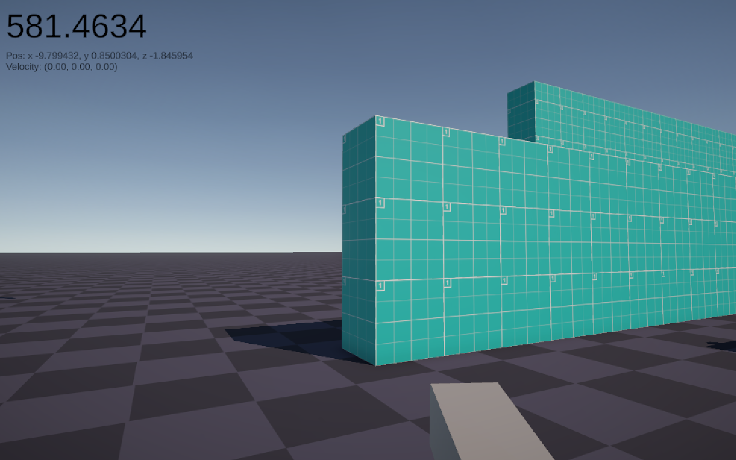

*(The player starts tall)*

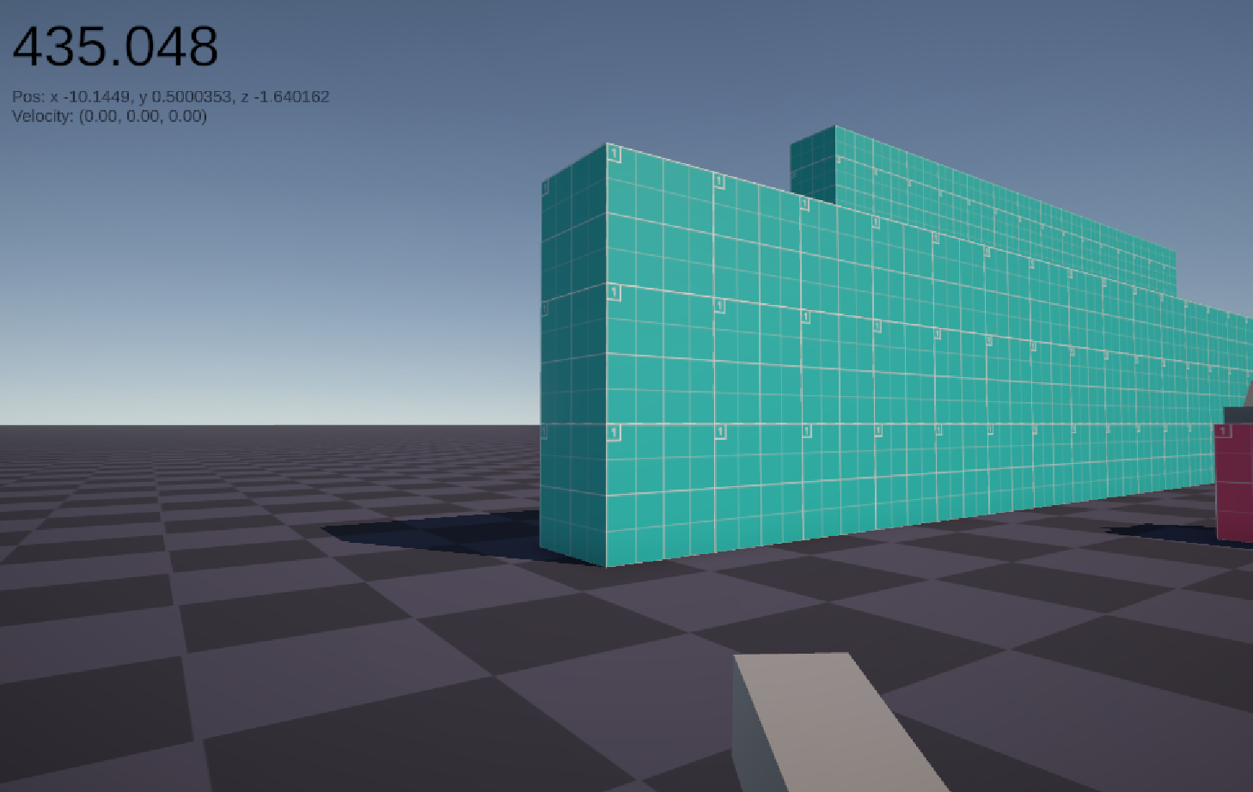

*(The player crouches)*

### Boosting

These will also be tested the same way as the strafing tests. The HUD was disabled for these tests.

|  |  |  |  |  |
| --- | --- | --- | --- | --- |
| What data fits criteria | Justification | Expected | Pass/Partial/Fail | Comments |
| Pressing the boost key while moving | This is the keys that the player can press to activate boosting | The player will double their current speed. | Pass |  |
| Pressing the boost key while not moving | This will test how the system evaluates the player’s speed | The player will not move | Pass |  |
| Pressing no input | Testing for the lack of inputs is also something that can happen on any frame, and must be tested correctly | The player remains at the standing height | Pass |  |
| Pressing an unrelated key (e.g. M) | This is invalid and should not affect the crouching system, and must be dealt properly | The player remains at the standing height | Pass |  |

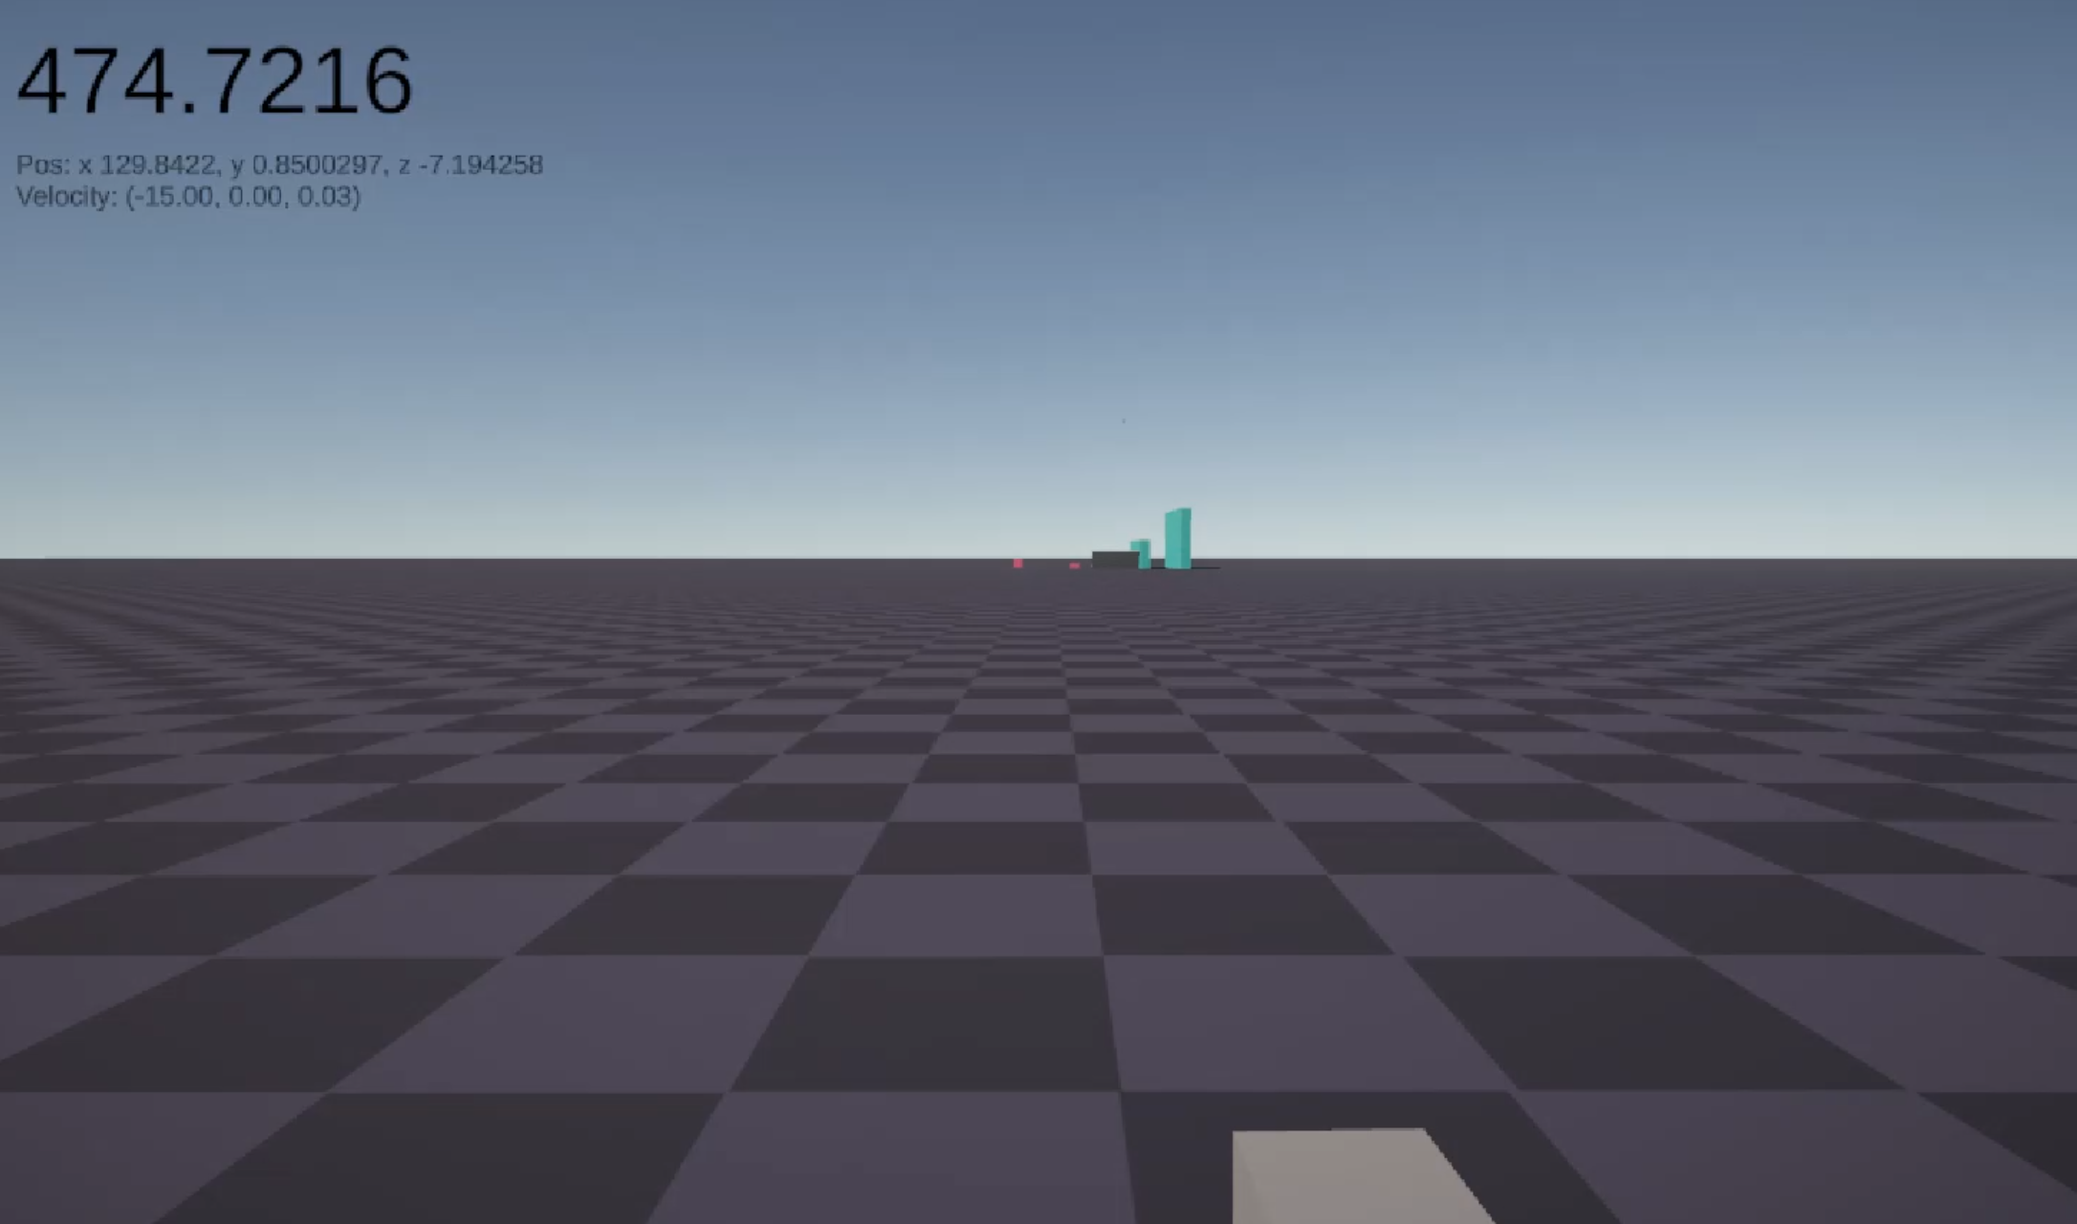

*(The player’s maximum sprinting speed of 15 m/s)*

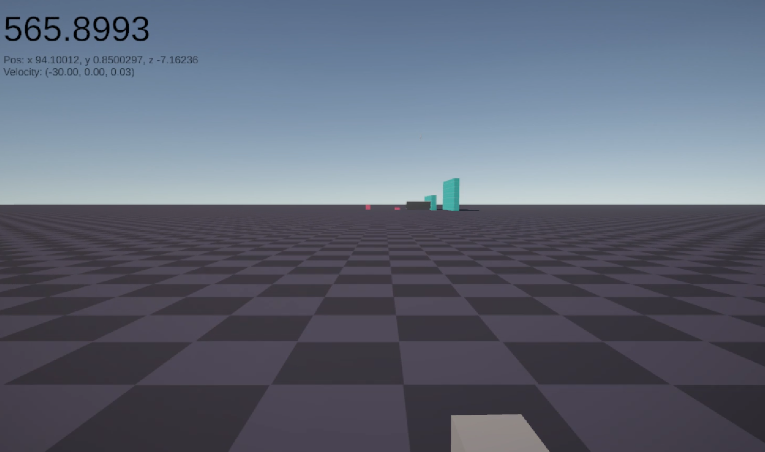

*(The player’s speed has doubled after pressing the boost button once)*

### Wallrunning

These tests are evaluated using 2 walls, of which the player will jump on and between them. The HUD was disabled for these tests.

|  |  |  |  |  |
| --- | --- | --- | --- | --- |
| What data fits criteria | Justification | Expected | Pass/Partial/Fail | Comments |
| Pressing forward on the wall | This is the most likely action that the player is going to do when they are on the wall, and as such, this should be the highest priority test | The player will move forward on the wall | Pass | It is not clear if the player has attached to the wall |
| Facing perpendicular to the wall | The player may want to dismount from the wall | The player will gain a speed boost as they disconnect from the wall and enter a walking state. | Pass |  |
| The player pressing the jump key while on the wall | Since the aim of the game is to maintain speed, the player will want to jump away from the wall instead of the other methods to maximise the speed gain | The player will dismount from the wall and gain some speed in the direction of the wall normal and upwards | Pass | No feedback responding if an air jump has been used or the wall jump was used, other than verifying that the air jump existed afterwards |
| Slowing down on the wall below a threshold | The player may attempt to turn around on the wall, or slow down, and it makes sense for this to mean that they can no longer hold onto the wall. | The player is pushed away from the wall | Pass |  |
| Pressing the jump key in the air while moving downwards on the wall | The player is still affected by gravity, if only by a little bit, so the player can end up moving downwards, which may make the jump useless. Hence this needs to be counteracted | The player will dismount from the wall and gain some speed in the direction of the wall normal and upwards | Pass | Once again, a lack of feedback makes it hard to distinguish between an air jump or a wall ump |
| Pressing another key (e.g. M) | An input not related to the system should not affect it | The player will slow down on the wall due to friction | Pass |  |

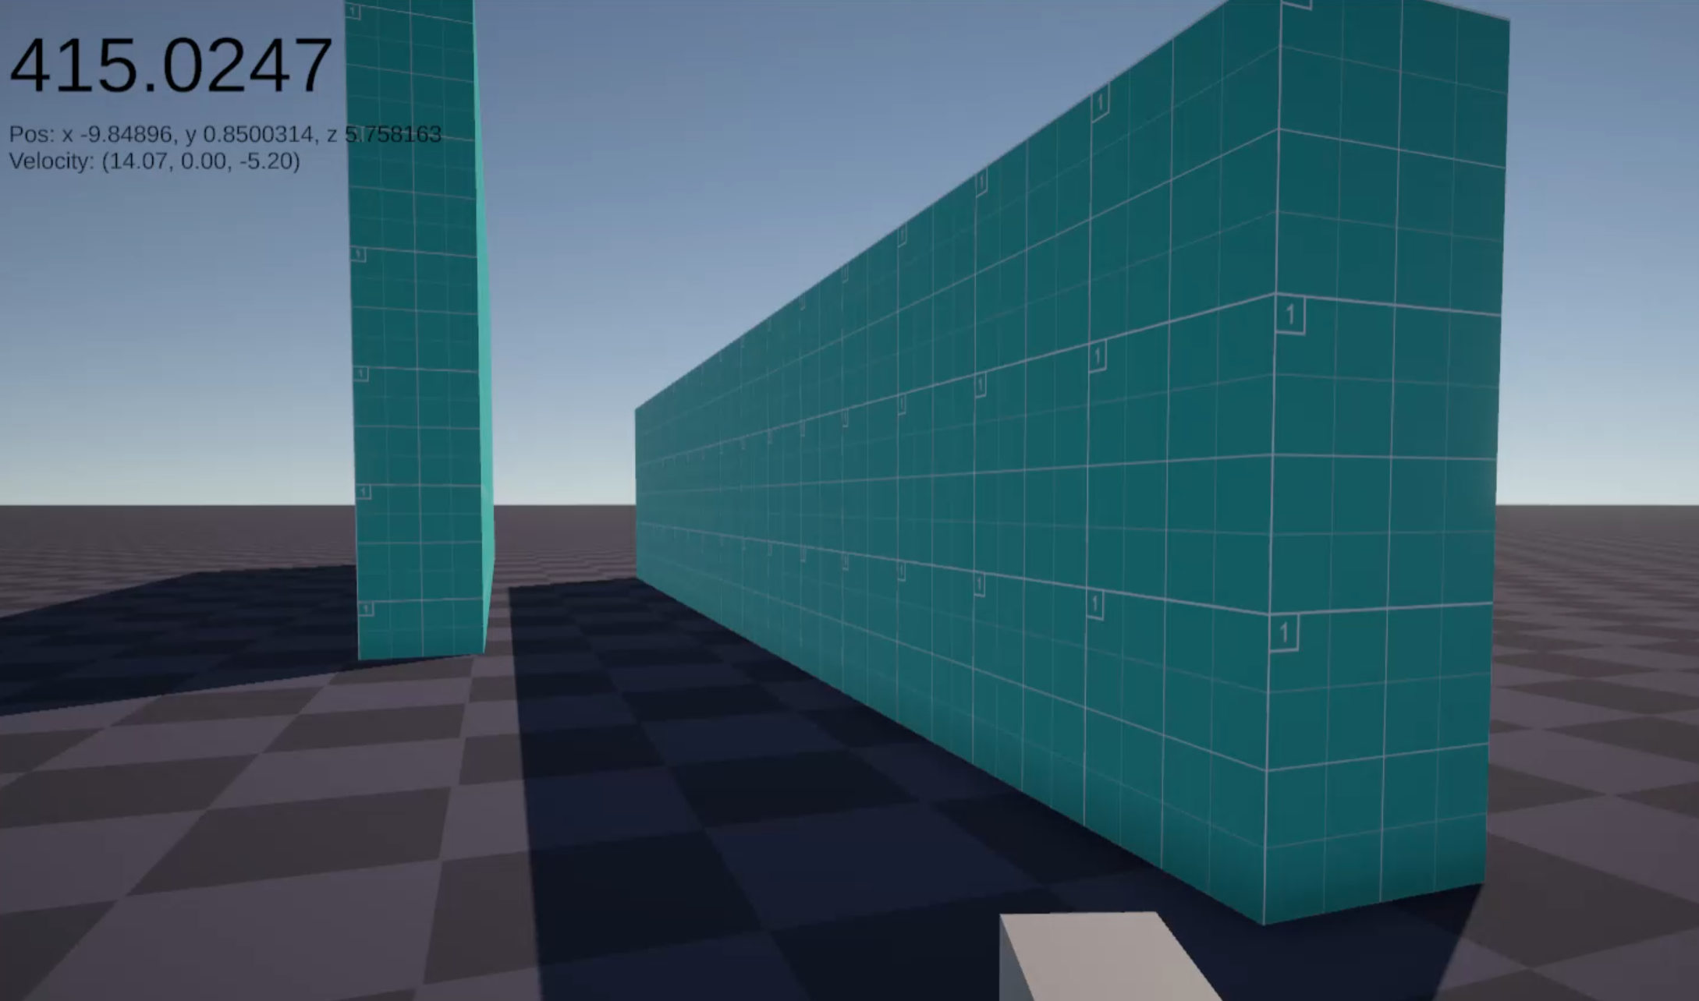

*(The player starts on the ground)*

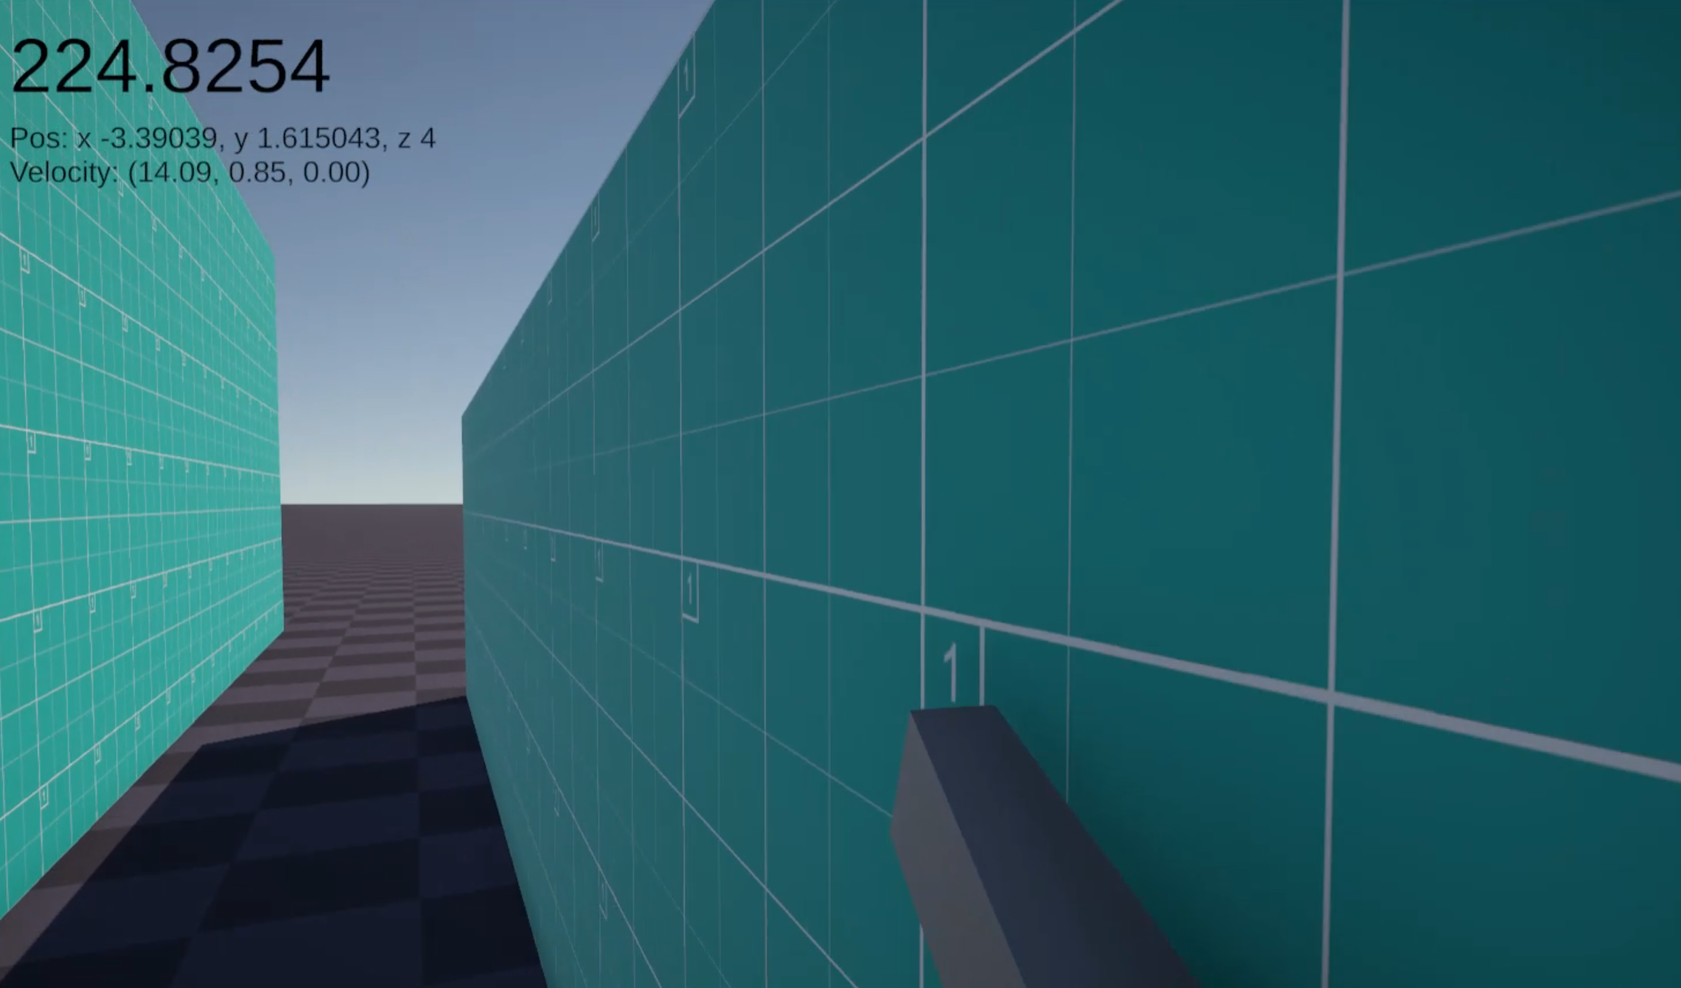

*(The player jumps onto one wall and runs along it)*

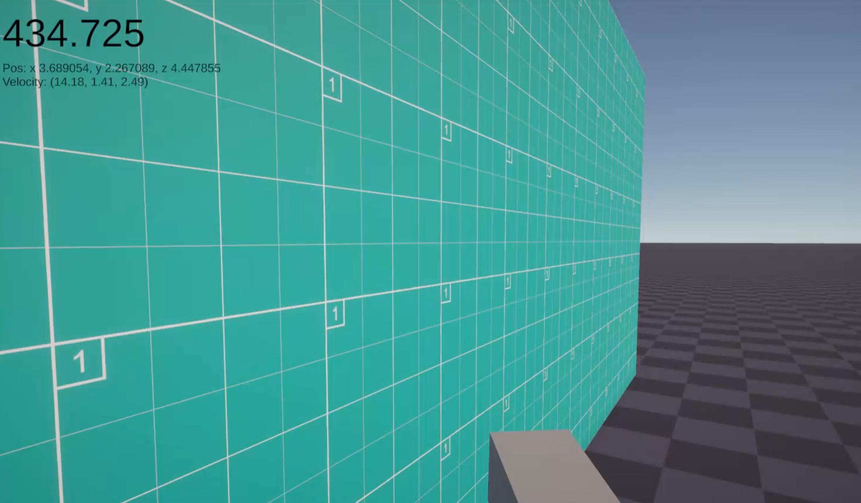

*(The player jumps off the wall, aiming for the next one)*

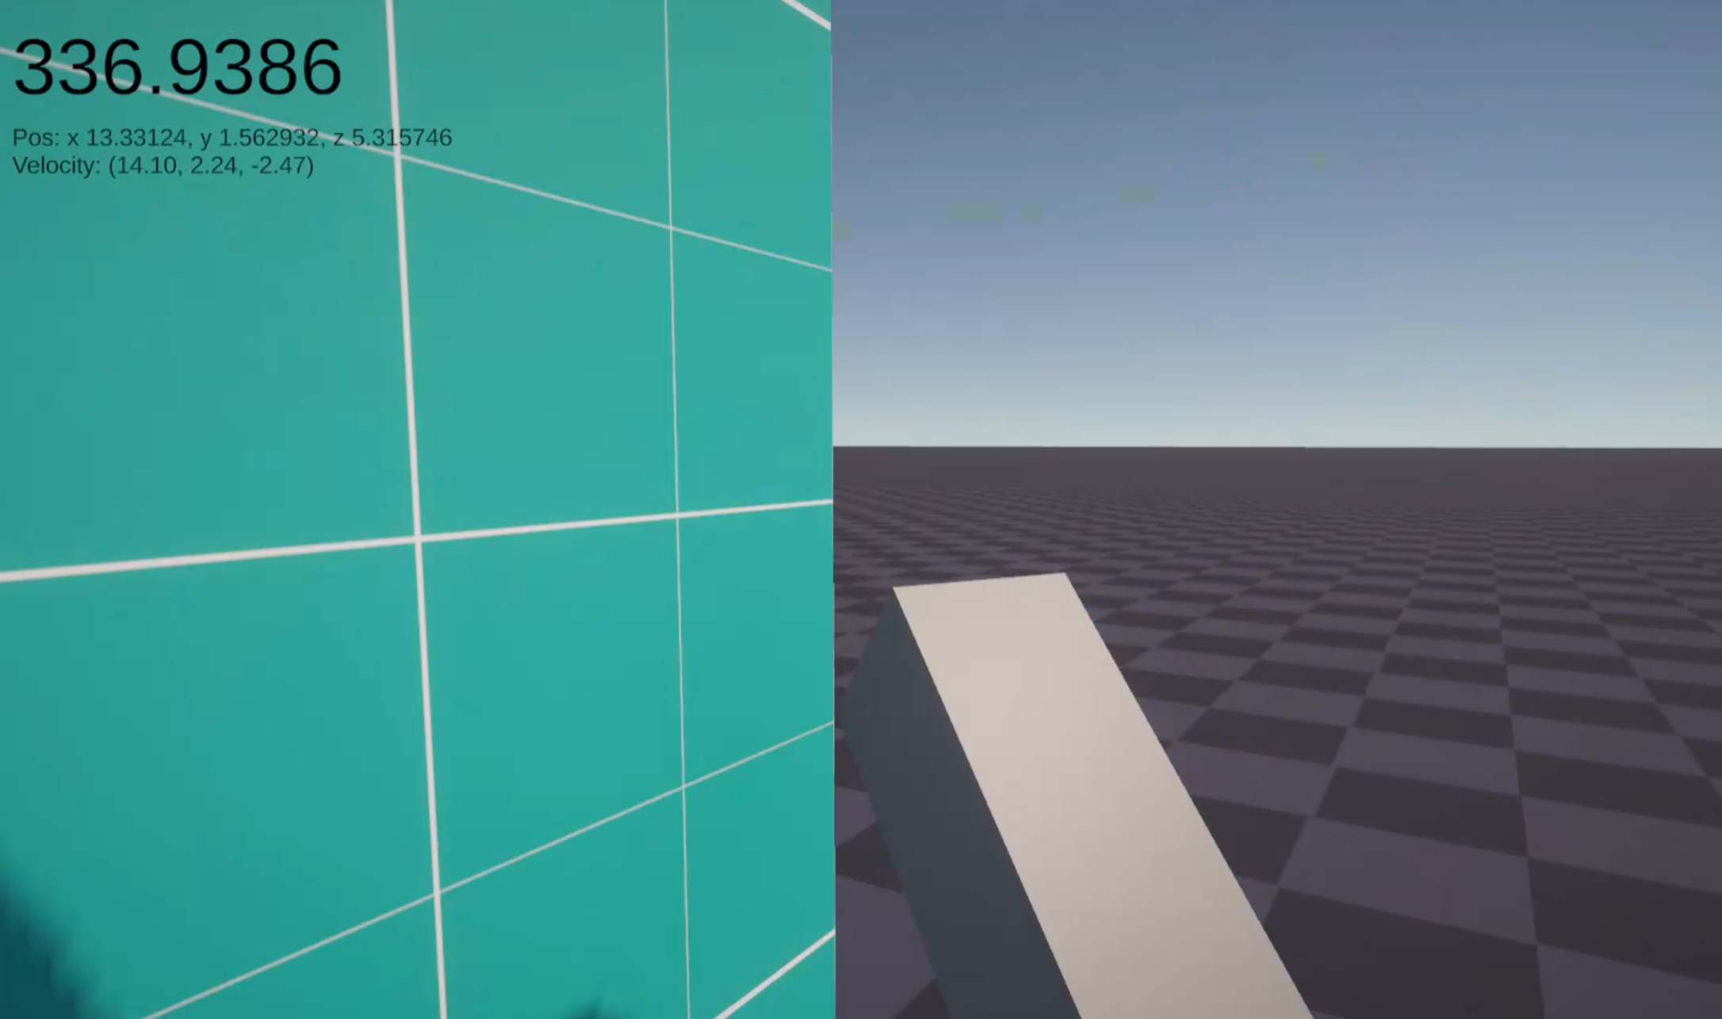

*(The player jumps off the next wall)*

### Using weapons

|  |  |  |  |  |
| --- | --- | --- | --- | --- |
| What data fits criteria | Justification | Expected | Pass/Partial/Fail | Comments |
| Pressing the fire input with an equipped weapon | This is the key the player will press when they want to fire the weapon, and so should be tested correctly | The equipped weapon will fire a bullet | Pass |  |
| Pressing the fire input with no equipped weapon | The player may accidentally press this input, and as such this needs to be handled | Nothing will happen to the weapons | Pass |  |
| Pressing the swap weapon input with no weapons while facing a weapon | The player will need to do this at the start of the level, and so nothing should break when they do so | The weapon will become equipped and move to the player’s hand and be added to the list of weapons | Pass |  |
| Pressing the swap weapon input with some weapons while facing a weapon | The player may do this when they want to pick up more weapons | The weapon will become equipped and move to the player’s hand and be added to the list of weapons | Pass |  |
| Pressing the swap weapon input with as many weapons as they can hold while facing a weapon | The player may do this when they run out of ammo on their current weapon | The weapon will become equipped and replace the previously equipped weapon | Pass |  |
| Pressing the swap weapon input while not facing a weapon | The player may accidentally press this input, and as such this needs to be handled | Nothing happens to the weapons | Pass |  |
| Pressing the reload input with an equipped weapon | The player may want to reload their weapons early while they have cover and some breathing time | The currently equipped weapon reloads as much ammunition as it can | Pass | There is no visual feedback that this is the case |
| Pressing the reload input with an equipped weapon, but no ammunition remaining | The player may want to reload their weapons earlier, but they shouldn’t be able to in this case | Nothing happens to the weapons | Pass | There is no visual feedback that the weapon is empty |
| Pressing the reload input with no equipped weapon | The player may accidentally press this input, and as such this needs to be handled | Nothing happens to the weapons | Pass |  |
| Pressing the zoom input with an equipped weapon, then releasing it | The player will need to zoom in when they want to have a precise shot, and so this should be tested properly | The player’s FOV zooms in, then back out. | Pass |  |
| Pressing the zoom input with no equipped weapon | The player may accidentally press this input, and as such this needs to be handled | Nothing happens to the weapons | Pass |  |
| Pressing no input | Testing for the lack of inputs is also something that can happen on any frame, and must be tested correctly | Nothing happens to the weapons | Pass |  |
| Pressing an unrelated key (e.g. M) | This is invalid and should not affect the jumping system, and must be dealt properly | Nothing happens to the weapons | Pass |  |

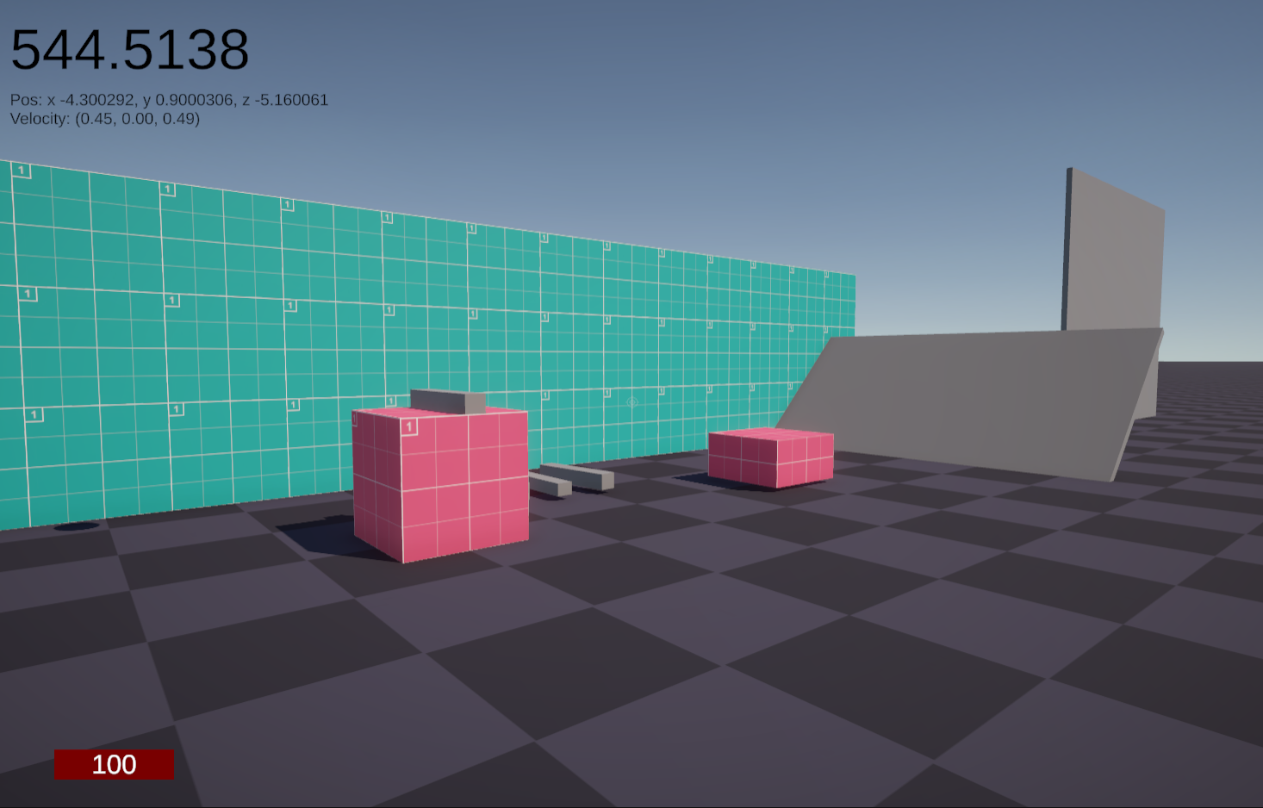

*(The player starts with no weapon equipped)*

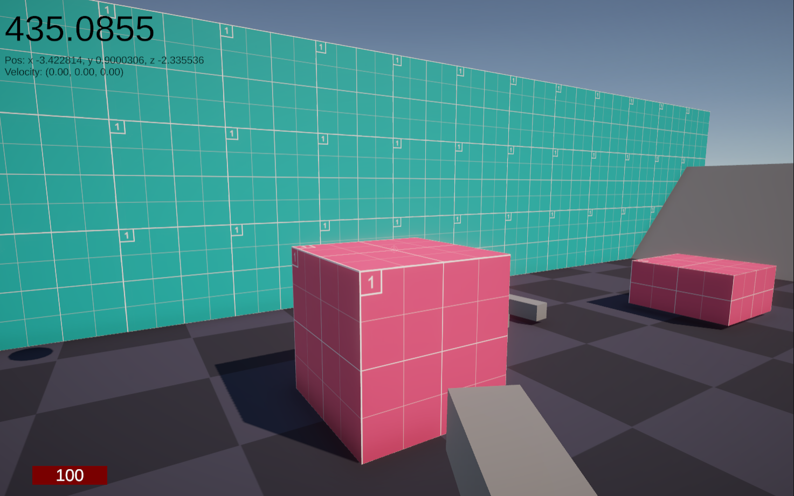

*(They then interact and pick up the weapon)*

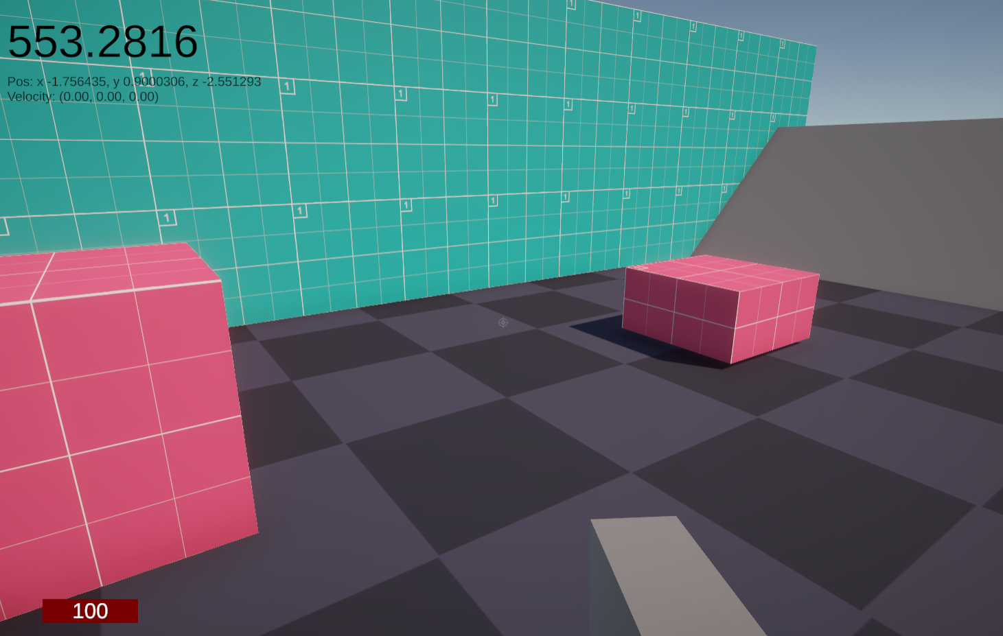

*(They then interact again to pick up another 3 weapons)*

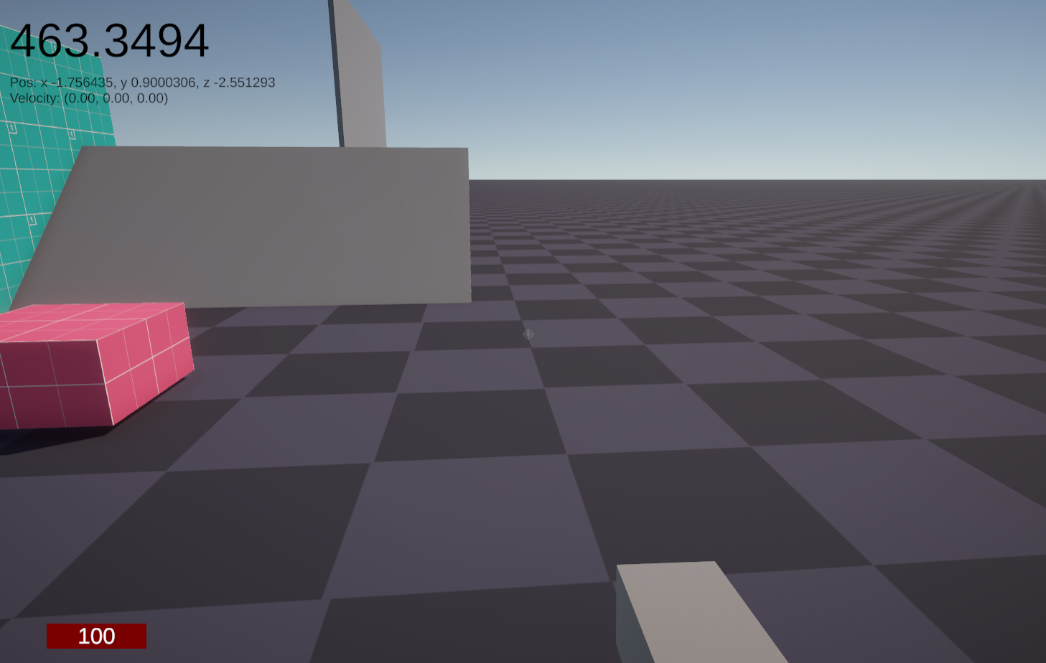

*(The player then swaps to the first slot by scrolling)*

### Taking damage

These tests will be evaluated using the spike, which will also simultaneously verify that the spike, and hence environmental damage, works as expected.

|  |  |  |  |  |
| --- | --- | --- | --- | --- |
| What data fits criteria | Justification | Expected | Pass/Partial/Fail | Comments |
| Get hit | This should lower the player’s health, but not enough to kill them, so it should still be visible to the player | The player losses health as shown on the HUD | Pass |  |
| Getting hit enough to lose all of their health | This will cause the player to die, and tests the death screen as well | The player is unable to control their character, and the death screen shows up | Pass |  |
| Pressing ‘Load’ on the death screen | The player will most definitely want to do this when they die, and should be tested properly | The game will reload the player’s save data and the player will be able to play once again | Pass |  |

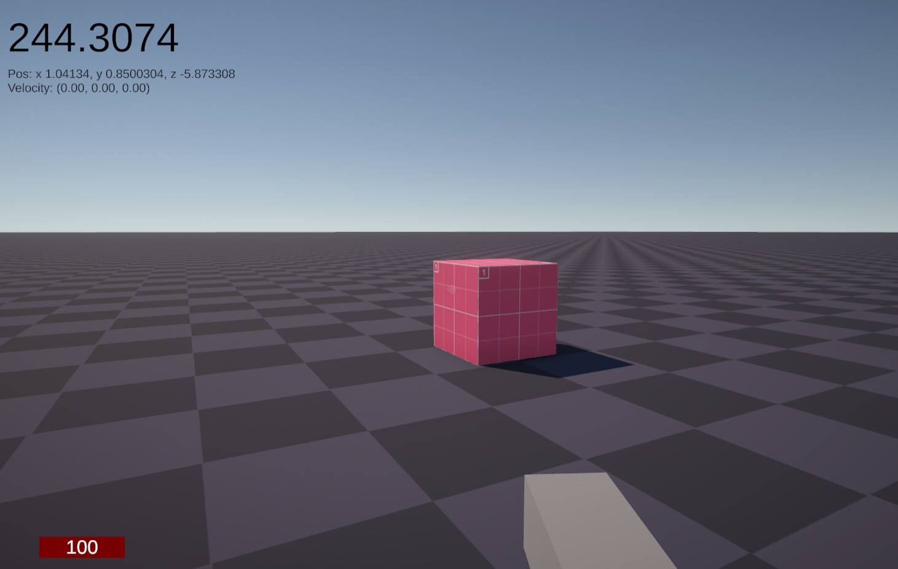

*(The player starts at full health)*

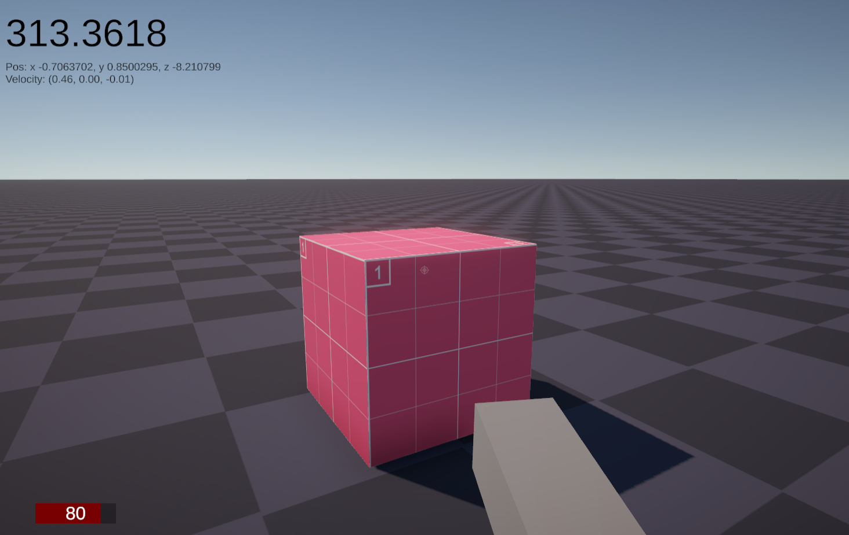

*(The player touches the spike and takes 20 damage)*

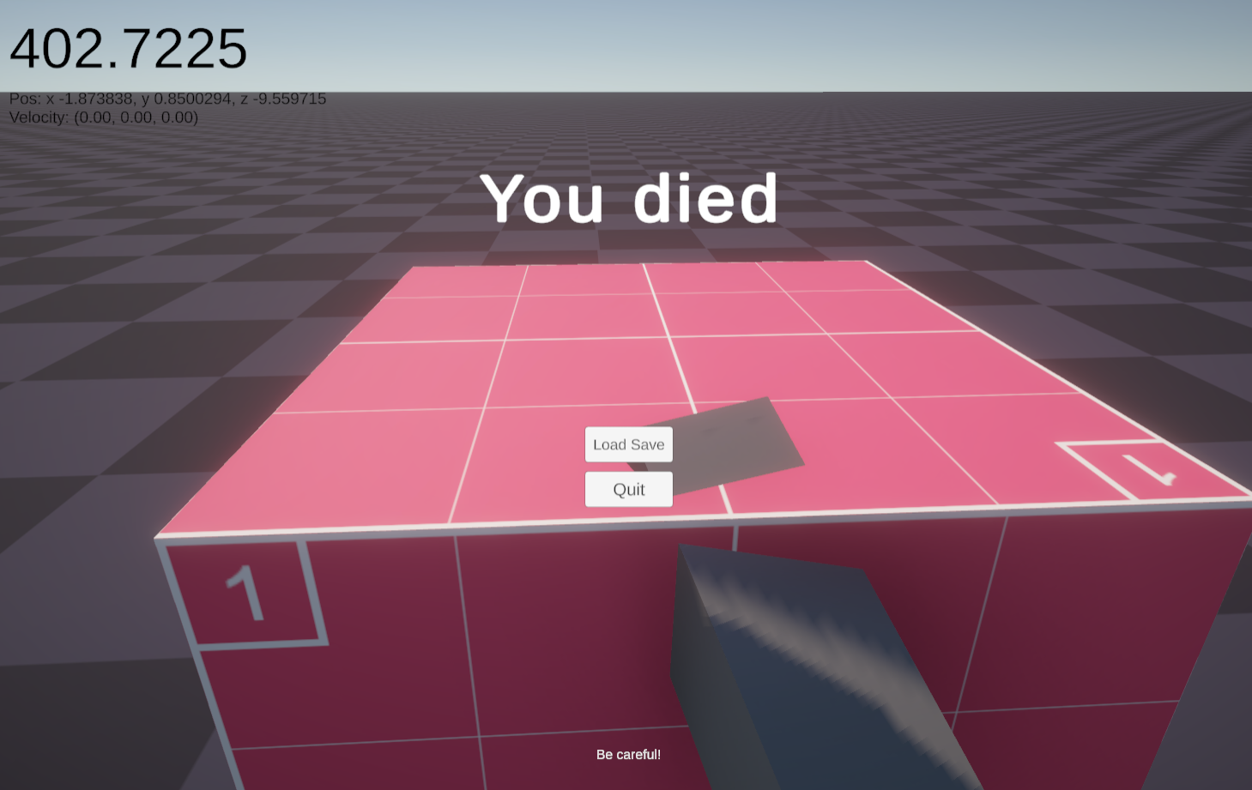

*(After touching the spike a few times, the player has died)*

### Saving

|  |  |  |  |  |
| --- | --- | --- | --- | --- |
| What data fits criteria | Justification | Expected | Pass/Partial/Fail | Comments |
| Pressing any save button | The player will want to save their current progress and not lose it, and this should work well | A new save file is created on the player’s computer | Pass |  |
| Making a new save slot | The player may want to replay the game at some point completely fresh, and this should allow them to make completely fresh experience | A new save slot folder is created on the player’s computer, along with a new basic save | Pass |  |
| Pressing any load button | The player will most definitely want to load their save when they get stuck or in other situations | The game will reload the player’s save data and the player will be able to play once again | Pass |  |
| Selecting to load a slot in the slot menu | The player will want to load into a save slot when the open the game and so this must be handled properly | The game will load the save with a loading screen, and load into the correct level | Pass |  |

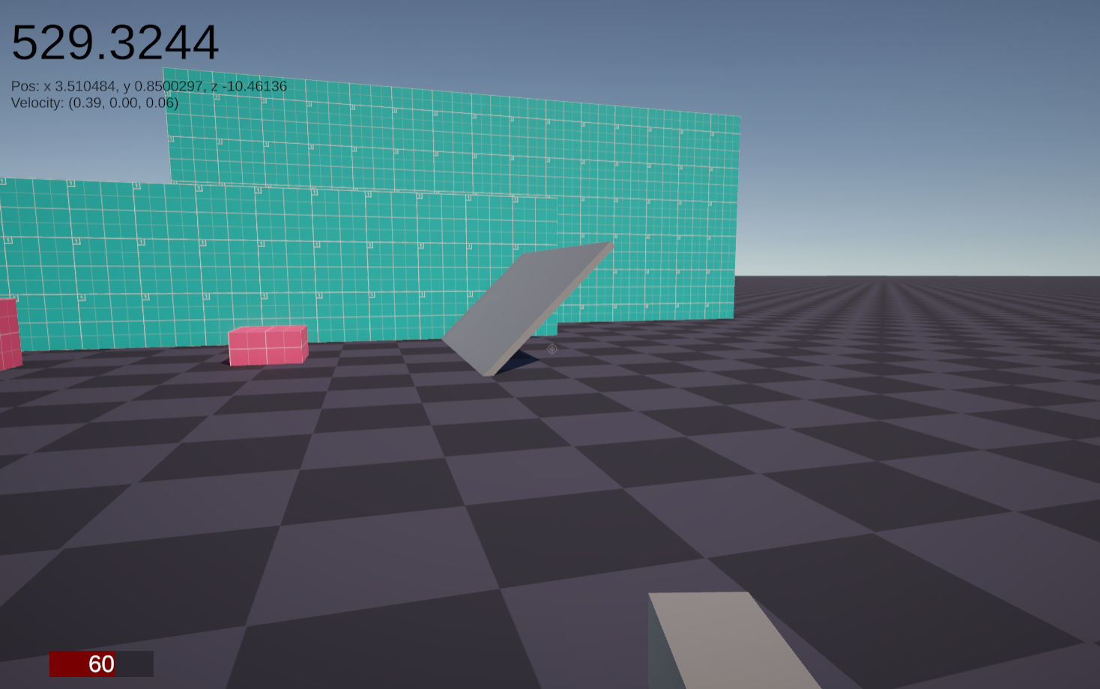

*(The player begins at this position with 60 health)*

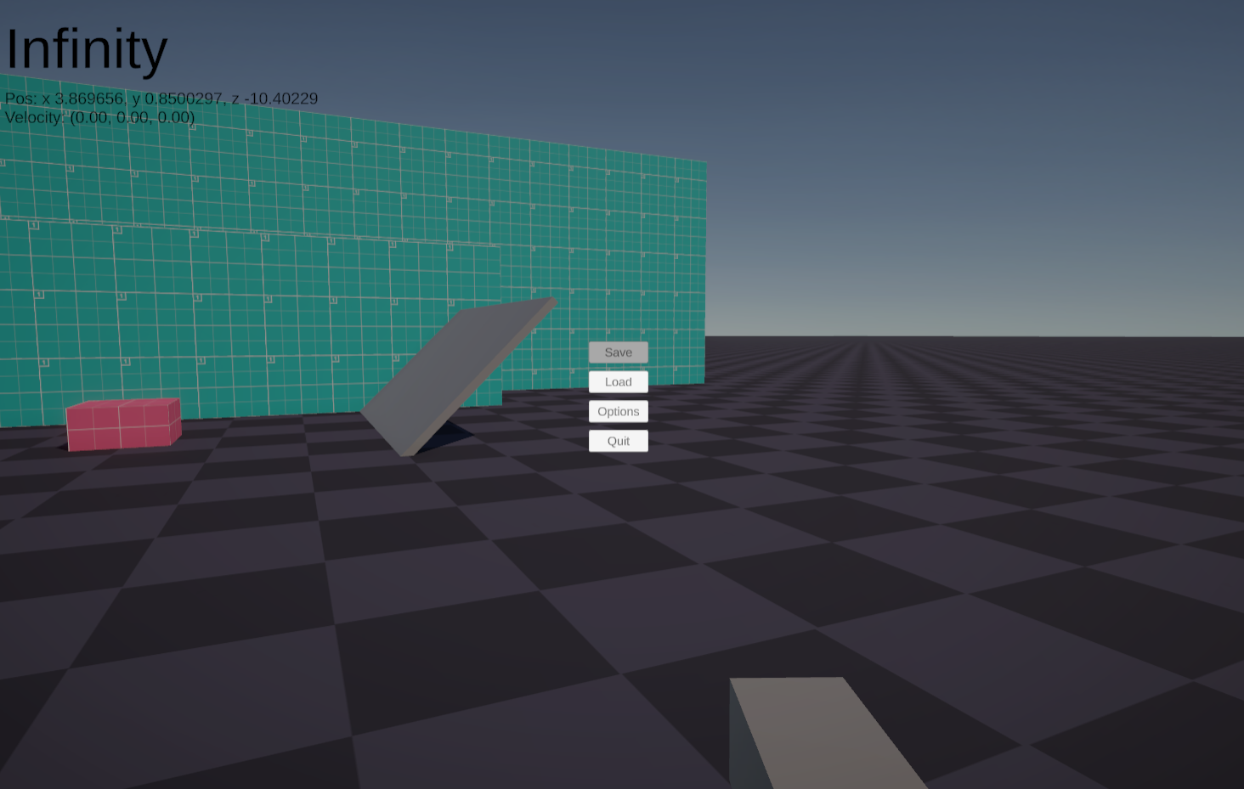

*(They then save)*

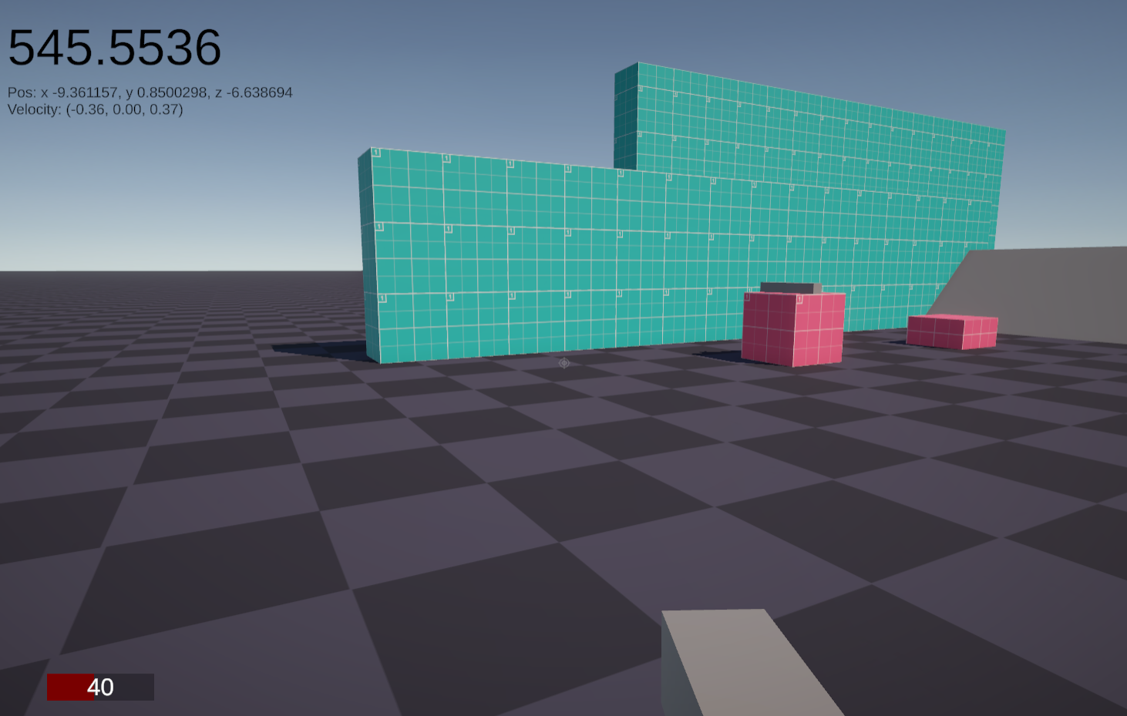

*(They move elsewhere and take damage)*

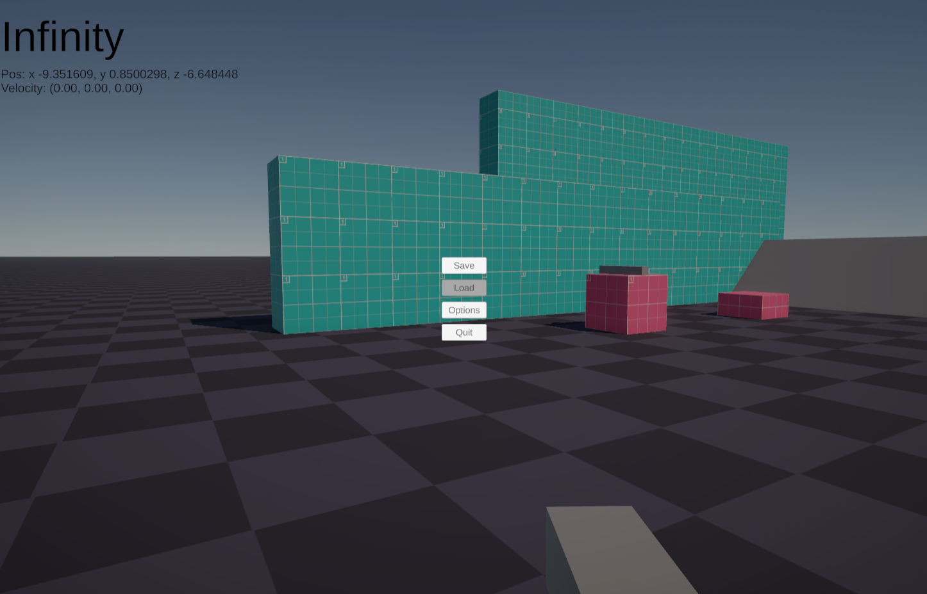

*(They then load the game)*

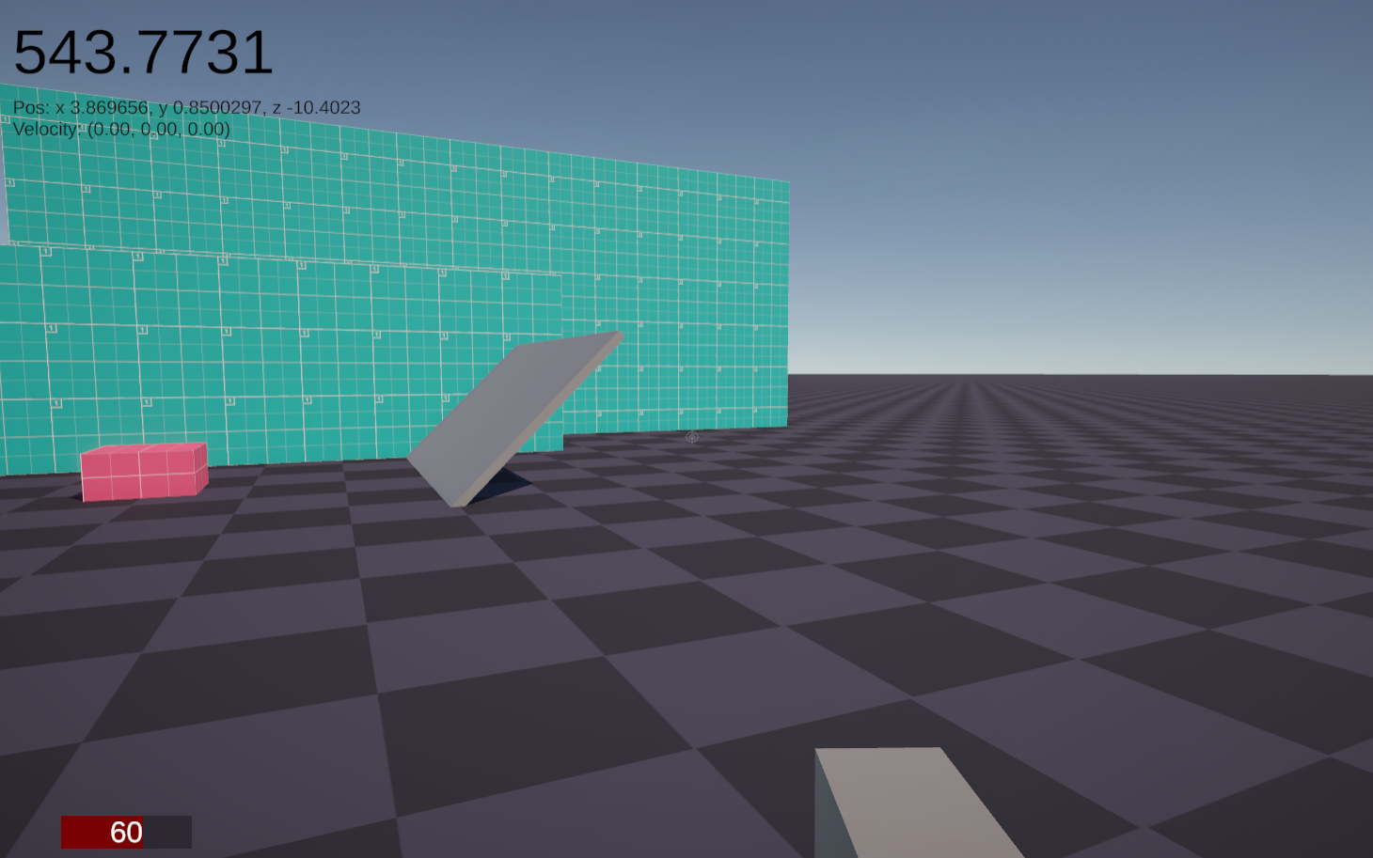

*(The save has loaded)*

### Dialogue

These tests will use an extremely simple test dialogue file that consists of tests to simply interpret lines and actors, along with a simple if statement checking the state of a variable in the save data, ‘seenTutorial’.

|  |  |  |  |  |
| --- | --- | --- | --- | --- |
| What data fits criteria | Justification | Expected | Pass/Partial/Fail | Comments |
| Pressing the interact key when facing a dialogue object | This is the key the player will press when they want to interact with the dialogue, and so should be tested correctly | A new dialogue line is displayed in the subtitle box that shows up | Pass |  |
| Pressing the interact key when not facing a dialogue object | The system should consider this an invalid input since the input should mean nothing when not facing an interactable | Nothing happens | Pass |  |
| Pressing the interact key when the next line is an if statement that passes | This will test whether the system can handle reading flags | The variable is read, and the line number jumps to the section | Pass |  |
| Pressing the interact key when the next line is an if statement that fails | This will test whether the system can handle reading flags | Only the line number increments | Partial | Will sometimes fail when the next line was a dialogue section |
| Pressing the interact key when the next line is an assignment statement | This will test whether the system can handle setting flags | The variable is set in the save data flags | Pass | There is no visual feedback for this succeeding |
| Pressing the interact key when the next line is a choice statement | This will test whether the system can handle choices properly, and respond appropriately | The choice menu shows up with each choice available to the player in a grid pattern | Fail | There was no choice menu, and the interpreter reported nothing when it reached here |
| Pressing no input | Testing for the lack of inputs is also something that can happen on any frame, and must be tested correctly | The player doesn’t move | Pass |  |
| Pressing an unrelated key (e.g. M) | This is invalid and should not affect the dialogue system, and must be dealt properly | Nothing happens | Pass |  |

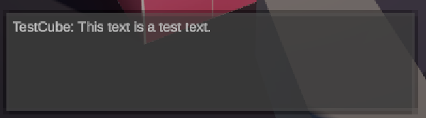

*(Interacting with the dialogue interaction once)*

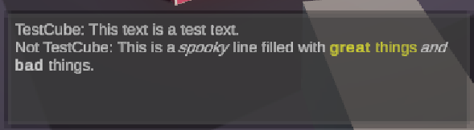

*(Interacting with the dialogue interaction twice rapidly)*

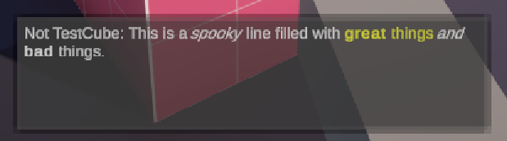

*(Not interacting with the dialogue after a bit causes the first one to disappear)*

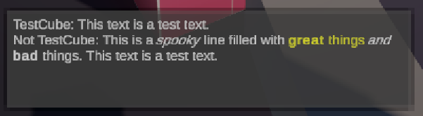

*(The first line is also part of the second line and is combined together – This matches the line #A1::#L1#L2 in the .dlg file)*

### Entity behaviour

|  |  |  |  |
| --- | --- | --- | --- |
| What data fits criteria | Justification | Likert Scale | Comments |
| The enemy successfully searches and find me | The enemies will need to search for the player, which will make the experience better for the player, since they can attempt to avoid the sight of the enemy | Disagree | It was very difficult for the enemy to find the player as the entity was not searching near the player |
| The enemy successfully targets and chases me | The enemy needs to be able to turn towards and chase after the player to be a potential threat to them. | Strongly agree | It is very difficult to escape the entities grasp once the player has been seen, which might be too difficult |
| Once targeted, the enemy successfully fires at me. | For the enemy to be a threat to the player, and encourage the intended behaviour, it needs to fight against the player | Neutral | The enemy would rarely fire back at the player as it struggled to appropriately fire its weapon when facing the player – the weapon looking slightly off from the player, even when the player was still. |
| The friendly entities follow the player successfully | Friendly entities are useful to the player only when they are able to reach the same destination as the player, and this requires that they follow the player | Strongly disagree | There were no friendly entities to be seen |
| The neutral entities run away successfully | Entities that cannot fight should constantly attempt to run from any opposition, signalling to the player that they are not to be fought | Strongly disagree | There were no neutral entities to be seen |
| The friendly entities help the player when fighting | The purpose of the friendly entities is to fight alongside the player, which needs them to fire against the enemies | Strongly disagree | There were no friendly entities to be seen |

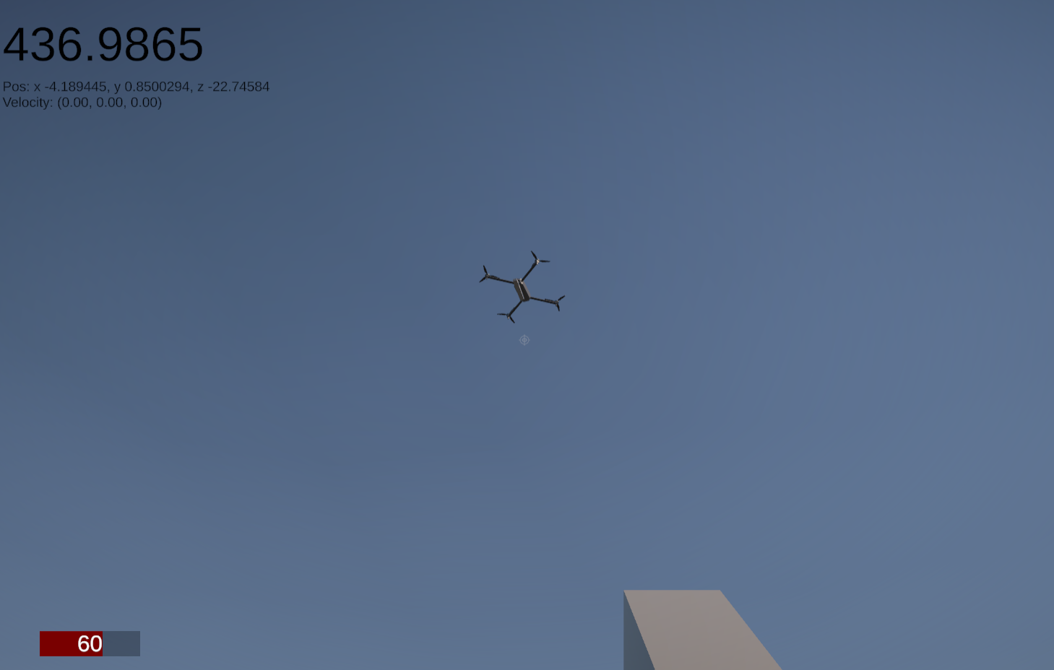

*(The drone is searching for the player)*

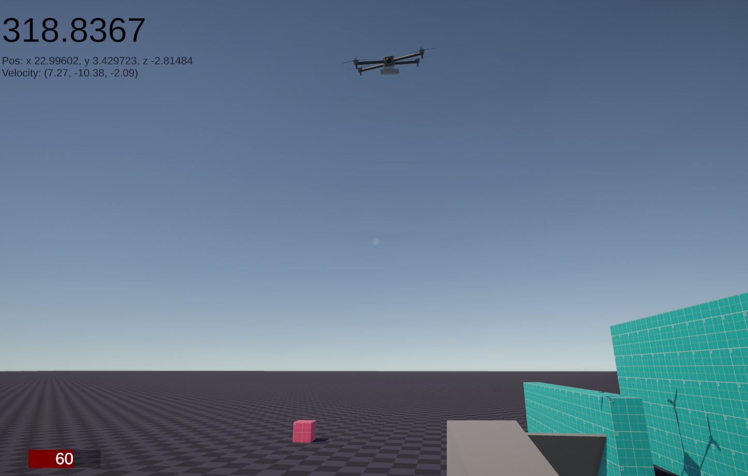

*(The drone has seen the player and locked onto them)*

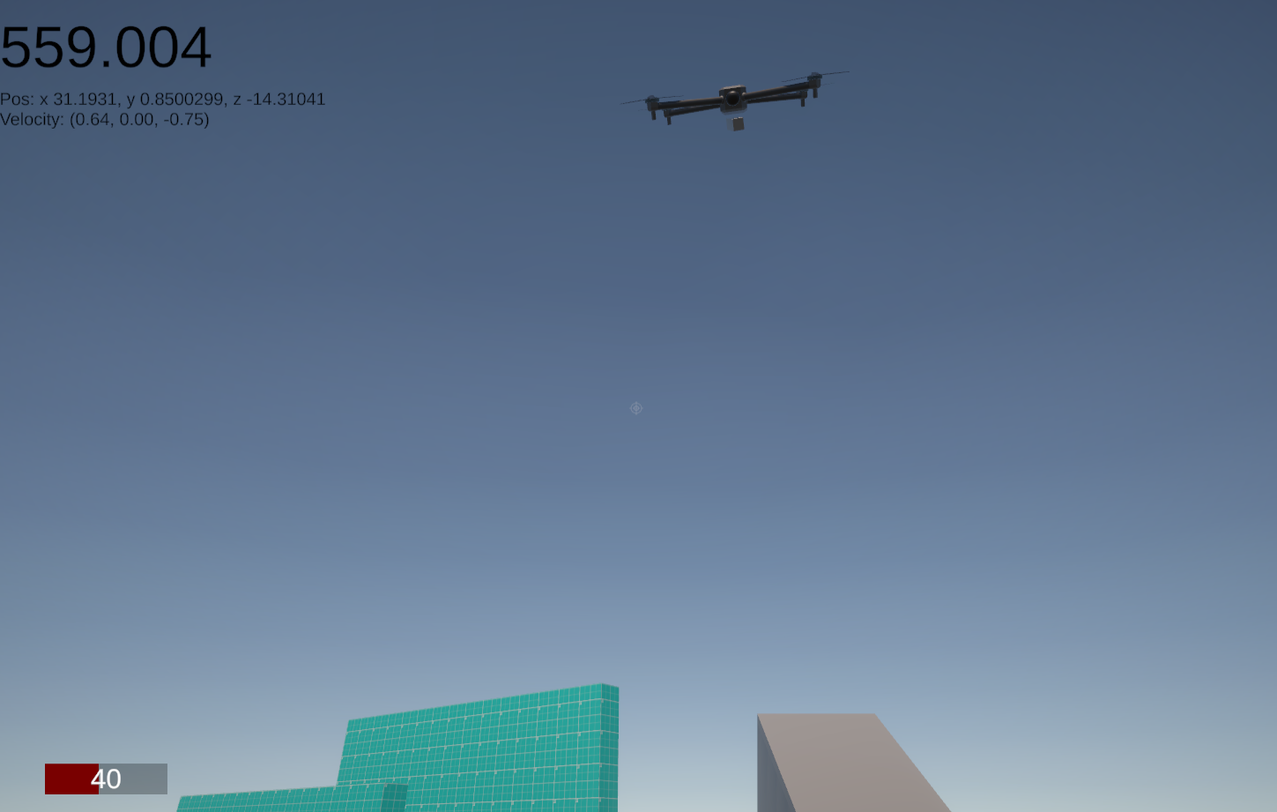

*(The drone has followed and fired at the player and the player has taken damage)*

### Usability Tests

|  |  |  |  |
| --- | --- | --- | --- |
| Statement | Justification | Likert Scale | Comments |
| The main menu is easy to navigate | This is the first screen that player will see when the open the game, and so it should be as easy to use as possible | Strongly agree | Very little to click on so it was easy to see where to go |
| The slot menu is easy to navigate | This is one of the more important menus that the player may interact with and as such it should not be difficult to navigate | Agree | When the player has lots of slots, it can be tedious and difficult to find the right slot through only the slot number |
| The pause menu is easy to navigate | The player will have the ability to do quite a lot during the game while accessing this menu, so anything that makes this menu difficult could lead to a frustrating experience | Strongly agree |  |
| The death menu is easy to navigate | The player is likely to visit this menu quite often, and so it should be as simple as possible to allow them to leave it as fast as possible | Strongly agree |  |
| The options menu is easy to navigate | The player will have a lot of control within this menu and so this menu should be usable and simple to use | Neutral | Having no values on the sliders made it difficult to tell get the same value again if changed |
| I can see my health on the HUD clearly. | The player should be able to see their health easily since this is an important part of the game and the player may be in danger if they can’t see it | Agree | When looking at somewhere white, the text becomes unreadable as it blends in |
| The health does not obstruct my view of the game | Conversely, if the health is too large, then the player will not be able to see the game’s world and may be in more danger | Agree | The health bar is opaque and does cover the small screen space that it does cover |
| I can see my current weapon on the HUD | The player should be able to see what weapon they have equipped and any information about that weapon | Strongly disagree | This was completely missing from the HUD |
| I can see the previous and next weapons on the HUD | The player should also be able to see what weapons they may be changing too as this also important information | Strongly disagree | This was also completely missing from the HUD |

#### Evidence – There is no game

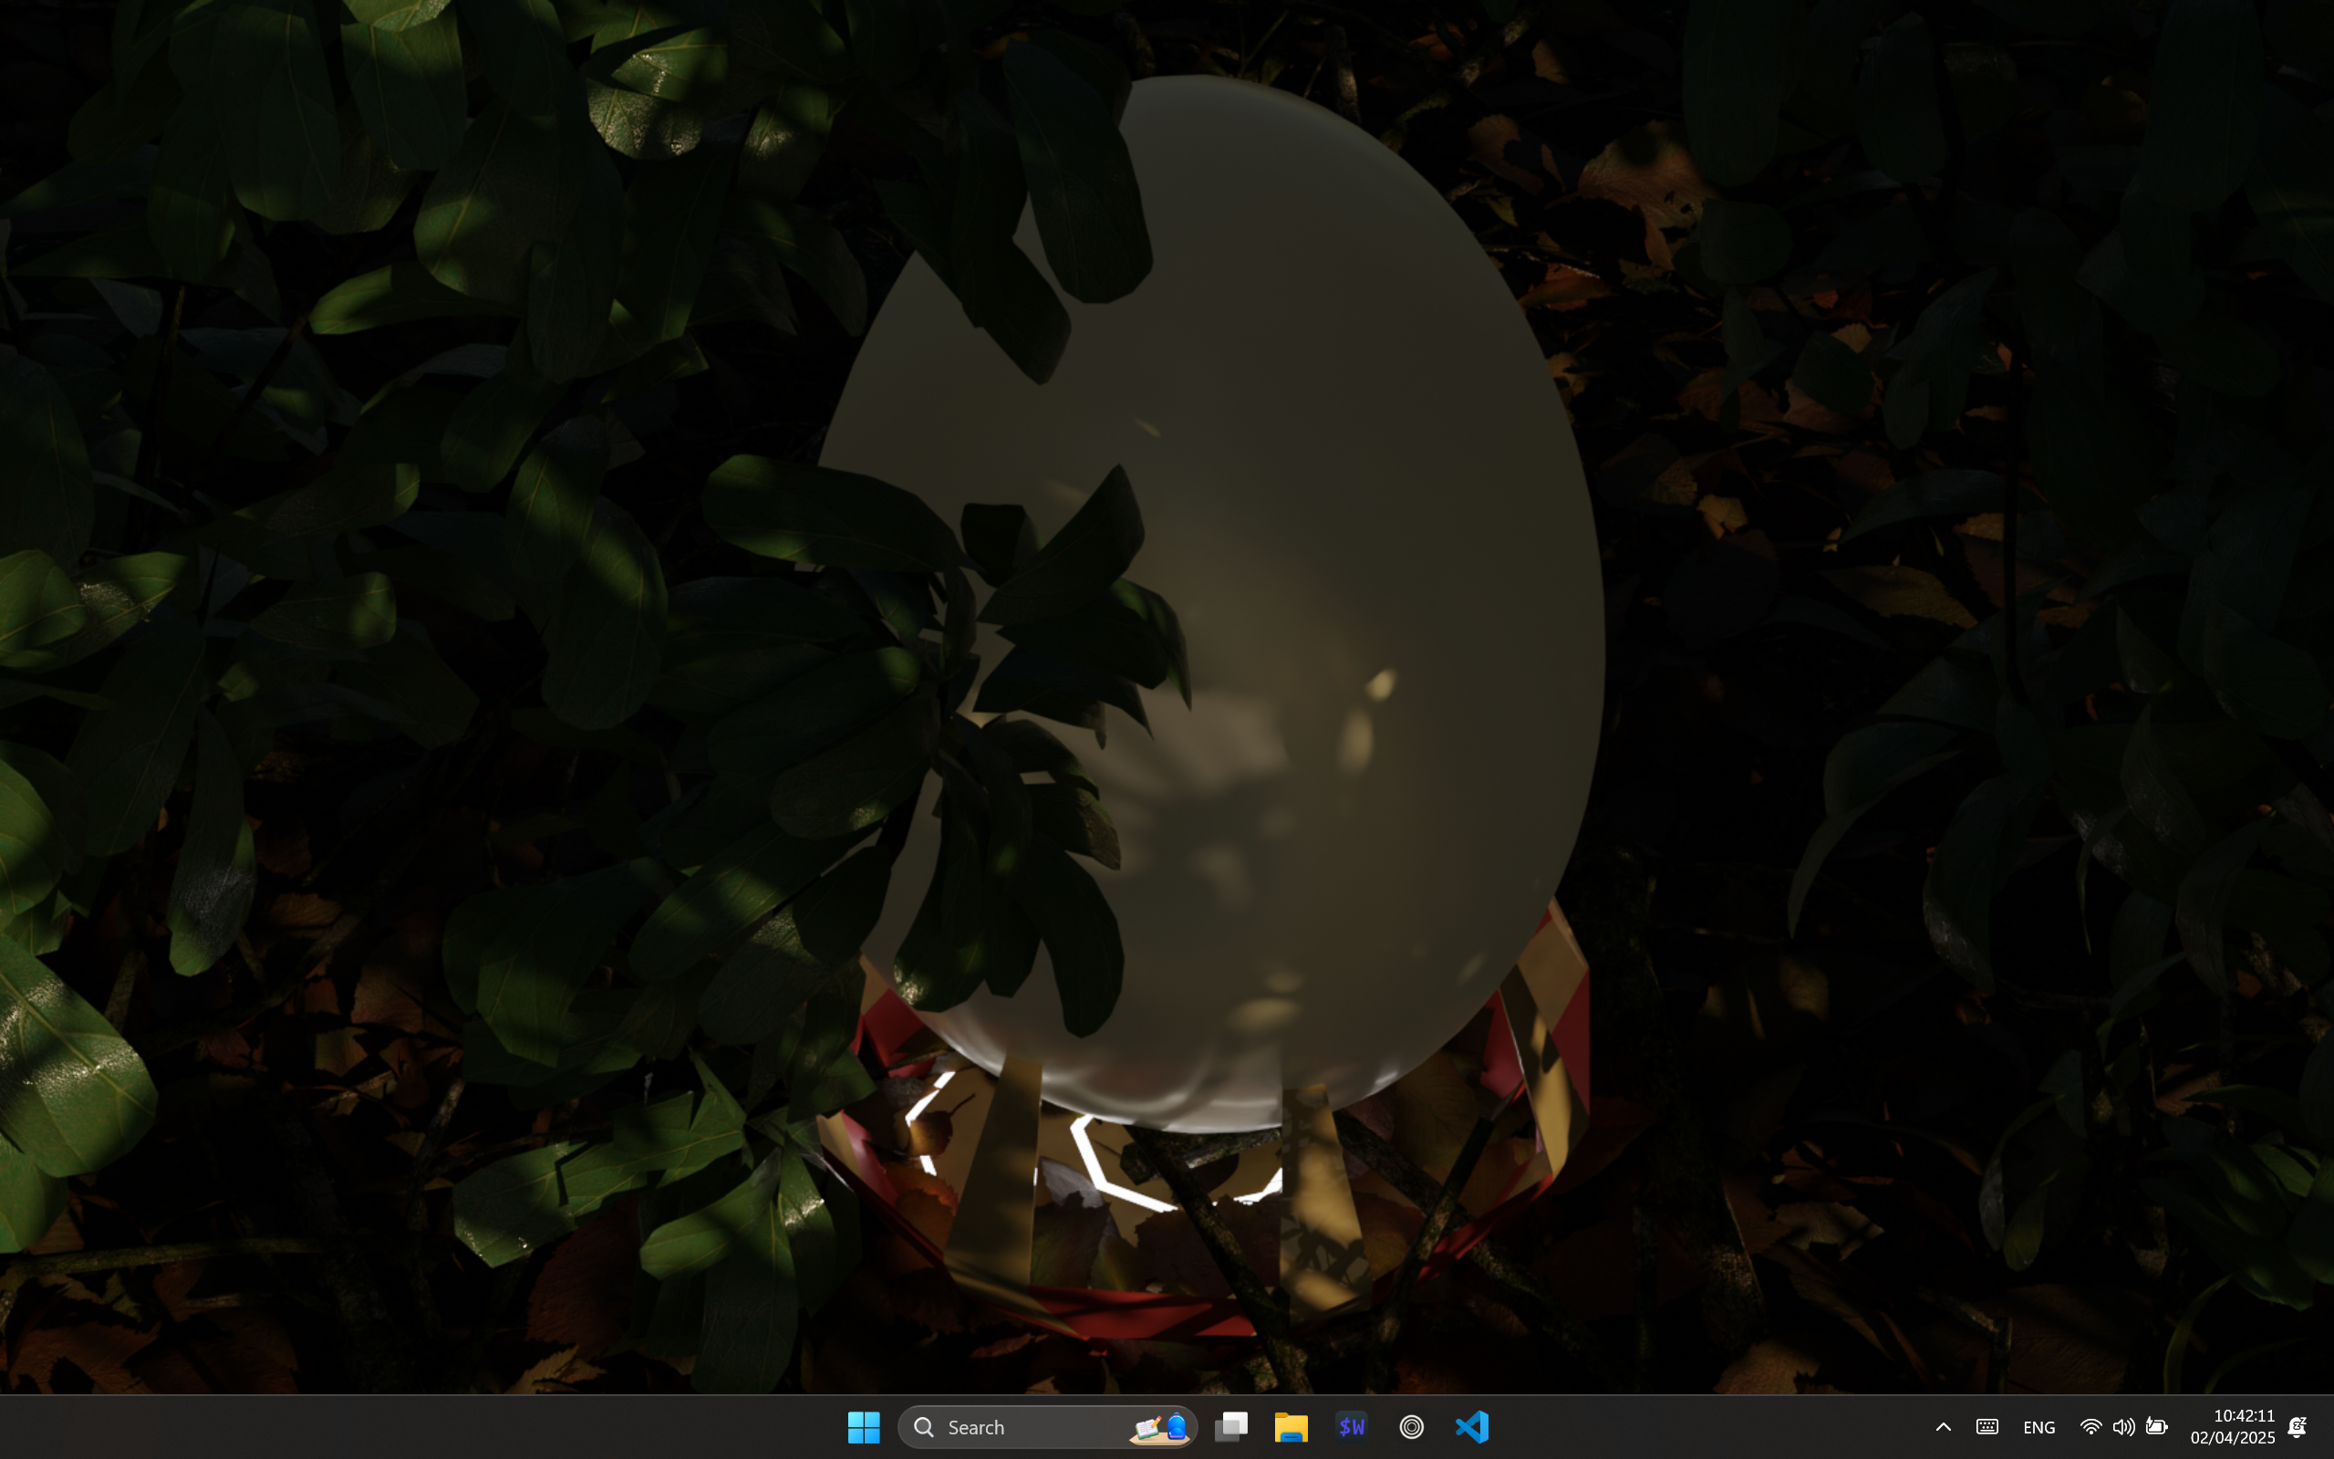

#### Evidence – Opening the game, Main Menu

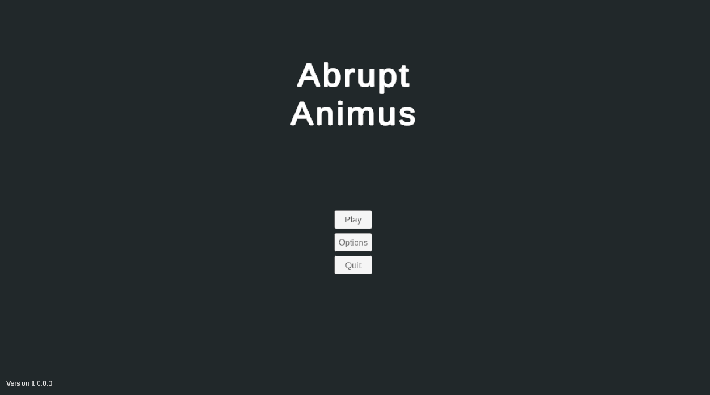

*(What the player sees as they first open the game)*

#### Evidence – Option Menu in the Main Menu



*(The options menu in the main menu)*

#### Evidence – Empty Slot Menu

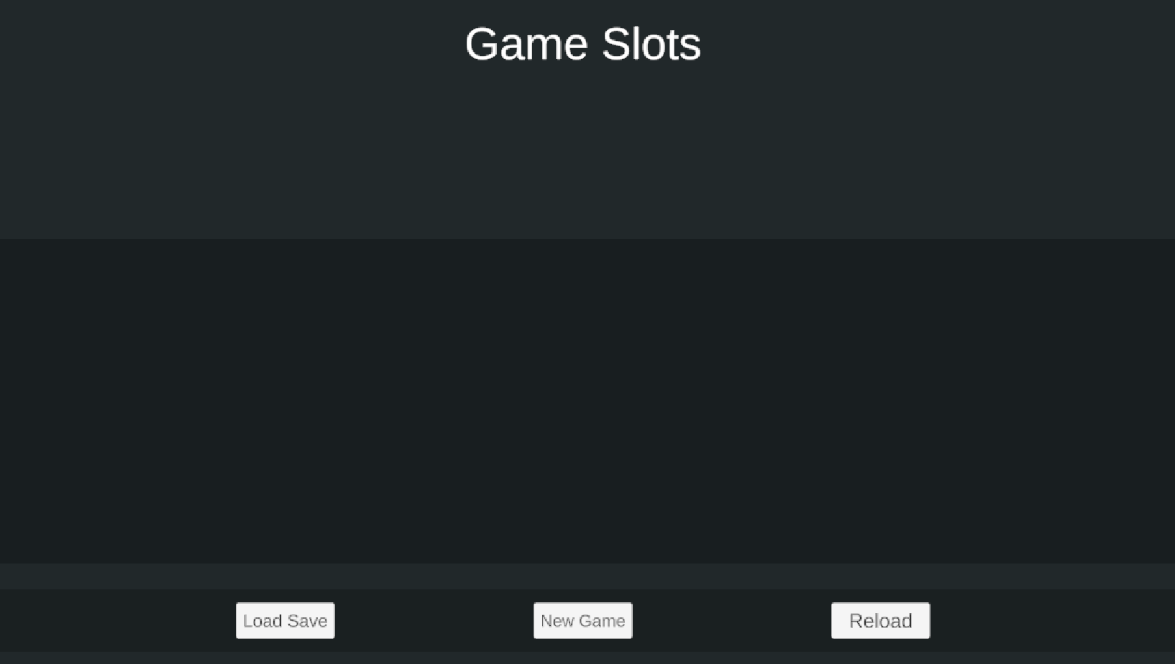

*(The slots menu upon opening the game for the first time)*

#### Evidence – Filled Slot Menu

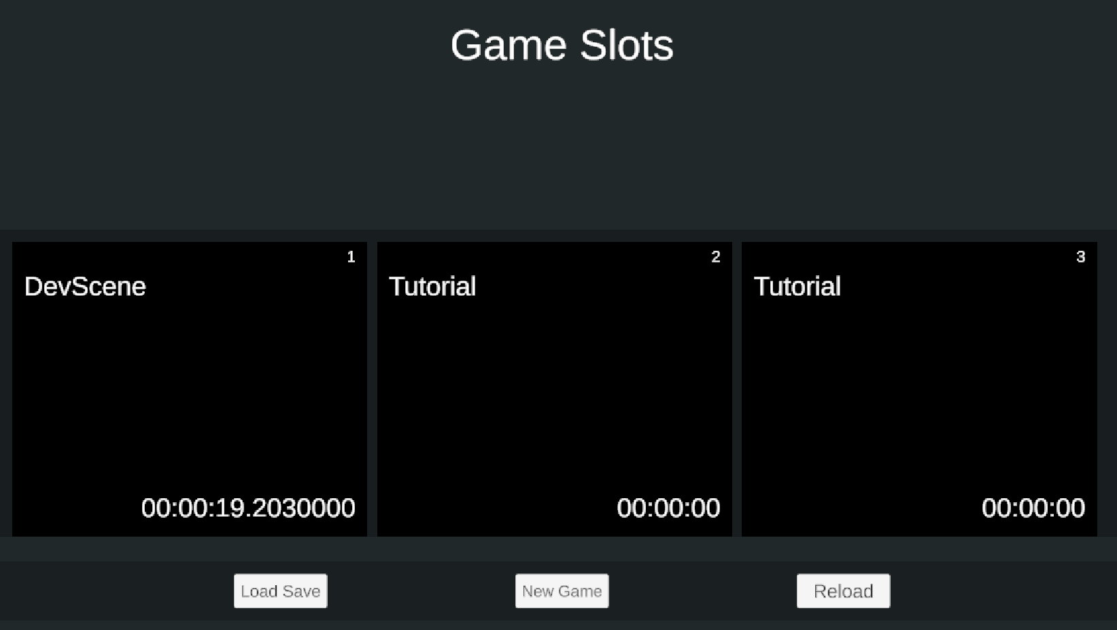

*(The slots menu with some filled in slots)*

#### Evidence – Loading Screen



*(The loading screen, with the scene finished loading)*

#### Evidence – HUD

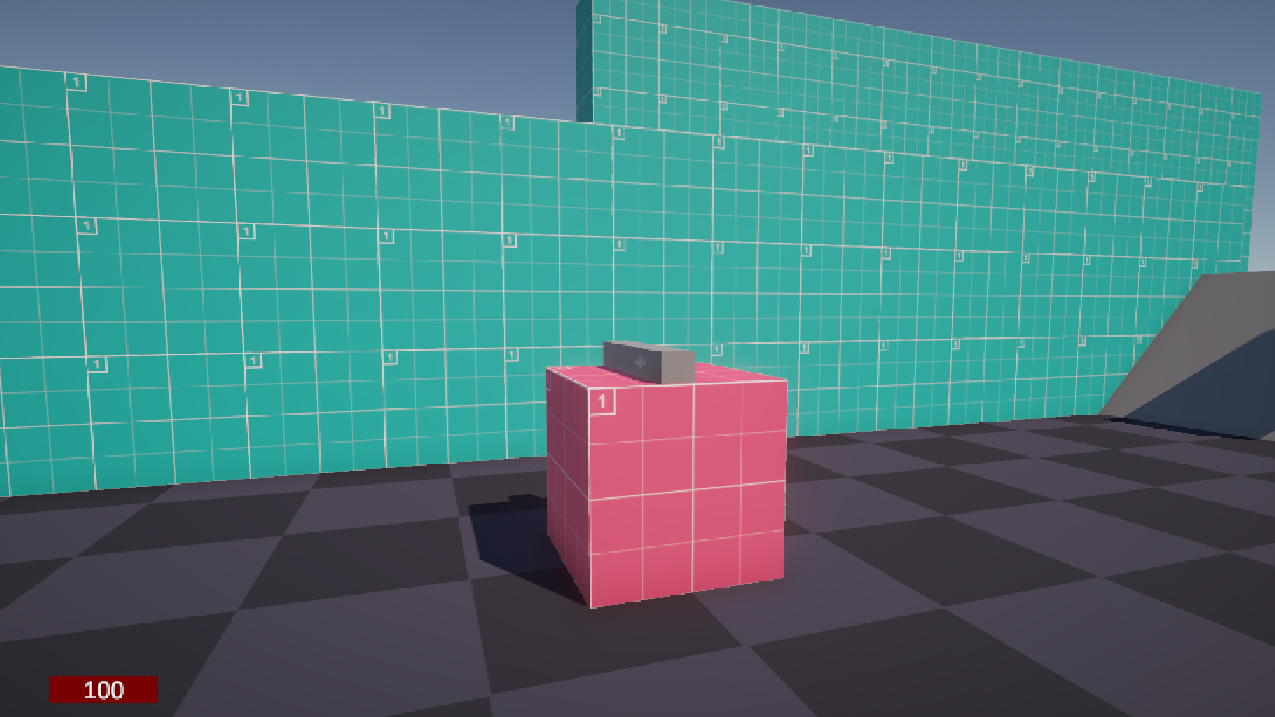

*(The HUD and player view when the player first loads into a save)*

#### Evidence – Pause Menu

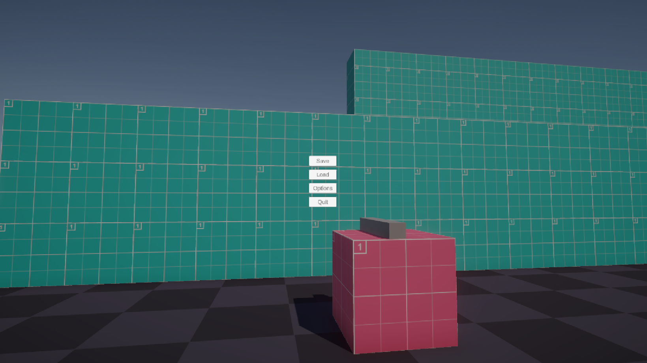

*(The pause menu)*

#### Evidence – Options menu in the Pause Menu

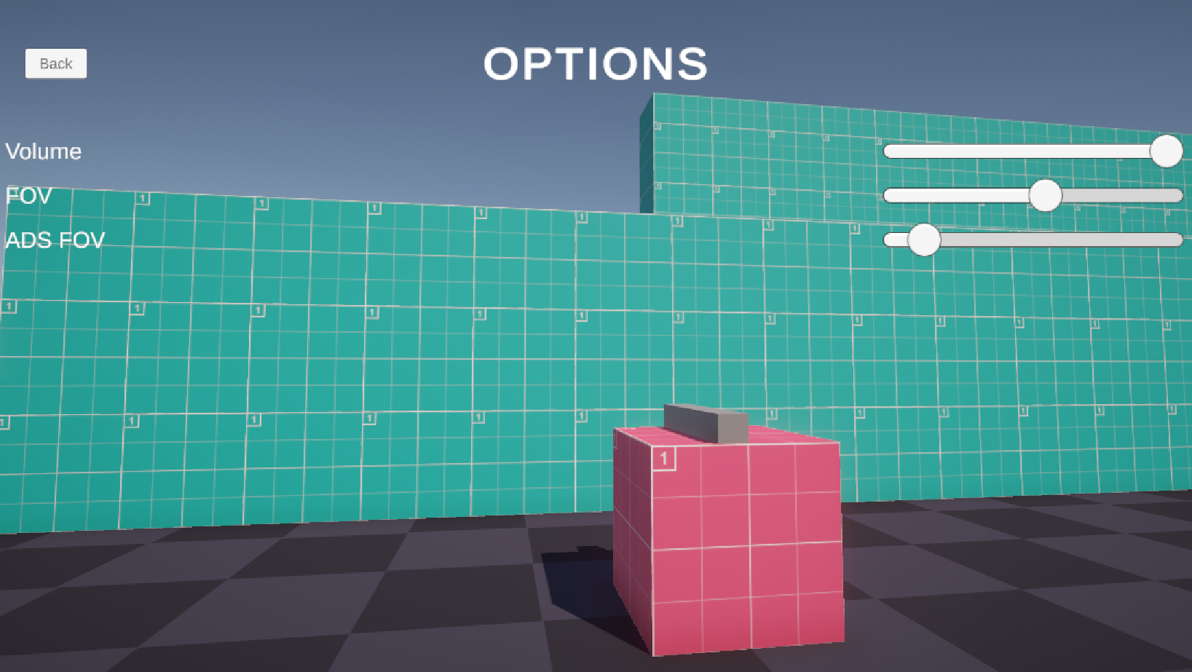

*(The options menu in the pause menu)*

## Success Criteria

Each criterion will be evaluated based upon the above test data and whether they were met fully, partially, or not met at all. They will also include extra comments from both stakeholders.

|  |  |  |
| --- | --- | --- |
| Criterion | Met rating | Stakeholder Comments |
| Strafing Movement | Fully met | Some of the movement feels a little bit slippery, and there is also the jittering bug that is experienced when no input is held after the player has moved. |
| Jump | Fully met | Double jumping works well but could add an extra boost in the direction that the player is facing. |
| Crouching | Fully met |  |
| Firing, swapping, reloading, zooming different weapons | Partially met | While the player could hold multiple weapons, these were all the same type, as different types of weapons were not implemented. |
| Can take damage | Fully met |  |
| Ability to go back to a save on death | Fully met | It may be useful to have information on how the player could avoid dying the way they died on this screen as a future feature. |
| Saving | Fully met | It could also be useful for the player to see all of the saves inside of a particular save slot, although this feature could add unnecessary bloat to the player’s screen. |
| Loading | Partially met | Excluding the known error with the loading of a save while in the pause menu, this system could allow the player to load one of the saves the player inside of their save slot, like the above note. |
| Interactable menus with audio feedback | Fully met |  |
| Dialogue | Partially met | The ability for the player to have choices with the system was cut. |
| Enemies searching and fighting back | Partially met | Enemy searching seems to be inconsistent and unreliable, especially for the drone. The enemy also struggles to point its weapon at the player, although once it does, it fires adequately. |
| The game runs at a minimum of 30 fps on typical hardware, as according to the Steam Hardware Survey | Fully met | The game runs far above 30 fps, even when stressed with extra enemies. |
| The game will have as few glitches as possible, with absolutely no game-breaking ones | Fully met | No game-breaking bugs were found |

### Interview

Henry Masters: Overall, I consider this project a success, even though there were some features that were unable to be implemented effectively, or at all. This has demonstrated the concept for this game very well, and my team have decided to continue developing this game as a result.

Amarveer Flora: I would also like to note that there are very few bugs with the game overall, so many of the features that are already in the game will not need much tweaking for you to use it.

Henry Masters: Ah, thank you for that extra note!

Stakeholder Signature:



## Limitations and Maintenance

Due to the extremely tight constraint of time, many planned features were not implemented, along with potential improvements that could have been put it. Of features that were not implemented at all, these include the end of level scoring system, along with optional special movement type – grappling. These systems could have been added, or like the grappling mechanic, identified too be as too much earlier on in the project design, rather than never reaching them in development. However, moving forward, implementing these systems can utilise the other systems already put into place, adding into them as necessary, and hopefully not requiring much modification of the already written systems. To implement grappling, I could add this into the movement script, just like wallrunning, or I could add it through a branched off script that uses a separate script that communicates with the player’s manager. Both ways will need to be checked through to see which one would be better to do in the long-term development for the game. In terms of the scoring system, this should be a completely isolated system, with most of its influence on other systems already having been implemented correctly. For example, its influence in the save system has already been partly implemented in the form of a template for what the data should look like. I could then further develop the system to modify and apply this data appropriately within the game manager.

There were also parts of the game that had to be reduced in size, such as the different types of weapons. I could add in melee weapons, which allows a different style of play for the player. It is important to allow the player to have different playstyles to encourage the player to use everything that they have to their disposal, and experiment with what I have handed to them. It will also allow more players to enjoy the game and give players their own artificial challenge by attempting to play without a type of weapon. These melee weapons could use a different system for applying damage, such as using part of the spike script to apply damage on contact with the weapon’s collider. On the other hand, a different, also common type of weapon is the explosive, which will encourage a completely different type of play style to both typical guns and melee weapons. Explosive weapons will also need to be balanced differently to other weapons, to make sure that it doesn’t become too powerful and have a negative effect on the player’s experience. I could do this by making explosives have a high damage effect on enemies within a certain range of them but conversely having an extremely long reload time or a slow rate of fire.

Another part of the combat system is the entity system. According to the evaluative tests, the entity behaviour is definitely dodgy and requires much improvement. Firstly, the entities are unable to sense the player accurately, especially for the drone and whenever the player is slightly above the soldier and tank. This is due to the entities’ searching algorithm using rays and only shooting them out in 1 plane – the flat XZ plane. This means that it never searches slightly above or below the entity and hence misses out the majority of the positions the player could be in, and where the player would expect that the entity would see them. This effects the player’s experience since it defeats the entire point of the enemies, making there be hardly any difficulty in the game, and taking a lot of the fun out of it. Firing more rays in the varied angles is a potential solution to this but falls into a performance problem when many enemies are firing of many, many rays to make sure that they don’t miss the player. A much more performant alternative involves a sphere cast. I could use 1 large sphere for each entity that encompasses their entire detection range and then work out the angle between it and every other entity that it collides with to decide whether it is worth to cast an extra ray to check it should actually be detected by the entity. This, while being more complicated, would completely fix the issues with the entity detection. A single sphere cast is also not that much more difficult to run that a single ray cast, making this the better option to implement moving forward.

Another feature for the entities was the ability for the player to have their own friendly team that would fight with them, and this would require the entity searching algorithm to check for entities with the opposite team as them, and then have the player be part of one of these teams. This would allow a way for the game to manage the difficulty the player experiences much better and allows a story aspect to develop much better in the game, hence justifying this feature. Having a story would lean into the secondary RPG genre of the game, which would justify the genre as being part of the game. With no story, the character is not fulfilling a role, and without any systems for the story exist, any story elements that are added would not mix as well with the game and feel natural. The dialogue system naturally ties into aiding a potential story, and this system was not completed in its entirety. The most interactive element of it, the player’s ability to make a choice, was cut out due to time constraints. This also meant that the menu for it was never created, and I could have added this into the game as a future addition, especially if I were to have more time. It would also be useful to fix the issue with the if statement, making sure that the player can fully experience all the options of dialogue that the system supplies.

The next limitation surrounds the optimisation of the game and making it easier to maintain and develop upon by the team at SillyAustralian. This limitation comes down to the duplicated code that exists between 2 functions in the player’s movement: Wallrun() and Movement(). Wallrun() uses virtually the exact same code as Movement(), adding the possibility of making it a wrapper function instead, and passing through the changed variable instead. This would improve the ease in maintaining the code and solving any errors in it, which is always beneficial.

The final limitations all surround usability and feedback. It is important that when the player does something, namely an input, they should get a response back, whether it be via particle effects, sound effects, or something else. There are many instances in this game where it would benefit from a response to the player’s actions. The first of these instances is constantly experienced by the player – the use of their weapon. When the player presses the fire button, there is no response from the game that the weapon has been fired, nor whether it hit anything. This can make it very confusing to understand whether the gun is out of ammunition or not. The only feedback that exists for the weapon being fired is when the enemy visibly disappears upon being killed, but this requires that the player has landed all the shots required to kill the enemy, which can frustrate the player. To fix this, I could implement sound effects that are played whenever the player fires the weapon, and also when it is reloading or out of ammunition. However, sourcing good sound effects are extremely difficult, especially due to budget constraint. I could also make the sound effect myself, but for a game meant to be extremely serious, I would be unable to make appropriate clips with my current ability, since I do not know anything about sound design. Another thing that could aid the issues surrounding weapon feedback is the display of the weapon’s current information using the intended feature on the HUD. Since this was missing, it became nigh impossible to get any feedback on your weapons’ current state. I could add this to the display and link this using an auxiliary script to translate between the HUD and PlayerGunInteraction. This will improve the usability of the game and make it easier to know what is happening in the game.

The last instance of something absolutely needing feedback that was pointed out in the evaluative testing is the wallrunning. It was pointed out that it wasn’t always clear when the player had initially started wallrunning, nor when the player had jumped off the wall or had fallen off the wall and then double jumped. For the former, I could implement a camera tilt away from the wall surface to truly make the player feel like they are running on the wall. For the latter, this can be solved with two different sound effects for jumping normally and for jumping, which runs into the same issues for the weapon sound effects. However, nonetheless, this should work well in increasing the usability of the game.

# Bibliography

Anon., 2024. [Online]   
Available at: https://tf2sr.github.io/TF2SR-Wiki/

Anon., n.d. *How to Tune a PID Controller.* [Online]   
Available at: https://pidexplained.com/how-to-tune-a-pid-controller/  
[Accessed 22 November 2024].

Atwood, J. & Spoisky, J., 2008. *Stack Overflow.* [Online]   
Available at: https://stackoverflow.com/  
[Accessed 26 June 2024].

d'Apprentissage, T. d. F. e., n.d. *Orthogonal Unit Differentiation.* [Online]   
Available at: https://tecfa.unige.ch/tecfa/maltt/VIP/Ressources/Articles/Game%20Design%20Patterns/collection/Alphabetical_Patterns/OrthogonalUnitDifferentiation.htm#:~:text=When%20Units%20in%20a%20game,with%20different%20types%20of%20abilities.  
[Accessed 24 July 2024].

Dev, P., 2023. *Collide And Slide - *Actually Decent* Character Collision From Scratch.* [Online]   
Available at: https://www.youtube.com/watch?v=YR6Q7dUz2uk  
[Accessed 25 July 2024].

Electronic Arts Inc.; Respawn Entertainment, 2018. *Titanfall 2.* [Online]   
Available at: https://www.ea.com/en-gb/games/titanfall/titanfall-2

Fadi, E., 2025. *Link to my GitHub.* [Online]   
Available at: https://github.com/RandomEF/Abrupt-Animus

Frei, D., 2022. *Saving Data in Unity using SQLite,* s.l.: s.n.

GeeksforGeeks, 2008. *Geeks for Geeks.* [Online]   
Available at: https://www.geeksforgeeks.org/  
[Accessed 23 September 2024].

gskinner, n.d. *RegExr.* [Online]   
Available at: https://regexr.com/  
[Accessed 27 August 2024].

Half Life Fandom, 2007. *Overwatch Soldier.* [Online]   
Available at: https://half-life.fandom.com/wiki/Overwatch_Soldier  
[Accessed 17 September 2024].

Huertas, R., n.d. s.l.: s.n.

id Software, 2016. *DOOM.* [Online]   
Available at: https://bethesda.net/en/game/doom-2016

id Software, 2020. *DOOM Eternal.* [Online]   
Available at: https://mods.bethesda.net/doometernal

Iyer, A., 2018. *Titanfall 2: How Design Informs Speed,* s.l.: s.n.

Leprawel, n.d. *Parkour Controller Script,* s.l.: s.n.

Microsoft, 2024. *C# Language Documentation.* [Online]   
Available at: https://learn.microsoft.com/en-us/dotnet/csharp/  
[Accessed 6 July 2024].

Official, T., 2016. *Titanfall 2: Inside Development,* s.l.: s.n.

OMOCAT LLC., 2020. *Omori.* [Online]   
Available at: https://www.omori-game.com/en

One More Level; Slipgate Ironworks, 2020. *Ghostrunner.* [Online]   
Available at: https://ghostrunnergame.com/

Patala, A. "., 2020. *Ultrakill.* [Online]   
Available at: https://store.steampowered.com/app/1229490/ULTRAKILL/

SFB Games, 2021. *ChipTone.* [Online]   
Available at: https://sfbgames.itch.io/chiptone  
[Accessed 20 February 2025].

Thirslund, A., 2012. *Brackeys YouTube channel.* [Online]   
Available at: https://www.youtube.com/@Brackeys  
[Accessed 4 September 2024].

Unity Technologies, 2022. *Megacity Metro – Large-Scale Multiplayer Demo | Unity.* [Online]   
Available at: https://unity.com/demos/megacity-competitive-action-sample  
[Accessed 22 February 2025].

Unity Technologies, 2025. *Unity Documentation.* [Online]   
Available at: https://docs.unity3d.com/6000.0/Documentation/ScriptReference/index.html

Valve Corporation, 1998. *Half Life.* [Online]   
Available at: https://www.half-life.com/en/halflife

Valve Corporation, 2025. *Steam Hardware Survey.* [Online]   
Available at: https://store.steampowered.com/hwsurvey  
[Accessed 28 March 2025].

Valve Developer Community, 2005. *Category:AI - Valve Developer Community.* [Online]   
Available at: https://developer.valvesoftware.com/wiki/Category:AI  
[Accessed 18 September 2024].

# Appendix (All the game’s code)

## UISounds.cs

|  |
| --- |
| using UnityEngine;  using UnityEngine.EventSystems;  using UnityEngine.AddressableAssets;  using UnityEngine.ResourceManagement.AsyncOperations;  using UnityEngine.UI;  public class UISounds : MonoBehaviour, IPointerEnterHandler  {      [SerializeField] AudioClip uiHover;      [SerializeField] AudioClip uiSelect;      void Awake()      {          Addressables.LoadAssetAsync<AudioClip>("Assets/Audio/SFX/UIHover.wav").Completed += (asyncOp) =>          { // Attempt to load the hover effect              if (asyncOp.Status == AsyncOperationStatus.Succeeded)              { // If the load succeeds                  uiHover = asyncOp.Result; // Assign the hover sound              }              else              {                  Debug.LogError("Failed to load UI audio.");              }          };          Addressables.LoadAssetAsync<AudioClip>("Assets/Audio/SFX/UISelect.wav").Completed += (asyncOp) =>          { // Attempt to load the select effect              if (asyncOp.Status == AsyncOperationStatus.Succeeded)              { // If the load succeeds                  uiSelect = asyncOp.Result; // Assign the hover sound              }              else              {                  Debug.LogError("Failed to load UI audio.");              }          };      }      void Start()      { // Run OnClick when the button is clicked          gameObject.GetComponent<Button>().onClick.AddListener(OnClick);      }      void OnClick()      {          AudioManager.Instance.PlaySFXClip(uiSelect, transform, 1); // Play uiSelect      }        public void OnPointerEnter(PointerEventData eventData)      { // When the mouse hovers over the button          AudioManager.Instance.PlaySFXClip(uiHover, transform, 1); // Play uiHover      }  } |

## CASCapsuleVisualiser.cs

|  |
| --- |
| using UnityEngine;  public class CollideAndSlideCapsuleVisualiser : MonoBehaviour  {      public Rigidbody player;      public GameObject playerObj;      public CapsuleCollider playerCollider;      public float playerHeight;      private void OnDrawGizmos()      { // Draws the top and bottom spheres of the capsule          Gizmos.DrawWireSphere((player.position + new Vector3(0f, playerCollider.height * playerHeight / 2f - playerCollider.radius)), playerCollider.radius);          Gizmos.DrawWireSphere((player.position - new Vector3(0f, playerCollider.height * playerHeight / 2f - playerCollider.radius)), playerCollider.radius);      }  } |

## FPS.cs

|  |
| --- |
| using UnityEngine;  using TMPro;  public class FPS : MonoBehaviour  {      public TMP_Text text;      int number = 0;      float currentAvg = 0;      public bool log;      void Update()      { // Displays the current framerate, will tank the fps          float displayVal = 1F / Time.deltaTime;          text.text = displayVal.ToString();          if (log)          {              Debug.Log(displayVal.ToString());          }      }      float UpdateAverage(float currentFPS)      { // Optional version that averages the fps across the whole game, not very helpful          number++;          currentAvg += (currentFPS - currentAvg) / number;          return currentAvg;      }  } |

## IsGroundedTest.cs

|  |
| --- |
| using UnityEngine;  public class IsGroundedTest : MonoBehaviour  {      public Rigidbody player;      public CapsuleCollider playerCollider;      public GameObject playerObj;      private void OnDrawGizmos()      { // Draws the overlap sphere used for depreciated ground check function          float groundDistance = player.GetComponent<PlayerMovement>().groundDistance;          float radius = player.transform.localScale.x * playerCollider.radius;          float playerHeight = player.transform.localScale.y * playerCollider.height;          Debug.DrawLine(player.transform.position, new Vector3(player.transform.position.x, player.transform.position.y - (0.85f), player.transform.position.z));          Gizmos.DrawWireSphere(new Vector3(player.transform.position.x, player.transform.position.y - groundDistance + radius - playerHeight / 2, player.transform.position.z), radius);          // For some reason, in the actual code the distance to the ground has to be multiplied by 2 so that it is 0.85f * 2      }  } |

## PosAndVelocity.cs

|  |
| --- |
| using UnityEngine;  using TMPro;  public class PosAndVelocity : MonoBehaviour  {      public TMP_Text text;      public Rigidbody player;      void Update()      { // Displays in a text box the player's velocity and position on the 3 axes          text.text = $"Pos: x {player.transform.position.x}, y {player.transform.position.y}, z {player.transform.position.z}<br>Velocity: {player.linearVelocity}";      }  } |

## DialogueInteraction.cs

|  |
| --- |
| using UnityEngine;  using System.Data;  using System.Collections.Generic;  using System.IO;  using System;  using System.Linq;  using Unity.VisualScripting;  using System.Text;  using Unity.Collections;  public class DialogueInteraction : Interactable  {      public PlayerManager gameManager;      private DialogueDatabaseManager ddm;      public DialogueManager dialogueManager;      private List<(int, string)> actorsInInteraction = new List<(int, string)>();      public UnityEngine.Object dialogueFile;      private string filepath;      [SerializeField] private Dictionary<string, int> dialogueSections = new Dictionary<string, int>();      private StreamReader fileReader;      void Start()      {          gameObject.tag = "Interact"; // Set the object that has this to be detected as interactable          gameManager = PlayerManager.Instance; // Fetch the player manager          ddm = DialogueDatabaseManager.Instance; // Fetch the dialogue database manager          dialogueManager = DialogueManager.Instance; // Fetch the dialogue manager          filepath = Path.Combine(Application.streamingAssetsPath, "Dialogue", dialogueFile.name + ".dlg"); // The path to the dialogue file          PreprocessSections(); // Fetch the dialogue sections          Debug.Log(ConvertLine("This is a _spooky_ line filled with <#FFFF00*great* things> ---_and_ *bad* things."));      }      public override void Interact()      {          (string, string, string[]) output = RetrieveNextLine(); // Get the next line          if (output.Item1 == "line")          { // If it is a line, send it to the dialogue manager              Debug.Log($"Sending line '{output.Item2 + ": " + output.Item3[0]}'");              dialogueManager.DisplayLine(output.Item2 + ": " + output.Item3[0]);          }      }      private void PreprocessSections()      {          StreamReader reader = new StreamReader(filepath);          int lineNumber = 1; // Start from the beginning of the file          while (!reader.EndOfStream)          { // While the end of the file has not been reached              string line = reader.ReadLine(); // Read the line into a variable              if (line.StartsWith("[") && line.EndsWith("]"))              { // If the line starts and ends with square brackets                  dialogueSections.Add(line[1..^1], lineNumber); // Store the name of the section with the line number              }              lineNumber++; // Next line          }      }      private string RequestNext(bool isDialogue, string language, int lineID)      {          IDbConnection connection = isDialogue ? ddm.OpenDialogueDb() : ddm.OpenActorDb(); // If the database needed is dialogue, open that table, otherwise open the actor table          IDbCommand lineRequest = connection.CreateCommand(); // Begin a query          lineRequest.CommandText = $"SELECT {language} FROM {(isDialogue ? "Dialogue" : "Actor")} WHERE id={lineID}"; // Select the language of ID lineID from the right table          IDataReader response = lineRequest.ExecuteReader(); // Execute the query          bool success = response.Read(); // Read a line and store it          if (!success)          { // If the query failed              Debug.LogError($"{(isDialogue ? "Line" : "Actor")} {lineID} is not in {(isDialogue ? "Dialogue" : "Actor")} table");              connection.Close();              return ""; // Return an empty string          }          string line = response.GetString(0); // Get the first string          connection.Close(); // Close the database          return line; // Return the line      }      private string ConvertLine(string line)      {          string copy = "";          bool firstItalics = true; // Tracks whether the first underscore is yet to come          bool firstBold = true; // Tracks whether the first asterisk is yet to come          for (int i = 0; i < line.Length; i++)          { // For every character in the line              if (line[i] == '\\')              { // Ignore the next character                  i++; // Skip over the next character              }              else if (line[i] == '<')              { // Begin reading a colour                  string hexColour = line.Substring(++i, 7); // Grab a colour code                  copy += "<color=" + hexColour + ">"; // Add the hexcode along with the <color= >                  i += 6; // Skip over the hexcode              }              else if (line[i] == '>')              {                  copy += "</color>"; // Replace with the ending tag              }              else if (line[i] == '_')              {                  if (firstItalics)                  {                      copy += "<i>"; // Replace with the starting italics tag                      firstItalics = false;                  }                  else                  {                      copy += "</i>"; // Replace with the ending italics tag                      firstItalics = true;                  }              }              else if (line[i] == '*')              {                  if (firstBold)                  {                      copy += "<b>"; // Replace with the starting bold tag                      firstBold = false;                  }                  else                  {                      copy += "</b>"; // Replace with then ending bold tag                      firstBold = true;                  }              }              else              {                  copy += line[i]; // Just copy the character              }          }          return copy;      }      // DLG Interpreter      private int lineNumber = 2; // The line of the file that the interpreter is on      /*      -> is the goto operator      [] is dialogue section      #Ax is Actor database      #Lx is Line database      :: actor line/actor split      @ is variable      = is variable assign      */      public (string, string, string[]) RetrieveNextLine()      {          while (true)          {              TreeNode tokenTree = Tokenizer(); // Tokenize the line              (string, string, string[]) returnVals = Analyzer(tokenTree); // Analyse the tokens of the lines              string type = returnVals.Item1;              if (type == "true")              { // If the analyzer has decided another line must be read                  continue; // Read another line              }              if (type == "line")              {                  string actor = returnVals.Item2; // Retrieve the actor                  string line = ConvertLine(returnVals.Item3[0]); // Convert the lone line                  string[] lines = new string[1]; // Make a new array of length 1 to store the converted line                  lines[0] = line; // Store the line in the return output                  return (type, actor, lines); // Return as appropriate              }              else if (type == "choice")              { // If the node is a choice node                  string[] lines = returnVals.Item3; // Fetch all the dialogue options                  string[] convertedLines = new string[lines.Length]; // Make a new array for however many dialogue options                  for (int i = 0; i < lines.Length; i++)                  { // For each option                      convertedLines[i] = ConvertLine(lines[i]); // Convert it and assign to the return output                  }                  return (type, returnVals.Item2, convertedLines); // returnVals.Item2 will be blank as the actor is assumed to be the player, but this must be passed through to fulfill the return type conditions              }              /*else if (type == "facing")              {              } */              else              {                  throw new Exception($"Line Retrieval: '{type}' was not a recognised type.");              }          }      }      private TreeNode Tokenizer()      {          TreeNode fileTree = new TreeNode(); // This is here in case a choice exists; in which case multiple lines need to be read at once          using (StreamReader fileReader = new StreamReader(filepath)){              for (int i = 0; i < lineNumber - 1; i++)              {                  fileReader.ReadLine(); // Skip lines until the current one is reached              }              int lastLineNumber = lineNumber - 1;              string line = fileReader.ReadLine(); // Read the current line              while (!fileReader.EndOfStream && lastLineNumber != lineNumber)              {                  if (line.Length < 3)                  { // The minimum length of the line cannot go below 3                      throw new Exception($"Tokenizer: The line '{line}' is missing information.");                  }                  byte[] lineBytes = Encoding.UTF8.GetBytes(line); // Convert into a list of characters                  MemoryStream stream = new MemoryStream(lineBytes); // Make into a stream for StreamReader later                  lastLineNumber = lineNumber; // Set the previous line                  StreamReader lineReader = new StreamReader(stream); // Prepare for reading per character                  TreeNode lineTree = new TreeNode(); // New node for the line                  lineTree.AddType("linetree");                  fileTree.AddChild(lineTree); // Add the node to the file tree                  ReadNext(lineReader, lineTree); // Tokenize the line                  bool shouldStay = false; // Initialise shouldStay                  if (fileTree.GetChildren()[^1].GetChildren()[^1].GetNodeType() == "choice")                  { // If the node is a choice node                      if (fileTree.GetChildren()[^1].GetChildren()[^1].value["end"] == "false")                      { // If it is not the last node in the choice - it is necessary to put this on a separate line to avoid an error                          shouldStay = true; // Require reading the next line                      }                  }                  string nextLine = fileReader.ReadLine(); // Check the next line                  if (nextLine[0] != '[' && nextLine != null)                  { // If the next line isn't a dialogue section header or the end of the file                      lineNumber++; // Now on the next line                      line = nextLine; // Set the current line                      if (!shouldStay)                      { // If staying is not required                          break; // Exit                      } else {                          throw new Exception("Expected another line to complete the choice: maybe you have an extra comma?");                      }                  }              }          }          return fileTree; // Return the read lines      }      // Tokenizer      private void ReadNext(StreamReader line, TreeNode lineTree)      {          while (!line.EndOfStream)          { // While the end of the line hasn't been reached              char token = ReadChar(line);              if (token == '#')              {                  ReadID(line, lineTree);              }              else if (token == '@')              {                  ReadIf(line, lineTree);              }              else if (token == '-')              {                  ReadJump(line, lineTree);              }              else if (token == '|')              {                  ReadChoice(line, lineTree);              }              else if (token == ':')              {                  token = ReadChar(line);                  if (token == ':')                  {                      ReadSeparator(line, lineTree);              }              else              {                  throw new Exception($"Tokenizer: The starting character '{token}' was not recognised.");              }          }      }                  } /*else if (token == '-'){                      ReadAnimation(line, lineTree);                  }*/      private char ReadChar(StreamReader line)      {          int character = 32; // ASCII for space          while (character == 32)          { // Skips over spaces              character = line.Read();          }          return character == -1 ? throw new Exception("Tokenizer: Nothing left to read.") : (char)character; // If it is not the end of the line, return the char      }      private char PeekChar(StreamReader line)      {          int character = 32; // ASCII for space          while (character == 32)          { // Skips over spaces              character = line.Peek();          }          return character == -1 ? throw new Exception("Tokenizer: Nothing left to peek.") : (char)character; // If it is not the end of the line, return the char      }      private void ReadID(StreamReader line, TreeNode lineTree)      {          char character = ReadChar(line); // Read the next character          int id = ReadNumber(line); // Read the number attached to it          TreeNode idNode = new TreeNode(); // Make a new ID node          lineTree.AddChild(idNode); // Add it to the line's children          if (character == 'A')          { // If the ID is an actor              idNode.AddType("actor");          }          else if (character == 'L')          { // If the ID is a line              idNode.AddType("line");          }          else          {              throw new Exception($"Tokenizer: Unable to decide if this is an actor or line reference: {character}");          }          idNode.value.Add("id", id.ToString()); // Add the number to the node's dictionary      }      private int ReadNumber(StreamReader line)      {          string num = "";          while (!line.EndOfStream)          { // While the end of the line hasn't been reached              char character = PeekChar(line); // Peek a character              if (int.TryParse(character.ToString(), out _))              { // If it is a number                  num += ReadChar(line); // Read it and and it to the number string              }              else              {                  break;              }          }          return int.Parse(num); // Return the number      }      private void ReadIf(StreamReader line, TreeNode lineTree)      {          TreeNode ifNode = new TreeNode(); // Make a new node          lineTree.AddChild(ifNode); // Add it to lineTree's children          ifNode.AddType("if"); // Set the type to 'if'          ReadVariable(line, ifNode); // Read the variable and add it to ifNode's children          ReadOperator(line, ifNode); // Read the operator and add it to ifNode's children          char character = PeekChar(line); // Peek at the next character          if (char.IsNumber(character))          { // If it is a number              TreeNode numNode = new TreeNode();              ifNode.AddChild(numNode); // Make a new child node to store the number              numNode.AddType("num"); // Set the type to 'num'              numNode.value.Add("num", ReadNumber(line).ToString()); // Assign the number to numNode          }          else if (char.IsLetter(character) || character == '_')          { // If the next character is a letter or _              ReadVariable(line, ifNode); // Read a variable          }          else          {              throw new Exception("Tokenizer: Nothing valid to compare to.");          }      }      private void ReadVariable(StreamReader line, TreeNode lineTree)      {          char character = PeekChar(line); // Check what the next character is          if (char.IsNumber(character))          { // A variable name can't start with a number              throw new Exception("Tokenizer: Variable can't start with a number!");          }          TreeNode variableNode = new TreeNode(); // Make a new node          lineTree.AddChild(variableNode); // Add it to lineTree's children          string variable = ""; // Define variable          while (!line.EndOfStream)          { // Until the end of the line              character = PeekChar(line); // Peek at the next character              if (char.IsLetterOrDigit(character) || character == '_')              { // If the character is valid                  variable += ReadChar(line); // Read it and add it to the name              }              else              {                  break;              }          }          variableNode.AddType("var"); // Add the type 'var'          variableNode.value.Add("var", variable); // Add the name of the variable      }      private string ReadOperator(StreamReader line, TreeNode lineTree)      {          string op = ""; // Create a variable to hold the operator          char[] opChars = { '!', '>', '<', '=' }; // List of the acceptable characters          TreeNode opNode = new TreeNode(); // Make a new node          lineTree.AddChild(opNode); // Add it to lineTree's children          while (!line.EndOfStream)          { // While not the end of the line              char character = PeekChar(line); // Check the next character              if (op.Length == 0 && opChars.Contains(character))              { // If nothing has been read and it’s a valid character                  op += ReadChar(line); // Add it to the string              }              else if (op.Length == 1 && opChars.Contains(character))              { // If it is a comparison                  op += ReadChar(line); // Add the character to the string                  opNode.AddType("comp"); // Assign the type as comparison                  opNode.value.Add("op", op); // Add the comparison type                  return op;              }              else if (op.Length == 1 && op == "=")              { // If it is only an assignment                  opNode.AddType("assign"); // Set the type as assignmentt                  return op;              }              else              {                  throw new Exception($"Tokenizer: Invalid operator '{op}'.");              }          }          throw new Exception($"Tokenizer: No valid operator found: '{op}'");      }      private void ReadJump(StreamReader line, TreeNode lineTree)      {          char character = ReadChar(line); // Read the next character          if (character == '>')          { // If it is an arror              string section = ""; // Define a variable for the section name              while (!line.EndOfStream)              { // Copy all other characters as the section name                  section += ReadChar(line);              }              TreeNode sectionNode = new TreeNode(); // Create a new node              lineTree.AddChild(sectionNode); // Add it to lineTree's children              sectionNode.AddType("jump"); // Set the type as jump              sectionNode.value.Add("section", section); // Set the section name          }          else          {              throw new Exception("Tokenizer: This is not a jump, what were you trying to signify?");          }      }      private void ReadChoice(StreamReader line, TreeNode lineTree)      {          TreeNode choiceNode = new TreeNode(); // Make a new node          choiceNode.AddType("choice"); // Set the type as choice          lineTree.AddChild(choiceNode); // Add to lineTree's children          while (!line.EndOfStream)          { // If it isn't the end of the line              char character = ReadChar(line); // Get the next character                if (character == '#')              { // Read an ID                  ReadID(line, lineTree);              }              else if (character == ',')              { // If there is a comma                  choiceNode.value.Add("end", "false"); // Mark that there will be another line                  return;              }              else              {                  throw new Exception($"Tokenizer: Unrecognised character '{character}' following choice line");              }          }          choiceNode.value.Add("end", "true"); // No comma = last option      }      private void ReadSeparator(StreamReader line, TreeNode lineTree)      { // Required to check for proper syntax          TreeNode separatorNode = new TreeNode(); // Make a new node          separatorNode.AddType("sep"); // Set the type as a separator          lineTree.AddChild(separatorNode); // Add to lineTree's children      }/*      private void ReadAnimation(StreamReader line, TreeNode lineTree){          char character = PeekChar(line);          if (character == '-'){              ReadChar(line);              TreeNode animNode = new TreeNode();              lineTree.AddChild(animNode);              animNode.AddType("anim");              animNode.value.Add("num", ReadNumber(line).ToString());          }      }*/      // Analysis      private (string, string, string[]) Analyzer(TreeNode fileTree)      {          string[] lines = new string[fileTree.GetChildren().Count]; // Make a new return array based on the number of lines          string returnType = "none"; // Default return type          string[] returnLines = new string[lines.Length]; // Copy of lines          for (int i = 0; i < fileTree.GetChildren().Count; i++)          { // For each line              TreeNode line = fileTree.GetChildren()[i]; // Get the line              List<TreeNode> elements = line.GetChildren(); // Get the elements of the line              if (elements[0].GetNodeType() == "actor")              { // If the line is an actor                  /*                  if (elements[1].GetNodeType() == "anim")                  {                      returnType = "animation";                      string returnActor = RequestNext(false, "actor", Int32.Parse(elements[0].value["id"]));                      string[] animID = { elements[1].value["num"] };                      return (returnType, returnActor, animID);                  } else if (elements[1].GetNodeType() == "sep" && elements[2].GetNodeType() == "actor"){                      returnType = "facing";                      string returnActor1 = RequestNext(false, "actor", Int32.Parse(elements[0].value["id"]));                      string[] returnActor2 = {RequestNext(false, "actor", Int32.Parse(elements[2].value["id"]))};                      return (returnType, returnActor1, returnActor2);                  }                  else */                  /* if (elements[1].GetNodeType() == "anim")                  {                      returnType = "anim";                      string returnActor = RequestNext(false, "actor", Int32.Parse(elements[0].value["id"]));                      string[] animID = {elements[1].value["num"]};                      return (returnType, returnActor, returnLines);                  } else */                  if (elements[1].GetNodeType() == "sep" && elements[2].GetNodeType() == "line")                  { // If a separator and a line node follow the actor                      returnType = "line"; // Set the return type to line                      returnLines[i] = LineAnalysis(elements.GetRange(2, elements.Count - 2)); // Analyse all the lines into 1                      string returnActor = RequestNext(false, "actor", Int32.Parse(elements[0].value["id"])); // Get the actor from the database                      return (returnType, returnActor, returnLines); // Return the values                  }                  else                  {                      foreach (TreeNode element in elements){                          Debug.Log(element.GetNodeType());                      }                      throw new Exception("Analysis: Unable to progress after discovering actor in analysis.");                  }              }              else if (elements[0].GetNodeType() == "jump")              {                  returnType = "true"; // Tell RequestNextLine that it needs to jump to another line                  JumpToSection(elements[0]); // Get the line number of the section                  return (returnType, null, null);              }              else if (elements[0].GetNodeType() == "if")              {                  returnType = "false";                  int var1 = AnalyseIf(elements[2]); // Analyse the third element                  if (elements[1].GetNodeType() == "assign")                  { // If the element is getting assigned                      if (elements[2].value["var"] == "choice")                      { // If the third element was the variable choice                          choice = var1; // Set choice to the value of var1                      }                      else                      {                          gameManager.SetVarValue(elements[2].value["var"], var1); // Tell the game manager to assign the variable in the save data                      }                  }                  else if (elements[1].GetNodeType() == "comp")                  { // If the variable is being compared                      int var2 = AnalyseIf(elements[3]); // Analyse the next variable                      bool passed = EvalComparison(var1, elements[1].value["op"], var2); // Compare the variables                      if (passed)                      { // If the comparison was true                          if (elements[4].GetNodeType() == "jump")                          { // If the next node is a jump node                              JumpToSection(elements[4]); // Set the line number to the section mentioned                              returnType = "true"; // Tell RequestNextLine that it needs to jump to another line                          }                          else                          {                              throw new Exception("Analysis: Expected a 'jump' node with a section.");                          }                      }                  }                  return (returnType, null, null);              }              else if (elements[0].GetNodeType() == "choice")              {                  returnType = "choice";                  TreeNode child = elements[0].GetChildren()[0];                  returnLines[i] = LineAnalysis(elements.GetRange(1, elements.Count - 1));                  // Not fully implemented              }              else              {                  throw new Exception($"Analysis: Unrecognised node type '{elements[0].GetNodeType()}' found in syntax analysis step.");              }          }          return (returnType, null, returnLines);      }      private int choice = 0;      private int AnalyseIf(TreeNode element)      {          if (element.GetNodeType() == "var")          { // If the node is variable              if (element.value["var"] == "choice")              { // If that variable is choice                  return choice; // Return the value of choice              }              // Get value of variable              return gameManager.GetVarValue(element.value["var"]); // Request the game manager for the value of the variable from the save data          }          else if (element.GetNodeType() == "num")          { // If the element was a number              return int.Parse(element.value["num"]); // Cast the number          }          else          {              throw new Exception($"Analysis: 'if' came across node of type {element.GetNodeType()} instead of a var or num");          }      }      private string LineAnalysis(List<TreeNode> lines)      {          string returnLine = ""; // Store the output line          for (int j = 0; j < lines.Count; j++)          { // For every dialogue line              returnLine += RequestNext(true, "english", Int32.Parse(lines[j].value["id"])) + " "; // Request it from the database then append it the output          }          returnLine = returnLine[..^1]; // Remove the trailing space          return returnLine;      }      private void JumpToSection(TreeNode jumpNode)      {          string section = jumpNode.value["section"]; // Get the line number of the section          lineNumber = dialogueSections[section] + 1; // Set the new line number      }      private bool EvalComparison(int variable, string op, int compareTo)      {          switch (op)          { // Compare based on the operator              case "==":                  return variable == compareTo;              case ">=":                  return variable >= compareTo;              case "<=":                  return variable <= compareTo;              case "!=":                  return variable != compareTo;              default:                  throw new Exception($"Analysis: {op} is not a valid comparison operator");          }      }  } |

## TreeNode.cs

|  |
| --- |
| using System.Collections.Generic;  using UnityEngine;  public class TreeNode  {      public Dictionary<string, string> value = new Dictionary<string, string>(); // Dictionary for values      private List<TreeNode> children = new List<TreeNode>(); // List of children      public void AddChild(TreeNode child)      { // Add a child          children.Add(child);      }      public List<TreeNode> GetChildren()      { // Get every child          return children;      }      public void AddType(string typeValue)      { // Add a type to the node          Debug.Log($"Adding type '{typeValue}'");          value.Add("type", typeValue); // Add the type      }      public string GetNodeType()      { // Get the node's type          return value["type"];      }  } |

## Entity.cs

|  |
| --- |
| using UnityEngine;  public abstract class Entity : MonoBehaviour  {      PlayerManager gameManager;      [SerializeField] private float maxHealth = 100;      [SerializeField] private float health = 100;      [SerializeField] private float defenseMultiplier = 0;      [SerializeField] private float healingMultiplier = 0;      public float MaxHealth { get { return maxHealth; } set { maxHealth = value; } }      public float Health { get { return health; } set { health = value; } }      public float DefenseMultiplier { get { return defenseMultiplier; } set { defenseMultiplier = value; } }      public float HealingMultiplier { get { return healingMultiplier; } set { healingMultiplier = value; } }      public virtual int merit => 1;      public virtual void Start()      {          Health = MaxHealth; // Sets the health to the maximum health          gameManager = PlayerManager.Instance; // Fetches a reference to the game manager      }      public void Damage(float attack)      {          Debug.Log("Ouch " + attack);          Health -= attack * (1 - DefenseMultiplier); // Reduce the damage taken by 1 - defenseMultiplier          Health = Mathf.Clamp(Health, 0, MaxHealth); // Make sure health cannot go below zero or above maximum health          if (Health <= 0)          { // Only kills when it takes damage              Kill(); // Kill the object          }      }      public void Healing(float heal)      {          Health += heal * (1 + HealingMultiplier); // Increases healing based on the healing multiplier          Health = Mathf.Clamp(Health, 0, MaxHealth); // Makes sure that the entity does not heal above what it can handle      }      public virtual void Kill()      {          Debug.Log($"Kill requested on {gameObject}");          gameManager.AddMerit(merit); // Award merit on death          Destroy(gameObject); // Destroy self      }  } |

## PlayerEntity.cs

|  |
| --- |
| using TMPro;  using UnityEngine;  using UnityEngine.AddressableAssets;  using UnityEngine.ResourceManagement.AsyncOperations;  using UnityEngine.UI;  public class PlayerEntity : Entity  {      public Slider slider;      public TMP_Text healthText;      bool run = true;      [SerializeField] private AudioClip death;      void Awake()      {          Addressables.LoadAssetAsync<AudioClip>("Assets/Audio/SFX/PlayerDeath.wav").Completed += (asyncOp) =>          { // Load the death sound effect              if (asyncOp.Status == AsyncOperationStatus.Succeeded)              { // If succeeded                  death = asyncOp.Result; // Assign the death sound              }              else              {                  Debug.LogError("Failed to load player death audio.");              }          };      }      public override void Start()      {          Health = MaxHealth;          if (slider == null)          {              Debug.Log("Health slider not assigned");              run = false;          }          else if (healthText == null)          {              Debug.Log("Health text not assigned.");              run = false;          }      }      public void UpgradeHealth(float extra)      {          MaxHealth += extra; // Add onto the maximum health the added amount      }      private void Update()      {          if (run)          {              slider.value = Health / MaxHealth; // Set the slider value to be the fraction of the health out of the maximum health              healthText.text = Health.ToString(); // Set the health text to the current remaining health          }      }      public override void Kill()      {          PlayerManager.Instance.inputs.Player.Disable(); // Disable the Player input map          PlayerManager.Instance.PlayerDeath(); // Tell the manager that the player has died          MenuManager.Instance.ChangeMenu("Death"); // Change to the death menu          AudioManager.Instance.PlaySFXClip(death, transform, 1f); // Play a death sound effect      }  } |

## EnemyEntity.cs

|  |
| --- |
| using UnityEngine;  public class EnemyEntity : Entity  {      public EnemyManager manager;      public GameObject target;      public Vector3 searchingTarget;      [SerializeField] protected bool searchTargetSet = false;      public EnemyManager.MemberState state;      protected Rigidbody rb;      public float maxMoveSpeed = 100;      public virtual float MaxMoveSpeed => maxMoveSpeed;      public virtual float RotationSpeed => 10f;      public virtual float FarTargetRange => 15f;      public virtual float NearTargetRange => 2.5f;      protected float midRange;      public virtual float DetectionRange => 20f;      protected int rayCount;      protected float rayAngle;      protected float maxSlope;      // should probably also have detection angle as well for long distance      protected LayerMask playerLayer;      //protected Vector3 groundNormal = Vector3.up;      [SerializeField] protected GameObject weapon;      protected Weapon weaponScript;      [SerializeField] protected Vector3 velocity;      public override int merit => 10;      [SerializeField] protected float proportionalGain = 1;      [SerializeField] protected float derivativeGain = 0.1f;      [SerializeField] protected float integralGain = 2;      protected Vector3 lastError = Vector3.zero;      protected Vector3 lastPosition = Vector3.zero;      [SerializeField] protected Vector3 storedIntegral = Vector3.one;      [SerializeField] protected float maxStoredIntegral = 2;      public enum DerivativeType      {          Velocity,          Error,      }      [SerializeField] public DerivativeType derivativeType = DerivativeType.Error;      protected bool initialised = false;      protected virtual void Awake()      {          SetAngles(); // work out the number of rays and the angle between them          //AssignConsts(); // Fetch constats          midRange = (FarTargetRange + NearTargetRange) / 2; // Calculate the position at which the enemy should be at      }      public void SetAngles()      { // Finds the angle needed to make sure that the player is not missed between rays          float quarterCircumference = 2 * Mathf.PI * DetectionRange * 0.25f; // Find the arc length          rayCount = Mathf.CeilToInt(quarterCircumference); // Calculate the number of rays          rayAngle = 90 / quarterCircumference; // Calculate the angle between each ray      }      public override void Start()      {          Health = MaxHealth;          rb = GetComponent<Rigidbody>();          playerLayer = LayerMask.GetMask("Player");      }      protected virtual void FixedUpdate()      {          EnemyLoop();      }      protected virtual void EnemyLoop()      {          /* search for enemies and move around          If enemies found switch to combat and alert manager          */          velocity = rb.linearVelocity; // Store a copy of the current velocity for debugging          Debug.DrawRay(rb.transform.position, rb.transform.rotation * Vector3.forward, Color.yellow);          if (state != EnemyManager.MemberState.None)          {              // Required for the first frame when no target is there or other cases              if (target != null)              {                  RotateToTarget(target.transform); // Rotate towards the target              }              if (state == EnemyManager.MemberState.Combat)              {                  // Move towards and fire                  Vector3 movementTarget = target.transform.position - (target.transform.position - rb.transform.position).normalized * midRange;                  ApplyMovement(movementTarget); // Calculate the new movement to the target                  Combat(); // Check if the weapon can be fired              }              else if (state == EnemyManager.MemberState.Searching)              {                  // Search target is reached if they are within 1 metre of it                  if ((searchingTarget - rb.transform.position).magnitude < 1 || !searchTargetSet)                  {                      SelectTarget(); // Select the next searching target                      ResetInitialisation(); // Skip calculating the derivative for this frame                      searchTargetSet = true; // Skips a potential problem on the first frame                  }                  ApplyMovement(searchingTarget); // Calculate the new movement to the target                  Searching(); // Search at the new position              }          }          lastPosition = rb.transform.position; // Store a copy of the current position      }      /*      To improve the system, it should check whether the player is still visible to the enemy each time, and it should also simultaneously update the searching target.      This will be used as the backup when the player is out of view, and will be used as the last known location of the player      Also start a timer which will have range of how long it is (random time within) which determines when the enemy loses aggro      Once the player has been seen and the manager has been updated, raise the awareness of the enemies in that group - might search more aggressively or detect the player faster      Could implement a sound detection system with priority levels      */      protected virtual void Combat()      { // Fire weapon          RaycastHit hitInfo;          if (Physics.Raycast( // Check if there the player is in the weapon's view              origin: rb.transform.position,              direction: weapon.transform.GetChild(0).forward,              hitInfo: out hitInfo,              maxDistance: DetectionRange,              layerMask: ~LayerMask.GetMask("Weapon")          ))          {              GameObject hit = hitInfo.collider.gameObject; // Grab the hit gameobject              Debug.Log($"Enemy {gameObject.GetInstanceID()} ({gameObject.name}) facing {hit.GetInstanceID()} ({hit.gameObject.name})");              Entity entityClass = hit.GetComponent<Entity>(); // Get the entity class from the object              if (entityClass != null)              { // If the object is damageable                  weaponScript.Fire(); // Fire the weapon                  Debug.Log($"Enemy {gameObject.GetInstanceID()} ({gameObject.name}) fired its {weaponScript.WeaponType}");              }          }      }      // At some point absolutely replace this with the NavMesh      protected virtual void ApplyMovement(Vector3 target)      { // Fetch changes in movement          float movementX = PIDUpdate(Time.fixedDeltaTime, rb.transform.position.x, target.x, ref lastPosition.x, ref lastError.x, ref storedIntegral.x);          float movementY = 0;          float movementZ = PIDUpdate(Time.fixedDeltaTime, rb.transform.position.z, target.z, ref lastPosition.z, ref lastError.z, ref storedIntegral.z);          Vector3 movementTotal = new Vector3(movementX, movementY, movementZ); // Combine the movement          if (movementTotal.magnitude > MaxMoveSpeed)          { // Limit the movement              movementTotal *= MaxMoveSpeed / movementTotal.magnitude; // set movementTotal's magnitude to the maxMoveSpeed          }          Debug.DrawRay(rb.transform.position, new Vector3(movementX, 0f, 0f).normalized, Color.red); // X direction          Debug.DrawRay(rb.transform.position, new Vector3(0f, movementY, 0f).normalized, Color.green); // Y direction          Debug.DrawRay(rb.transform.position, new Vector3(0f, 0f, movementZ).normalized, Color.blue); // Z direction          Debug.DrawRay(rb.transform.position, movementTotal.normalized, Color.black); // Total direction          rb.AddForce(movementTotal, ForceMode.VelocityChange); // Apply movement      }      //TODO Change to an overlap sphere checking angles instead and a singular downwards raycast with no max distance      // Allows for changing of the looking direction      protected void Searching()      {          for (int i = 0; i < rayCount; i++)          {              RaycastHit hitInfo;              Vector3 rayDirection = Quaternion.AngleAxis(-45f + rayAngle * i, Vector3.up) * Vector3.forward; // Calculate ray direction              rayDirection = rb.transform.rotation * rayDirection; // Make it relative to the entity              Debug.DrawRay(rb.transform.position, rayDirection, Color.red);              if (Physics.Raycast( // Check if a ray has intersected with a target                  origin: rb.transform.position,                  direction: rayDirection,                  hitInfo: out hitInfo,                  maxDistance: DetectionRange,                  layerMask: playerLayer              ))              {                  Debug.DrawRay(rb.transform.position, rayDirection, Color.green);                  state = EnemyManager.MemberState.Combat; // Set state to combat                  target = hitInfo.collider.gameObject; // Set target to the player's gameobject                  break;              }          }      }      //UpdateManager(EnemyManager.MemberState.Combat);      protected void SelectTarget()      {          bool found;          Vector3 point = GetClosestPoint(out found);          if (!found)          { // If piece of level geometry is not found within the entity’s detection range              searchingTarget.y = rb.transform.position.y - DetectionRange; // Set the target to be below it.              return;          }          Vector3 entityToPoint = rb.transform.position - point; // Calculate the distance to the found point          if (entityToPoint.magnitude > DetectionRange)          { // If the point is outside the range of the entity              searchingTarget = point - entityToPoint.normalized * Random.Range(0, DetectionRange); // Set the target distance as a random distance towards the closest point.              return;          }          bool accessible = false;          while (!accessible)          { // While the target is not accessible, generate a new point              searchingTarget.x = Random.Range(-DetectionRange, DetectionRange); // Generate X point              searchingTarget.y = Random.Range(-DetectionRange, DetectionRange); // Generate Y point              searchingTarget.z = Random.Range(-DetectionRange, DetectionRange); // Generate Z point              searchingTarget = searchingTarget + rb.transform.position; // Make the point relative to the current position of the player              RaycastHit hitInfo;              if (Physics.Raycast( // Check that there is no object between the target and the entity                  origin: rb.transform.position,                  direction: (searchingTarget - rb.transform.position).normalized,                  hitInfo: out hitInfo,                  maxDistance: DetectionRange,                  layerMask: playerLayer              ))              {                  if ((hitInfo.point - rb.transform.position).magnitude < 1f)                  { // If the point is too close to the entity                      continue;                  }                  else                  { // The point is set                      searchingTarget = hitInfo.point;                      accessible = true; // Used to exit the loop                  }              }          }          ResetInitialisation(); // Reset the derivative      }      protected Vector3 GetClosestPoint(out bool found)      {          Collider[] colliders = Physics.OverlapSphere(              position: rb.transform.position,              radius: DetectionRange * 2          ); // Get list of colliders nearby          found = false;          Vector3 point = Vector3.zero;          float distSqrd = Mathf.Infinity; // Start off with an infinite distance          foreach (Collider collider in colliders)          {              found = true;              if ((rb.transform.position - collider.transform.position).sqrMagnitude < distSqrd)              { // if the distance to this collider is less than the current smallest                  distSqrd = (rb.transform.position - collider.transform.position).sqrMagnitude; // Set its distance as the new smallest one                  point = collider.ClosestPoint(rb.transform.position); // Get the exact distance to the point              }          }          return point;      }      private void UpdateManager(EnemyManager.MemberState state)      {          // send new state to manager      }      protected virtual float PIDUpdate(float timeStep, float currentValue, float targetValue, ref float lastPosition, ref float lastError, ref float storedIntegral)      {          float error = targetValue - currentValue; // Calculate the difference          float force = proportionalGain * error; // Calculate the P term          float derivative = 0; // Default derivative value          if (initialised)          { // If the target has not recently changed              if (derivativeType == DerivativeType.Error)              { // If using the error to calculate the derivative                  if (error - lastError != 0)                  { // Verify that an error will not occur                      derivative = (error - lastError) / timeStep; // Rate of change                  }              }              else              { // If using the position to calculate the derivative                  if (currentValue - lastPosition != 0)                  { // Verify that an error will not occur                      derivative = (currentValue - lastPosition) / timeStep; // Rate of change                  }              }          }          else          { // If the target has recently changed              initialised = true; // Allows skipping of the error          }          derivative *= derivativeGain;          storedIntegral = Mathf.Clamp(storedIntegral + error * timeStep, -maxStoredIntegral, maxStoredIntegral); // Make sure the stored errors do not exceed the limit          float integral = integralGain * storedIntegral; // Calculate the I term          lastError = error; // Store the current error value for the next iteraction          return force + integral + derivative; // Return the total      }      public void ResetInitialisation() => initialised = false;      protected virtual void RotateToTarget(Transform target)      {          Vector3 targetDirection = target.transform.position - weapon.transform.position; // Get the direction from the weapon to the target          targetDirection.y = 0;          Quaternion dirInQuaternion = Quaternion.LookRotation(targetDirection.normalized, Vector3.up); // Rotation for the next step          rb.transform.rotation = Quaternion.Slerp(rb.transform.rotation, dirInQuaternion, RotationSpeed * Time.fixedDeltaTime); // Rotate the enemy so that the gun is in position to fire the player      }      public override void Kill()      {          weapon.GetComponent<Rigidbody>().useGravity = true; // Allow the weapon to react normally          weapon.GetComponent<Rigidbody>().detectCollisions = true; // Allow it to detect collision          weapon.GetComponent<Rigidbody>().isKinematic = true; // Allow it to be moved by the Physics system          weapon.transform.SetParent(null); // Release the weapon          PlayerManager.Instance.AddMerit(merit); // Award merit on death          Destroy(gameObject); // Destroy self      }  } |

## Drone.cs

|  |
| --- |
| using UnityEngine;  public class Drone : EnemyEntity  {      public override float MaxMoveSpeed => maxMoveSpeed;      public override float FarTargetRange => 25f;      public override float NearTargetRange => 5f;      public override float DetectionRange => 30f;      public override int merit => 15;      public override void Start()      {          Health = MaxHealth;          rb = GetComponent<Rigidbody>();          playerLayer = LayerMask.GetMask("Player");      }      protected override void FixedUpdate()      {          EnemyLoop();      }      protected override void EnemyLoop()      {          /* search for enemies and move around          If enemies found switch to combat and alert manager          */          velocity = rb.linearVelocity; // Store a copy of the current velocity for debugging          Debug.DrawRay(rb.transform.position, rb.transform.rotation * Vector3.forward, Color.yellow);          if (state != EnemyManager.MemberState.None)          {              // Required for the first frame when no target is there or other cases              if (target != null)              {                  RotateToTarget(target.transform); // Rotate towards the target              }              if (state == EnemyManager.MemberState.Combat)              {                  // Move towards and fire                  Vector3 movementTarget = target.transform.position - (target.transform.position - rb.transform.position).normalized * midRange;                  ApplyMovement(movementTarget); // Calculate the new movement to the target                  Combat(); // Check if the weapon can be fired              }              else if (state == EnemyManager.MemberState.Searching)              {                  // Search target is reached if they are within 1 metre of it                  if ((searchingTarget - rb.transform.position).magnitude < 1 || !searchTargetSet)                  {                      SelectTarget(); // Select the next searching target                      ResetInitialisation(); // Skip calculating the derivative for this frame                      searchTargetSet = true; // Skips a potential problem on the first frame                  }                  ApplyMovement(searchingTarget); // Calculate the new movement to the target                  Searching(); // Search at the new position              }          }          lastPosition = rb.transform.position; // Store a copy of the current position      }      protected override void ApplyMovement(Vector3 target)      {          float movementX = PIDUpdate(Time.fixedDeltaTime, rb.transform.position.x, target.x, ref lastPosition.x, ref lastError.x, ref storedIntegral.x);          float movementY = PIDUpdate(Time.fixedDeltaTime, rb.transform.position.y, target.y, ref lastPosition.y, ref lastError.y, ref storedIntegral.y);          float movementZ = PIDUpdate(Time.fixedDeltaTime, rb.transform.position.z, target.z, ref lastPosition.z, ref lastError.z, ref storedIntegral.z);          Vector3 movementTotal = new Vector3(movementX, movementY, movementZ); // Combine the movement          if (movementTotal.magnitude > MaxMoveSpeed)          { // Limit the movement              movementTotal *= MaxMoveSpeed / movementTotal.magnitude; // set movementTotal's magnitude to the maxMoveSpeed          }          Debug.DrawRay(rb.transform.position, new Vector3(movementX, 0f, 0f).normalized, Color.red); // X direction          Debug.DrawRay(rb.transform.position, new Vector3(0f, movementY, 0f).normalized, Color.green); // Y direction          Debug.DrawRay(rb.transform.position, new Vector3(0f, 0f, movementZ).normalized, Color.blue); // Z direction          Debug.DrawRay(rb.transform.position, movementTotal.normalized, Color.black); // Total direction          rb.AddForce(movementTotal, ForceMode.VelocityChange); // Apply movement      }      protected override void RotateToTarget(Transform target)      {          Vector3 targetDirection = target.transform.position - weapon.transform.position; // Get the direction from the weapon to the target          Quaternion dirInQuaternion = Quaternion.LookRotation(targetDirection.normalized, Vector3.up); // Rotation for the next step          rb.transform.rotation = Quaternion.Slerp(rb.transform.rotation, dirInQuaternion, RotationSpeed * Time.fixedDeltaTime); // Rotate the enemy so that the gun is in position to fire the player      }  } |

## Tank.cs

|  |
| --- |
| public class Tank : EnemyEntity  {      public override float MaxMoveSpeed => 1f;      public override int merit => 100;  } |

## Soldier.cs

|  |
| --- |
| public class NewMonoBehaviourScript : EnemyEntity  {      public override float MaxMoveSpeed => 5f;      public override int merit => 10;  } |

## EnemyManager.cs

|  |
| --- |
| using UnityEngine;  public class EnemyManager : MonoBehaviour  {      public (GameObject, MemberState)[] squad; // Array of every sqad member and their state      public enum MemberState      {          None,          Searching,          Combat,          Dead      }      public void MemberDeath(GameObject member)      {          for (int i = 0; i < squad.Length; i++)          { // Go through every member in the squad              if (squad[i].Item1 == member)              { // If the currently selected member is the one that died                  squad[i].Item2 = MemberState.Dead; // Mark it interally as dead                  break;              }          }      }      public void MemberStateChange(MemberState state)      { // Whenever a member changes state, alert the other members      }  } |

## AudioManager.cs

|  |
| --- |
| using UnityEngine;  using UnityEngine.Audio;  public class AudioManager : MonoBehaviour  {      public static AudioManager Instance;      [SerializeField] private AudioSource sfxPrefab;      [SerializeField] private AudioMixer mixer;      void Awake()      {          if (Instance == null)          { // Set the static reference to this              Instance = this;          }      }      public void PlaySFXClip(AudioClip clip, Transform location, float volume)      {          AudioSource source = Instantiate(sfxPrefab, location.position, Quaternion.identity); // Make a new prefab at the location specified with no rotation          source.clip = clip; // Set the clip to start playing          source.volume = volume; // Set the volume of the clip          source.Play(); // Allow the clip to start playing          Destroy(source.gameObject, source.clip.length); // Destroy the object once the clip ends      }      public void SetMasterVolume(float volume)      { // Set the volume of the Master channel          mixer.SetFloat("masterVolume", volume);      }      public void SetSFXVolume(float volume)      { // Set the volume of the SFX channel          mixer.SetFloat("sfxVolume", volume);      }  } |

## DialogueDatabaseManager.cs

|  |
| --- |
| using UnityEngine;  using System.Data;  using Mono.Data.Sqlite;  using System.IO;  public class DialogueDatabaseManager : MonoBehaviour  {      public static DialogueDatabaseManager Instance;      void Awake()      {          if (Instance == null)          { // If the instance has not been assigned              Instance = this; // Set it as this one          }      }      public IDbConnection OpenDialogueDb()      { // Open the database with the dialogue table          return OpenDb("Dialogue", new string[] { "english TEXT" });      }      public IDbConnection OpenActorDb()      { // Open the database with the actor table          return OpenDb("Actor", new string[] { "actor TEXT" });      }      private IDbConnection OpenDb(string tableName, string[] columns)      {          string database = "URI=file:" + Path.Combine(Application.streamingAssetsPath, "Dialogue.sqlite"); // Get a path to the database          IDbConnection connection = new SqliteConnection(database); // Create a connection to it          connection.Open(); // Open the connection          IDbCommand createTable = connection.CreateCommand(); // Begin creating a new command          string columnText = ""; // Store the creation text for the columns          foreach (string column in columns)          { // For each column supplied              columnText += column + ", "; // Add it to columnText          }          columnText = columnText[..^2]; // Remove the trailing ', '          createTable.CommandText = $"CREATE TABLE IF NOT EXISTS {tableName} (id INTEGER PRIMARY KEY, {columnText})"; // Set the SQL command          createTable.ExecuteReader(); // Execute the query          return connection;      }  } |

## DialogueManager.cs

|  |
| --- |
| using System.Collections;  using System.Collections.Generic;  using TMPro;  using UnityEngine;  public class DialogueManager : MonoBehaviour  {      public static DialogueManager Instance;      public Canvas subtitleCanvas;      public TMP_Text textObj;      public float fadeAwayTimer = 2;      public int maxLines = 5;      public List<string> lines = new List<string>();      // Start is called once before the first execution of Update after the MonoBehaviour is created      void Start()      {          if (Instance == null)          { // Assign the static reference to this instance              Instance = this;          }      }      void Update()      {          if (lines.Count == 0)          { // If no lines are shown              subtitleCanvas.GetComponent<CanvasGroup>().alpha = 0; // Hide the canvas              return;          }          string text = "";          foreach (string line in lines)          { // For every line              text += line + "\n"; // Construct the line that goes in the text object          }          textObj.text = text; // Assign the text inside      }      public void DisplayLine(string text)      {          Debug.Log($"Sent text: '{text}'");          subtitleCanvas.GetComponent<CanvasGroup>().alpha = 1; // Show the subtitle box          if (lines.Count >= maxLines)          { // If too many lines are shown              lines.Remove(lines[0]); // Remove the starting one              StopCoroutine(Timer(lines[0])); // Stop the timer for that piece of text          }          lines.Add(text); // Add the new line          StartCoroutine(Timer(text)); // Start a fade out time for that line      }      private IEnumerator Timer(string text)      {          yield return new WaitForSeconds(fadeAwayTimer); // Wait some seconds before the line is removed          lines.Remove(text); // Remove the line      }  } |

## MenuManager.cs

|  |
| --- |
| using System;  using System.Collections.Generic;  using System.Linq;  using UnityEngine;  using UnityEngine.SceneManagement;  public class MenuManager : MonoBehaviour  {      public static MenuManager Instance;      public PlayerManager manager;      public Canvas main;      public Canvas slots;      public Canvas options;      public Canvas pause;      public Canvas hud;      public Canvas death;      public string currentMenu = "";      public string lastMenu = "";  #nullable enable      [SerializeField]      public Dictionary<string, (Canvas, bool)> currentCanvas;  #nullable disable      void Awake()      {          if (Instance == null)          {              Instance = this; // Sets the menu manager to this object          }          currentCanvas = new Dictionary<string, (Canvas, bool)>()          { // Assign the canvas and the interactability of each canvas              { "Main", (main, true) },              { "Slots", (slots, true) },              { "Pause", (pause, true) },              { "HUD", (hud, false) },              { "Options", (options, true) },              { "Death", (death, true) },          };      }      void Start()      {          manager = PlayerManager.Instance; // Grab the player manager          FetchCanvases(new Scene(), new LoadSceneMode()); // Fetch all the canvases          SceneManager.sceneLoaded += FetchCanvases; // Attach the fetching of the canvases to every scene load          DisableAll(); // Disable every canvas          ChangeMenu(manager.GetCanvasOpen(SceneManager.GetActiveScene().name)); // Change the canvas      }      public void FetchCanvases(Scene _, LoadSceneMode __)      { // Attempt to fetch a reference to every canvas          foreach (string canvas in currentCanvas.Keys.ToList())          { // get a copy of the keys              if (currentCanvas[canvas].Item1 == null)              { // If there is no canvas object                  try                  {                      currentCanvas[canvas] = (                          GameObject.Find(canvas).GetComponent<Canvas>(),                          currentCanvas[canvas].Item2                      ); // try to find the canvas and assign it if so                  }                  catch (NullReferenceException e)                  { // If it doesn't exist, log the error                      Debug.LogError("Caught exception: " + e.Message);                      continue;                  }              }          }          Debug.Log("Fetched all canvases");          //ChangeMenu(manager.GetCanvasOpen(SceneManager.GetActiveScene().name));      }      public void DisableAll()      {          foreach ((Canvas, bool) canvas in currentCanvas.Values.ToList())          { // get a copy of the values              if (canvas.Item1 != null)              { // If the canvas exists                  canvas.Item1.GetComponent<CanvasGroup>().interactable = false; // Make the player unable to interact with the menu                  canvas.Item1.GetComponent<CanvasGroup>().blocksRaycasts = false; // Make it invisible to all inputs                  canvas.Item1.GetComponent<CanvasGroup>().alpha = 0; // Make it invisible to the player              }          }          Debug.Log("Disabled all canvases");      }      public void ChangeMenu(string menu)      {          if (!currentCanvas.Keys.Contains(menu)){ // If the menu is not in the dictionary keys              Debug.LogError($"The menu '{menu}' is not in the registered list of accepted menus");          }          if (currentMenu != "" && currentCanvas[currentMenu].Item1 != null)          { // Disable the current menu if it exists              currentCanvas[currentMenu].Item1.GetComponent<CanvasGroup>().interactable = false; // Make the player unable to interact with the menu              currentCanvas[currentMenu].Item1.GetComponent<CanvasGroup>().blocksRaycasts = false; // Make it invisible to all inputs              currentCanvas[currentMenu].Item1.GetComponent<CanvasGroup>().alpha = 0; // Make it invisible to the player              lastMenu = currentMenu; // Sets the previous menu to the current one          } // Enable the new canvas          currentCanvas[menu].Item1.GetComponent<CanvasGroup>().interactable = currentCanvas[menu].Item2; // Make it interactable if it is supposed to be          currentCanvas[menu].Item1.GetComponent<CanvasGroup>().blocksRaycasts = currentCanvas[menu].Item2; // Make it possible for inputs to sense it if you should be able to interact with it          currentCanvas[menu].Item1.GetComponent<CanvasGroup>().alpha = 1; // Make it visible to the player          currentMenu = menu; // Changes the current menu          Debug.Log($"Changed menu to '{menu}'");          manager.SetCursorMode();      }      public void GoBack()      {          if (lastMenu != "" && currentCanvas[lastMenu].Item1 != null)          { // If there is a previous menu and it exists in the scene.              ChangeMenu(lastMenu); // change to the previous menu          }          else          {              Debug.LogWarning("No back menu option set!");          }      }      public bool GetCurrentCanvasInteractability()      {          return currentCanvas[currentMenu].Item2;      }  } |

## PlayerManager.cs

|  |
| --- |
| using Mono.Data.Sqlite;  using System;  using System.Data;  using System.IO;  using System.Reflection;  using UnityEngine;  using UnityEngine.AddressableAssets;  using UnityEngine.ResourceManagement.AsyncOperations;  using UnityEngine.SceneManagement;  public class PlayerManager : MonoBehaviour  {      public static PlayerManager Instance;      public GameObject player;      public LevelLoading sceneLoader;      public MenuManager menuManager;      private IDbConnection db;      public PlayerInputs inputs;      public SaveData saveData;      public int merit = 0;      public float sanity = 100f;      public int totalKills;      public int currentSlot = 1;      void Awake()      {          if (Instance == null)          {              Instance = this; // Sets the player manager to this object          }          inputs = new PlayerInputs(); // make a new set of player inputs          inputs.Menu.Enable(); // Enabling only the Menu input map          saveData = new SaveData(); // make a new empty saveData      }      void Start()      {          menuManager = MenuManager.Instance; // Get the menu manager          DontDestroyOnLoad(gameObject); // Since the game will start in the title screen, it makes sure that the player, manager, and all things attached are loaded and maintained across all scene loads          //saveData.playerData.player = player;          //SceneManager.sceneLoaded += ApplyData;          SceneManager.sceneLoaded += SceneLoad; // Attach the relevant functions to the new scene load          //FetchReferences();          //SceneManager.sceneLoaded += FetchPlayer;      }      public void SaveGame(string type)      {          saveData.UpdateSaveData(player); // Update the save data          SaveSystem.Save(saveData, type, currentSlot); // Write a save file with the current save data      }      void ApplyData()      { // When a scene loads, it reloads the save data          player.GetComponent<PlayerEntity>().Health = saveData.playerData.health; // Apply the player's health          player.GetComponent<PlayerEntity>().MaxHealth = saveData.playerData.maxHealth; // Apply the player's maximum health          player.transform.position = saveData.playerData.position; // Apply the player's position          player.GetComponent<Rigidbody>().linearVelocity = saveData.playerData.velocity; // Apply the player's velocity          player.transform.rotation = saveData.playerData.bodyRotation; // Apply the player's body's rotation          Camera.main.transform.rotation = saveData.playerData.lookRotation; // Apply the player's vertical looking direction          // Grab the prefab in the right order for the weapons          foreach (WeaponData data in saveData.playerData.weaponSlots)          {              Addressables.LoadAssetAsync<GameObject>(data.name).Completed += (asyncOp) =>              { // Load the weapon based on the ID                  if (asyncOp.Status == AsyncOperationStatus.Succeeded)                  { // If the load succeded                      GameObject weapon = Instantiate(asyncOp.Result); // Create the weapon                      player.GetComponent<PlayerGunInteraction>().AddWeapon(weapon); // Add the weapon to the player                      weapon.GetComponent<Weapon>().TotalAmmo = data.totalAmmo; // Set the weapon's total ammo                      weapon.GetComponent<Weapon>().AmmoInClip = data.ammoInClip; // Set the remaining ammo in the weapon's clip                      weapon.GetComponent<Weapon>().ClipCapacity = data.clipCapacity; // Set the maximum capacity of the clip in the weapon                  }                  else                  {                      Debug.LogError("Failed to load weapon");                  }              };          }          player.GetComponent<PlayerGunInteraction>().activeWeaponSlot = saveData.playerData.activeWeaponSlot; // Set the active weapon          merit = saveData.playerData.merit; // Set the merit the player has          sanity = saveData.playerData.sanity; // Set the player's sanity level          totalKills = saveData.playerData.totalKills; // Set the player's total kills      }      public void SetSlotandData(int slot, SaveData data)      {          currentSlot = slot; // Assign the slot to load          saveData = data; // Assign the save data      }      public void LoadSlot(string sceneName)      {          if(Application.CanStreamedLevelBeLoaded(sceneName)){ // Check if the level exists              menuManager.DisableAll();              sceneLoader.gameObject.SetActive(true); // Enables the load screen              sceneLoader.Load(sceneName); // Once the new scene has loaded, execution will return here          }          else          {              Debug.LogError($"Scene '{sceneName}' does not exist.");          }      }      public void LoadGame()      { // Used after a death to call SceneLoad          SceneLoad(SceneManager.GetActiveScene(), new LoadSceneMode()); // Wrapper      }      public void LoadNextLevel(string sceneName)      {          SaveGame("Auto"); // Make an automatic save in case the level crashes the game          LoadSlot(sceneName); // Load the next scene      }  #nullable enable      public int GetVarValue(string variableName)      { // Gets the value of the variable named within itself from the world flags          Type type = typeof(WorldFlags); // Gets the id of the type of WorldFlags          PropertyInfo? property = type.GetProperty(variableName); // Potentially null output from trying to find the variable          if (property == null)          {              Debug.LogError($"{variableName} is not a variable of the manager.");              return -1; // Error code          }          else          {              return Convert.ToInt32(property.GetValue(saveData.worldFlags, null)); // Cast to an integer          }      }      public void SetVarValue(string variableName, int value)      { // Sets the value of the variable named within itself          Type type = typeof(WorldFlags); // Gets the id of the type of WorldFlags          PropertyInfo? property = type.GetProperty(variableName); // Potentially null output from trying to find the variable          if (property == null)          {              Debug.LogError($"{variableName} is not a variable of the manager.");              // Do nothing to not cause havoc          }          else          {              property.SetValue(saveData, value); // save the changed value          }      }  #nullable disable      public void AddMerit(int amount) => merit += amount; // Increment the merit by amount. If amount is negative, allows subtracting merit as well      private IDbConnection OpenDb()      { // Opens the database and returns a connection to it          string database = "URI=file:" + Path.Combine(Application.streamingAssetsPath, "SceneInfo.sqlite"); // The exact file path to where it is stored          IDbConnection connection = new SqliteConnection(database); // Make a new connection with it          connection.Open(); // Open the connection          IDbCommand createTable = connection.CreateCommand(); // Begins a query          createTable.CommandText = $"CREATE TABLE IF NOT EXISTS SceneInfo (name TEXT PRIMARY KEY NOT NULL, moveability INTEGER DEFAULT 1, startX REAL DEFAULT 0, startY REAL DEFAULT 0.85001, startZ REAL DEFAULT 0, maxEnemyCount INTEGER DEFAULT 0, menuOpen TEXT DEFAULT 'HUD')"; // Verifies that the required table exists, and creates it if not          createTable.ExecuteReader(); // Execute the query          return connection;      }      private (IDataReader, bool) QueryDatabase(string sceneName, string field)      {          db = OpenDb(); // Open and store a reference to the database          IDbCommand request = db.CreateCommand(); // Begins a query          request.CommandText = $"SELECT {field} FROM SceneInfo WHERE name='{sceneName}'"; // Get whether the player's movement script should be enabled or not          IDataReader response = request.ExecuteReader(); // Execute the query          bool success = response.Read(); // Read if the query succeded          if (!success)          {              Debug.LogWarning($"Scene '{sceneName}' does not have an entry in the info database for the player's {field}.");          }          return (response, success); // Most of the time the scene will be a level, so it is safer to put true.      }      public bool GetMoveability(string sceneName)      {          (IDataReader response, bool success) = QueryDatabase(sceneName, "moveability"); // Query for the moveability          bool output = success ? response.GetInt32(0) != 0 : true; // return whether the first integer result is equal to 0 if succeded, otherwise return true since it will usually be a level          db.Close(); // Close the database          return output;      }      public string GetCanvasOpen(string sceneName)      {          (IDataReader response, bool success) = QueryDatabase(sceneName, "menuOpen"); // Query for the open canvas          string output = success ? response.GetString(0) : "HUD";  // Return the first string result if succeded, otherwise return "HUD" since it will usually be a level          db.Close(); // Close the database          return output;      }      private Vector3 GetStartPos(string sceneName)      {          (IDataReader response, bool success) = QueryDatabase(sceneName, "startX, startY, startZ"); // Query for the start position          Vector3 output = success ? new Vector3(response.GetFloat(0), response.GetFloat(1), response.GetFloat(2)) : new Vector3(0, 0.85f, 0); // Return the combination of the 3 axis if succeded or the database default otherwise          db.Close(); // Close the database          return output;      }      void SceneLoad(Scene scene, LoadSceneMode __)      {          sceneLoader.gameObject.SetActive(false);          if (GetMoveability(scene.name))          { // If the player should move              inputs.Player.Enable(); // Enable movement              inputs.Menu.Disable(); // Disable menu inputs          }          else          {              inputs.Player.Disable(); // Disable movement              inputs.Menu.Enable(); // Enable menu inputs          }          player.transform.position = GetStartPos(scene.name); // Grab the player's start position          Debug.Log("Requested canvas on scene load");          menuManager.ChangeMenu(GetCanvasOpen(scene.name)); // Change the menu to the one that should be open          player.GetComponent<PlayerMovement>().movementState = PlayerMovement.PlayerMovementState.idle; // Give the player the ability to move          ApplyData(); // Reload the save data      }      public void PlayerDeath()      {          player.GetComponent<PlayerMovement>().movementState = PlayerMovement.PlayerMovementState.dead; // Stop the player's movement      }      public void SetCursorMode()      {          Camera.main.GetComponent<PlayerLook>().SetCursorLock(SceneManager.GetActiveScene(), new LoadSceneMode()); // Set whether the cursor should be locked or not      }      public void Quit()      {  #if UNITY_EDITOR // If this function is being run inside the Unity Editor          UnityEditor.EditorApplication.isPlaying = false; // Set the current playing state to false  #else          Application.Quit(); // Call the system-level quit on the game  #endif      }  } |

## Options.cs

|  |
| --- |
| using UnityEngine;  using UnityEngine.UI;  public class Options : MonoBehaviour  {      [SerializeField] private Slider volume;      [SerializeField] private Slider fov;      [SerializeField] private Slider zoomFov;      public void UpdateVolume()      {          AudioManager.Instance.SetMasterVolume(Mathf.Lerp(-80, 0, volume.value)); // Set the master volume to the value of the slider      }      public void UpdateNormalFOV()      {          PlayerManager.Instance.player.GetComponent<PlayerGunInteraction>().fov = fov.value; // Set the normal FOV      }      public void UpdateZoomedFOV()      {          PlayerManager.Instance.player.GetComponent<PlayerGunInteraction>().zoomFov = zoomFov.value; // Set the zoomed in FOV      }  } |

## PauseGame.cs

|  |
| --- |
| using UnityEngine;  using UnityEngine.InputSystem;  using UnityEngine.SceneManagement;  public class PauseGame : MonoBehaviour  {      private PlayerManager manager;      private PlayerInputs playerInputs;      bool paused = false;      void Start()      {          manager = PlayerManager.Instance; // Get the game manager          playerInputs = manager.inputs; // Get the player's inputs          playerInputs.Player.Pause.performed += Pause; // Run Pause() when the player pauses the game          playerInputs.Menu.Exit.performed += Pause; // Run Pause() when the player unpauses the game      }      private void Pause(InputAction.CallbackContext context)      {          if (paused)          { // If the game is paused              playerInputs.Player.Enable(); // Enable the normal inputs              playerInputs.Menu.Disable(); // Disable the menu inputs              manager.menuManager.ChangeMenu("HUD"); // Change to the HUD              Time.timeScale = 1; // Resume the game              paused = false; // The game is no longer paused          }          else          {              playerInputs.Menu.Enable(); // Enable the menu inputs              playerInputs.Player.Disable(); // Disable the normal inputs              manager.menuManager.ChangeMenu("Pause"); // Change to the pause menu              Time.timeScale = 0; // Pause the game              paused = true; // The game is currently paused          }      }  } |

## BodyDetection.cs

|  |
| --- |
| using UnityEngine;  public class BodyDetection : MonoBehaviour  {      public PlayerMovement bodyScript;      private void OnCollisionStay(Collision collision)      { // When the body touches something          bodyScript.CollisionDetected(collision); // Send all collision data to the movement script      }      private void OnCollisionExit(Collision collision)      { // When the body stops touching something          bodyScript.CollisionDetected(collision); // Send all collision data to the movement script      }  } |

## PlayerGunInteraction.cs

|  |
| --- |
| using System.Collections.Generic;  using UnityEngine;  using UnityEngine.InputSystem;  public class PlayerGunInteraction : MonoBehaviour  {      Camera playerHead;      public Transform weaponHold;      public Transform weaponStow;      // private Vector3 difference;      public PlayerManager manager;      public List<GameObject> weaponSlots = new List<GameObject>(); // Maybe reimplement as a list, so that scrolling works      public int activeWeaponSlot = 0;      public int maxWeapons = 4;      private PlayerInputs playerInputs;      private PlayerLook lookScript;      private LayerMask notPlayerLayer;      [Header("Zoom")]      public float fov = 60;      public float zoomFov = 20;      [SerializeField] private float rotationSpeed = 10f;      /*      This script should handle swapping between weapon slots, picking up weapons, firing the weapons      */      private void Start()      {          manager = PlayerManager.Instance; // Get the game manager          playerInputs = manager.inputs; // Get the player's inputs          playerHead = Camera.main; // Get the camera          lookScript = Camera.main.GetComponent<PlayerLook>(); // Get the player's looking script          notPlayerLayer = ~LayerMask.GetMask("Player"); // Get the layer that the player isn't on          playerInputs.Player.Fire.performed += Fire; // Run Fire() when the player presses the fire key          playerInputs.Player.Reload.performed += Reload; // Run Reload() when the player presses the reload key          playerInputs.Player.SwapWeapon.performed += SwapWeapon; // Run SwapWeapon() when the player wants to swap the weapon          playerInputs.Player.WeaponSlot1.performed += (i) => SwapSpecificSlot(1); // Swap to slot 1          playerInputs.Player.WeaponSlot2.performed += (i) => SwapSpecificSlot(2); // Swap to slot 2          playerInputs.Player.WeaponSlot3.performed += (i) => SwapSpecificSlot(3); // Swap to slot 3          playerInputs.Player.WeaponSlot4.performed += (i) => SwapSpecificSlot(4); // Swap to slot 3          playerInputs.Player.Interact.performed += Interact; // Run Interact() when the player presses the interact key          foreach (GameObject weapon in weaponSlots)          { // for every equipped weapon              if (weapon != null)              { // If it exists                  weapon.SetActive(false); // Disable it                  weapon.GetComponent<Rigidbody>().isKinematic = true; // Disable the physics system for it                  weapon.GetComponent<Rigidbody>().detectCollisions = false; // Disable its ability to detect collision                  weapon.transform.position = weaponStow.position; // Move the weapon to the stowed position              }          }          if (weaponSlots.Count > 0)          { // If the player has more than 1 weapon              weaponSlots[0].SetActive(true); // Activate the first one              weaponSlots[0].transform.position = weaponHold.position; // Place it into the held position          }      }      private void Update()      {          Zoom(); // Check the fov state          if (activeWeaponSlot >= maxWeapons || activeWeaponSlot < 0)          { // if the current weapon slot is outside the maximum weapon range              activeWeaponSlot = Wrap(activeWeaponSlot, weaponSlots); // Wrap it appropriately          }          if (weaponSlots.Count > 0)          { // If there is a weapon active              RaycastHit playerHit;              Quaternion lookRotation = playerHead.transform.rotation; // temporarily store the current facing rotation              if (Physics.Raycast( // if this raycast hits something                  origin: playerHead.transform.position,                  direction: playerHead.transform.rotation * Vector3.forward,                  hitInfo: out playerHit,                  layerMask: notPlayerLayer,                  maxDistance: Mathf.Infinity                  ))              {                  Vector3 pointDirection = (playerHit.point - weaponSlots[activeWeaponSlot].transform.position).normalized; // find the direction the weapon needs to point towards                  lookRotation = Quaternion.LookRotation(pointDirection); // Store the required rotation to reach the target              }              weaponSlots[activeWeaponSlot].transform.rotation = Quaternion.Slerp(weaponSlots[activeWeaponSlot].transform.rotation, lookRotation, rotationSpeed * Time.deltaTime); // smoothly turn the weapon towards the          }      }      private GameObject SelectFireWeapon()      { // Get the currently seleccted weapon          return weaponSlots[activeWeaponSlot];      }      private int Wrap(int value, List<GameObject> list)      {          return ((value % list.Count) + list.Count) % list.Count; // Wrap both around negatively and positively      }      private void Fire(InputAction.CallbackContext inputType)      {          if (weaponSlots.Count > 0)          { // Checks that there is a weapon to fire              GameObject weapon = SelectFireWeapon(); // Get the current weapon              weapon.GetComponent<Gun>().Fire(); // Fire it          }      }      private void Reload(InputAction.CallbackContext inputType)      {          if (weaponSlots.Count > 0)          { //  Checks that there is a weapon to reload              GameObject weapon = SelectFireWeapon(); // Get the current weapon              weapon.GetComponent<Gun>().Reload(); // Reload it          }      }      private void Zoom()      {          if (playerInputs.Player.Zoom.inProgress)          { // If currently pressing zoom              Camera.main.fieldOfView = zoomFov; // Set the camera fov to the zoomed in one              lookScript.sensitivity = lookScript.zoomSensitivity; // Decrease the camera sensitivity          }          else          {              Camera.main.fieldOfView = fov; // Set the camera fov to the normal one              lookScript.sensitivity = lookScript.normalSensitivity; // Return the camera sensitivity to normal          }      }      private void SwapWeapon(InputAction.CallbackContext inputType)      {          if (weaponSlots.Count > 0)          { // If the player has weapons              int direction = (int)inputType.ReadValue<float>(); // Get the swap direction and cast it to an integer              weaponSlots[activeWeaponSlot].SetActive(false); // Disable the current weapon              weaponSlots[activeWeaponSlot].transform.position = weaponStow.position; // Move to the stowed position              activeWeaponSlot = Wrap(activeWeaponSlot + direction, weaponSlots); // Get the new slot              weaponSlots[activeWeaponSlot].transform.position = weaponHold.position; // Move that weapon to the held position              weaponSlots[activeWeaponSlot].SetActive(true); // Enable this weapon          }      }      private void SwapSpecificSlot(int slot)      {          if (slot > weaponSlots.Count)          { // Don't swap if there aren’t that many weapons to swap to              return;          }          if (weaponSlots[slot] == null)          { // If that weapon doesn't exist don't swap to it              return;          }          weaponSlots[activeWeaponSlot].SetActive(false); // Disable the current weapon          weaponSlots[activeWeaponSlot].transform.position = weaponStow.position; // Move to the stowed position          activeWeaponSlot = slot; // Swap to the specific slot          weaponSlots[activeWeaponSlot].transform.position = weaponHold.position; // Move that weapon to the held position          weaponSlots[activeWeaponSlot].SetActive(true); // Enable this weapon      }      private int GetSwapSlot(out bool wasUsed)      {          if (weaponSlots.Count == 0){ // If there are no weapons              wasUsed = false;              return 0;          }          if (weaponSlots.Count < maxWeapons)          { // If there are places left              wasUsed = false;              return activeWeaponSlot + 1;          }          wasUsed = true;          return activeWeaponSlot; // Return the current slot if there isn't an empty one      }      private void Interact(InputAction.CallbackContext inputType)      {          RaycastHit hit;          Debug.DrawLine(playerHead.transform.position, playerHead.transform.position + playerHead.transform.rotation * Vector3.forward, Color.red, 1f);          if (Physics.Raycast(origin: playerHead.transform.position, direction: playerHead.transform.rotation * Vector3.forward, hitInfo: out hit))          { // If the raycast collides with something              Debug.Log("Raycast hit " + hit.collider.gameObject.name);              if (hit.collider.gameObject.tag == "Interact")              { // If the hit object is interactable                  InteractHit(hit.collider.gameObject); // Interact with it              }              else if (hit.collider.gameObject.tag == "Weapon")              { // If the hit object is a weapon                  AddWeapon(hit.collider.gameObject); // Add the weapon to the player's slots              }          }      }      public void AddWeapon(GameObject hit)      {          Debug.Log("weapon interaction");          bool wasUsed;          int temp = GetSwapSlot(out wasUsed); // Check which slot to swap into          if (wasUsed)          { // remove the current weapon              weaponSlots[activeWeaponSlot].transform.SetParent(null, true); // Free the weapon from the player              weaponSlots[activeWeaponSlot].GetComponent<Rigidbody>().isKinematic = false; // Allow the physics system to push it              weaponSlots[activeWeaponSlot].GetComponent<Rigidbody>().detectCollisions = true; // Allow it to detect collisions          }          else if (!weaponSlots.Contains(hit))          { // add the new weapon              weaponSlots.Add(hit);          }          activeWeaponSlot = temp; // Set the new weapon slot          // Format the new weapon to the appropriate locations and properties          weaponSlots[activeWeaponSlot].transform.SetParent(playerHead.transform, true); // Parent the weapon to the camera          weaponSlots[activeWeaponSlot].GetComponent<Rigidbody>().isKinematic = true; // Disable the physics system from interacting with it          weaponSlots[activeWeaponSlot].GetComponent<Rigidbody>().detectCollisions = false; // Don't allow it to detect collisions          weaponSlots[activeWeaponSlot].transform.position = weaponHold.position; // Put the weapon in the held position          weaponSlots[activeWeaponSlot].transform.rotation = weaponHold.rotation; // Rotate the weapon properly      }      private void InteractHit(GameObject hit)      {          hit.GetComponent<Interactable>().Interact(); // Call Interact() on the interactable      }  } |

## PlayerLook.cs

|  |
| --- |
| using UnityEditor;  using UnityEngine;  using UnityEngine.InputSystem;  using UnityEngine.SceneManagement;  public class PlayerLook : MonoBehaviour  {      public PlayerManager manager;      private InputAction lookAction;      [SerializeField] private Rigidbody playerBody;      private float verticalRotation = 0f;      public float sensitivity = 1;      public float normalSensitivity = 1;      public float zoomSensitivity = 0.5f;      void Start()      {          manager = PlayerManager.Instance; // Fetch a reference to the game manager          lookAction = manager.inputs.Player.Look; // Fetch a reference to the looking input for quick access          //gameObject.transform.SetParent(playerBody.transform, true);          SceneManager.sceneLoaded += SetCursorLock; // Run SetCursorLock() every time a scene loads          //Cursor.lockState = CursorLockMode.Locked;          SetCursorLock(SceneManager.GetActiveScene(), new LoadSceneMode()); //      }      // Update is called once per frame      void Update()      {          Look();      }      void Look()      {          Vector2 lookMotion = lookAction.ReadValue<Vector2>() * sensitivity / 20; // Work out the effective motion of the camera          playerBody.rotation = playerBody.rotation * Quaternion.Euler(Vector3.up * lookMotion.x); // Apply the body rotation          verticalRotation -= lookMotion.y; // Work out the total vertical rotation          verticalRotation = Mathf.Clamp(verticalRotation, -90f, 90f); // Clamp the output to stop the player looking upside down          transform.localRotation = Quaternion.Euler(verticalRotation, 0f, 0f); // Apply the camera rotation      }      public void SetCursorLock(Scene scene, LoadSceneMode _)      {          if (manager.GetMoveability(scene.name) && !MenuManager.Instance.GetCurrentCanvasInteractability())          { // If the player can move, and the current canvas isn't interactable              Cursor.lockState = CursorLockMode.Locked; // Lock the player's cursor              Debug.Log("Locked cursor.");          }          else          {              Cursor.lockState = CursorLockMode.None; // Unlock the player's cursor              Debug.Log("Unlocked cursor.");          }      }  } |

## PlayerMovement.cs

|  |
| --- |
| using UnityEngine;  using UnityEngine.InputSystem;  public class PlayerMovement : MonoBehaviour  {      public PlayerManager manager;      private PlayerInputs playerInputs; // Use if using the C# Class      // private PlayerInput playerInput; // Use if using the Unity Interface      [Header("Character Dimensions")]      [SerializeField] public float playerRadius = 0.5f;      [SerializeField] public float standingHeight = 1.7f;      [SerializeField] public float crouchingHeight = 1f;      [Header("Ground Checks")]      [SerializeField] private bool isGrounded = false;      [SerializeField] private LayerMask playerLayer;      [SerializeField] public float groundDistance = 0.03f;      [SerializeField] public float maxSlope;      [SerializeField] public Vector3 groundNormal = Vector3.up;      [Header("Jumping")]      [SerializeField] private float gravity = -9.81f;      [SerializeField] private float jumpForce = 3.5f;      [SerializeField] private int airJumpsTotal = 1;      [SerializeField] private int airJumpsLeft = 1;      [Header("Movement")]      [SerializeField] public Vector3 movement;      [SerializeField] public PlayerMovementState movementState;      [SerializeField] public PlayerMovementState lastMovementState = PlayerMovementState.idle;      [SerializeField] private float friction = 0.9f;      [SerializeField] private float drag = 0.01f;      [SerializeField] private Vector3 velocity;      [SerializeField] private Vector3 surfaceVelocity;      [SerializeField] private Vector2 inputDirection;      [SerializeField] private float preBoostVelocity;      [SerializeField] private float baseMovementAcceleration = 10f;      [SerializeField] private float boostMultiplier = 2f;      [Header("Crouching")]      [SerializeField] private bool lastHoldCrouchState = false;      [SerializeField] private bool holdCrouch = false;      [SerializeField] private bool toggleCrouch = false;      [SerializeField] private bool wasSliding = false;      [SerializeField] private float startedSliding;      [SerializeField] private bool slideCapSet;      [Header("Wallrunning")]      [SerializeField] private Vector3 wallNormal;      [SerializeField] private bool stuckToWall;      [SerializeField] private float wallSeparationAngle = 30f;      [SerializeField] private float wallFallSpeed = 2f;      [SerializeField] private float separationBoost = 2f;      [SerializeField] private float gravityMultiplier = 0.1f;      [Header("Speed Caps")]      [SerializeField] private float maxCrouchSpeed = 4.5f;      [SerializeField] private float maxSlidingSpeed = 15f;      [SerializeField] private float maxWalkSpeed = 7.5f;      [SerializeField] private float maxSprintSpeed = 15f;      [SerializeField] private float maxBoostSpeed;      [SerializeField] private float maxWallrunningSpeed = 30f;      [Header("Objects")]      [SerializeField] private GameObject body;      [SerializeField] private Rigidbody player;      [SerializeField] private CapsuleCollider playerCollider;      const float minSpeed = 1e-4f;      public enum PlayerMovementState      {          idle,          crouching,          sliding,          walking,          sprinting,          boosting,          wallrunning,          dead      }      private void Start()      {          manager = PlayerManager.Instance;          playerLayer = LayerMask.GetMask("Standable");          player = body.GetComponent<Rigidbody>();          playerCollider = body.GetComponent<CapsuleCollider>();          SetPlayerDimensions(standingHeight);          playerInputs = manager.inputs;          playerInputs.Player.Jump.performed += Jump;          playerInputs.Player.Boost.performed += Boost;          maxSlope = GlobalConstants.maxSlope;          movementState = PlayerMovementState.idle;          airJumpsLeft = airJumpsTotal;      }      private void Update()      {          if (movementState != PlayerMovementState.dead)          { // If the player isn't dead              velocity = player.linearVelocity; // Store the current velocity for ease of use              if (movementState == PlayerMovementState.wallrunning)              { // If the player is wallrunning                  surfaceVelocity = Vector3.ProjectOnPlane(velocity, wallNormal); // project the velocity on the wall              }              else              {                  surfaceVelocity = Vector3.ProjectOnPlane(velocity, groundNormal); // project the velocity on the floor              }              inputDirection = playerInputs.Player.Movement.ReadValue<Vector2>().normalized; // Get the input for ease of use              bool crouching = CrouchControlState(); // Get the current crouching state              SetMovementState(crouching); // Set the current movement state              if (movementState == PlayerMovementState.wallrunning)              { // If wallrunning, disable all crouching states                  holdCrouch = false;                  toggleCrouch = false;                  lastHoldCrouchState = false;                  Wallrun(); // Wallrunning specific function              }              else              {                  Crouch(); // Decide if the player should change size                  Movement(); // Generic movement function              }              if (inputDirection.magnitude == 0 && surfaceVelocity.magnitude < 0.1f)              { // If moving very slowly horizontally and with no input                  player.linearVelocity = new Vector3(0, velocity.y, 0); // Reset the horizontal movement              }              lastMovementState = movementState; // Store the current movement state          }          else          {              player.linearVelocity = Vector3.zero; // freeze the player          }      }      private void FixedUpdate()      {          Gravity(); // Apply gravity          player.AddForce(movement, ForceMode.VelocityChange); // Apply total movement          movement = Vector3.zero; // Reset movement      }      private void SetMovementState(bool isCrouched)      {          if (stuckToWall)          { // If on the wall              movementState = PlayerMovementState.wallrunning;          }          else if (surfaceVelocity.magnitude <= maxWalkSpeed && isCrouched && movementState != PlayerMovementState.sliding)          { // If crouching              movementState = PlayerMovementState.crouching;              wasSliding = false; // Not sliding          }          else if (surfaceVelocity.magnitude > maxWalkSpeed && isCrouched)          { // If sliding              movementState = PlayerMovementState.sliding;              if (!wasSliding)              { // The player has just changed state                  wasSliding = true; // Have started sliding                  startedSliding = Time.time; // Set the current time              }              if (slideCapSet)              { // If the maximum sliding speed has been set                  maxSlidingSpeed = surfaceVelocity.magnitude; // Set the current velocity as the limit              }          }          else if ((surfaceVelocity.magnitude < preBoostVelocity - 1 && surfaceVelocity.magnitude > minSpeed && surfaceVelocity.magnitude < maxWalkSpeed && !playerInputs.Player.Sprint.inProgress && movementState == PlayerMovementState.boosting) || (surfaceVelocity.magnitude > minSpeed && surfaceVelocity.magnitude <= maxWalkSpeed && !playerInputs.Player.Sprint.inProgress && movementState != PlayerMovementState.boosting))          { // If the player is walking, based on if they aren't supposed to be boosting or sprinting              movementState = PlayerMovementState.walking;              wasSliding = false; // Not sliding          }          else if ((surfaceVelocity.magnitude < preBoostVelocity - 1 && surfaceVelocity.magnitude > minSpeed && surfaceVelocity.magnitude < maxSprintSpeed && playerInputs.Player.Sprint.inProgress && movementState == PlayerMovementState.boosting) || (surfaceVelocity.magnitude > minSpeed && surfaceVelocity.magnitude <= maxSprintSpeed && playerInputs.Player.Sprint.inProgress && movementState != PlayerMovementState.boosting))          { // If the player is walking based on if they aren't supposed to be boosting and are currently holding down the sprint key              movementState = PlayerMovementState.sprinting;              wasSliding = false; // Not sliding          }          else if (inputDirection.magnitude == 0)          { // If no input is held and not in any of the other states              movementState = PlayerMovementState.idle;              wasSliding = false; // Not sliding          }      }      private void SetPlayerDimensions(float height)      {          float previousHeight = playerCollider.height; // Store the current height          playerCollider.height = height; // Set the new height          player.transform.position -= new Vector3(0, (previousHeight - height) / 2, 0); // Work out the movement distance      }      private bool CrouchControlState()      {          holdCrouch = playerInputs.Player.HoldCrouch.inProgress; // Get the status of the hold crouch          if (playerInputs.Player.ToggleCrouch.triggered)          { // If the player just pressed the toggle crouch              toggleCrouch = !toggleCrouch; // Invert the toggle crouch          }          if (holdCrouch)          { // If the player is holding crouch              lastHoldCrouchState = true;              return true;          }          else          {              if (lastHoldCrouchState)              { // If the player just let go of crouching                  toggleCrouch = false;              }              lastHoldCrouchState = false; // Store for the next iteration              return toggleCrouch;          }      }      private void Crouch()      {          if (lastMovementState != movementState)          { // If the player wasn't previously crouching              if (movementState == PlayerMovementState.crouching || movementState == PlayerMovementState.sliding)              { // If the player is supposed to be short                  SetPlayerDimensions(crouchingHeight);              }              else              {                  SetPlayerDimensions(standingHeight);              }          }      }      private void Gravity()      {          if (stuckToWall)          { // If wallrunning              movement += Physics.gravity / -9.81f * gravity * gravityMultiplier * Time.fixedDeltaTime;          }          else if (!isGrounded)          { // If in the air              movement += Physics.gravity / -9.81f * gravity * Time.fixedDeltaTime;          }      }      private float FrictionMultiplier()      {          if (!isGrounded)          { // If in the air              return 1 - drag;          }          else if (movementState == PlayerMovementState.boosting)          { // If boosting              return 1 - friction / 10;          }          else if (movementState == PlayerMovementState.sliding)          { // If sliding              return 1 - friction / 2;          }          else if (inputDirection.magnitude == 0)          { // If the player has let go of the inputs              return 1 - friction;          }          else          { // Default friction              return SpeedFunction(Mathf.Clamp(surfaceVelocity.magnitude, 0, 1f), 1, 1) - 1;          }      }      private float MaxSpeed()      {          switch (movementState)          { // Return the correct max speed based on the current movement state              case PlayerMovementState.crouching:                  return maxCrouchSpeed;              case PlayerMovementState.wallrunning:                  return maxWallrunningSpeed;              case PlayerMovementState.sliding:                  return maxSlidingSpeed;              case PlayerMovementState.walking:                  return maxWalkSpeed;              case PlayerMovementState.sprinting:                  return maxSprintSpeed;              case PlayerMovementState.boosting:                  return maxBoostSpeed;              case PlayerMovementState.idle:                  return maxWalkSpeed;              default:                  return surfaceVelocity.magnitude;          }      }      private float Pow4(float num)      {          return num * num * num * num; // num ^ 4      }      private float SpeedFunction(float speed, float a, float b)      {          return -(Pow4(speed / a) / (b * b * b)) + b; // The function for calculating the acceleration based on the speed      }      private float CalculateAccelerationMultiplier(Vector2? speed = null)      {          if (speed == null) // no speed is supplied          {              speed = surfaceVelocity; // Use the surface velocity          }          float clampedMagnitude = Vector2.ClampMagnitude((Vector2)speed, MaxSpeed()).magnitude; // Stop the speed from overflowing          float acceleration;          switch (movementState)          {              case PlayerMovementState.walking: // When the player is walking                  acceleration = SpeedFunction(clampedMagnitude, 0.75f, 10);                  break;              case PlayerMovementState.sprinting: // When the player is sprinting                  acceleration = SpeedFunction(clampedMagnitude, 1, 15f);                  break;              case PlayerMovementState.boosting: // When the player is boosting                  acceleration = 10f;                  break;              case PlayerMovementState.crouching: // When the player is crouching                  acceleration = SpeedFunction(clampedMagnitude, 0.45f, 10f);                  break;              case PlayerMovementState.sliding: // When the player is sliding                  float currentTime = Time.time; // Get the current time                  float difference = currentTime - startedSliding; // Work out how long the player has been sliding                  if (difference < 0.1)                  { // If it’s still initial                      acceleration = -5 * difference + 20; // Apply a high acceleration                      slideCapSet = false; // The maximum sliding limit hasn't been set                  }                  else                  {                      acceleration = 0.5f; // Apply a low acceleration                      slideCapSet = true; // The maximum sliding speed has been set                  }                  break;              case PlayerMovementState.wallrunning: // When the player is wallrunning                  acceleration = SpeedFunction(clampedMagnitude, 1.5f, 20f);                  break;              default:                  acceleration = 0f;                  break;          }          return acceleration + baseMovementAcceleration;      }      private void Movement()      {          float maxSpeed = MaxSpeed(); // Get the maximum speed for that state          float acceleration = CalculateAccelerationMultiplier(); // Get the acceleration for that state          Vector3 target = player.rotation * new Vector3(inputDirection.x, 0, inputDirection.y); // Get the target          float alignment = Vector3.Dot(surfaceVelocity.normalized, target.normalized);          if (surfaceVelocity.magnitude > maxSpeed)          { // If moving faster than the maximum speed              acceleration *= surfaceVelocity.magnitude / maxSpeed; // Reduce the acceleration to counteract the speed overflow          }          target = target * maxSpeed - surfaceVelocity; // Work out how much extra acceleration is needed          if (target.magnitude < 0.5f) // If moving very slowly          {              acceleration *= target.magnitude / 0.5f;          }          if (alignment <= 0)          { // If attempting to move in a wildly opposite direction              acceleration *= 2;          }          target = Vector3.ProjectOnPlane(target, groundNormal).normalized; // Project target on the ground          target *= acceleration; // Work out the next movement          target -= target * FrictionMultiplier(); // take a percentage away from friction          movement += target * Time.deltaTime; // add it to the movement for the next physics timestep          /*          Vector2 directionGround = new Vector2(direction.x, direction.z);          if (directionGround.magnitude * Time.deltaTime < 0 && -directionGround.magnitude * Time.deltaTime > surfaceVelocity.magnitude){              Debug.Log("did this");              direction.x = -surfaceVelocity.x/Time.deltaTime;              direction.z = -surfaceVelocity.y/Time.deltaTime;          }*/      }      //todo rotate camera away from wall      private void Wallrun()      {          Vector3 target = player.rotation * new Vector3(inputDirection.x, 0, inputDirection.y); // Get the intended movement globally          if (Mathf.Abs(Vector3.Angle(wallNormal, target)) < wallSeparationAngle)          { // If attempting to move away from the wall              stuckToWall = false; // Remove from wall              movement += wallNormal * separationBoost * Time.deltaTime; // provide a boost to be pushed off the wawll              movementState = PlayerMovementState.walking; // Set state to walking              return;          }          else if (player.linearVelocity.magnitude < wallFallSpeed)          {              stuckToWall = false; // Remove from wall              movement += wallNormal * separationBoost * Time.deltaTime * 0.1f; // Provide a small boost to be kicked off the wall              movementState = PlayerMovementState.walking; // Set state to walking              return;          }          float maxSpeed = MaxSpeed(); // Get the maximum speed for that state          float acceleration = CalculateAccelerationMultiplier(); // Get the acceleration for that state          Vector3 wallVelocity = Vector3.ProjectOnPlane(player.linearVelocity, wallNormal); // Could probably change at some point to surface velocity          if (wallVelocity.magnitude > maxSpeed)          { // If moving above the maximum wallrunning speed              acceleration *= wallVelocity.magnitude / maxSpeed;          }          target = target * maxSpeed - wallVelocity; // Work out how much extra acceleration is needed          target = Vector3.ProjectOnPlane(target, wallNormal).normalized; // Project target on the ground          target *= acceleration; // Work out the next movement          target -= target * FrictionMultiplier(); // take a percentage away from friction          movement += target * Time.deltaTime; // add it to the movement for the next physics timestep      }      private void Jump(InputAction.CallbackContext inputType)      {          /*          Vector3 direction = inputDirection == Vector2.zero ? surfaceVelocity.normalized : player.rotation * new Vector3(inputDirection.x, 0, inputDirection.y);          direction.y += 1;            direction *= jumpForce;          if (movementState == PlayerMovementState.wallrunning){              direction += -wallNormal * jumpForce * 2;          }          float alignment = Vector3.Dot(surfaceVelocity.normalized, inputDirection);          if (alignment < 0){              direction += -surfaceVelocity;          }*/          Vector3 direction = Vector3.up * jumpForce;          if (movementState == PlayerMovementState.wallrunning)          { // If wallrunning              direction += wallNormal * jumpForce; // Make sure to push the player away from the wall              direction = direction.normalized * jumpForce; // Push with a predetermined magnitude              if (velocity.y < 0)              { // If moving down                  direction.y -= velocity.y; // Move the player back upwards              }              movement += direction; // Add force for the next tick              return;          }          if (velocity.y < 0)          { // If the player is moving downwards, provide enough force to move them back upwards              direction.y -= velocity.y;          }          if (isGrounded)          { // If on the ground              Debug.Log("Jumped");              movement += direction; // Jump normally              //player.AddForce(direction, ForceMode.VelocityChange);          }          else if (airJumpsLeft > 0)          { // If allowed to double jump              movement += direction; // Apply the same movement              //player.AddForce(direction, ForceMode.VelocityChange);              airJumpsLeft--; // Remove 1 double jump              Debug.Log($"Air jumped, jumps left: {airJumpsLeft}");          }      }      private void Boost(InputAction.CallbackContext inputType)      {          movementState = PlayerMovementState.boosting; // Set state to boosting          preBoostVelocity = surfaceVelocity.magnitude < maxSprintSpeed ? maxSprintSpeed : surfaceVelocity.magnitude; // If the player is moving below the maximum sprint speed, set the calculated speed to the sprinting speed, otherwise set it to the current speed          inputDirection = playerInputs.Player.Movement.ReadValue<Vector2>().normalized; // Get the player's inputs          Vector3 boostMovement = player.rotation * new Vector3(inputDirection.x, 0, inputDirection.y) * preBoostVelocity * (boostMultiplier - 1); // Work out how much extra speed the player will gain          maxBoostSpeed = velocity.magnitude + boostMovement.magnitude; // Sets the maximum speed          movement += boostMovement; // Adds it to the movement      }      public void CollisionDetected(Collision collision)      { // This function is called externally by the body          if (collision.contacts.Length > 0)          { // If the player is touching something              bool onWall = false; // Track if the player is on a wall              isGrounded = false; // Track if the player is on a floor              foreach (ContactPoint contact in collision.contacts)              {                  float slopeAngle = Vector3.Angle(contact.normal, Vector3.up); // Calculate the angle of the slope from the vertical                  airJumpsLeft = airJumpsTotal; // Resets the airjumps                  if (slopeAngle <= maxSlope)                  { // If on the ground                      isGrounded = true;                      groundNormal = contact.normal;                      break;                  }                  else                  { // On the wall                      onWall = true;                      wallNormal = contact.normal;                  }              }              if (onWall && !isGrounded)              { // The player is wallrunning                  movementState = PlayerMovementState.wallrunning;                  stuckToWall = true;              }          }          else          { // Not touching anything              isGrounded = false; // In the air              stuckToWall = false; // No longer on the wall              movementState = PlayerMovementState.walking; // apply normal walking state              groundNormal = Vector3.up; // Reset groundNormal to default          }      }  } |

## Checkpoint.cs

|  |
| --- |
| using UnityEngine;  public class Checkpoint : MonoBehaviour  {      public PlayerManager manager;      void Start()      {          manager = PlayerManager.Instance; // Get the game manager      }      private void OnTriggerEnter(Collider other)      {          if (other.gameObject.tag == "Player")          { // If the player has touched the checkpoint              manager.SaveGame("Auto"); // Create an automatic save              Debug.Log("Saved");          }      }  } |

## LevelBullets.cs

|  |
| --- |
| [System.Serializable]  public class LevelBullets  {      public BulletSaveData[] level1;      public LevelBullets()      {          level1 = new BulletSaveData[50]; // Each level can hold a maximum of 50 bullets      }  }  [System.Serializable]  public class BulletSaveData  {      public SerVector3 position;      public int timePlacedIntoSave;      public BulletSaveData()      { // Create empty bullet data          position = new SerVector3(0, 0, 0);          timePlacedIntoSave = -1;      }      public BulletSaveData(SerVector3 position, int currentTime)      { // Set the data of the bullets          this.position = position;          timePlacedIntoSave = currentTime;      }  } |

## LevelHighscores.cs

|  |
| --- |
| using System.Collections.Generic;  [System.Serializable]  public class LevelHighscores  {      public HighscoreData level1;      public LevelHighscores()      {          level1 = new HighscoreData();      }  }  [System.Serializable]  public class HighscoreData  {      public int time;      public int enemiesKilled;      public bool[] secretsFound;      public int deaths;      public List<string> weaponsUsed;      public HighscoreData()      { // Empty highscore data          time = 0;          enemiesKilled = 0;          secretsFound = new bool[5];          deaths = 0;          weaponsUsed = new List<string>();      }      public HighscoreData(int time, int enemiesKilled, bool[] secretsFound, int deaths, List<string> weaponsUsed)      { // Fill in the highscore data          this.time = time;          this.enemiesKilled = enemiesKilled;          this.secretsFound = secretsFound;          this.deaths = deaths;          this.weaponsUsed = weaponsUsed;      }  } |

## PlayerData.cs

|  |
| --- |
| using System.Collections.Generic;  using Newtonsoft.Json;  using UnityEngine;  using UnityEngine.SceneManagement;  [System.Serializable]  public class PlayerData  {      public string currentScene;      public float health;      public float maxHealth;      public SerVector3 position;      public SerVector3 velocity;      public SerQuaternion bodyRotation;      public SerQuaternion lookRotation;      public List<WeaponData> weaponSlots;      public int activeWeaponSlot;      public int merit;      public float sanity;      public float timeOnSave;      public int totalKills;      public PlayerData()      { // Initialise PlayerData with some default values          currentScene = "Tutorial";          health = 100f;          maxHealth = health;          position = new SerVector3(0, 0.85f, 0);          velocity = new SerVector3(0, 0, 0);          bodyRotation = new SerQuaternion(0, 0, 0, 0);          lookRotation = new SerQuaternion(0, 0, 0, 0);          weaponSlots = new List<WeaponData>();          activeWeaponSlot = 0;          merit = 0;          sanity = 100f;          timeOnSave = 0;          totalKills = 0;      }      public void UpdateData(GameObject player)      {          currentScene = SceneManager.GetActiveScene().name; // Get the scene the player is in          health = player.GetComponent<PlayerEntity>().Health; // Get the player's health from their entity script          maxHealth = player.GetComponent<PlayerEntity>().MaxHealth; // Get the player's maximum health from their entity script          position = player.transform.position; // Get the player's position          velocity = player.GetComponent<Rigidbody>().linearVelocity; // Get the player's current velocity from the rigidbody attached to it          bodyRotation = player.transform.rotation; // Get the player's current rotation          lookRotation = Camera.main.transform.rotation; // Get the camera's rotation          weaponSlots = new List<WeaponData>(); // Clear the weapon slots          foreach (GameObject weapon in player.GetComponent<PlayerGunInteraction>().weaponSlots) // Get a list every weapon currently equipped          {              Weapon weaponScript = weapon.GetComponent<Weapon>(); // Get the underlying Weapon script of the weapon              weaponSlots.Add(new WeaponData(weaponScript.WeaponType, weaponScript.TotalAmmo, weaponScript.AmmoInClip, weaponScript.ClipCapacity)); // Make new weapon save data and add it to the list          }          activeWeaponSlot = player.GetComponent<PlayerGunInteraction>().activeWeaponSlot; // Save the position of the currently equipped weapon          merit = PlayerManager.Instance.merit; // Assign merit          sanity = PlayerManager.Instance.sanity; // Assign sanity          timeOnSave += Time.realtimeSinceStartup; // Add on the time that the player has had the game open          totalKills = PlayerManager.Instance.totalKills; // Get the total kills the player has done      }  }  [System.Serializable]  public class WeaponData  {      public string name;      public int totalAmmo;      public int ammoInClip;      public int clipCapacity;      public WeaponData(string name, int totalAmmo, int ammoInClip, int clipCapacity)      { // Copies the important weapon data into a smaller format          this.name = name;          this.totalAmmo = totalAmmo;          this.ammoInClip = ammoInClip;          this.clipCapacity = clipCapacity;      }  } |

## WorldFlags.cs

|  |
| --- |
| [System.Serializable]  public class WorldFlags  {      int seenTutorial = 0;  } |

## SaveData.cs

|  |
| --- |
| using UnityEngine;  [System.Serializable]  public class SaveData  {      public PlayerData playerData;      public WorldFlags worldFlags;      public LevelHighscores levelHighscores;      public LevelBullets levelBullets;      public SaveData()      { // Initialises new save data with the default values          playerData = new PlayerData();          worldFlags = new WorldFlags();          levelHighscores = new LevelHighscores();          levelBullets = new LevelBullets();      }      public void UpdateSaveData(GameObject player)      { // Update the player's save data          playerData.UpdateData(player);      }  } |

## SaveSystem.cs

|  |
| --- |
| using UnityEngine;  using System.IO;  using System.Globalization;  using System.Text.RegularExpressions;  using System;  using Newtonsoft.Json;  using System.Collections.Generic;  public class CompareSaves : IComparer<string>  {      public int Compare(string s1, string s2){          return int.Parse(Regex.Match(Path.GetFileNameWithoutExtension(s1).ToString(), @"\d+$").ToString()) > int.Parse(Regex.Match(Path.GetFileNameWithoutExtension(s2).ToString(), @"\d+$").ToString()) ? 1 : -1; // if the number on the first string is larger than the second, return 1, else return -1      }  }  public static class SaveSystem  {      public static void Save(SaveData data, string type, int saveSlot)      {          type = new CultureInfo("en-US", false).TextInfo.ToTitleCase(type); // Make sure the type is following the naming convention          string path = Path.Combine(Application.persistentDataPath, "Saves", "Slot" + saveSlot.ToString(), type); // Make the path to the folder          string fileMatch = "Slot" + saveSlot.ToString() + type + "*.dat"; // Get the pattern for the important files in the folder          string[] matches = Directory.GetFiles(path, fileMatch); // Get all files that match the pattern          Array.Sort(matches, new CompareSaves()); // Sort the files based on the last number          int fileNum = 1; // Default value if no files are found          if (matches.Length > 0)          {              string lastFile = matches[^1]; // Get the latest file in the directory              lastFile = Path.GetFileNameWithoutExtension(lastFile).ToString(); // Get only the name of the file              fileNum = Int32.Parse(Regex.Match(lastFile, @"\d+$").ToString()) + 1; // Get the number of the file and increment it          }          path = Path.Combine(path, "Slot" + saveSlot.ToString() + type + fileNum.ToString() + ".dat"); // Make the name of the new file          using (StreamWriter stream = new StreamWriter(path)) // Make the file on the system          {              string json = JsonConvert.SerializeObject(data, Formatting.Indented); // Convert the save data into JSON              stream.Write(json); // Fill with constructed save data          }          // Modify Lookup          Dictionary<string, string> lookup = GetLookup(); // Read the lookup          lookup[$"Slot{saveSlot}"] = path; // Edit this slot's new path          List<string> keys = new List<string>(lookup.Keys); // Get all the keys          List<string> values = new List<string>(lookup.Values); // Get all the values          using (StreamWriter lookupWriter = new StreamWriter(Path.Combine(Application.persistentDataPath, "SaveLookup.txt")))          { // Write over SaveLookup.txt              for (int i = 0; i < keys.Count; i++) // For each key in the dictionary              {                  lookupWriter.WriteLine(keys[i] + "," + values[i]); // Write each line with a comma as the separator              }          }      }      public static SaveData LoadSave(string path)      {          if (!File.Exists(path)){ // If the file doesn't exist              Debug.Log($"File at '{path}' does not exist.");          }          SaveData data; // Define the save data          using (StreamReader sr = new StreamReader(path))          { // Open the file for reading              data = JsonConvert.DeserializeObject<SaveData>(sr.ReadToEnd()); // Convert the file back into a SaveData class          }          return data; // Return the read data      }      public static List<SaveSlot> ListAllSlots()      {          Dictionary<string, string> lookupPairs = GetLookup(); // Get the slot pairs          if (lookupPairs == null) // If there are no saves made          {              return new List<SaveSlot>(); // Return an empty list          }          string path = Path.Combine(Application.persistentDataPath, "Saves"); // Path to the saves folder          if (!Directory.Exists(path)) // If no saves have been made          {              Directory.CreateDirectory(path); // Create the folder              return new List<SaveSlot>(); // Return an empty list          }          string[] directories = Directory.GetDirectories(path); // Get all the folders within the Saves folder          List<SaveSlot> slotList = new List<SaveSlot>(); // Create a new          foreach (string directory in directories)          { // For every save slot              string folder = directory.Substring(path.Length).TrimStart(Path.DirectorySeparatorChar); // Get the folder name              string savePath = lookupPairs[folder]; // Get the filepath              SaveSlot slot = new SaveSlot(savePath); // Create a new container              slotList.Add(slot); // Add it to the list          }          return slotList; // Return the SaveSlot list      }      public static Dictionary<string, string> GetLookup()      {          if (!File.Exists(Path.Combine(Application.persistentDataPath, "SaveLookup.txt")))          { // If the file doesn't exist              File.Create(Path.Combine(Application.persistentDataPath, "SaveLookup.txt")).Close(); // Create it and close it          }          string[] pathLookup = File.ReadAllLines(Path.Combine(Application.persistentDataPath, "SaveLookup.txt")); // Read every line and store as an array          Dictionary<string, string> lookupPairs = new Dictionary<string, string>(); // Make a new dictionary          foreach (string lookup in pathLookup)          { // For every line in the file              string[] pairArray = lookup.Split(','); // Split it into pairs              lookupPairs.Add(pairArray[0], pairArray[1]); // Add each pair into the dictionary          }          return lookupPairs; // Return the dictionary      }      public static SaveData NewSave()      {          if (!Directory.Exists(Path.Combine(Application.persistentDataPath, "Saves"))) // If Saves doesn't exist          {              Directory.CreateDirectory(Path.Combine(Application.persistentDataPath, "Saves")); // Create it          }          string[] dirs = Directory.GetDirectories(Path.Combine(Application.persistentDataPath, "Saves")); // Get all Save slots          Array.Sort(dirs, new CompareSaves()); // Sort the slots using the same system          int dirNum = 1;          if (dirs.Length > 0)          {              string lastDir = dirs[^1]; // Get the last directory              dirNum = Int32.Parse(Regex.Match(lastDir, @"\d+$").ToString()) + 1; // Get the number of the last slot          }          // Create the folders for the save slot          string folderName = "Slot" + dirNum.ToString(); // Create the folder name          if (!Directory.Exists(Path.Combine(Application.persistentDataPath, "Saves", folderName))) // If the folder doesn't exist          {              Directory.CreateDirectory(Path.Combine(Application.persistentDataPath, "Saves", folderName)); // Create the folder              Directory.CreateDirectory(Path.Combine(Application.persistentDataPath, "Saves", folderName, "Manual")); // Create the Manual folder inside              Directory.CreateDirectory(Path.Combine(Application.persistentDataPath, "Saves", folderName, "Auto")); // Create the Auto folder inside          }          else          {              throw new Exception($"The save folder {dirNum} was unable to be created.");          }          // Create the save file          SaveData data = new SaveData(); // Create new save data          string path = Path.Combine(Application.persistentDataPath, "Saves", folderName, "Manual", "Slot" + dirNum.ToString() + "Manual1.dat"); // Get the path to the file          using (StreamWriter saveWriter = new StreamWriter(path)) // Make the file on the system          {              string json = JsonConvert.SerializeObject(data, Formatting.Indented); // Convert the save data into JSON              saveWriter.Write(json); // Fill with constructed save data          }          // Modify the lookup          if (!File.Exists(Path.Combine(Application.persistentDataPath, "SaveLookup.txt"))) // If the lookup doesn't exist          {              File.Create(Path.Combine(Application.persistentDataPath, "SaveLookup.txt")).Close(); // Make it and then close it          }          File.AppendAllText(Path.Combine(Application.persistentDataPath, "SaveLookup.txt"), $"{folderName},{path}\n"); // Append the necessary pair          return data; // Return the save data      }  }  public class SaveSlot  {      public string dataPath; // Exists so that SaveData only has 1 instance open at any time for memory      public string number;      public string sceneName;      public float time;      public SaveSlot(string dataPath)      {          this.dataPath = dataPath; // Stores the path to the save on the disk          number = Regex.Match(Path.GetFileName(dataPath), @"(?<=Slot)\d+").ToString(); // Gets the ending number from every slot          SaveData data = SaveSystem.LoadSave(dataPath); // Opens the save file to read values          sceneName = data.playerData.currentScene; // Gets the scene the save was in          time = data.playerData.timeOnSave; // Gets the amount of time the player has spent in the save      }  } |

## SerializableStructs.cs

|  |
| --- |
| using UnityEngine;  [System.Serializable]  public struct SerVector3  {      public float x;      public float y;      public float z;      public SerVector3(float x, float y, float z)      {          this.x = x;          this.y = y;          this.z = z;      }      public static implicit operator Vector3(SerVector3 v)      { // This is used for casting from SerVector to Vector3          return new Vector3(v.x, v.y, v.z);      }      public static implicit operator SerVector3(Vector3 v)      { // This is used for casting from Vector3 to SerVector          return new SerVector3(v.x, v.y, v.z);      }  }  [System.Serializable]  public struct SerQuaternion  {      public float x;      public float y;      public float z;      public float w;      public SerQuaternion(float x, float y, float z, float w)      {          this.x = x;          this.y = y;          this.z = z;          this.w = w;      }      public static implicit operator Quaternion(SerQuaternion q)      { // This is used for casting from SerQuaternion to Quaternion          return new Quaternion(q.x, q.y, q.z, q.w);      }      public static implicit operator SerQuaternion(Quaternion q)      { // This is used for casting from Quaternion to SerQuaternion          return new SerQuaternion(q.x, q.y, q.z, q.w);      }  } |

## GUISlots.cs

|  |
| --- |
| using System.Collections.Generic;  using UnityEngine;  using TMPro;  using System;  public class GUISlots : MonoBehaviour  {      [SerializeField] GameObject slotPrefab;      private List<SaveSlot> slots;      private void Start()      {          DisplaySaves(); // Display the saves when the game starts      }      public void DisplaySaves()      {          for (int i = gameObject.transform.childCount - 1; i >= 0; i--)          { // Destroy all existing visual slots, going backwards to avoid errors              Destroy(gameObject.transform.GetChild(i).gameObject);          }          slots = SaveSystem.ListAllSlots(); // Get all the slots          foreach (SaveSlot slot in slots)          { // For every slot              GameObject slotInList = Instantiate(slotPrefab, gameObject.transform); // Make a new object              var image = slotInList.transform.GetChild(0); // Get the image              slotInList.transform.GetChild(1).GetComponent<SelectSlot>().dataPath = slot.dataPath; // Set the datapath              TMP_Text number = slotInList.transform.GetChild(2).gameObject.GetComponent<TMP_Text>(); // Get the number text element              TMP_Text time = slotInList.transform.GetChild(3).gameObject.GetComponent<TMP_Text>(); // Get the time text element              TMP_Text scene = slotInList.transform.GetChild(4).gameObject.GetComponent<TMP_Text>(); // Get the scene text element              var saves = slotInList.transform.GetChild(5); // Get the saves button              number.text = slot.number; // Set the slot number              time.text = TimeSpan.FromSeconds(slot.time).ToString(); // Set the time in save              scene.text = slot.sceneName; // set the scene name          }      }  } |

## LevelLoading.cs

|  |
| --- |
| using System.Collections;  using UnityEngine;  using UnityEngine.SceneManagement;  using UnityEngine.UI;  public class LevelLoading : MonoBehaviour  {      public Slider progressBar;      public Button button;      private AsyncOperation op;      public void Load(string sceneName)      {          button.gameObject.SetActive(false); // Make sure that the button is disabled          StartCoroutine(DisplayProgress(sceneName)); // Start loading      }      public void ShowButton(){          if (button == null){ // If the button is not assigned              button = transform.GetChild(2).GetComponent<Button>(); // Assign the button          }          button.gameObject.SetActive(true); // Enable the button      }      public void FinishLoad() {          op.allowSceneActivation = true; // Switch to the new scene      }      IEnumerator DisplayProgress(string sceneName)      {          AsyncOperation load = SceneManager.LoadSceneAsync(sceneName); // Begin loading the scene in the background          op = load; // Store so that the button can use later          load.allowSceneActivation = false; // Make sure the level does not automatically replace the one          Debug.Log($"Started scene load of scene '{sceneName}'");          while (progressBar.value < 1) // While the bar has not finished - makes sure that the player sees a filled in bar          {              float progress = Mathf.Clamp01(load.progress / 0.9f); // Get the current progress                progressBar.value = progress; // Assign the progress to the bar              yield return new WaitForEndOfFrame(); // Wait for the end of frame              if (progressBar == null){ // If the progress bar has been dereferenced                  progressBar = transform.GetChild(1).GetComponent<Slider>(); // Get the slider object              }          }          ShowButton(); // Show the button      }  } |

## NewGame.cs

|  |
| --- |
| using UnityEngine;  using UnityEngine.UI;  public class NewGame : MonoBehaviour  {      private void Start()      {          Button button = gameObject.GetComponent<Button>(); // Get the button this is attached on          button.onClick.AddListener(NewGameButton); // Listen for the player clicking it      }      public void NewGameButton()      { // Make a new save          PlayerManager.Instance.saveData = SaveSystem.NewSave();      }  } |

## SelectSlot.cs

|  |
| --- |
| using UnityEngine;  public class SelectSlot : MonoBehaviour  {      public string dataPath;      public void SelectThisSlot()      {          GameObject obj = GameObject.Find("Load"); // Find the load button          SlotSelection button = obj.GetComponent<SlotSelection>(); // Get the selection script on it          button.selected = gameObject; // Set this object as the most recently selected      }  } |

## SlotSelection.cs

|  |
| --- |
| using System;  using UnityEngine;  using TMPro;  public class SlotSelection : MonoBehaviour  {      public GameObject selected;      public void LoadSelected()      {          if (selected == null)          { // If nothing has been selected, don't continue              return;          }          SaveData data = SaveSystem.LoadSave(selected.GetComponent<SelectSlot>().dataPath); // Get the save data          int slot = int.Parse(selected.transform.parent.GetChild(2).gameObject.GetComponent<TMP_Text>().text); // Get the slot number          PlayerManager.Instance.SetSlotandData(slot, data); // Send the slot number and data to the game manager          PlayerManager.Instance.LoadSlot(selected.transform.parent.GetChild(4).gameObject.GetComponent<TMP_Text>().text); // Load the game slot      }  } |

## GlobalConstants.cs

|  |
| --- |
| public static class GlobalConstants  {      public static float maxSlope = 60f;  } |

## Interactable.cs

|  |
| --- |
| using UnityEngine;  public abstract class Interactable : MonoBehaviour  {      void Start()      {          gameObject.tag = "Interact"; // Mark the current object as an interactable      }      abstract public void Interact(); // Define the required Interact method  } |